OpenLdap 安装配置

1.准备工作
1)节点1:192.168.149.150 做服务器 ；
节点2:192.168.149.155 做客户端
2)挂载系统盘

2.服务端安装 LDAP 服务 并配置 步骤：
1)安装ldap服务端软件
yum install openldap-servers.x86_64
2)配置sldap.conf
cp -a /usr/share/openldap-servers/slapd.conf.obsolete /etc/openldap/slapd.conf # 主配置文件
cp -a /usr/share/openldap-servers/DB_CONFIG.example /var/lib/ldap/DB_CONFIG
3)生成密码
[root@rhev ~]# slappasswd -s youpasswd
{SSHA}R8TK0liZzbrWT0xR4ctoIGiHNccXVJIi
4)配置主文件dc
107 by dn.exact="cn=admin,dc=racher,dc=com" read

114 database bdb
115 suffix "dc=racher,dc=com"
116 checkpoint 1024 15
117 rootdn "cn=admin,dc=racher,dc=com"
118 # Cleartext passwords, especially for the rootdn, should
119 # be avoided. See slappasswd(8) and slapd.conf(5) for details.
120 # Use of strong authentication encouraged.
121 # rootpw secret
122 # rootpw {crypt}ijFYNcSNctBYg
123 rootpw {SSHA}R8TK0liZzbrWT0xR4ctoIGiHNccXVJIi

5)删除原始文件
rm -rf slapd.d/* # 删除原始的文件
slaptest -f /etc/openldap/slapd.conf -F /etc/openldap/slapd.d/ # 重新生成一下，这里很重要
config file testing succeeded
6)修改文件权限
chown -R ldap:ldap /etc/openldap/slapd.d/
chown -R ldap:ldap /var/lib/ldap/
6)端口检查
netstat -ntplu | grep slapd # ldap监听端口为tcp: 389

slaptest -f /etc/openldap/slapd.conf -F /etc/openldap/slapd.d/

3.安装配置migrationtools 并创建ldpa测试账号
1)安装migrationtools
yum install migrationtools -y
2)创建用户
cd /usr/share/migrationtools/
mkdir /ldaphome
[root@rhev tmp]# useradd -d /ldaphome/ldapuser2 ldapuser2
[root@rhev tmp]# echo 'ldapuser2' | passwd ldapuser2 --stdin
3)编辑文件/usr/share/migrationtools/migrate_common.ph
70 # Default DNS domain
71 $DEFAULT_MAIL_DOMAIN = "racher.com";
72
73 # Default base
74 $DEFAULT_BASE = "dc=racher,dc=com";

4)利用pl脚本将/etc/passwd 和/etc/shadow生成LDAP能读懂的文件格式，保存在/tmp/下

./migrate_base.pl > /tmp/base.ldif #生成三个文件: base.ldif、asswd.ldif、oup.ldif

grep ldapuser1 /etc/passwd > /tmp/passwd.in
./migrate_passwd.pl /tmp/passwd.in > /tmp/passwd.ldif

grep ldapuser1 /etc/group > /tmp/group.in
./migrate_group.pl /tmp/group.in > /tmp/group.ldif

5)编辑 /tmp/base.ldif
1 dn: dc=racher,dc=com
2 dc: racher
3 objectClass: top
4 objectClass: domain

36 dn: ou=People,dc=racher,dc=com
37 ou: People
38 objectClass: top
39 objectClass: organizationalUnit

41 dn: ou=Group,dc=racher,dc=com
42 ou: Group
43 objectClass: top
44 objectClass: organizationalUnit

6)编辑 /tmp/passwd.ldif

dn: uid=ldapuser1,ou=People,dc=racher,dc=com
uid: ldapuser1
cn: ldapuser1
objectClass: account
objectClass: posixAccount
objectClass: top
objectClass: shadowAccount
userPassword: {crypt}$6$GyDAJ2r2$3lZ1FlwCAbktNpd5SwEl/wtLQuDFVsDJojyTc9dYdETgJaBKUleoGb5qnpkS18inwVffnhQVxFM.vJeL1CQic1
shadowLastChange: 17105
shadowMin: 0
shadowMax: 99999
shadowWarning: 7
loginShell: /bin/bash
uidNumber: 502
gidNumber: 502
homeDirectory: /ldaphome/ldapuser1

7)编辑 /tmp/group.ldif
dn: cn=ldapuser1,ou=Group,dc=racher,dc=com
objectClass: posixGroup
objectClass: top
cn: ldapuser1
userPassword: {crypt}x
gidNumber: 502

8)把这三个文件导入到LDAP，这样LDAP的数据库里就有了我们想要的用户
ldapadd -x -D "cn=admin,dc=racher,dc=com" -W -f /tmp/base.ldif
ldapadd -x -D "cn=admin,dc=racher,dc=com" -W -f /tmp/passwd.ldif
ldapadd -x -D "cn=admin,dc=racher,dc=com" -W -f /tmp/group.ldif

至此 已配置完一个 ldapuser1 用户为 ldap 用户。

4.ldap 客户端配置

1)配置 setup neirong ，没有此工具，可以 yum -y install setuptool 安装

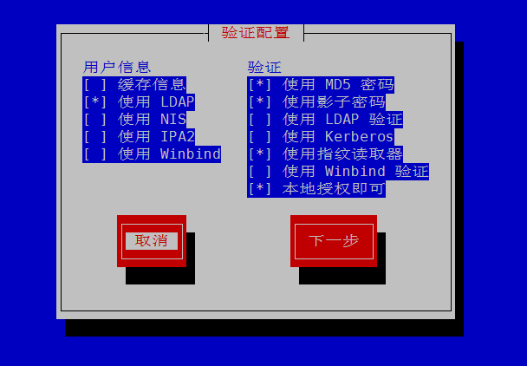

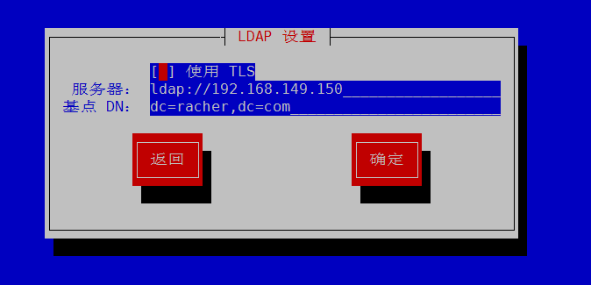

2) 安装nfs-utils 使用showmount 查看服务器共享目录
yum install nfs-utils -y

//查看已经挂载上了共享目录
[root@cldap etc]# showmount -e 192.168.149.150
Export list for 192.168.149.150:
/ldaphome 192.168.149.0/24

3)安装autofs包
yum install autofs -y
4)添加挂载规则

vim /etc/auto.master
/ldaphome /etc/auto.nfs # 添加一条新的规则

vim /etc/auto.nfs # 添加自动挂载的规则
* -fstype=nfs,rw,async 192.168.118.14:/ldaphome/& # 挂载192.168.118.14:/ldaphome/到本地的/ldaphome

4)直接测试
[root@cldap etc]# su - ldapuser1
[ldapuser1@cldap ~]$ pwd
/ldaphome/ldapuser1
[ldapuser1@cldap ~]$

[ldapuser1@cldap ~]$ df
Filesystem 1K-blocks Used Available Use% Mounted on
... ...
192.168.149.150:/ldaphome/ldapuser1
59862528 9865216 46956544 18% /ldaphome/ldapuser1

