INTERNSHIP AT KODLA SOFTWARE

Summer Training Report
CMSE 400

Mohamed, Ahmed, 19700493
Number of working days: 20 2nd
Period of Training: 21/01/2025 – 19/02/2025
Company Name: Kodla software
Company Address: İsmet İnönü Blv 108, Gazimağusa 99450

Computer Engineering Department
Eastern Mediterranean University

ACKNOWLEDGEMENT
I would like to express my sincere gratitude to my supervisor, Mr. Utku, for his guidance and support throughout my internship at Kodla Software. His expertise and encouragement were invaluable in helping me complete my project successfully. I also extend my thanks to the entire team at Kodla Software for providing me with the opportunity to work on a real-world project and for their assistance during my training period. Finally, I would like to thank my peers, professors and the Computer Engineering Department at Eastern Mediterranean University for their continuous support and for equipping me with the knowledge and skills necessary for this internship.

ABSTRACT
During my internship at Kodla Software, I worked on developing a Task Management System using modern web technologies such as Python Flask, PostgreSQL, and Bootstrap. The project aimed to create a web-based application that allows users to manage tasks, assign roles, and track progress efficiently. The system includes features such as user authentication, role-based access control, file uploads, and password reset functionality. The project was completed using an agile methodology, with weekly sprints and regular feedback from my supervisor. The final product is a fully functional web application that can be deployed in a production environment. This internship provided me with hands-on experience in software development, teamwork, and problem-solving, which will be invaluable for my future career as a software engineer.
Keywords: Flask, PostgreSQL, Task Management, Role-Based Access Control, Web Development

TABLE OF CONTENTS Page
ACKNOWLEDGEMENT II
ABSTRACT III
TABLE OF CONTENTS IV
LIST OF FIGURES V
LIST OF TABLES VI
1. INTRODUCTION 1
2. COMPANY OVERVIEW 2
3. OBJECTIVES / PROBLEM DEFINITION 3
4. WORK DONE AND METHODOLOGY APPLIED 4
5. RESULTS AND DISCUSSION 5
6. NEW skIlls and knowledge gaIned through the experIence and the Importance of lIfelong learnIng 6
7. CONCLUSIONS 7
8. REFERENCES 8
9. APPENDIX 9

LIST OF FIGURESFigure 1.1: System Architecture Diagram
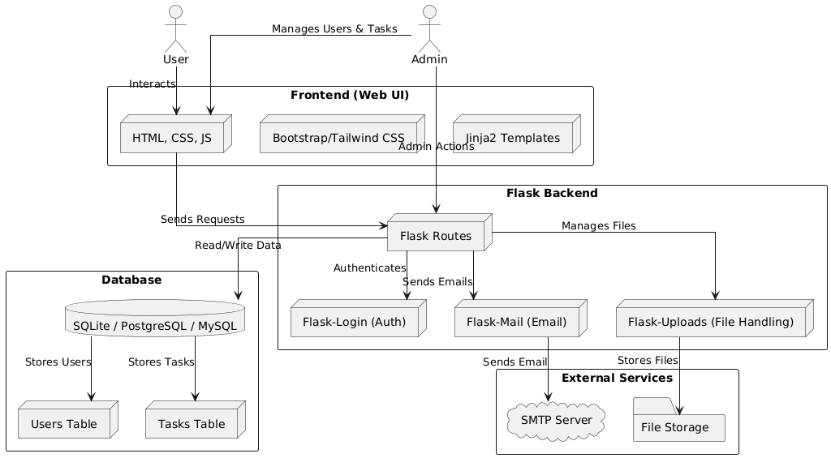
Figure 4.1: Task Management System Workflow
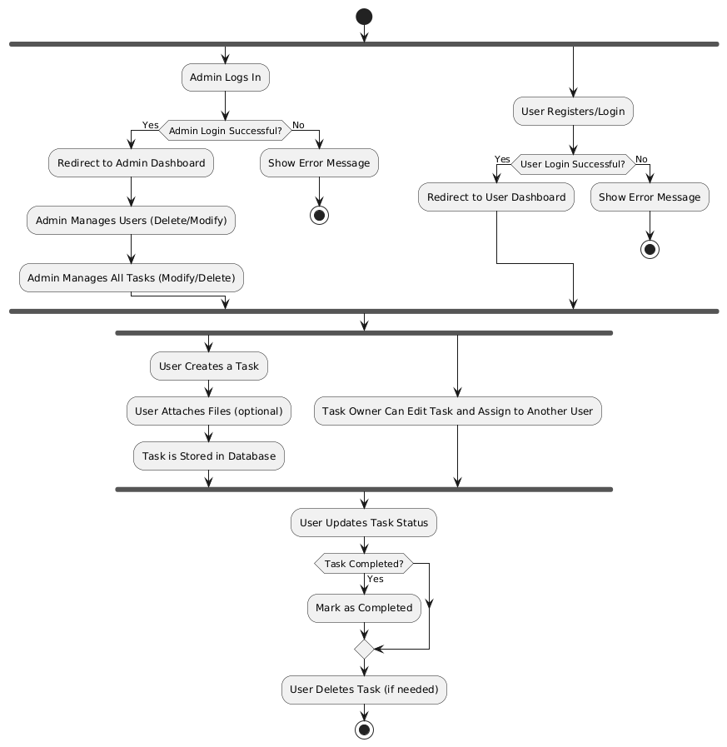
Figure 5.1: User Interface Screenshots
LIST OF TABLES

Table 4.1: Technologies Used in the Project

Category | Technology | Description
Frontend | HTML, CSS, JavaScript | Used for building the user interface
 | Bootstrap / Tailwind CSS | CSS frameworks for responsive design
 | Jinja2 Templates | Templating engine for rendering dynamic content
Backend | Flask | Lightweight Python web framework
 | Flask-Login | Manages user authentication and sessions
 | Flask-Mail | Handles email notifications (e.g., password reset)
 | Flask-SQLAlchemy | ORM for database interactions
 | Flask-Uploads | Manages file handling and uploads
Database | SQLite (Development) | Lightweight database for local development
 | PostgreSQL (Prod) | Scalable relational databases for production
Security | Werkzeug Security | Provides password hashing and security functions
External  Services | SMTP Server | Used for sending emails
 | File Storage | Stores user-uploaded files

1. INTRODUCTION
During my internship, I was tasked with developing a Task Management System to streamline task tracking and collaboration within the company. The project aimed to address the challenges of managing tasks across multiple teams and ensuring accountability through role-based access control. The system allows users to create, update, and delete tasks, attach files, and reset passwords via email. My contributions included designing the system architecture, implementing the backend using Python Flask, and developing the frontend using Bootstrap. This report outlines the objectives, methodology, results, and conclusions of the project.

2. COMPANY OVERVIEW

Kodla Software is a software development company based in Gazimağusa, Cyprus. Founded in 2010, the company specializes in developing custom software solutions for businesses across various industries, including healthcare, education, and finance. Kodla Software employs over 50 professionals, including software engineers, data scientists, and UX/UI designers. The company uses a wide range of technologies, including Python, JavaScript, PostgreSQL, and Docker, to deliver high-quality software products. During my internship, I worked under the guidance of Mr. Utku, who provided me with valuable insights into software development best practices.

3. OBJECTIVES / PROBLEM DEFINITION
The primary objective of the project was to develop a Task Management System that allows users to:
- Create, update, and delete tasks.
- Assign roles (Admin and User) to control access.
- Attach files to tasks for better collaboration.
- Reset passwords via email for enhanced security.
The system was designed to improve task tracking and collaboration within the company by providing a centralized platform for managing tasks and ensuring accountability through role-based access control.

4. WORK DONE AND METHODOLOGY APPLIED
The project was developed using an agile methodology, with weekly sprints and regular feedback from my supervisor. The system was built using the following technologies:
- Backend: Python Flask, PostgreSQL, Flask-SQLAlchemy, Flask-Login, Flask-Mail, Flask-Uploads.
- Frontend: HTML, CSS, Bootstrap, JavaScript.
The development process involved the following steps:
- Requirement Analysis: Understanding the needs of the company and defining the scope of the project.
- System Design: Creating the system architecture and database schema.
- Implementation: Writing the backend and frontend code, integrating user authentication, and implementing file uploads.
- Testing: Testing the system for bugs and performance issues.

5. RESULTS AND DISCUSSION
The final product is a fully functional Task Management System that meets the objectives outlined in the project. The system allows users to:
- Register and log in securely.
- Create, update, and delete tasks.
- Attach files to tasks.
- Reset passwords via email.
The system was tested extensively, and the results are summarized in Table 5.1. The user interface is intuitive and responsive, as shown in Figure 5.1.

6. NEW skIlls and knowledge gaIned through the experIence and the Importance of lIfelong learnIng

Why do you think there is a need to engage in lifelong learning?

In the rapidly evolving field of software engineering, lifelong learning is essential to stay updated with the latest technologies and best practices. The industry is constantly changing, and new tools and frameworks are introduced regularly. To remain competitive and deliver high-quality solutions, it is crucial to continuously learn and adapt.

What have you done so far to learn new things independently?

During my internship, I took the initiative to learn new technologies such as Docker and Flask-Mail independently. I also participated in online courses and tutorials to deepen my understanding of web development and database management.

What are you planning to do to continue learning in the future?

I plan to continue learning by:

Taking advanced courses in software development and cloud computing.

Working on other projects to gain practical experience.

Attending industry conferences and workshops to stay updated with the latest trends.

7. CONCLUSIONS
The Task Management System developed during my internship at Kodla Software is a robust and scalable solution for managing tasks and improving collaboration. The project provided me with hands-on experience in software development, and problem-solving. The skills and knowledge gained during this internship will be invaluable for my academic studies and future career as a software engineer. I am confident that this experience has prepared me to tackle more complex challenges in the field of software engineering.

8. REFERENCES
- Flask Documentation. (n.d.). Retrieved from https://flask.palletsprojects.com/
- PostgreSQL Documentation. (n.d.). Retrieved from https://www.postgresql.org/docs/
- Bootstrap Documentation. (n.d.). Retrieved from https://getbootstrap.com/docs/
- Docker Documentation. (n.d.). Retrieved from https://docs.docker.com/

9. APPENDIX
git clone https://github.com/yourusername/task-management-system.gitAPPENDIX A
APPENDIX B
APPENDIX C

