Name: LaRae Snoddy
Email: referencechecks@extern.com
Phone (if required): (917) 983-0880

Proj 1
what, how, or why this is a market research challenge
Demonstrated proficiency in conducting comprehensive market research within the gaming industry and exploring diverse genres.
Leveraged immersive gameplay experiences to gain profound insights into player psychology.
Provided actionable insights to the Mobalytics team for decision-making on player engagement initiatives and overall business strategy.

Customer insights - Sales trends, Product or Process Data, Feedback, Personal Interest and Lifestyle
Improve business
Personalize customer experience
Beat the competition

#introduction - give your intro
# gamingindustry - consumer insights related convo
Market Research Analyst - should know anything and everything about something
Conducts research and gathers data using various methods - online search surveys, interviews and data analysis tools.
Collect, Analyze, Interpret (trends) and Output ( reports and presentations)
Make understand consumer preferences, market dynamics and competitive landscape - strategic decision making and improve overall business performance

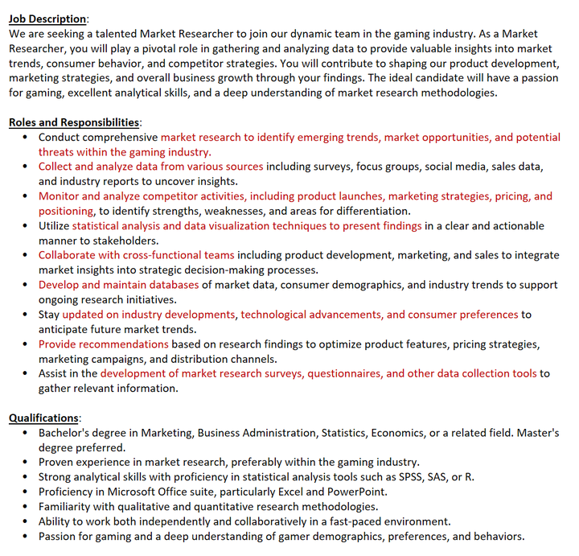
Game research - geography, revenue distribution within the value chain, platform, monetization model -- [modern] genre of the game, type of player, other micro segments like art style, multiplayer vs single player, game themes etc
Game data Sources - Newzoo(expensive). Video Game Insights- Steam Analytics, Top Charts. Streamspy.
Indie game marketing tools - Steam DB, Game Data Crunch, Twitch Tracker, Wirewalk, Steam Likes
THINK
1. What skills do you think you already have to be a good market researcher?
2. What skills do you want to further hone to be a great market research professional?
Mission and Vision (KEEP IN MIND)
To enhance every player's gaming experience and help maximize the enjoyment of their favorite games.
We are the go to place for information players want while playing any game. We know what you play, how you like to play, what information you might want, and deliver it to you in a personalized and customizable way at the perfect time.
GPI - Gamer Performance Index
The 8 main Skills - Fighting, Farming, Vision, Aggression, Toughness, Teamplay, Consistency, Versatility
Before, During, After and Between - When
Gaming Diversity Types - Genres, Platforms, Player Perspective, Multiplayer options. Additional -- art style, narrative structure and competitive scene and more.
Release of new consoles by Microsoft and Sony in 2020, along with subscription services, has expanded access to more games and increased revenue potential.
Key Insights
:moneybag: The gaming industry’s immense revenue potential is evident through the comparison of Fortnite’s $1.8 billion revenues to the world’s highest-grossing movie, Avengers: Endgame.
:earth_africa: China’s dominance in the gaming industry showcases the country’s significant market size and the cultural impact of video games.
:video_game: Live streaming has revolutionized the gaming experience, allowing gamers to connect with audiences and creating new opportunities for content creators and influencers.
:chart_with_upwards_trend: The gaming industry’s resilience during the pandemic demonstrates its ability to adapt and thrive in challenging circumstances.
:video_game: The release of new consoles and subscription services indicates the industry’s continuous evolution and commitment to providing a diverse range of gaming experiences.
:moneybag: The gaming industry’s revenue potential is not limited to game sales but also extends to various monetization models, such as in-game purchases, subscriptions, and sponsorships.
:earth_africa: The global reach of the gaming industry highlights its universal appeal and the potential for further growth, particularly in emerging markets.
:arrows_counterclockwise: The evolution of AI in video games has been a gradual process over several decades, with significant advancements in recent years.
:dart: The future of AI in gaming is uncertain, with potential positive impacts on gameplay depth, skill level, and replayability, but also concerns about cheating and monetization.
:video_game: Single-player and co-op games may benefit greatly from AI, offering unique and personalized experiences that enhance replayability.
:no_entry_sign: Effective AI detection systems are crucial to combat cheating in online multiplayer games and maintain a fair playing environment.
:money_with_wings: The monetization of AI-driven games should be carefully managed to avoid negatively impacting player experiences and creating pay-to-win scenarios.
:earth_africa: Game developers hold a significant responsibility in shaping the future of AI in gaming and should consider the broader implications and potential consequences of their innovations.
:handshake: Collaboration between AI researchers and game developers can lead to groundbreaking advancements in AI-driven gameplay and immersive experiences.

Motivation, Immersion, Flow and Player types
Motivation - intrinsic, extrinsic
Immersion - challenge, reward, autonomy and social interaction ( elements - balance )
Flow - emotions +ve, -ve

Pyramid Principle
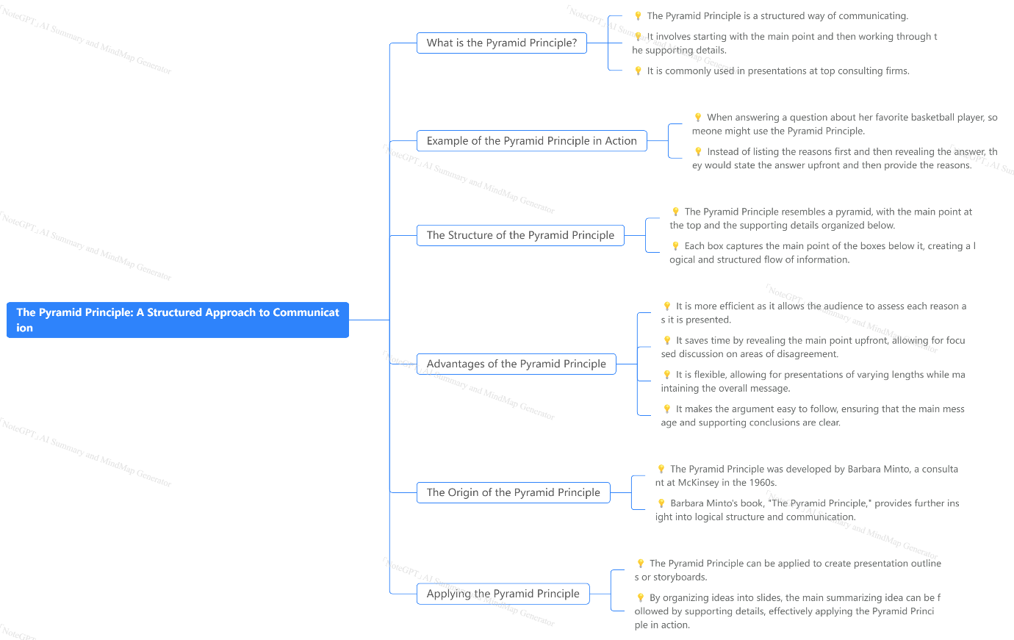
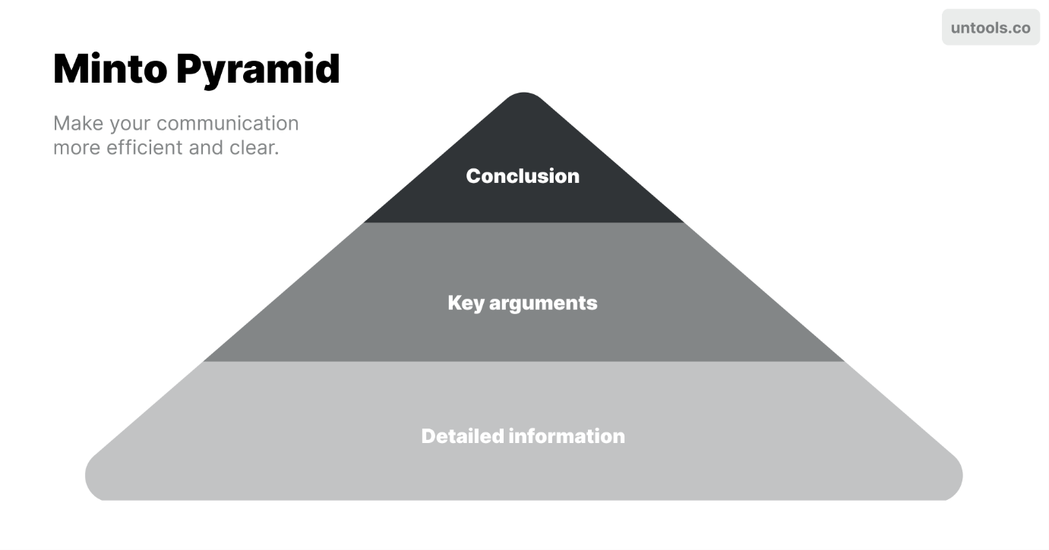
M.O.V.I.E. framework – Message, Organization, Visualization, Insights, Extras
🔍 The first step is to decide on a clear message for the slide.
📊 Organize the data to support the message using the pyramid principle.
🖼️ Visualize the information with charts, icons, or graphics.
💎 Make the insights clear by stating them directly and highlighting them.
📝 Take care of formatting, alignment, and including sources as extras.
- Pick a clear and concise message for your slide.
- Avoid forcing your message into a pre-determined template.
- Use the pyramid principle to break down your message into supporting points.
- Organize your data into categories that align with your message.
- Use charts, icons, and graphics to make your information more visually appealing.
- Visualization helps the audience understand the details quickly.
- State your insights directly and clearly.
- Highlight important information using bold text, callouts, and lines
- Pay attention to formatting, alignment, and footnotes.
- Make sure your slide is error-free and includes all necessary details.

