Abstract

Introduction

Related work

Proposed method
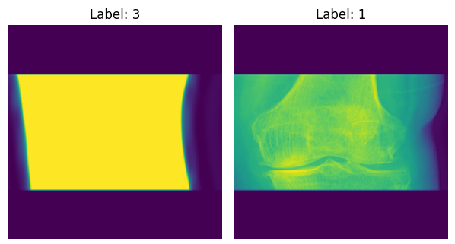

Data Modification
Adjusting for the 16 bit images
Removing duplicated and invalid Osteopenia images
Reshaping double knee images
Don’t need to worry about the distribution as it is still relatively balanced after removing osteo images.

Fully Connected Network
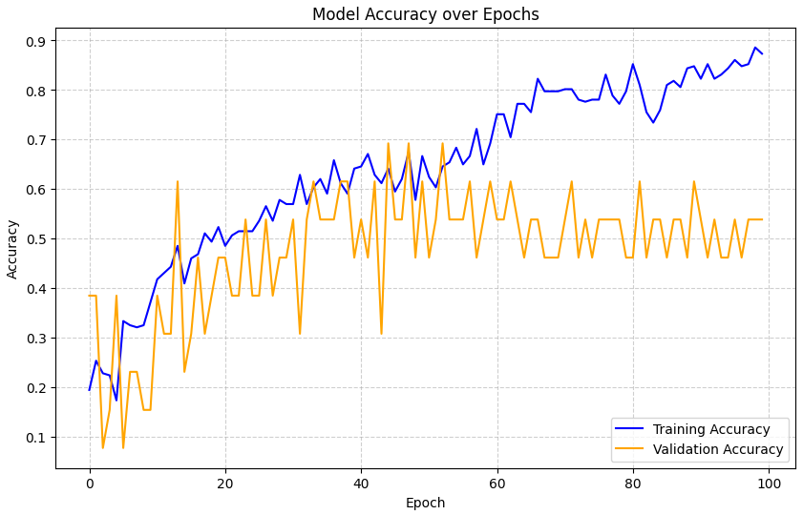
Figure 1: fully connected NN, 3 dense layers of 128, using relu
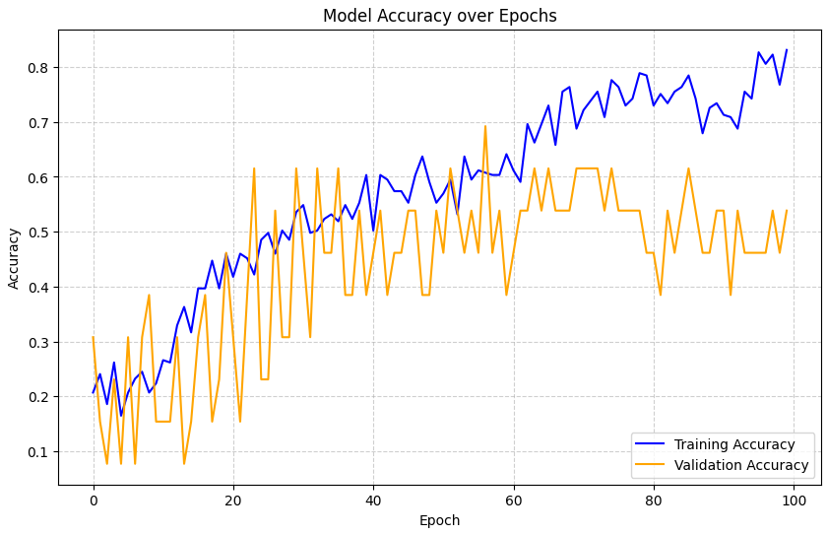
Figure 2: Fully connected NN 4 layers of 246, using relu

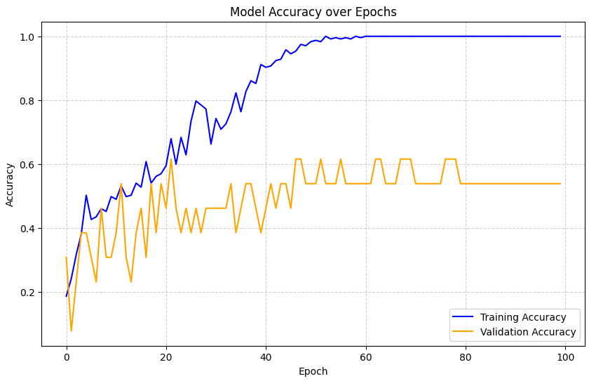
Figure 3: Convolutional network overfitting way before 100 epochs
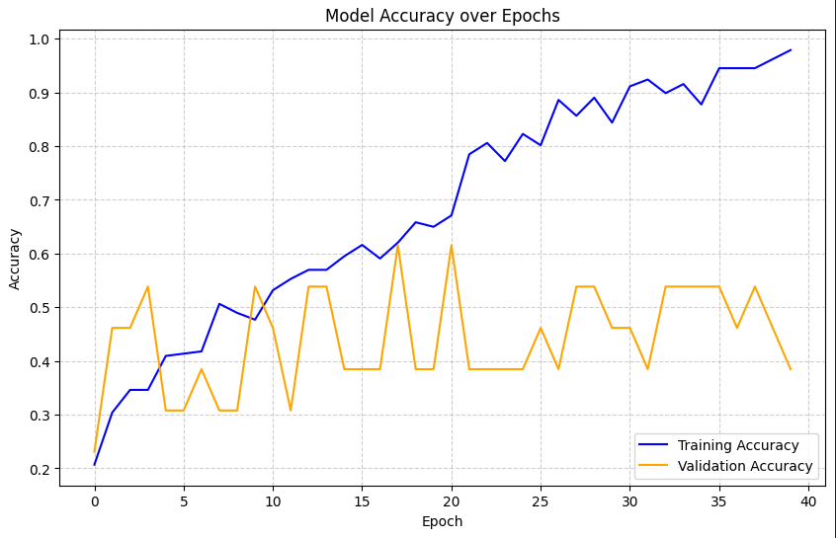
Figure 4: Convolutional network still not getting past 0.65 accuracy on validation
Is this due to the small data set?

Using MobileNet v2
No major improvements over
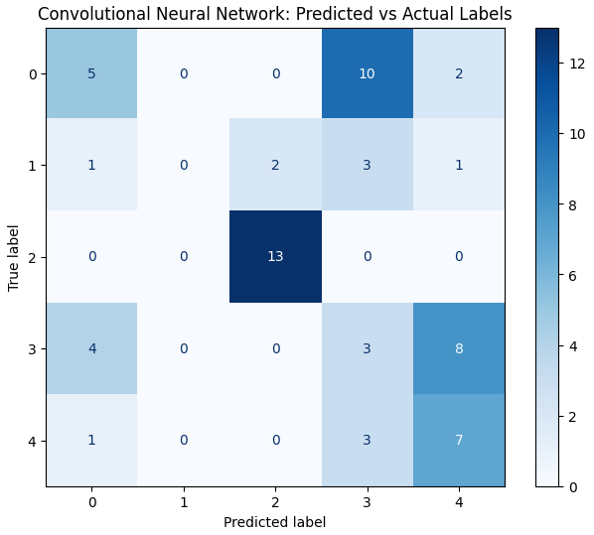
Very different results with different splits of the data.
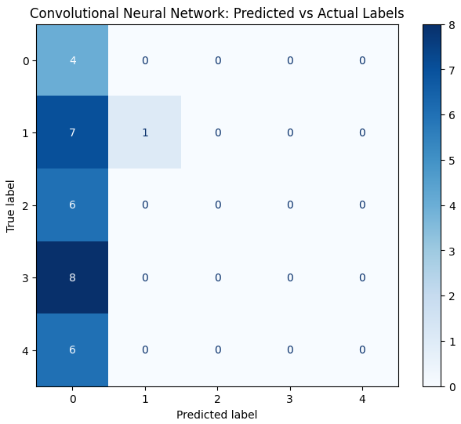

Experimental Results

Summary

