Kellgren-Lawrence grading with deep learning

Abstract
This report aims to corroborate the findings of similar work of the use of deep learning to assist in the grading of medical x-rays, specifically we will be attempting to teach models to grade the x-rays of knees on the Kellgren and Lawrence grading system. The data set we are working with is a set of ~350 images. We approached the data set with 4 different models: random forest, fully connected network, convolutional neural network, and a pretrained model using MobileNetV2. The results are consistent with other work, with more complex method and the use of pretrained models showing improvements for small datasets.

Introduction
The report covers what has been achieved and how we achieved it. The sections are as follows; an overview of related work where we highlight relevant research on the topic, proposed method where we discuss preprocessing, experimental set up, the models used and training process. Then the experimental results show the results of the models. Followed by the Summary.

Related Work
The most relevant work to this report is Automating classification of osteoarthritis according to Kellgren-Lawrence in the knee using deep learning in an unfiltered adult population by Simon Olsson et al. where they trained a Convolutional Neural Network with ResNet architecture on a data set of over 6000 images and achieved an AUC of 0.87. This work directly achieves what we have set out to do, but with a much larger data set and a much more complex model, that can take full advantage of the larger data set. [1]
Another key work that relates to the issues in our work is Image Classification With Small Datasets: Overview and Benchmark by Lorenzo Brigato et al. where they discuss the issues with small data sets and using machine learning techniques, highlighting the use and limitations of pretrained models for small data sets, and the importance of hyper parameters. [2]

Proposed Method

Preprocessing
For the small data set all images need to be padded and resampled to 224 x 224. This is important as the data must all be of the same shape for the models to work. There are some exceptions to this simple preprocessing.
Firstly, images labeled “Osteopenia…” are duplicated across multiple categories. For this reason, all images containing “Osteopenia” in the title have been removed from the dataset.
Secondly, there are images that include a slim image of 2 knees, whereas most images in the data set have only one knee in the picture, this is important as osteoarthritis can be graded per knee. Therefore, some images of 2 knees may only have one knee that applies to that class. Typically, both knees are of a similar grade [3]. This occurs most frequently in class 2Mild, where 41/61 images are of this type, so to prevent unbalance of the data set, only one of the 2 knees will be used. To do this we can check when an image’s width is greater than 2 times its height and then crop down the image.
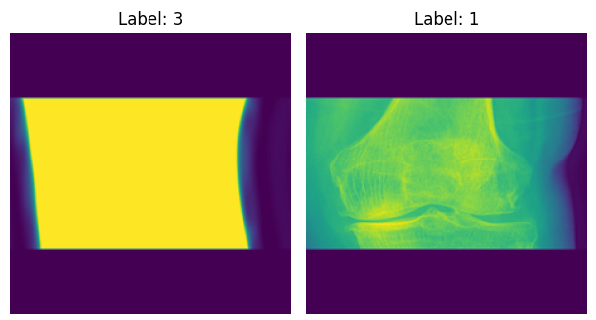
Thirdly, most images use 8-bit depth and some use 16-bit depth. This leads to images with 16-bit depth appearing ‘blown out’ after being taken into the data set, and the detail is lost, above is an image showing the comparison of the 2 different bit depths after being read from the file. To accommodate this issue, the bit depth is identified at the point of reading the file and adjusted so that detail is maintained across all images.
After preprocessing the groups are distributed as: Normal: 70, Doubtful: 58, Mild: 50, Moderate: 73, Severe: 62 (313 total).

Experimental Setup
The data is initially split into train and test sets, with 80% for training and 20% for testing. The same split is used for all the models to allow for fair comparison, with such a small dataset how the data is split can have a massive effect on performance. For the neural network models, the training data is split again into training and validation is to be used for each iteration, with 80% for training and 20% for validation (64% and 16% of whole data set).

Models

Baseline: Random Forest
Random Forest is a non-linear ensemble machine learning method and will serve as our baseline model. For random forest the data is flattened into a 1d vector and does not use the 224 x 224 format, as it cannot handle special data. We are using 100 estimators for our random forest.

Fully Connected Network (FCN)
The first deep learning model is FCN, with 3 hidden layers, each with 64 neurons, a smaller size was chosen to prevent memorization of the data set. It uses ReLU for the hidden layers’ activation and SoftMax for the output layer. Like with random forest it cannot handle spatial data and the input is flattened.

Convolutional Neural Network (CNN)
The second deep learning model is CNN; CNN uses 2 Convolutional layers that can detect local patterns like edges. It also uses max pooling, which reduces the dimensionality of the data. There are 2 layers and then the output is flattened and fed into 2 fully connected layers of 64 neurons using ReLU, and SoftMax for the output.

MobileNetV2 Pre-trained Network (PTN)
MobileNetV2 is a CNN that has already been trained on ILSVRC-2012 consisting of over 1 million images. This pretrained model is then able to identify key features like edges and gaps, which are very important for our use case, and helps with the limitation of using a small data set. Then we use a global average pooling (GAP) layer instead of just a flatten layer, this reduces the number of weights and prevents memorization of the data. The output of the GAP layer is then fed into 2 fully connected layers of 64 neurons using ReLU, and then SoftMax for the output layer.

Training process
For the neural networks, checkpointing is used to achieve the best performance of the model before it memorizes the data set and starts to overfit. This is monitored on the validation accuracy, and the iteration that has the highest score is then used to attain scores on the test set. This means that all the models can achieve their best results on the tests, giving a fairer comparison.

Experimental Results
The hyper parameters were chosen through experimentation to attain better accuracy, more experimentation on the activation functions, drop out and batch size, further raising the performance of the models. Further experimentation unfortunately fell out of scope due to time constraints.
It is also important to note the importance of the random state of the test train split, with some models having high variance depending on the split, the values presented are generally representative.

Evaluation
For each model we generate a confusion matrix from the test data, where we can see the discrepancies between the true class and predictions, i.e. which classes the models are making more mistakes. We also find the accuracy for each class and overall, as the dataset is mostly balanced accuracy is a valid metric to use to compare different models and our results against other work. We also generate a graph for the training and validation accuracy for the deep learning models; this allows us to validate that we are giving the models enough epochs to reach their generalised form.

Model Hyper parameters and results

Baseline: Random Forest
For the random forest we have used 100 estimators, and have left other hyper parameters as the defaults, of note are minimum leaf samples = 1 and max features = square root, deviation from these showed no improvement.
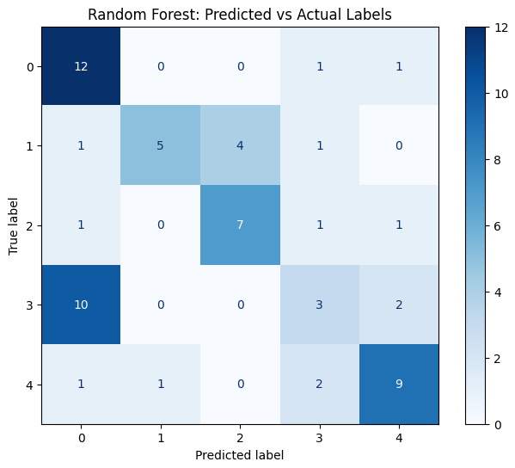
Random forest scored an accuracy of 0.54, showing that some patterns were learnt. On the confusion matrix shown above you can see that the random forest tended to confuse category 3 and category 0. Overall, beginning to generalise, this is shown by mistakes often being in categories that are next to each other e.g. predicting 3 when the true label was 4 or vice versa.

Fully Connected Network (FCN)
For the fully connected network we used 3 dense layers of 64 neurons, the model was given 250 epochs to fully explore the loss landscape. A batch size of 32 was chosen to provide more opportunities to adjust weights and learn.
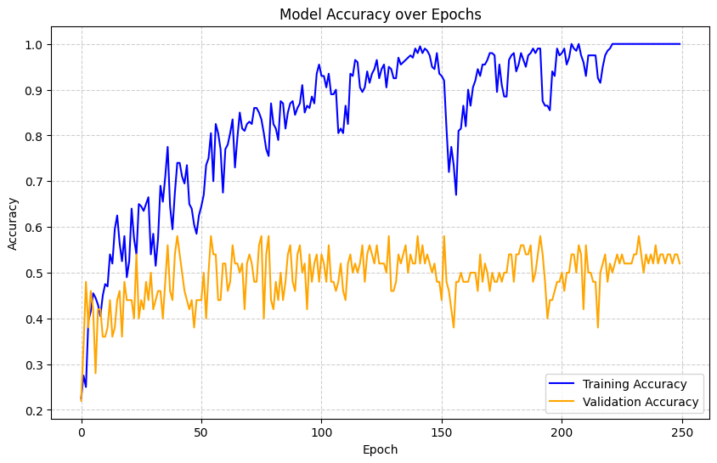
Above is the training and validation accuracy against the epochs. You will notice that the training accuracy drops at points in the training, this can be attributed to the small data set, as the small valdiation set can have large changes in score with a few different guesses being correct or false.
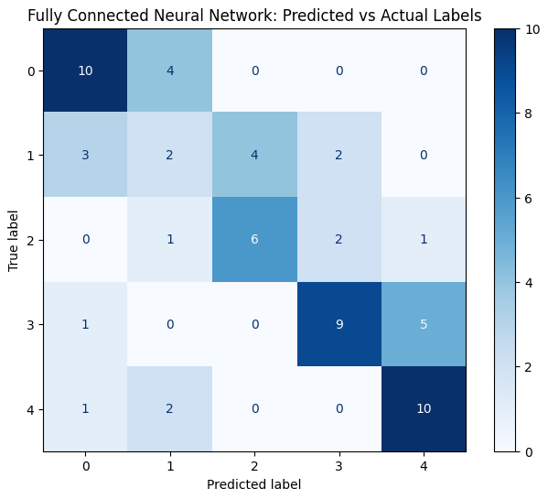
Above is the confusion matrix for the fully connected network generated from the test data, the overall accuracy of the model is 0.59, slightly surpassing random forest. As the confusion matrix shows the model has generalise the data even more so than the random forest. With the model struggling most with category 1 with an accuracy of 0.2.

Convolutional Neural Network (CNN)
For the Convolutional Neural Network there is first a layer of 32 filters taking in a 3 x 3 kernel, an industry standard, with max pooling of 2 x 2, making the model less sensitive to specific location. The next layer of 64 filters also with a 3 x 3 kernel, with another max pooling layer. This then feeds into 2 dense layers of 64 neurons. With training parameters matching the FNN apart from the epochs where the CNN was given 60.
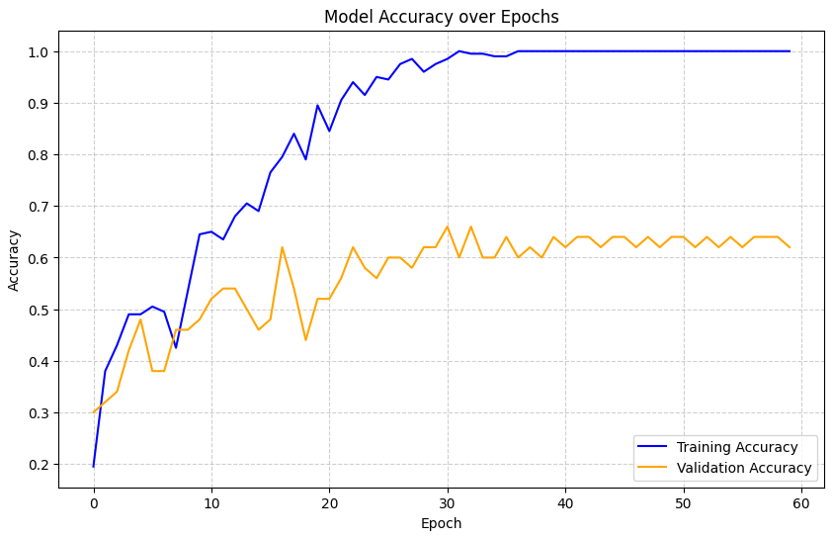
Above is the training and validation accuracy against the epochs, with the model reaching it’s best validation accuracy while the training accuracy is approaching 100%, this suggests that the model is capturing transaltabe information all the way to 100% training accuracy.
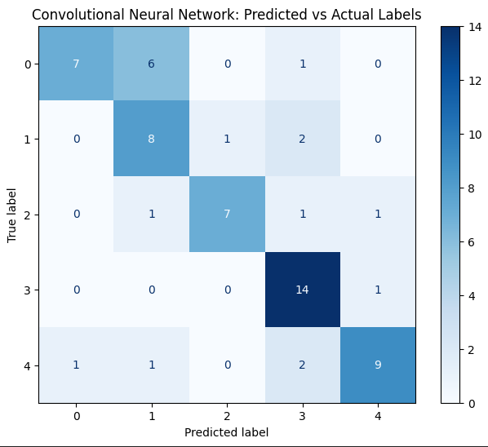
Above is the confusion matrix, the overall accuracy was 0.71, surpassing random forest and FCN by a considerable gap. The confusion matrix also shows greater generalisation.

MobileNetV2 Pre-trained Network (PTN)
For the PTN we used the MobileNetV2 as the base model, without the top (the final layers of the model) and also used the ImageNet weights. Training is set to false for this base model, as we do not want to affect the weights of the model in training. This is fed into 2 dense layers of 64 neurons. With training parameters matching the FNN apart from the epochs where the PTN was given 80.
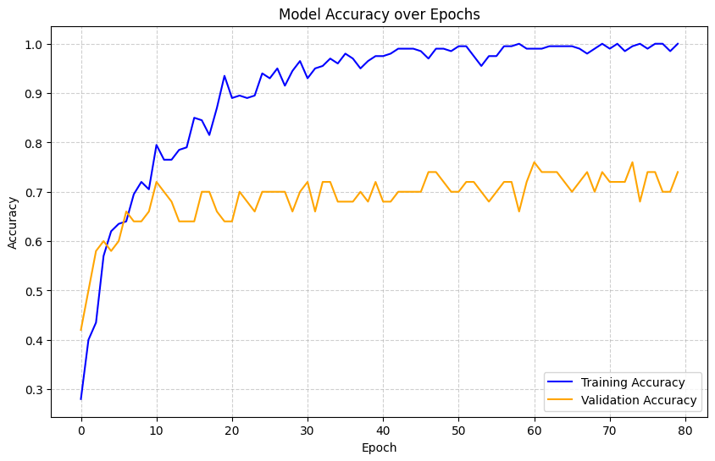
Above is training and validation accuracy against the epochs, where we can see that validation slowly climbs as training accuracy remained around 100% similar to the case with the convolutional network.
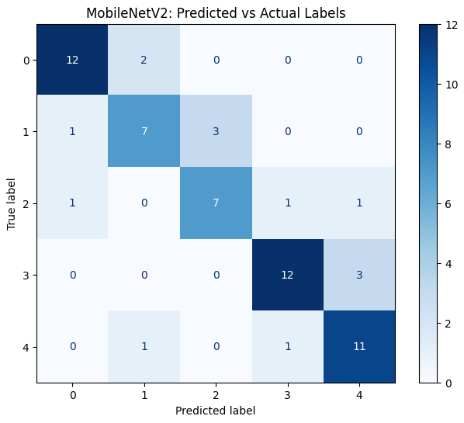
Above is the confusion matrix, the overall accuracy was 0.78, surpassing random forest, FCN and CNN by a considerable gap again. The confusion matrix also shows greater generalisation.

Overview
With increasing complexity of the models, they have been more capable of generalising the data. The pretrained networks performance highlights the advantages of using a pretrained network for small datasets like the one we are using. Below is a bar graph of the all the accuracy results for each category and the overall accuracy.

Summary
As our results show, deep learning methods can provide a viable option for automatically grading x-rays like the ones in this dataset, with convolutional methods being able to use spatial information to have greater accuracy. With a small dataset like the one we have worked with pretrained models offer even greater accuracy and are a clear best option.

References
[1] S. Olsson, E. Akbarian, A. Lind, A. S. Razavian, and M. Gordon, "Automating classification of osteoarthritis according to Kellgren-Lawrence in the knee using deep learning in an unfiltered adult population," BMC Musculoskelet. Disord., vol. 22, no. 1, p. 844, Oct. 2021, doi: 10.1186/s12891-021-04722-7.
[2] L. Brigato, B. Barz, L. Iocchi, and J. Denzler, "Image classification with small datasets: Overview and benchmark," IEEE Access, vol. 10, pp. 49233–49250, 2022, doi: 10.1109/ACCESS.2022.3172939.
[3] A. J. Metcalfe, M. L. Andersson, and R. Goodfellow et al., "Is knee osteoarthritis a symmetrical disease? Analysis of a 12 year prospective cohort study," BMC Musculoskelet. Disord., vol. 13, p. 153, Aug. 2012, doi: 10.1186/1471-2474-13-153.
[4] M. Sandler, A. Howard, M. Zhu, A. Zhmoginov, and L. -C. Chen, "MobileNetV2: Inverted residuals and linearized bottlenecks," in Proc. IEEE/CVF Conf. Comput. Vis. Pattern Recognit. (CVPR), Salt Lake City, UT, USA, 2018, pp. 4510–4520, doi: 10.1109/CVPR.2018.00474.

