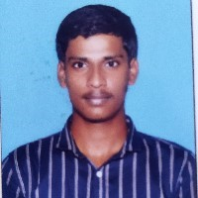

, RA1911028010087



Course



:



.



, CSE,



2023



Email



:



jv8898@srmist.edu.in



Mobile



:



8939139158



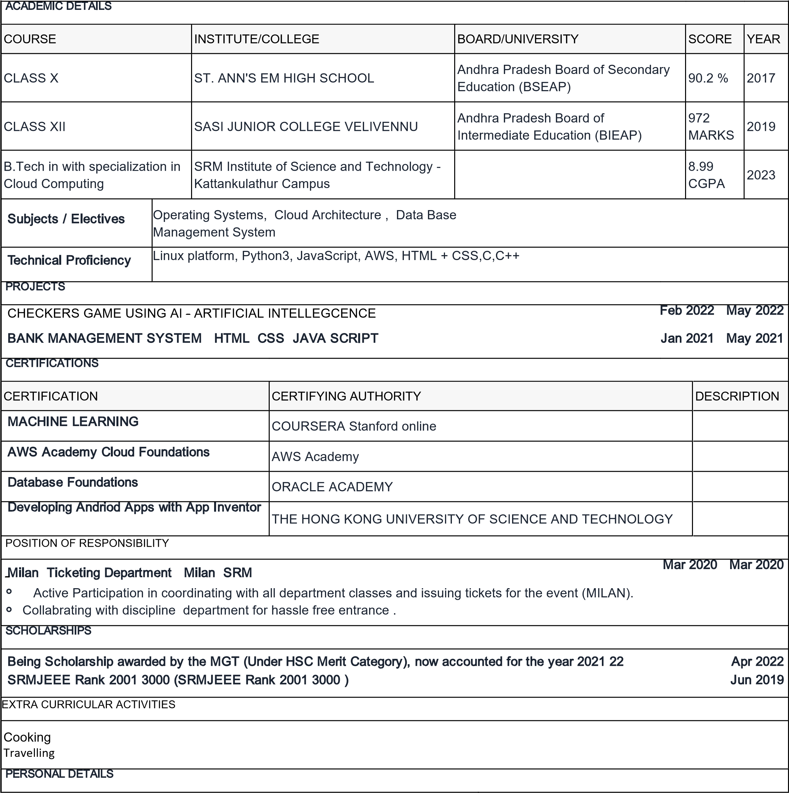

|  |  |
| --- | --- |
| Date of birth: 15 January 2002 | Father's name: Jalla. Srinivas |
| Permanent address:  1-87,near ramalayam street,Kothapusalamarru,  Bhimavaram,  West Godavari, Andhra Pradesh,  PIN - 534239 | Languages known:  English, Hindi, Telugu |
| Permanent contact number: 8939139158 | Nationality: Indian |
| Passport availability: No |  |