Jose Velazquez Saenz
Module 2.3 Assignment
Diagram:
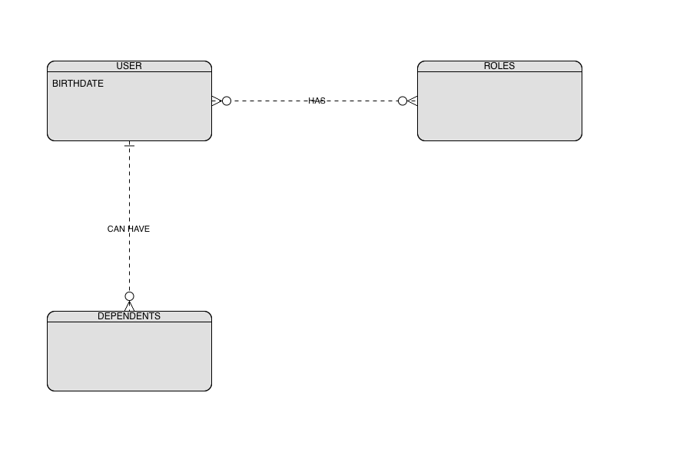
NoSQL Data Structure:
{
“User_Name”: “Jose”,
“Birthdate”: “MM/DD/YYYY”,
“Role”: [
{ “Role”: “Example”, }
{ “Role”: “Example”, }
] ,
“Dependents”: [
{ “Dependents”: “Example”, }
{ “Dependents”: “Example”, }
]
}

