Jose Velazquez Saenz
Module 5.2 Assignment

MySQL MID() Function:
The MID() function is used to extract a specific portion of a string, starting at a chosen position and returning a set number of characters. It is helpful when analyzing text, such as extracting numbers from product codes, isolating parts of phone numbers, or cleaning data stored in fixed formats. Since MID() is simply a synonym for SUBSTRING(), you would use it anytime you need to grab a segment from a larger text value for reporting, formatting, or data processing.
SELECT MID(example_cat, 4, 3) AS ExtractString FROM ex_column;
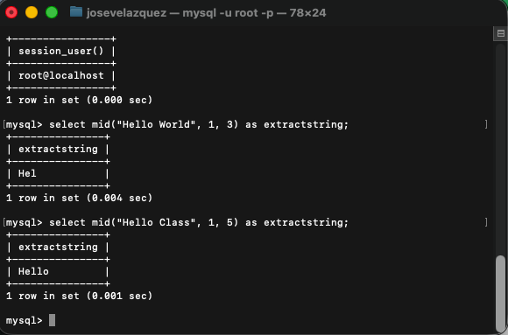

MySQL LOCATE() Function:
The LOCATE() function is used to find the position of a substring within a larger string. It helps check whether specific text exists or for analyzing and validating data based on where particular characters or patterns appear. It returns the starting position of the match, or zero if it is not found.
SELECT LOCATE(“substring”, “string”) AS MatchPosition
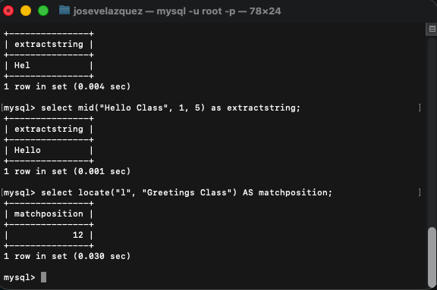

MySQL IF() Function:
The IF() function lets you perform quick conditional logic inside a query. It returns one value when a condition is true and another if it is false, making it useful for labeling data, handling defaults, or customizing output. For example, turning a 1into "Active" and a 0 into "Inactive" directly in a SELECT statement.
SELECT example_cat IF(Quantity>10, "MORE", "LESS") FROM ex_table;
