Jose Velazquez Saenz
Assignment 9.2

Testing Tutorial connection:
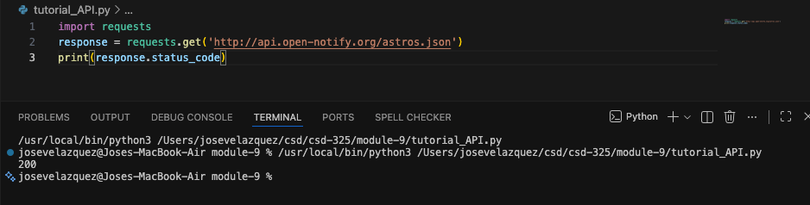
Formatted Tutorial results:
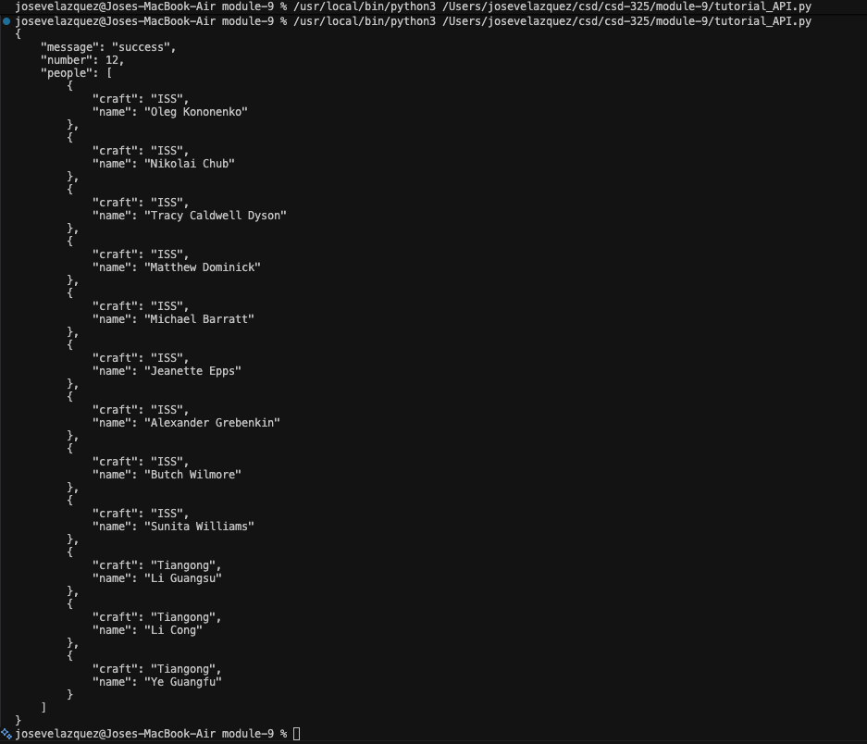

Example API connection:
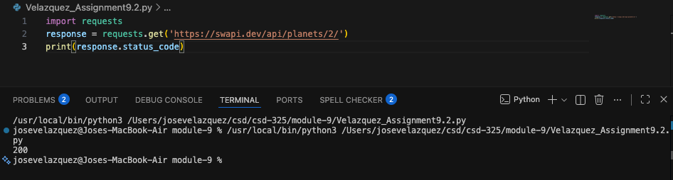
Request Response no formatting:
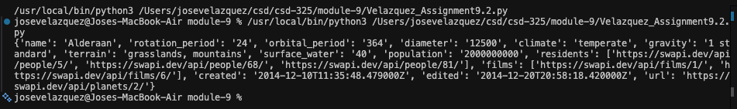
Request Response with formatting:
