Jose Velazquez Saenz
Module 8.2 Assignment

Flowchart:
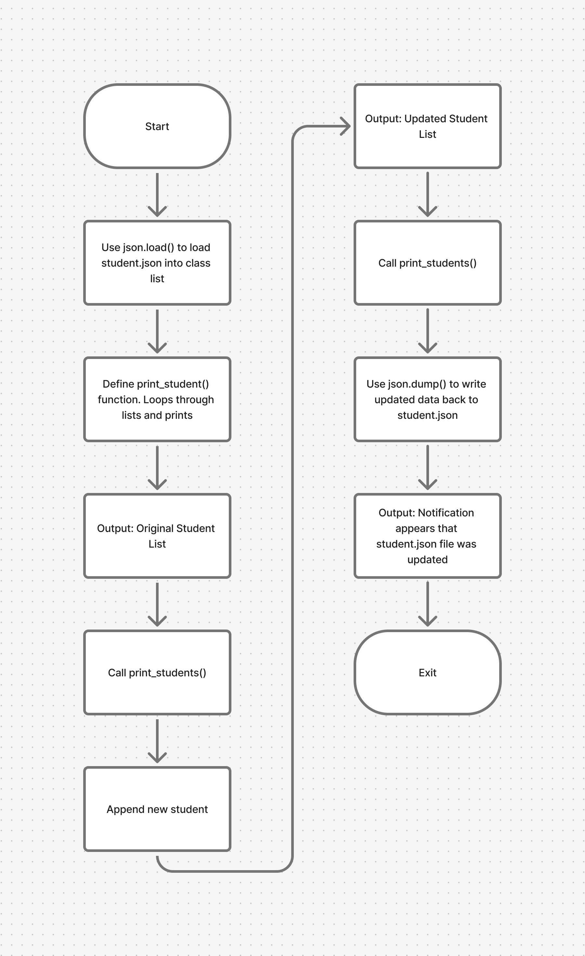
Output of running program:
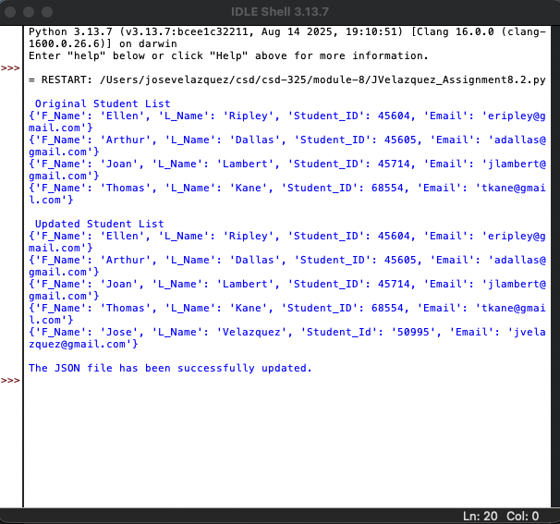

Updated student.json file:
