Jose Velazquez Saenz
Module 11.2 Assignment

Run-server command:
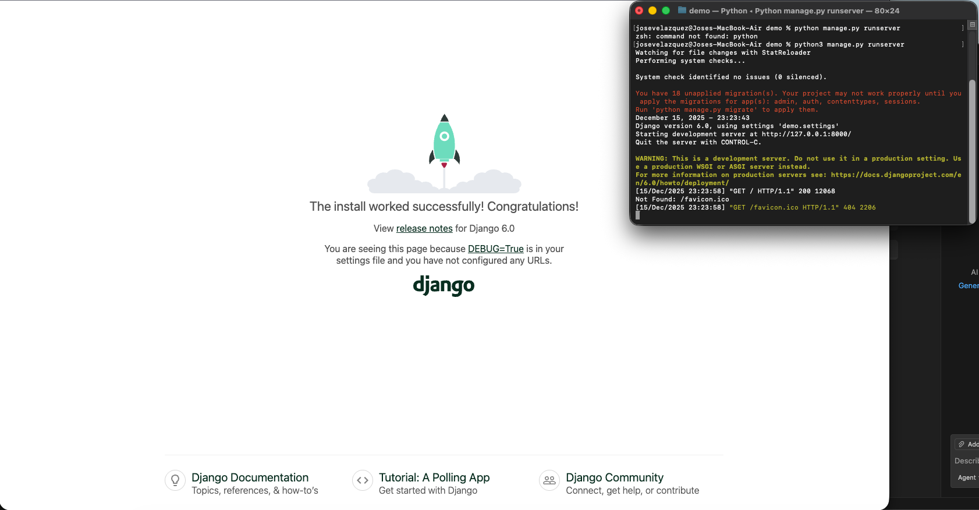

Local Host:
