Jose Velazquez Saenz
Module 1.3 Assignment
Makeup for Week 12

Flowchart:
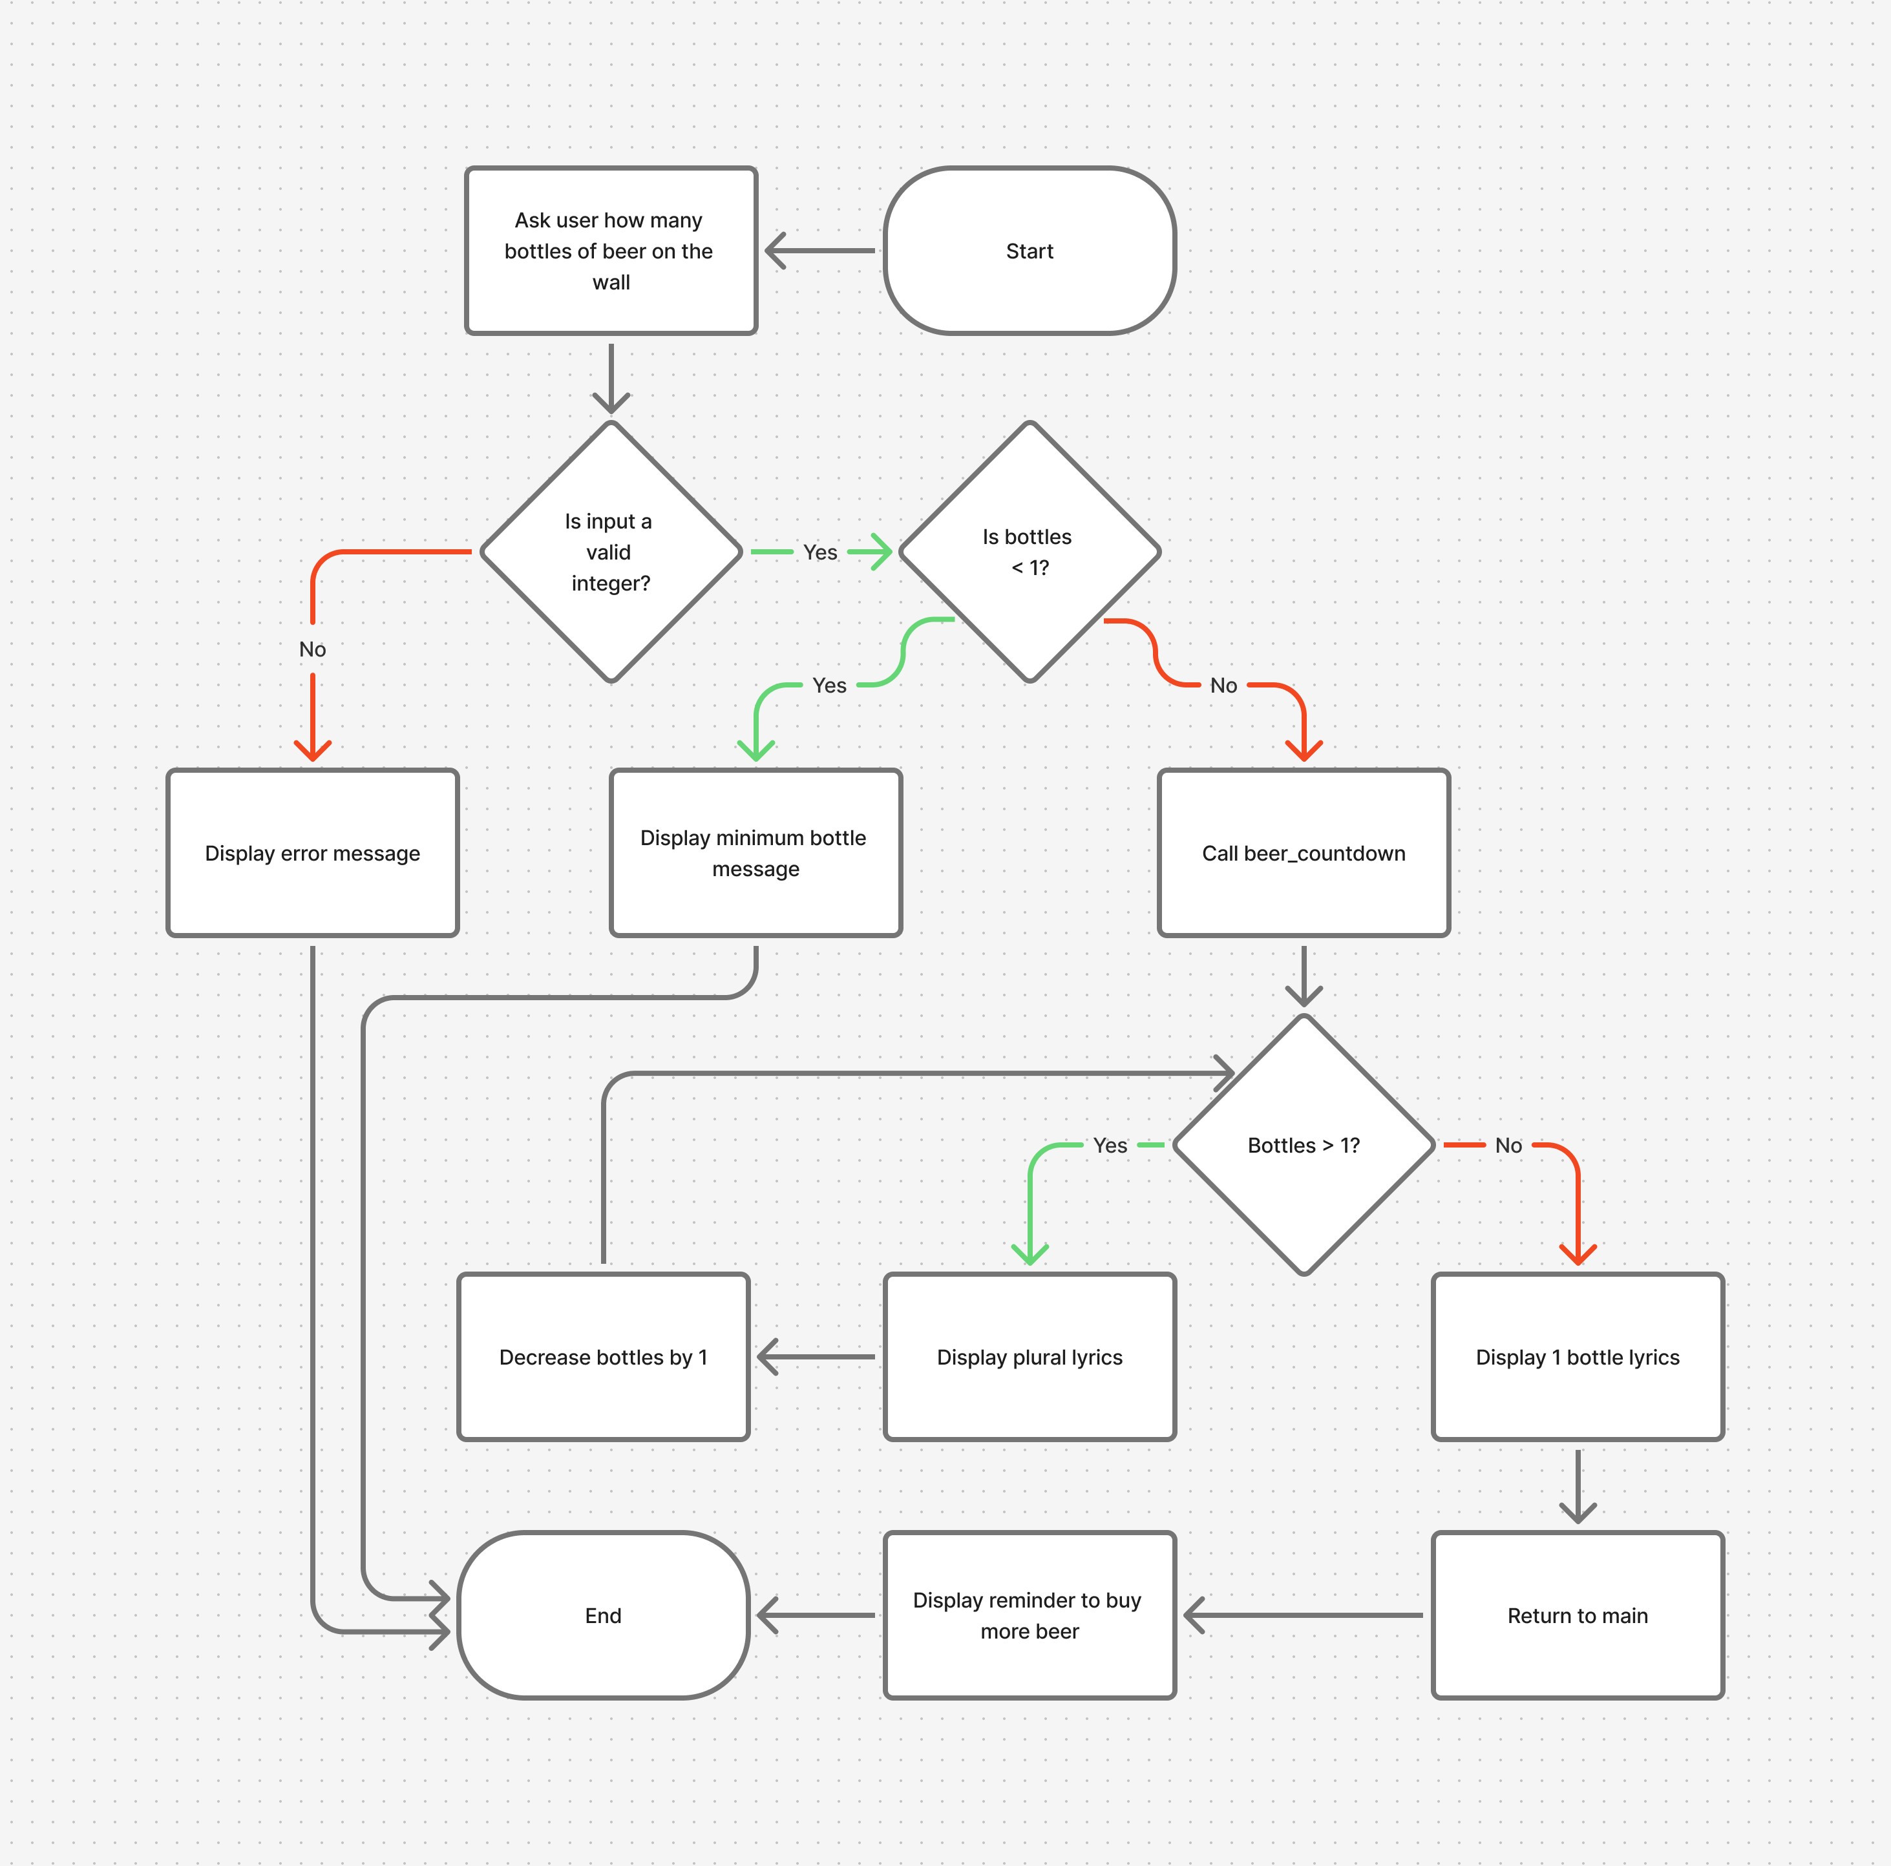

Output: 