Jose Velazquez
Module 4.2 Assignment
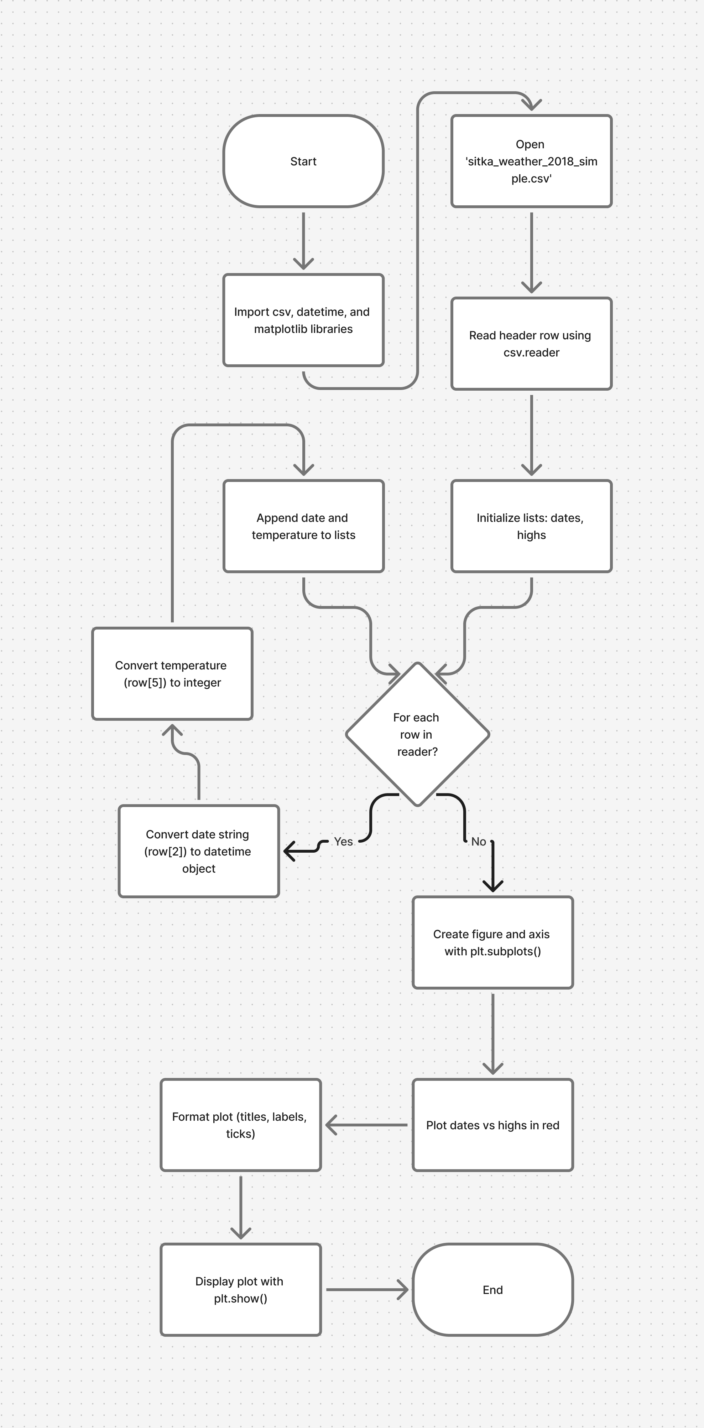
Initial Diagram
No Changes Made
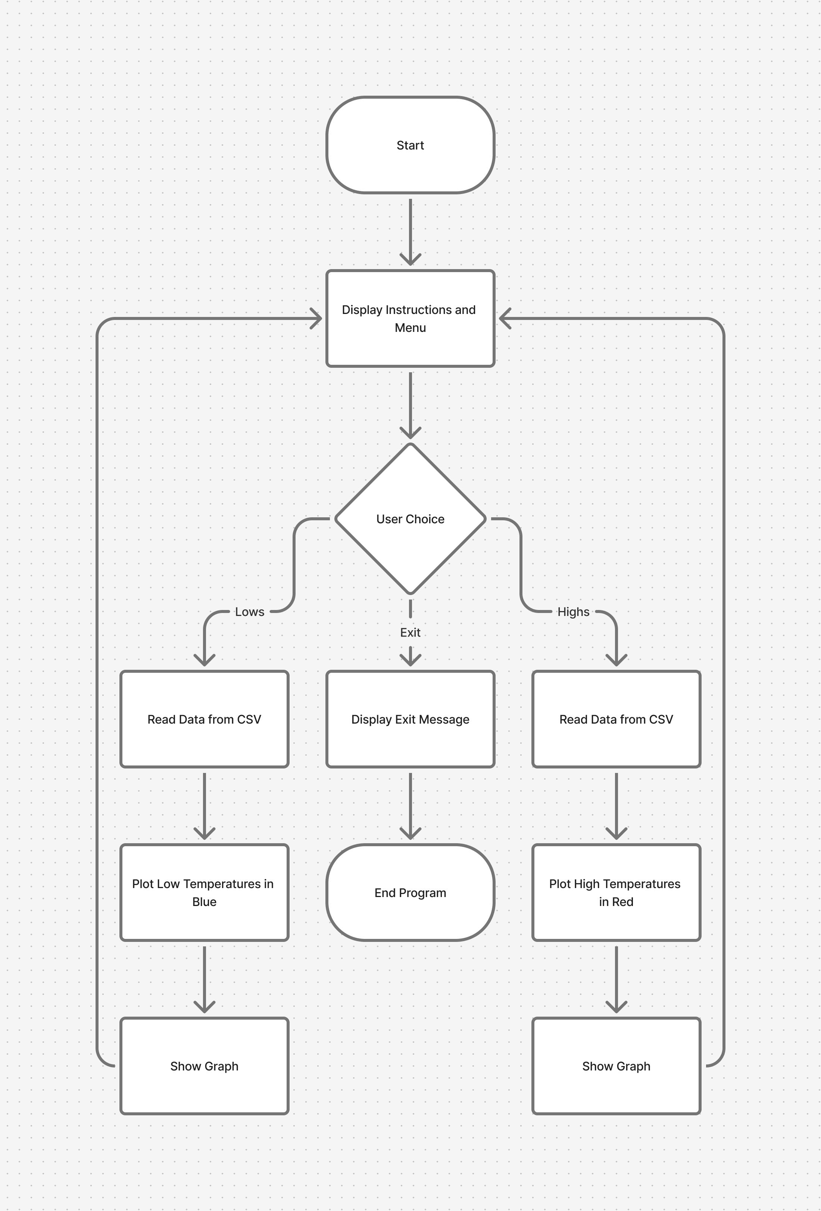
Final Diagram
With Changes

