Jose Velazquez Saenz
Module 7.2 Assignment

City_function.py
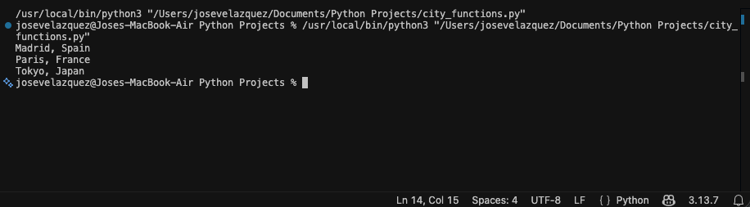

Test_cities.py
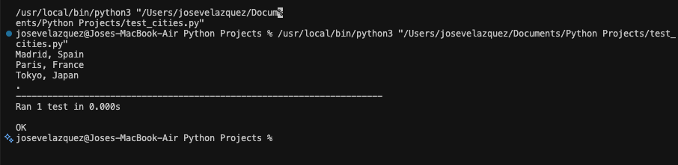

Failed output, population update:
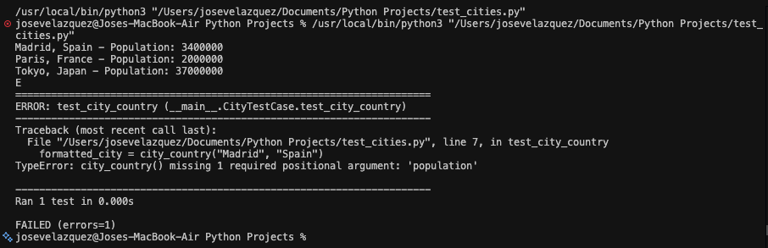

Population parameter optional:
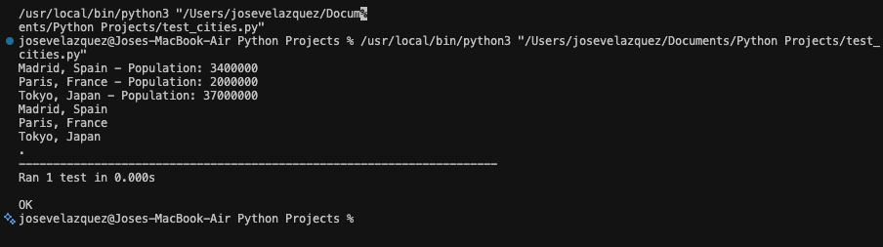

Failed output, language update:
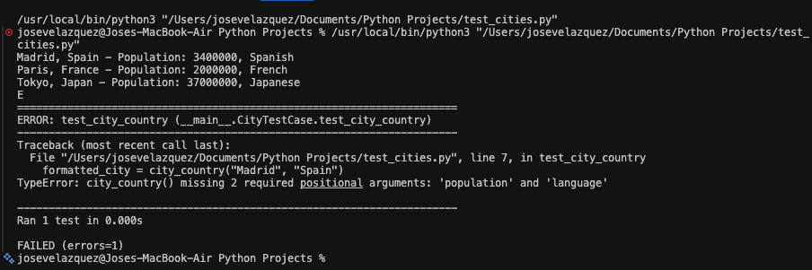

Language set as optional:
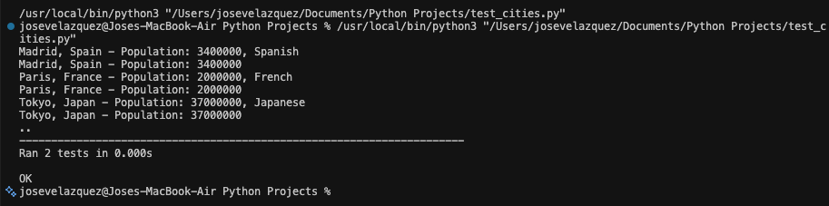

Final:
