Jose Velazquez Saenz
January 25, 2026
Module 3.2 Assignment
CSS Check:
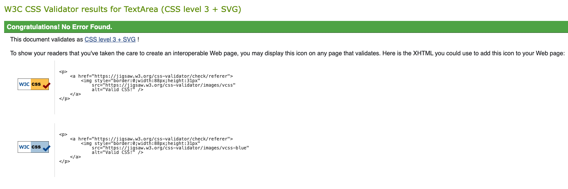
HTML Check:
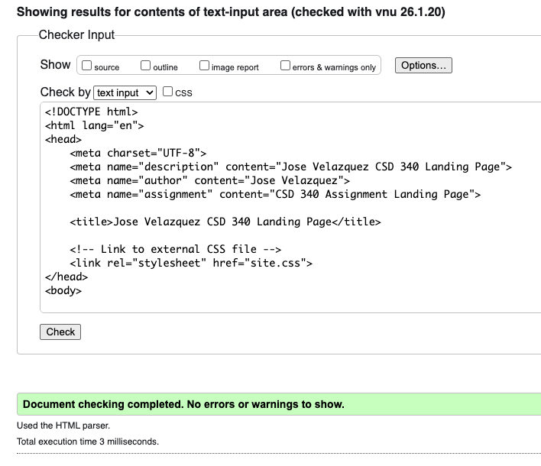
Results:
