Jose Velazquez Saenz
CSD380: DevOps
Professor Sue Sampson
July 3, 2026

Value Stream Map Assignment
Example: Weekly Grocery Shopping and Meal Prep
Time span: One week

The article “3 Easy Steps for Using VSM in Everyday Life” explains that value stream management can be applied to anything by following three steps: visualizing the process, analyzing lean metrics, and optimizing the process. This assignment uses those same steps but applies them to a different everyday process: preparing groceries and meals for the week.

Graphic Value Stream Map
The current value stream begins with planning meals and ends when meals are cooked and packed for the week. The purpose of the map is to show where time is spent and where waste can be reduced.
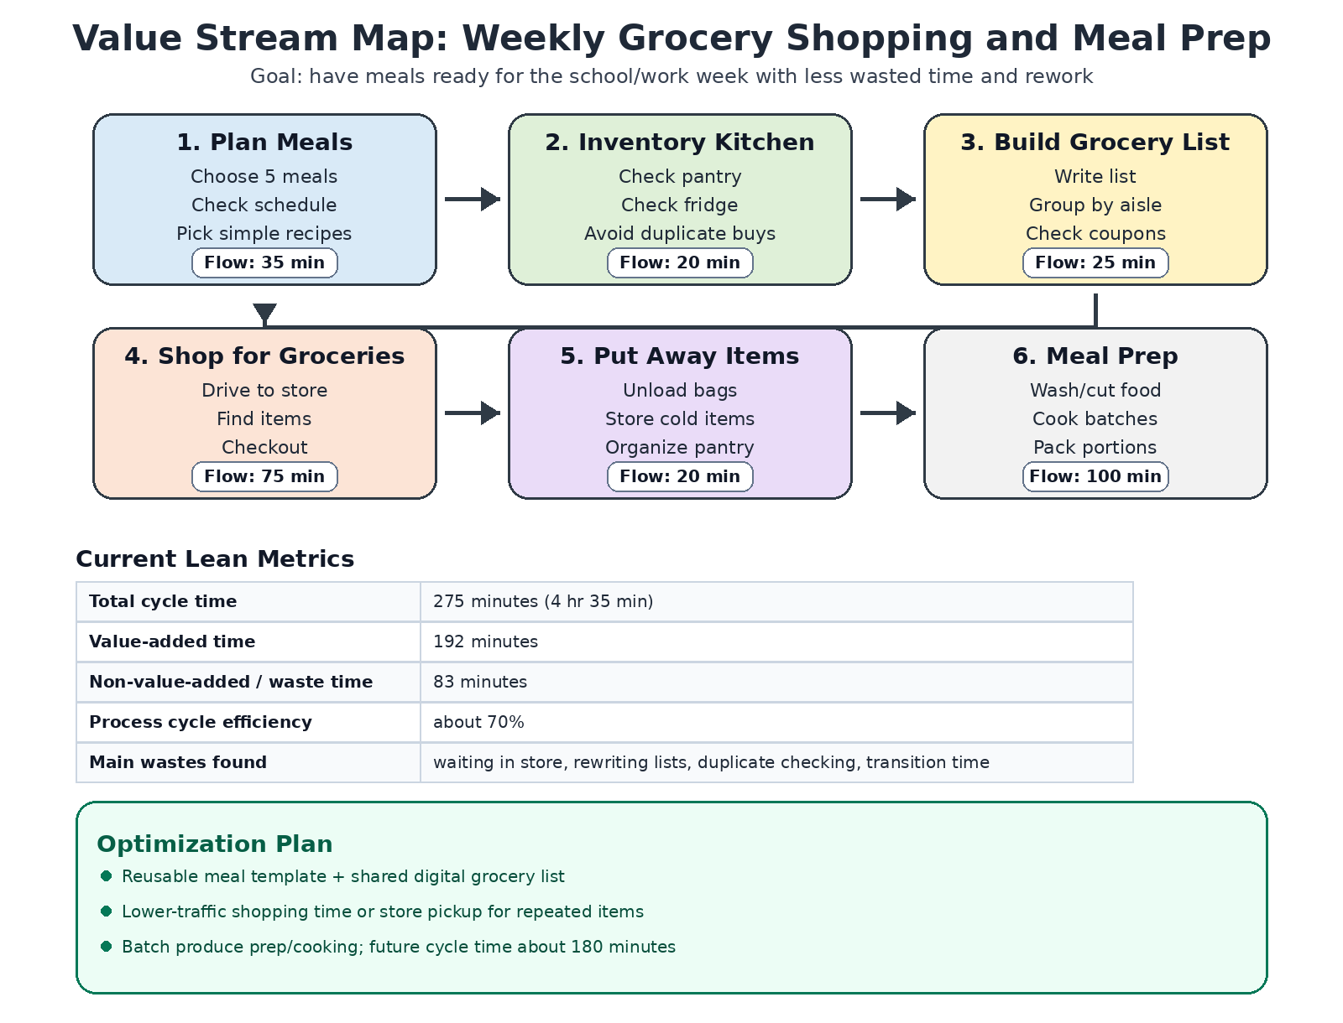
Current State Process
- Plan Meals: Choose meals for the week, check the weekly schedule, and decide which recipes to make.
- Inventory Kitchen: Check the pantry, refrigerator, and freezer to see what is already available.
- Build Grocery List: Create a shopping list and group items by store section.
- Shop for Groceries: Drive to the store, locate items, wait in checkout, and return home.
- Put Away Items: Unload bags, store cold items first, and organize pantry items.
- Meal Prep: Wash produce, cut ingredients, cook batches, and portion into containers.
Lean Metrics Analysis
For this value stream, cycle time means the total time from starting the weekly food plan to having meals ready. Value-added time includes work that helps create the finished meals, while waste includes waiting, rework, extra movement, or unnecessary tasks.
Stage | Flow Time | Value-Added Time | Waste / Delay | Main Issue
Plan Meals | 35 min | 20 min | 15 min | Starting from scratch each week
Inventory Kitchen | 20 min | 12 min | 8 min | Checking the same areas more than once
Build Grocery List | 25 min | 15 min | 10 min | Rewriting and reorganizing the list
Shop for Groceries | 75 min | 50 min | 25 min | Traffic, searching aisles, checkout waiting
Put Away Items | 20 min | 15 min | 5 min | Extra movement between kitchen areas
Meal Prep | 100 min | 80 min | 20 min | Stopping to wash/cut items one at a time
Total | 275 min | 192 min | 83 min | Process cycle efficiency: about 70%
Analysis of Waste
The biggest delay in this process happens during the grocery shopping stage. Some of that time is necessary, but part of it comes from shopping during busy times, walking back and forth across the store, and waiting in checkout lines. Another source of waste happens before shopping begins. When meals are planned from scratch every week, extra time is spent deciding what to cook and rebuilding the grocery list.
Meal prep also contains waste because ingredients are sometimes washed, cut, and prepared one at a time. This creates extra transitions between the sink, counter, stove, and refrigerator. The process still produces value, but it could be smoother if similar tasks were grouped.
Optimization Plan
- Eliminate waste: Use a reusable meal template with common meals, snacks, and ingredients. This prevents having to start from scratch every week and reduces planning time.
- Improve workflow: Keep a shared digital grocery list organized by store section. As items run out during the week, they can be added immediately instead of trying to remember everything later.
- Reduce waiting time: Shop during low-traffic times or use store pickup for repeat items. This reduces wait time at checkout and the time spent searching for common products.
- Batch similar work: Wash and cut produce together, cook proteins together when possible, and pack meals in a single setup. This reduces unnecessary movement and setup time.
- Create a simple model: use a weekly checklist to review the schedule, check food safety dates, label containers, and store meals correctly. This keeps the process consistent and reduces mistakes.

Future State Metrics
After applying the improvements, the estimated cycle time could drop from 275 minutes to about 180 minutes. This would save about 95 minutes each week while still producing the same result.
Stage | Current Flow Time | Future Flow Time | Estimated Improvement
Plan Meals | 35 min | 20 min | 15 min saved
Inventory Kitchen | 20 min | 10 min | 10 min saved
Build Grocery List | 25 min | 10 min | 15 min saved
Shop for Groceries | 75 min | 50 min | 25 min saved
Put Away Items | 20 min | 15 min | 5 min saved
Meal Prep | 100 min | 75 min | 25 min saved
Total | 275 min | 180 min | 95 min saved

Conclusion
This value stream map shows that a typical weekly task can be analyzed the same way a software delivery process is analyzed. By visualizing the steps, measuring cycle time and flow time, and then updating the process, it becomes easier to see where time is being wasted. For weekly grocery shopping and meal prep, the best improvements are creating a reusable meal plan, using a digital list, shopping more strategically, and batching work. These changes would make the process faster, more organized, and easier to repeat each week.

