Classification from Data

(plots done with the first three handovers from Handover-Data p2-3)

***Handover Definition***

First step in this proposed classification scheme is to define handover starts from the data. This is been accomplished by looking at stats between the four combinations of user 1 hand to user 2 hand (left-left, left-right, right-left, right-right). When the hands are close, velocity is zero and acceleration is positive, we have a handover. The closest distance between hand is then the hand combination that has performed the handover. An example is shown in Figure 1.

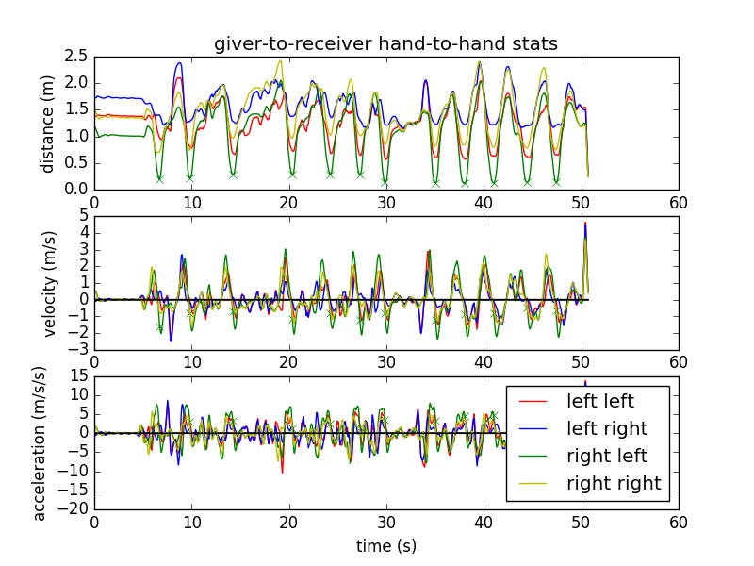

Figure 1. Handover stats

***Embedding Visualizations***

This is what a three state classification looks like in its 2-dimensional embedding via spectral clustering (ie the basis vectors associated with the two smallest eigenvalues of the laplacian matrix of the graph similarity): (Technically this is only in one dimension, but the second dimension is constant. The clustering is nearly just a set of one-dimensional linear classifiers)

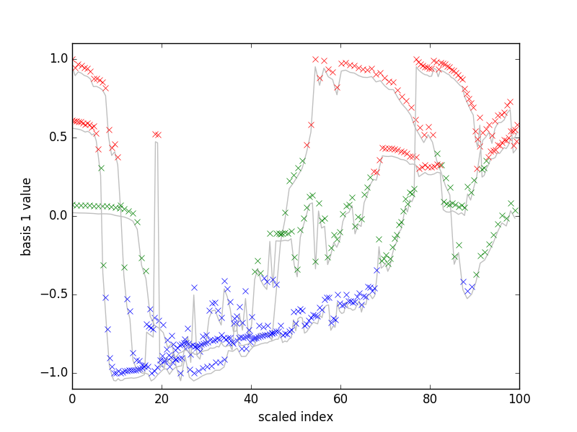

Figure 2. Plot showing Laplacian-based embedding with three clusters for three consecutive handovers– Raw basis data

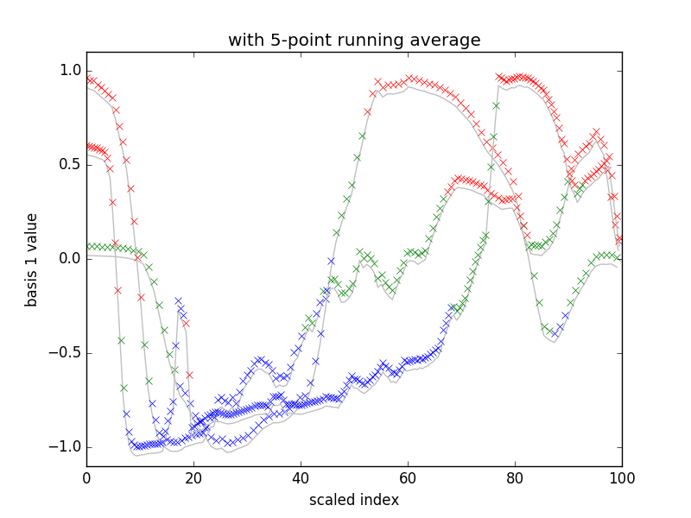

Figure 3. Plot showing Laplacian-based embedding with three clusters for three consecutive handovers – basis with 5-point running average for smoothing transitions (however, this hasn’t been reclassified with kmeans++. This seems to show where a kalman filter (or just this running average approach) could be useful in defining the states)

***Classification through Updating State Distributions***

As a potential classification scheme, we could define original states based on spectral clustering and create normal distributions of states from the data points. For successive handover, we can find the 1 dimensional embedding and define new points within a threshold (say, 1 standard deviation) as being a part of those originally defined states, and those outside of that threshold to be potentially new states. If the new state become highly relevant compared to the other states, the new state can be defined. Any states that are defined as meeting these criteria are used to classify the new data points coming in real time from the Kinect into their appropriate states. Thus, we would have the important-to-classify states being updated at each handover end, as well as being able to classify incoming data on the fly. Next up is to define probability tables for P(next state | current state).

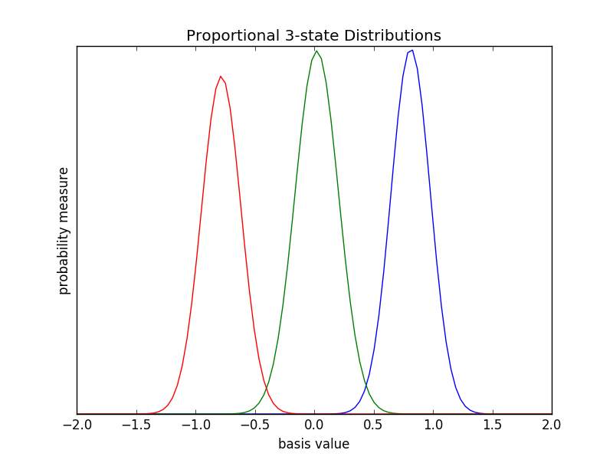

Figure 4. Plot Normal distributions for each of the three states for one of the handovers plotted in Figures 1 and 2. Sizes are proportional to the number of points that most strongly within each distribution.

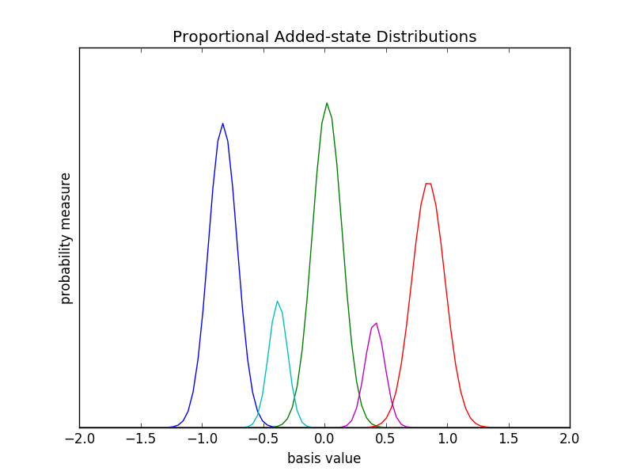

Figure 5. Plot Normal distributions that keep points within 1.5 standard deviations of the original and the added distributions that do not fall in that threshold. Sizes are proportional to the number of points that most strongly within each distribution.