1. Installing Miniconda

VERY IMPORTANT! If you already have Anaconda or Miniconda installed, skip this section and go directly to Section 2.

1.1. Open terminal

Windows
VERY IMPORTANT! These instructions are intended for pure Windows computers, do not use WSL (Ubuntu) terminals in Windows.
Search “Windows PowerShell” in the Windows Search Bar and open it.
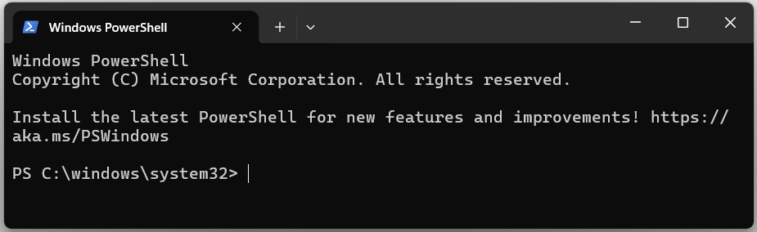
Follow the instructions for “Windows PowerShell” in 1.2.

MacOs
Type “Terminal” in the Search bar or look for it in Utilities and open. You should see a terminal like this:
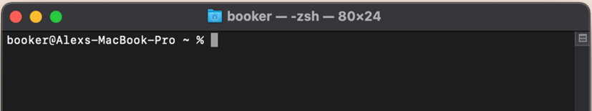
Follow the instructions for “macOS” in 1.2.

Linux
VERY IMPORTANT! These instructions are intended for pure Linux computers, do not use WSL (Ubuntu) terminals in Windows.
Look for “Terminal” in the Activities item and open. Alternatively try Ctrl + Alt + T. You should see a terminal like this:
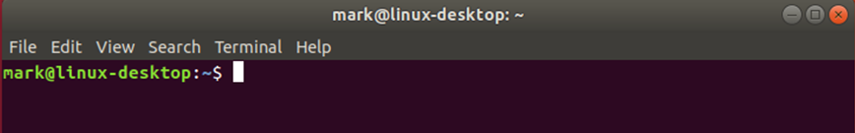
Follow the instructions for “Linux” in 1.2.

1.2. Download and Install Miniconda. Go to “https://www.anaconda.com/docs/getting-started/miniconda/install” and select your OS in the “Quickstart install instructions” tab:
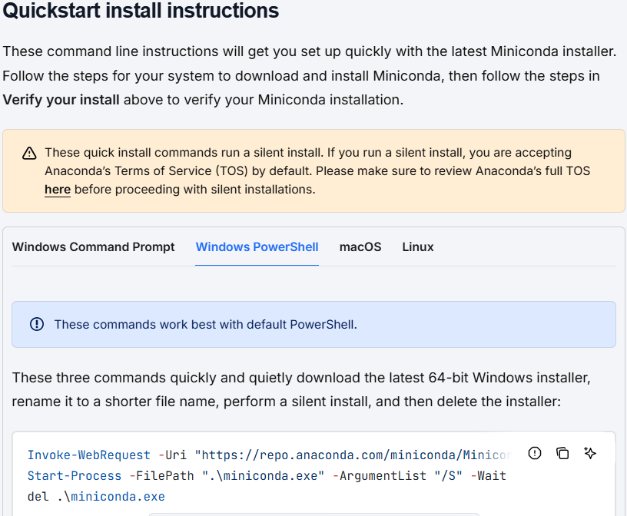
* VERY IMPORTANT! Follow all the instructions that they provide in 3 steps, DO NOT stop after executing the commands from step 1. It is recommended to run line by line.

Potential error in Windows 11
During the Miniconda installation, if you get error messages like these:
Invoke-WebRequest : Access to the path 'C:\windows\system32\Miniconda3-latest-Windows-x86_64.exe' is denied.
At line:1 char:1
+ Invoke-WebRequest -Uri "https://repo.anaconda.com/miniconda/Miniconda ...
+ ~~~~~~~~~~~~~~~~~~~~~~~~~~~~~~~~~~~~~~~~~~~~~~~~~~~~~~~~~~~~~~~~~~~~~
+ CategoryInfo : NotSpecified: (:) [Invoke-WebRequest], UnauthorizedAccessException
+ FullyQualifiedErrorId : System.UnauthorizedAccessException,Microsoft.PowerShell.Commands.InvokeWebRequestCommand
You need to run this command on the PowerShell terminal:
cd $HOME
and then try again with the commands suggested in the miniconda webpage (step 1.2).

2. Visual Studio Code installation

2.1. Installing Visual Studio Code (3 min)

Download and install Visual Studio Code (VSC) using this link:

https://code.visualstudio.com/Download

2.2. Installing extensions of Visual Studio Code (3 min)

2.2.1. Open VSC

2.2.2. Go to the extensions panel (squares icon in the left sidebar) and search for all the next extensions.
- Jupyter
- Prettier - Code formatter
- Python
- Python Indent
- Rainbow CSV

3. Downloading Workshop Materials (when available)

3.1. Download the files needed for these lessons.

3.2. Create a folder called “ML_course” on your computer.

VERY IMPORTANT 1! To avoid issues, do not create the folder in a OneDrive folder with cloud synchronization.
VERY IMPORTANT 2! To avoid issues, do not create the folder too deep within your system (i.e., long PATHs such as “C:/Users/Folder_1/Folder_2/Folder_3/…/ML_course”).
VERY IMPORTANT 3! To avoid issues, do not create the folder inside other folders with names containing characters other than unaccented English letters (A–Z, a–z), numbers or underscores “_”. Examples:
Good: “C:/Users/jv/Desktop/ML_course”
Problematic characters: á, é, í, ó, ú, ñ, spaces, periods, commas...

3.3. Move the downloaded materials to the new folder.

3.4. Unzip the file.

4. Virtual Environment Configuration

Python’s virtual environment is a tool that creates an independent space to manage projects and its modules and versions. In other words, it creates various workspaces on one serve/computer

4.1. Open a new terminal:
4.1.A. Windows: after installing Miniconda (Step 1.2), you can now open an “Anaconda prompt”. Look for this tool in your applications and open it.

4.1.B. In macOS and Linux, open a terminal as you did in step 1.1.

4.2. Create New Conda Environments (named cheminf & almos)

4.2.1. Go to the “ML_course/Prerequisites/Setup_and_testing” folder created in step 3. For this, you need to use the “cd” command in the terminal. For example, if your “ML_course/Prerequisites/Setup_and_testing” folder is in:
C:/Users/ML_course/Prerequisites/Setup_and_testing
You need to type the following command in your terminal:
cd C:/users/ML_course/Prerequisites/Setup_and_testing

HELP: At this point, your terminal should be in the “Setup_and_testing” folder. Your terminal shows the working folder on the left. For example, in the image below, the terminal is on the “C:/Users” folder.
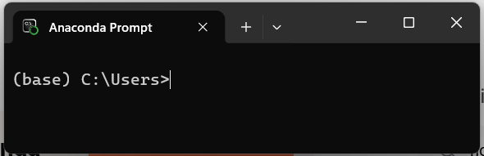

4.2.2. Make sure that you don’t have any previous environments with the same names as those to install (i.e., cheminf, baybe, chemtorch, etc.). For this, execute:
conda env list
and check on the list (image below, red rectangle).
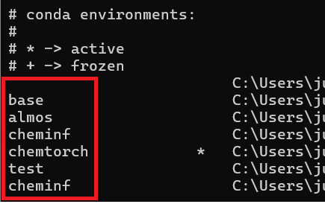
If you have environments with the same names, remove them before attempting to install the environments from point 4.2.3. To remove environments, use the following command:
conda env remove -y -n ENVIRONMENT
**But first, replace ENVIRONMENT for the name of the environment to remove, for example, the following command removes the cheminf environment:
conda env remove -y -n cheminf

4.2.3. Execute the three following commands separately. Note some installations may take a few minutes.
conda env create -f cheminf.yaml
conda env create -f almos.yaml
conda env create -f environment_TS_CAMLC.yml

5. How to use Visual Studio Code and check the set up

5.1. cheminf environment

5.1.1. Open, using VSC, the “CHEMINF_course_setup.ipynb” Jupyter Notebook unzipped from the previous step (in the “ML_course/Prerequisites/Setup_and_testing” folder).
* (.ipynb means Interactive Python Notebook)

VERY IMPORTANT! To open the notebook, do not double-click the file with your mouse. Instead, first open VSC and select “Open Folder” (image below). You will then see the files in your folder listed on the left side of the screen. From there, select the notebook to open it.
If you don’t follow this process, VSC might not be able to detect the kernels from the points below.
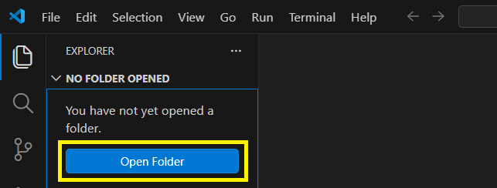
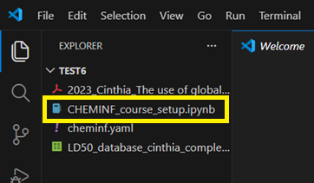

5.1.2. When VSC opens, select the “cheminf” kernel. VERY IMPORTANT! By default, the program opens the “base” kernel, make sure that you see the “cheminf” kernel loaded as it is shown in the picture below:
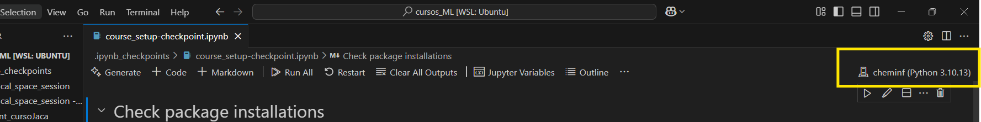
VERY IMPORTANT! If you do not see the Jupyter kernel directly, just click on Python Environments and select the one you want to use.
VERY IMPORTANT 2! If you still do not see the Jupyter kernel, look for a blue button in the bottom-left part of the interface asking you to enable “Python,” “Kernels,” or “Jupyter Notebook.”

5.1.3. Run the code cells by clicking “Run All” (image), placing the cursor on each cell and pressing the play button, or pressing Shift + Enter.
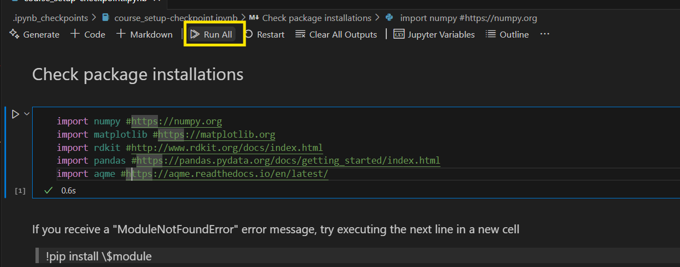

5.1.4. Check that each cell indicates that the library or program has been installed correctly.
5.1.5. Close the “CHEMINF_course_setup.ipynb” Jupyter Notebook and, then, close VSC.

5.2. almos environment

5.2.1. Open, using VSC, the “ALMOS_course_setup.ipynb” Jupyter Notebook unzipped from the previous step (in the “ML_course/Prerequisites/Setup_and_testing” folder).

5.2.2. When VSC opens, select the almos kernel (see step 5.1.2, but this time with “almos”)

5.2.3. Run the code cells by clicking “Run All”, placing the cursor on each cell and pressing the play button, or pressing Shift + Enter (see step 5.1.3)

5.2.4. Check that each cell indicates that the library or program has been installed correctly.
5.2.5. Close the “ALMOS_course_setup.ipynb” Jupyter Notebook and, then, close VSC.

5.3. bayesian_ts environment

5.3.1. Open, using VSC, the “BAYESIAN_TS_course_setup.ipynb” Jupyter Notebook unzipped from the previous step (in the “ML_course/Prerequisites/Setup_and_testing” folder).

5.3.2. When VSC opens, select the bayesian_ts kernel (see step 5.1.2, but this time with “bayesian_ts”)

5.3.3. Run the code cells by clicking “Run All”, placing the cursor on each cell and pressing the play button, or pressing Shift + Enter (see step 5.1.3)

5.3.4. Check that each cell indicates that the library or program has been installed correctly.
5.3.5. Close the “BAYESIAN_TS_course_setup.ipynb” Jupyter Notebook and, then, close VSC.

6. Checking CSV files

A CSV (Comma-Separated Values) file is a simple text file used to store tabular data, where each line represents a row and values are separated by commas. It's commonly used for exchanging data between programs like spreadsheets and databases.

Possible errors when working with CSV files in Windows:
Try to open a CSV file from the course folder, for example: test.csv (from the “Setup_and_testing” folder, see step 4.2.1)
If when opening a CSV file everything is condensed into a single column, you can change this in your system’s settings.
Moreover, in Excel to change the decimal separator in File Options Advanced, and in the “editing options” section (first one), uncheck the “use system separators” and change the decimal separator to a period instead of a comma. You can erase the thousand separator. Then click ok, and the settings should have changed so that the .csv files function correctly.

7. Testing easyROB

7.1. easyROB executable (preferred option)
Follow the instructions from:
https://github.com/MiguelMartzFdez/easyROB

7.2. Portable version (plan B)
Follow the instructions from:
https://github.com/MiguelMartzFdez/easyROB_portable

7.3. easyROB from terminal (plan C)
This method runs easyROB using a standard ROBERT installation (non-portable).

Steps
7.3.1. Open an Anaconda Prompt (Windows) or Terminal (macOS/Linux).

7.3.2. Activate the conda environment where ROBERT is installed:

conda activate cheminf

7.3.3. Run easyrob:

easyrob

