Class 5

John Smith

May 3rd, 2014

# Class 5 R graphics and plots  
  
# get the data in  
weight <- read.table("bimm143_05_rstats/weight_chart.txt",   
 header = TRUE)  
  
# plot a scaterplot of age vs weight  
  
plot(weight[,1], weight[,2],  
 xlab = "Age (months)",  
 ylab = "Weight (Kg)", main = "Age vs. weight", type = "b", pch = 15, cex = 1.3)

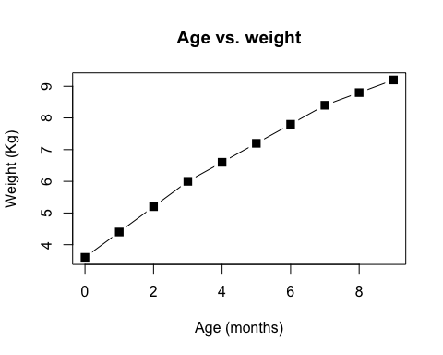

# Bar Plot section 2B  
feature <- read.table("bimm143_05_rstats/feature_counts.txt",  
 header = TRUE, sep = "\t")  
  
  
# old par values  
  
old.par <- par()$mar  
  
par(mar=c(5,11,4,3))  
  
barplot(feature$Count, horiz = T, ylab = "A title",  
 names.arg = feature$Feature, main = "Features",  
 las = 1)

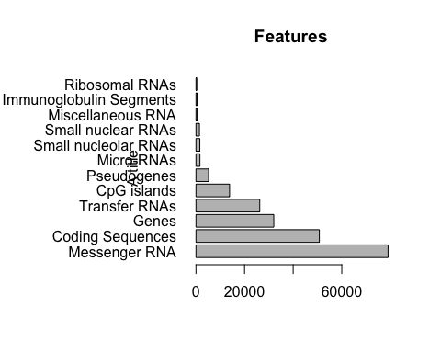

# 3A  
  
mf <- read.delim("bimm143_05_rstats/male_female_counts.txt", header = TRUE )  
  
  
barplot(mf$Count, names.arg = mf$Sample, las = 2, col = rainbow(10))

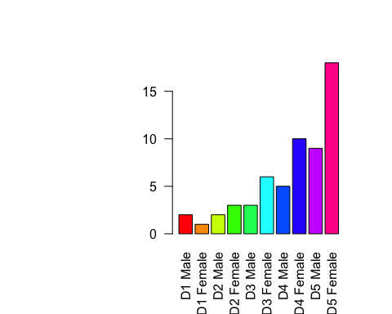

rainbow(10)

## [1] "#FF0000FF" "#FF9900FF" "#CCFF00FF" "#33FF00FF" "#00FF66FF"  
## [6] "#00FFFFFF" "#0066FFFF" "#3300FFFF" "#CC00FFFF" "#FF0099FF"

# 3B  
  
genes <- read.delim("bimm143_05_rstats/up_down_expression.txt")  
  
  
table(genes$State)

##   
## down unchanging up   
## 72 4997 127

length(genes$State)

## [1] 5196

palette(c("blue", "grey", "red"))  
plot(genes$Condition1, genes$Condition2, col = genes$State, xlab = "Expression condition 1", ylab = "Expression condition 2")

