Fitbit Members in United: Exploration

Seth Grossinger

August 3, 2018

## Preliminary work

Before we look at the characteristics of members with Fitbits I would like to better understand which members to potentially include. Initially we’re interested in broad comparisons, and if we find something interesting we can further drill down. I’m looking at a single year of claims for adults members and looking at

* Age/Gender
* Utilzation
  + average count of Inpatient hospital admissions
  + average count of ER visits that did not result in an admission
  + PMPM allowable amounts, totals and Medical/Rx breakdowns
  + Charlson score
  + Charlson indicators.

I am *not* currently including RAF/HCCs. We can drill in further in the future, but the Charlson scores I’m using are much easier (at least computationally) to compute. Either serves as an imperfect proxy for health status, so for now we’ll save RAF/HCCs for future exploration. In addition, the sample sizes we’re working with are large, so I can afford to paint with a broad brush and use simple rules. For example, I’m using + Adults = born before 1999 + all members continuously enrolled in the same plan during 2017 + Charlson scores and indicators built requiring only a single diagnosis during 2017, with no filters based on visit type, place of service, provider or the like.

As an example of how to interpret these scores, ‘Diabetes’ for a member wouldn’t indicate that the member meets clinical criteria for diabetes, just that she had at least one diagnosis in 2017 related to diabetes. If the ‘Diabetes’ rate in a group of members is 6.8%, that just means it’s likely that more people in the group have diabetes than in a different group with a 5.9% rate.

#### Members I’ll include

Different categories of insurance have different utilization patterns. Also, again to keep things simple I’m using MiniHPDM as our data source. There may be groups or categories for which our data is better than others, so I want to make sure I pick members for whom I have at least some confidence in the completeness (and comparability) of our data.

To start, I grouped members by their group’s company (United Healthcare/Uniprise) and financing arrangment (ASO/FI/…) as indicated in our membership files.

|  |  |  |  |  |  |  |  |  |  |  |  |  |  |  |  |
| --- | --- | --- | --- | --- | --- | --- | --- | --- | --- | --- | --- | --- | --- | --- | --- |
| Company | Fund | MbrCnt | Age | Female | HasEmail | HasFitbit | IP.Admit | ER.Visit | PMPM | Med | Rx | Charlson | Diabetes | HTN | Depression |
| UNIPRISE | ASO | 6,577,414 | 46.0 | 50.5% | 53.7% | 5.6% | 0.05 | 0.18 | $430 | $402 | $28 | 0.64 | 6.9% | 18.2% | 5.9% |
| UHC | ASO | 3,014,557 | 44.1 | 50.1% | 49.9% | 5.2% | 0.05 | 0.17 | $472 | $405 | $68 | 0.64 | 7.2% | 18.2% | 5.9% |
| UHC | FI | 2,494,049 | 43.3 | 48.4% | 56.7% | 5.6% | 0.05 | 0.18 | $481 | $379 | $101 | 0.60 | 6.6% | 17.7% | 6.0% |
| NULL | NULL | 1,663,628 | 67.4 | 55.6% | 20.5% | 1.4% | 0.00 | 0.02 | $43 | $33 | $9 | 0.05 | 0.6% | 1.7% | 0.6% |
| UNIPRISE | FI | 222,334 | 55.1 | 47.3% | 45.5% | 3.9% | 0.09 | 0.25 | $459 | $382 | $77 | 1.19 | 13.2% | 32.6% | 6.6% |
| NULL | NULL | 170,237 | 45.6 | 52.9% | 9.1% | 0.9% | 0.00 | 0.00 | $2 | $2 | $0 | 0.00 | 0.0% | 0.1% | 0.0% |
| UHC | PI | 156,429 | 42.5 | 49.1% | 61.1% | 6.2% | 0.05 | 0.15 | $545 | $434 | $111 | 0.54 | 5.2% | 14.4% | 6.4% |
| MAMSI-UHC | FI | 64,701 | 48.8 | 50.6% | 51.0% | 4.8% | 0.06 | 0.24 | $517 | $355 | $161 | 1.00 | 12.7% | 29.4% | 6.0% |
| UNIPRISE | PI | 3,212 | 63.2 | 49.4% | 42.1% | 4.2% | 0.12 | 0.29 | $396 | $396 | $0 | 1.49 | 14.6% | 39.4% | 8.9% |

For Fully Insured we typically restrict to UHC/FI. It seems like both Uniprise and UHC are potentially usable for both ASO and FI. I’ve seen misleading figures for UHC-ASO in the past, but to be sure I took a look at the 10 largest customer segments within each grouping.

#### UHC FI

There are a few groups that look like they have abnormally low utilization, but no group accounts for a large share of overall membership of 2.5MM and in aggregate the numbers look reasonable. This is the segment we typically focus in our commercial analyses.

|  |  |  |  |  |  |  |
| --- | --- | --- | --- | --- | --- | --- |
| MbrCnt | Age | Female | IP.Admit | ER.Visit | PMPM | Charlson |
| 2,494,049 | 43.3 | 48.4% | 0.05 | 0.18 | $481 | 0.6 |
| Rnk | CUST_SEG_NM | MbrCnt | Age | Female | IP.Admit | ER.Visit | PMPM | Charlson |
| 1 | NORTHSIDE INDEPENDENT SCHOOL DISTRICT | 13,375 | 42.0 | 64.4% | 0.05 | 0.17 | $421 | 0.66 |
| 2 | SOUTHWEST CARPENTERS HEALTH AND WELFARE TRUST (MEDICAL) | 12,748 | 40.0 | 43.8% | 0.01 | 0.07 | $117 | 0.15 |
| 3 | STATE OF WISCONSIN | 9,453 | 46.1 | 52.6% | 0.06 | 0.21 | $518 | 0.81 |
| 4 | ARIZONA STATE RETIREMENT SYSTEM | 8,661 | 58.2 | 59.7% | 0.05 | 0.16 | $697 | 1.11 |
| 5 | DISTRICT OF COLUMBIA GOVERNMENT | 7,805 | 41.0 | 56.3% | 0.06 | 0.33 | $535 | 0.77 |
| 6 | GENERAL ATOMICS | 7,063 | 44.6 | 45.7% | 0.02 | 0.05 | $177 | 0.23 |
| 7 | AT&T | 6,796 | 39.0 | 45.6% | 0.05 | 0.28 | $501 | 0.64 |
| 8 | VIRGINIAS HEALTH INSURANCE MARKETPLACE | 6,534 | 43.8 | 55.8% | 0.05 | 0.22 | $505 | 0.75 |
| 9 | CITY AND COUNTY OF DENVER | 5,151 | 44.1 | 51.5% | 0.05 | 0.19 | $642 | 0.67 |
| 10 | FEDERAL EMPLOYEES HEALTH BENEFITS PROGRAM LR | 4,923 | 43.8 | 53.1% | 0.04 | 0.18 | $409 | 0.70 |

#### UHC ASO

Contrary to my expectation, overall utilization for this group looks reasonable. However, several of the largest groups (Royal Caribbean, BD-BDIL, Lloyd’s of London) are foreign insurance companies (or cruise lines) that cover their members when travelling in the US through a reciprocal agreement. These groups each account for over 1% of overall members and have clearly different utilization. I’ll exclude them from this analysis, though it’d be good to try to understand this group and whether there’s a way to make a finer-grain decision about who to include in the future.

|  |  |  |  |  |  |  |
| --- | --- | --- | --- | --- | --- | --- |
| MbrCnt | Age | Female | IP.Admit | ER.Visit | PMPM | Charlson |
| 3,014,557 | 44.1 | 50.1% | 0.05 | 0.17 | $472 | 0.64 |
| Rnk | CUST_SEG_NM | MbrCnt | Age | Female | IP.Admit | ER.Visit | PMPM | Charlson |
| 1 | ROYAL CARIBBEAN CRUISES LTD. | 66,953 | 36.1 | 20.9% | 0.00 | 0.01 | $23 | 0.01 |
| 2 | BD-BDIL | 60,617 | 45.5 | 53.8% | 0.01 | 0.01 | $70 | 0.04 |
| 3 | STATE OF ARIZONA | 53,506 | 47.2 | 54.3% | 0.06 | 0.22 | $477 | 0.97 |
| 4 | SEVEN CORNERS - LLOYDS OF LONDON | 48,250 | 38.3 | 59.6% | 0.00 | 0.00 | $2 | 0.00 |
| 5 | NORTHWELL HEALTH | 41,497 | 43.5 | 59.0% | 0.08 | 0.17 | $658 | 0.78 |
| 6 | THE SCHOOL DISTRICT OF PALM BEACH COUNTY | 26,586 | 45.5 | 62.3% | 0.05 | 0.21 | $551 | 0.85 |
| 7 | UNIVERSITY OF MISSOURI | 26,425 | 44.5 | 54.9% | 0.06 | 0.18 | $409 | 0.68 |
| 8 | STATE OF RHODE ISLAND | 26,345 | 48.1 | 52.4% | 0.07 | 0.22 | $510 | 1.02 |
| 9 | CITY OF AUSTIN | 23,878 | 47.2 | 44.4% | 0.07 | 0.24 | $648 | 0.94 |
| 10 | PORT AUTHORITY OF NY & NJ | 23,660 | 55.9 | 47.9% | 0.09 | 0.24 | $544 | 1.38 |

#### Uniprise ASO

These comprise the large national companies you’d think of as likely ASO clients. Interestingly, while the overall utilization for this group appears reasonable the largest group by far, AT&T Care Plus, accounts for a full 8% of the membership and is a clear outlier. This [appears](https://careplus.att.com/) to be a supplemental policy and should probably be excluded in the future. (And the next largest group also appears to be an outlier.)

|  |  |  |  |  |  |  |
| --- | --- | --- | --- | --- | --- | --- |
| MbrCnt | Age | Female | IP.Admit | ER.Visit | PMPM | Charlson |
| 6,577,414 | 46 | 50.5% | 0.05 | 0.18 | $430 | 0.64 |
| Rnk | CUST_SEG_NM | MbrCnt | Age | Female | IP.Admit | ER.Visit | PMPM | Charlson |
| 1 | AT&T INC.-CARE PLUS | 532,826 | 59.2 | 53.7% | 0.01 | 0.05 | $134 | 0.21 |
| 2 | RAILROAD EMPLOYEES NATIONAL HEALTH & WELFARE PLAN | 196,640 | 41.0 | 45.1% | 0.03 | 0.14 | $279 | 0.36 |
| 3 | WAL-MART STORES INC. ASSOCIATES HEALTH AND WELFARE PLAN | 139,102 | 43.4 | 54.7% | 0.06 | 0.30 | $404 | 0.72 |
| 4 | JPMORGAN CHASE & CO. | 132,235 | 42.3 | 53.8% | 0.05 | 0.16 | $467 | 0.62 |
| 5 | DELTA AIR LINES INC | 119,226 | 46.2 | 50.8% | 0.05 | 0.16 | $605 | 0.70 |
| 6 | WELLS FARGO | 116,456 | 41.9 | 54.0% | 0.05 | 0.17 | $446 | 0.59 |
| 7 | SOUTHWEST AIRLINES COMPANY | 84,090 | 43.4 | 50.0% | 0.04 | 0.18 | $483 | 0.62 |
| 8 | GENERAL ELECTRIC | 82,701 | 45.5 | 45.7% | 0.05 | 0.15 | $420 | 0.61 |
| 9 | RAYTHEON COMPANY | 80,854 | 45.8 | 47.4% | 0.05 | 0.14 | $484 | 0.69 |
| 10 | AMERICAN AIRLINES | 80,011 | 59.1 | 48.4% | 0.06 | 0.17 | $301 | 1.01 |

#### Uniprise FI

We’ve typically excluded these companies in the past from our commercial analyses. I’m not sure what these represent. The members are relatively old, which could account for the high utilization/Charlson scores. This is largely driven by the largest customer segment, with over 1/3 of the total members. There are relatively few members overall, especially in relation to the companies they represent. For example, there are 7,000 members from Starbucks and 16,000 from HP Enterprise, small percentages of their overall workforces. We’ll exclude them for now, but this is another group of customers it would be good to better understand in the future.

|  |  |  |  |  |  |  |
| --- | --- | --- | --- | --- | --- | --- |
| MbrCnt | Age | Female | IP.Admit | ER.Visit | PMPM | Charlson |
| 222,334 | 55.1 | 47.3% | 0.09 | 0.25 | $459 | 1.19 |
| Rnk | CUST_SEG_NM | MbrCnt | Age | Female | IP.Admit | ER.Visit | PMPM | Charlson |
| 1 | HEALTH AND WELFARE COMMITTEE COOPERATING RAILWAY LABOR ORGANIZATIONS | 83,717 | 74.5 | 42.6% | 0.16 | 0.31 | $280 | 1.99 |
| 2 | HEWLETT PACKARD ENTERPRISE COMPANY | 16,211 | 45.2 | 49.0% | 0.04 | 0.14 | $554 | 0.69 |
| 3 | ARAMARK CORPORATION | 8,662 | 46.6 | 54.4% | 0.07 | 0.29 | $667 | 0.92 |
| 4 | STARBUCKS CORPORATION | 7,025 | 35.5 | 58.3% | 0.04 | 0.15 | $355 | 0.31 |
| 5 | FIRST DATA CORPORATION | 6,846 | 43.2 | 52.0% | 0.05 | 0.17 | $530 | 0.69 |
| 6 | RICOH AMERICAS CORPORATION | 5,688 | 46.4 | 48.8% | 0.06 | 0.20 | $697 | 0.88 |
| 7 | HILTON DOMESTIC OPERATING COMPANY INC. | 5,547 | 45.3 | 54.6% | 0.07 | 0.22 | $650 | 0.87 |
| 8 | AON SERVICE CORPORATION | 5,053 | 42.1 | 59.1% | 0.06 | 0.20 | $616 | 0.64 |
| 9 | DARDEN RESTAURANTS INC. | 4,787 | 40.3 | 47.8% | 0.05 | 0.26 | $478 | 0.54 |
| 10 | WOOD GROUP U.S. HOLDINGS INC. | 4,742 | 42.6 | 43.5% | 0.05 | 0.17 | $580 | 0.65 |

## Initial Fitbit member exploration

We matched email addresses of Unitedhealth commercial members with Fitbit members.

As an initial question, whose email addresses do we have? I know that claims vary by age, by gender, and by funding arrangment (fully-insured vs self-funded/ASO). Since we’re potentially matching only members whose email addresses we have, let’s make sure they’re similar to the overall membership before proceed to a comparison of Fitbit members.

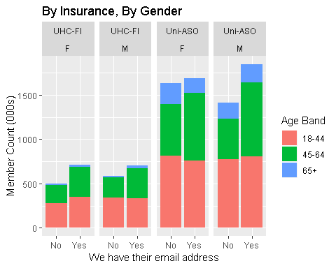

Overall, it seems like we’re slightly more likely to have email addresses for women in FI and for men in ASO, but I’m not sure what that tells us. However, when we look at utilization a problem becomes evident.

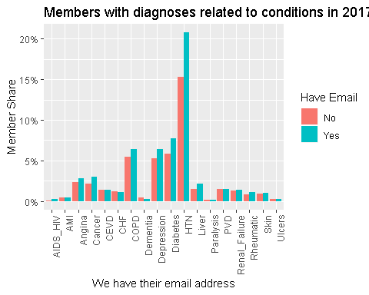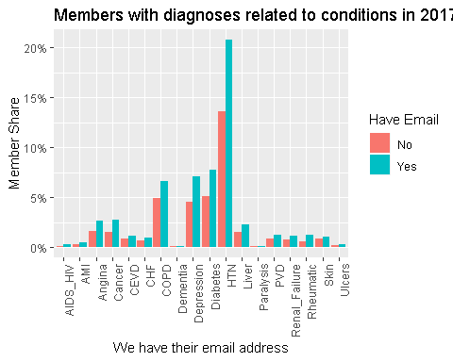

The pattern is the same for FI and ASO: members whose email addresses we know are significantly (in a practical if not statistical sense–I haven’t performed any statistical tests) more likely to have had a diagnosis related to virtually every condition. We see this in utilization statistics as well.

|  |  |  |  |  |  |  |  |  |  |  |  |  |  |
| --- | --- | --- | --- | --- | --- | --- | --- | --- | --- | --- | --- | --- | --- |
| Insurance | HaveEmail | MbrCnt | Age | Female | IP.Admit | ER.Visit | PMPM | Med | Rx | Charlson | Diabetes | HTN | Depression |
| UHC-FI | No | 1,080,348 | 41.2 | 45.9% | 0.040 | 0.179 | $338 | $288 | $50 | 0.46 | 5.1% | 13.6% | 4.6% |
| UHC-FI | Yes | 1,413,701 | 45.0 | 50.3% | 0.052 | 0.173 | $589 | $449 | $140 | 0.71 | 7.7% | 20.8% | 7.1% |
| UHC-FI | Total | 2,494,049 | 43.3 | 48.4% | 0.047 | 0.176 | $481 | $379 | $101 | 0.60 | 6.6% | 17.7% | 6% |
| Insurance | HaveEmail | MbrCnt | Age | Female | IP.Admit | ER.Visit | PMPM | Med | Rx | Charlson | Diabetes | HTN | Depression |
| Uni-ASO | No | 3,045,962 | 44.4 | 53.7% | 0.049 | 0.183 | $336 | $325 | $12 | 0.56 | 5.8% | 15.3% | 5.2% |
| Uni-ASO | Yes | 3,531,452 | 47.3 | 47.8% | 0.055 | 0.169 | $510 | $469 | $41 | 0.72 | 7.8% | 20.7% | 6.4% |
| Uni-ASO | Total | 6,577,414 | 46.0 | 50.5% | 0.052 | 0.175 | $430 | $402 | $28 | 0.64 | 6.9% | 18.2% | 5.9% |

I don’t know the sources of our email addresses, but it makes intuitive sense. If you’re healthy and have no claims or need to find a provider we’re probably less likely to know your email address. If you have many claims to manage and need to find many different providers there’s probably a good chance we have your email address.

Given all of that, though, it’s clear that we shouldn’t compare members who have Fitbits with all other members. Since we would only potentially know if a member has a Fitbit if we know the member’s email address, we should compare members who have Fitbits only to other members whose email addresses we have. So let’s go ahead and do that.

## Explore members with (and without) Fitbits

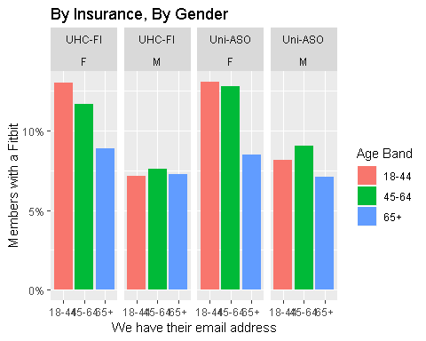

|  |  |  |  |  |  |  |  |  |  |  |  |  |  |
| --- | --- | --- | --- | --- | --- | --- | --- | --- | --- | --- | --- | --- | --- |
| Insurance | HaveFitbit | MbrCnt | Age | Female | IP.Admit | ER.Visit | PMPM | Med | Rx | Charlson | Diabetes | HTN | Depression |
| UHC-FI | No | 1,275,001 | 45.1 | 49% | 0.052 | 0.177 | $589 | $449 | $140 | 0.71 | 7.9% | 21% | 7% |
| UHC-FI | Yes | 138,700 | 44.6 | 62.7% | 0.049 | 0.138 | $595 | $452 | $143 | 0.66 | 6.4% | 19.2% | 7.8% |
| UHC-FI | Total | 1,413,701 | 45.0 | 50.3% | 0.052 | 0.173 | $589 | $449 | $140 | 0.71 | 7.7% | 20.8% | 7.1% |
| Insurance | HaveFitbit | MbrCnt | Age | Female | IP.Admit | ER.Visit | PMPM | Med | Rx | Charlson | Diabetes | HTN | Depression |
| Uni-ASO | No | 3,165,013 | 47.4 | 46.7% | 0.055 | 0.172 | $509 | $468 | $41 | 0.72 | 7.9% | 20.8% | 6.4% |
| Uni-ASO | Yes | 366,439 | 46.8 | 57.5% | 0.049 | 0.137 | $521 | $481 | $41 | 0.68 | 6.7% | 19.9% | 6.8% |
| Uni-ASO | Total | 3,531,452 | 47.3 | 47.8% | 0.055 | 0.169 | $510 | $469 | $41 | 0.72 | 7.8% | 20.7% | 6.4% |