**UCL Media Project Overview**

It is possible with the web interface to search on the Google Fusion Tables backend. Changes to the Fusion Table will be displayed on the map.

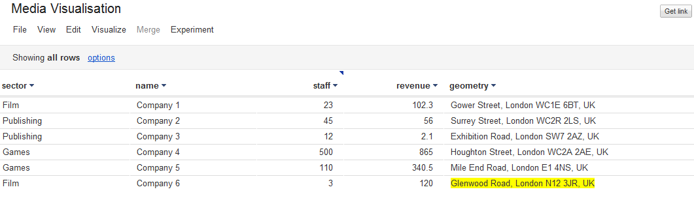

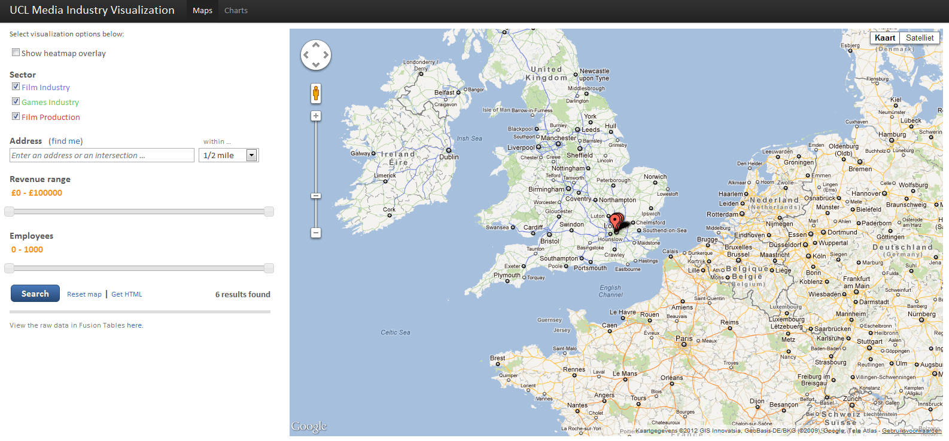

**Search and Display Options**

There are different ways to search the database and display the data on the map.

**Heatmap**

By selecting “show heatmap overlay” a heatmap of the data will be generated. Sufficient data is needed to generate a heatmap.



**Sector**

This option filters companies by Sector.



**Location**



The within option will only return results within a radius of x miles.

**Revenue Range**



**Employee Range**

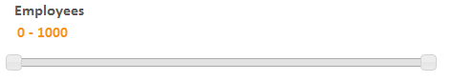

**Generate the HTML code of the map that’s currently displayed** 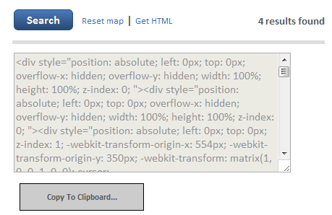

**Charts**

