C-009 INVESTIGATIVE CASE BRIEF
Cross-Regional Harassment Network Using Shared Infrastructure
Synthetic Abuse Investigation Portfolio | SQL | Python | Network Analysis | Human Validation
27  Primary accounts | 450  Events analyzed | 5  Direct case links | 100  Evidence score / 100
INDEPENDENT SYNTHETIC PORTFOLIO: All accounts, targets, devices, content, and events are fictional. This project is not affiliated with or endorsed by OpenAI. Automated findings require human validation.
EXECUTIVE ASSESSMENT
C-009 is assessed with high confidence as a coordinated account network exhibiting shared infrastructure, cross-case account overlap, repeated content families, post-enforcement behavior, functional role differentiation, and language obfuscation. The available synthetic evidence is more consistent with organized activity than with unrelated users independently engaging in similar conduct.
• Ground-truth label: True Positive - Coordinated Network.
• Evidence sufficiency score: 100.0/100 using a transparent, non-enforcement portfolio rubric.
• Strongest direct linkage: C-003 through post-enforcement evasion, strength 0.91 with 11 evidence items.
• Other high-confidence links: C-002, C-008, C-007, and C-001.
PRINCIPAL EVIDENCE
• Five C-009 accounts also appear in another synthetic investigation; all five are marked as previously enforced and high risk.
• Four devices link C-009 activity to other cases, including DEV-X05 across C-003, C-006, C-008, and C-009.
• Eighteen C-009 content hashes recur in at least one additional case, providing corroborating template and semantic-family evidence.
• The network contains four recurring roles: controller, amplifier, infrastructure helper, and replacement account.
• Recorded enforcement activity includes 9 human-validated actions with a median triage time of 29 minutes.
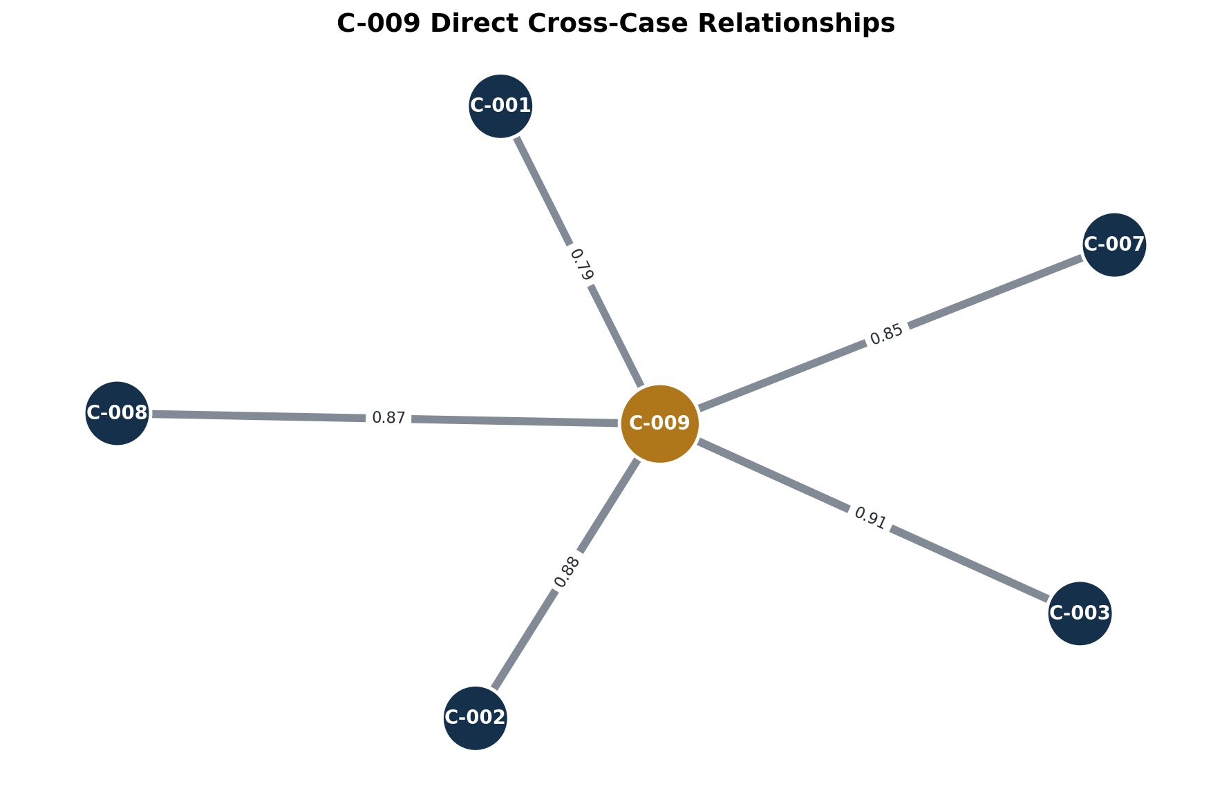
Figure 1. Direct cross-case links; edge labels show synthetic link strength.
FUNCTIONAL ROLE ANALYSIS
Role | Accounts | Events | Average Risk
controller | 7 | 125 | 0.724
amplifier | 8 | 115 | 0.685
infrastructure_helper | 6 | 111 | 0.696
replacement_account | 6 | 99 | 0.687
Controllers show the highest average synthetic risk score. Amplifiers account for the largest number of accounts and substantial event volume, while infrastructure helpers and replacement accounts support persistence, continuity, and evasion. Role differentiation is not conclusive by itself, but it reinforces the shared-account, device, content, and enforcement evidence.
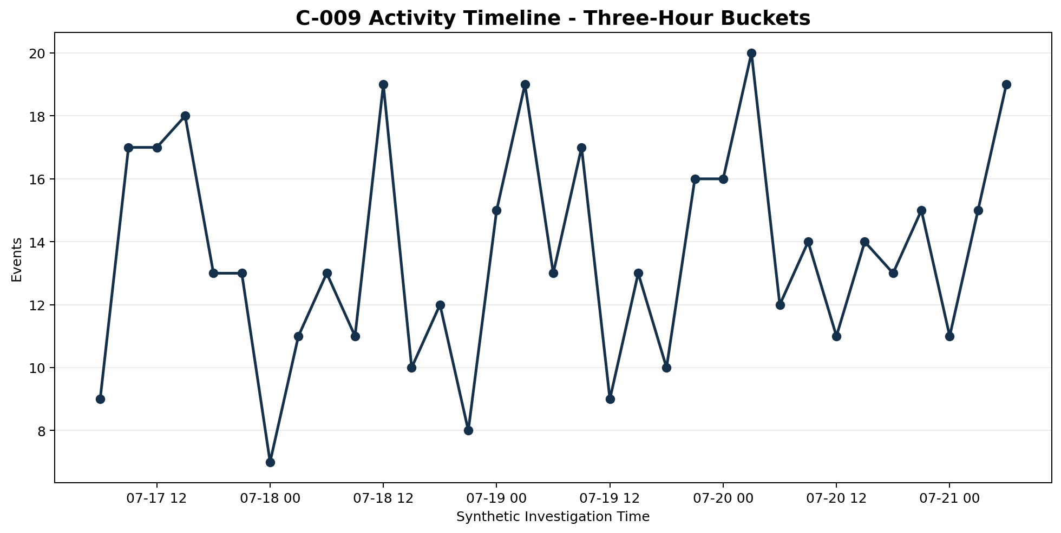
Figure 2. Synthetic C-009 activity volume in three-hour buckets.
COMPETING HYPOTHESES
H1 - Coordinated network: strongly supported by cross-case accounts, shared devices, repeated content families, prior enforcement, specialized roles, and five high-confidence case relationships.
H2 - Coincidental parallel behavior: plausible for isolated similarities but substantially less persuasive when the independent linkage categories are considered together.
H3 - Shared legitimate environment: a workplace, household, or public access point could explain some infrastructure overlap. The synthetic record contains no corroborating evidence for such an environment, and the role and enforcement patterns weaken this explanation.
H4 - Detection artifact: generated content families can inflate similarity. Content recurrence is therefore treated as corroboration rather than the sole basis for the assessment.
FINDINGS AND RECOMMENDATIONS
• Treat C-009 and its five directly linked cases as one coordinated investigative cluster for further human review.
• Preserve account, device, session, content-family, target, and prior-enforcement evidence in a defensible audit trail.
• Prioritize controller roles and previously enforced accounts while validating ownership, context, and alternative explanations.
• Develop reusable detection features for cross-case account membership, shared infrastructure, template recurrence, role differentiation, and post-enforcement reappearance.
• Require analyst validation before enforcement whenever shared infrastructure or content similarity is the only linkage.
• Measure detection quality against the benign control case C-010 and mixed-ground-truth cases C-005 and C-007.
LIMITATIONS
• The dataset is synthetic and deliberately contains discoverable ground-truth relationships.
• Content is represented through safe placeholders rather than natural language.
• Device and network sharing can have benign explanations.
• Risk scores are synthetic analytical features, not validated production-model outputs.
• No automated score or graph relationship should be treated as an enforcement decision.
CONCLUSION
C-009 is assessed as a coordinated cross-regional network linked to five other investigations. Cross-case accounts, shared devices, repeated content, prior-enforcement indicators, and differentiated roles support the finding. SQL and Python surfaced the relationships; human judgment determined their meaning and limitations.

