Joshua Van Deren, Jacob Lai, Grant Savage, Joy Tan

February 23, 2018

SE310

Siewert

**SE310, Analysis and Design of Software Systems**

**Exercise #3 – Requirements, Specification, Analysis, and Architecture Level Design**

1. The application we chose is a Command Line Interface (CLI) Chat. The main objective of this application is to create a platform where users can connect to a server and chat with other users. Users can either chat one on one or partake in a group chat. This project includes many operations. As can be found on the repository, fourteen capability requirements are:
   1. Must generate an ID made of a string of random characters and numbers for every user that connects to the server
   2. Every user must have the ability to create a room
   3. Every user must have the ability to leave a room
   4. Every user must have the ability to send a message
   5. Every user can join either a one on one chat or a group chat
   6. A user can only be in one chat room or in none at any given moment
   7. The user that creates a room becomes the administrator of that room
   8. Once the administrator of the room leaves, all participants in the room are kicked out and the room is deleted
   9. Any user within a room can choose to lock the room so that no other user can enter that specific chat room
   10. Any user within a locked room can choose to unlock that room
   11. The name of any room is created by the user and no two rooms can have the same name
   12. Every user has a designated random color for their name when their messages appear in the chat
   13. Any user has the ability to block another user or to unblock those they have blocked
   14. Every room has a variable keeping track of the number of participants in the room and the ID of those participants
2. Use Case: 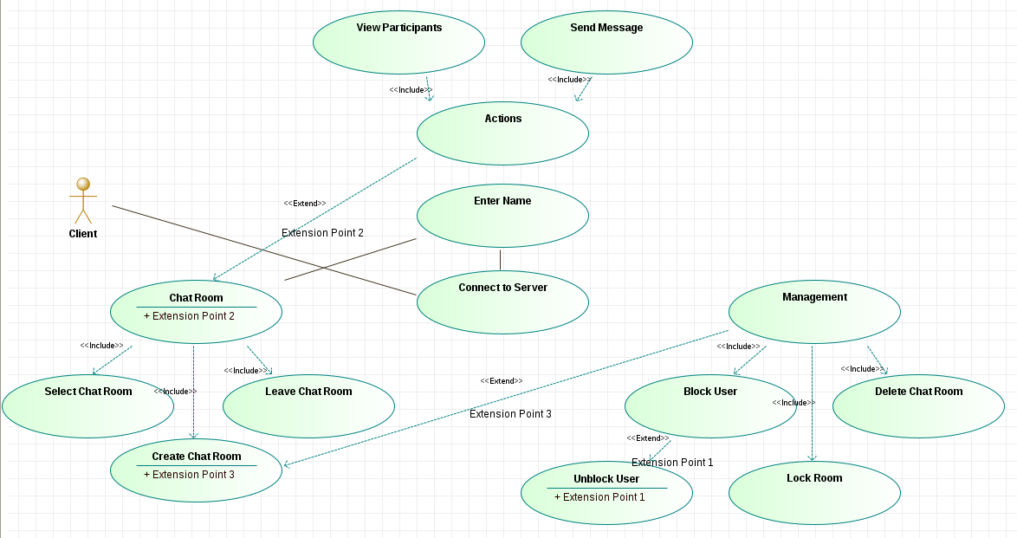

**Figure 1**: Use Case model

Classes and Domain:

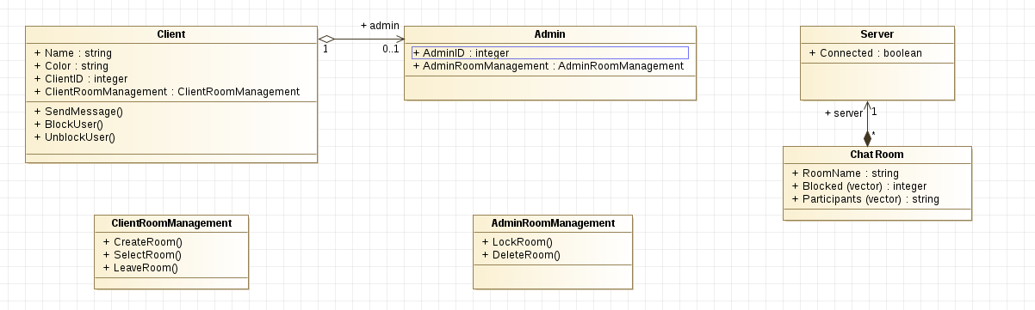

**Figure 2**: Original Class diagram with attributes, relationships, and operations

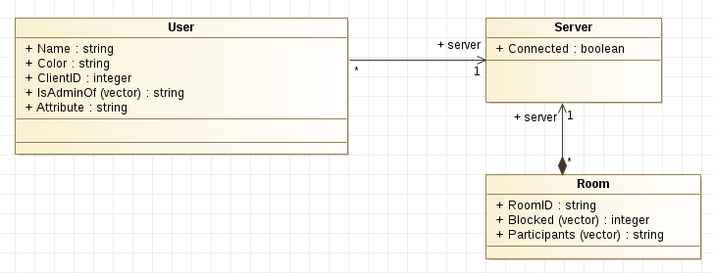

**Figure 3**: Revised Class diagram with attributes and relationships

OIM and Operations:

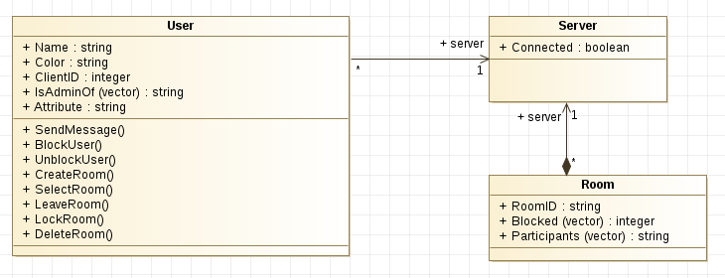

**Figure 4**: Revised Class diagram with attributes, relationships, and operations

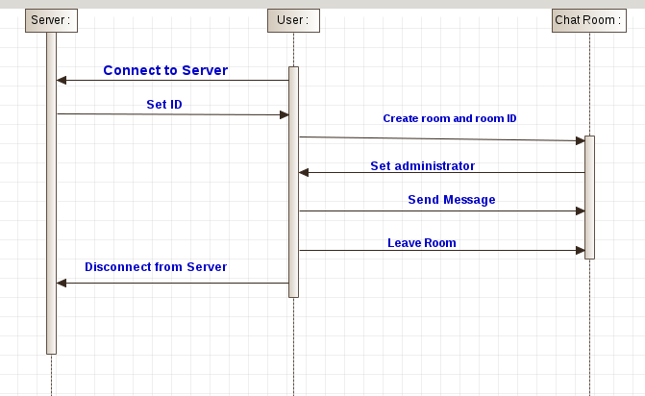

**Figure 5**: Object Interaction Model for one user

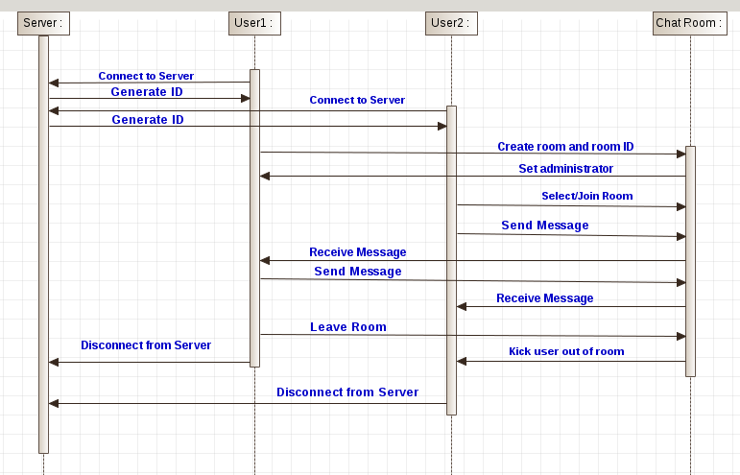

**Figure 6**: Object Interaction Model for two users sending messages

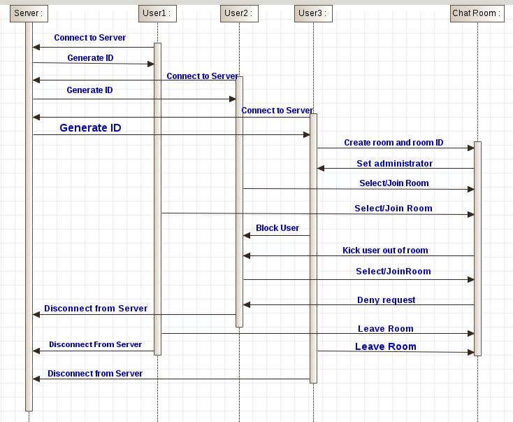

**Figure 7**: Object Interaction Model for three users with use of blocking a user

Prototype:

Can be found on the GitHub repository “cli_chat”