­­­­­­Joy Tan, Grant Savage, Joshua Van Deren, Jacob Lai

SE420 - Software Quality Assurance

Assignment #4

March 8, 2018

1. 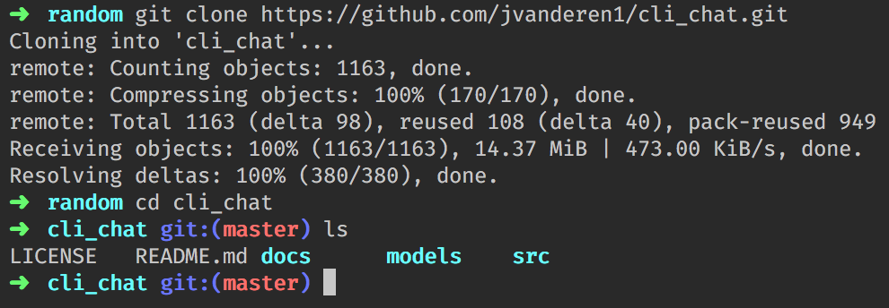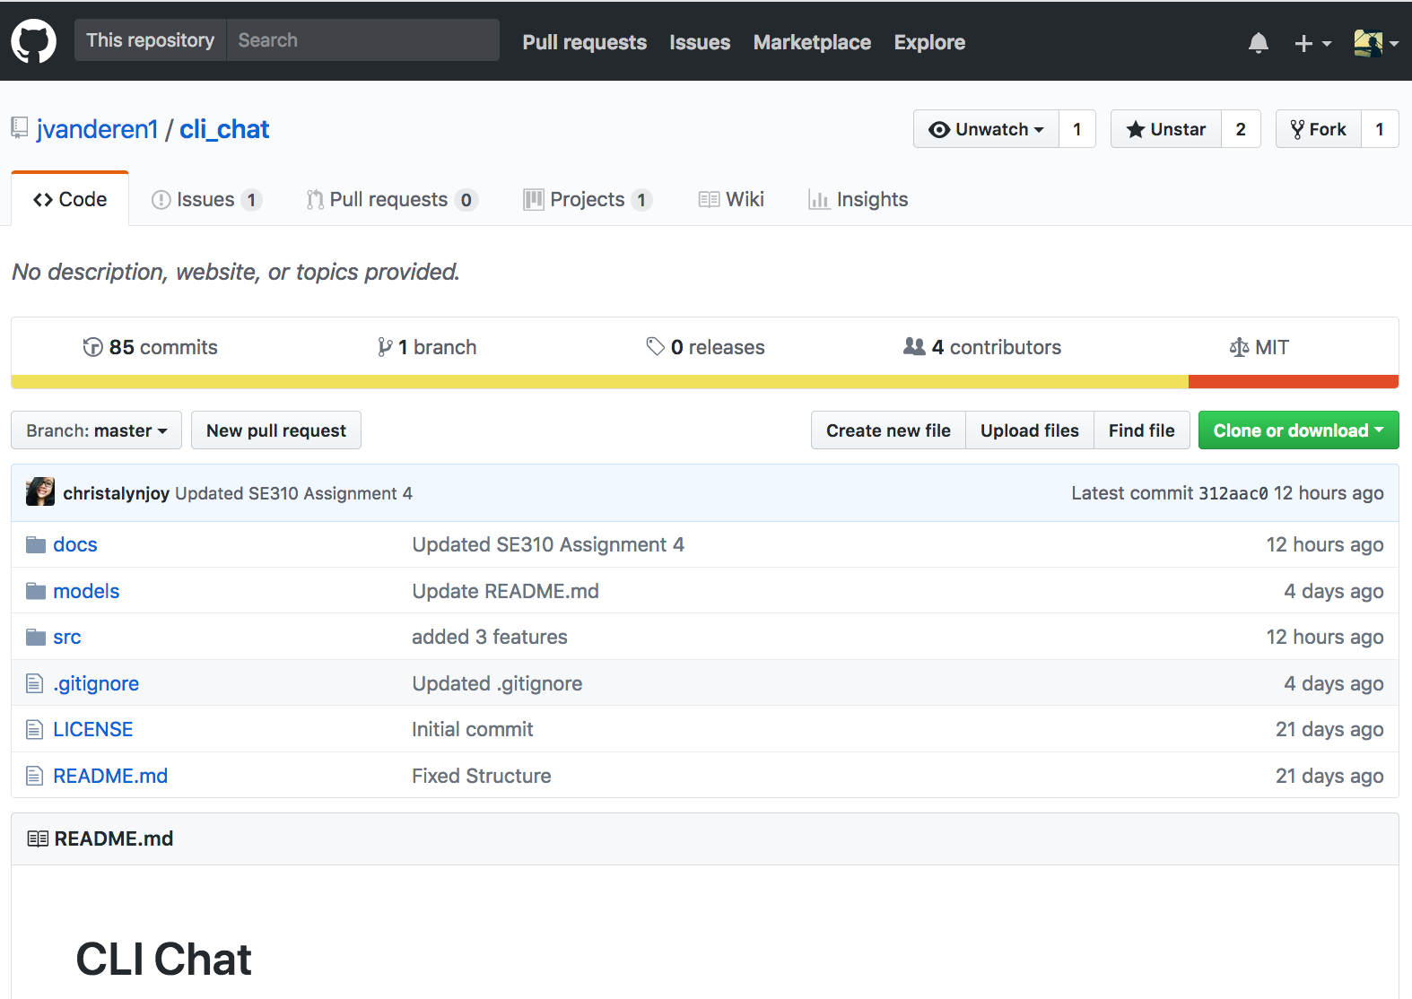From the beginning of this project we used CMVC for pushing our code up to a single repository and managing versions of our code. We used GitHub to do all of this. Here is a screen shot of our code pushed to our GitHub repository.  
     
     
     
     
     
     
     
     
     
     
     
     
     
     
     
     
     
     
     
     
     
     
     
     
     
     
   Here is a screen shot of the cloned repository:  
     
     
     
     
     
     
     
     
   We also opened an issue on GitHub. The issue we opened is for a bug that allows a user to message themselves:  
   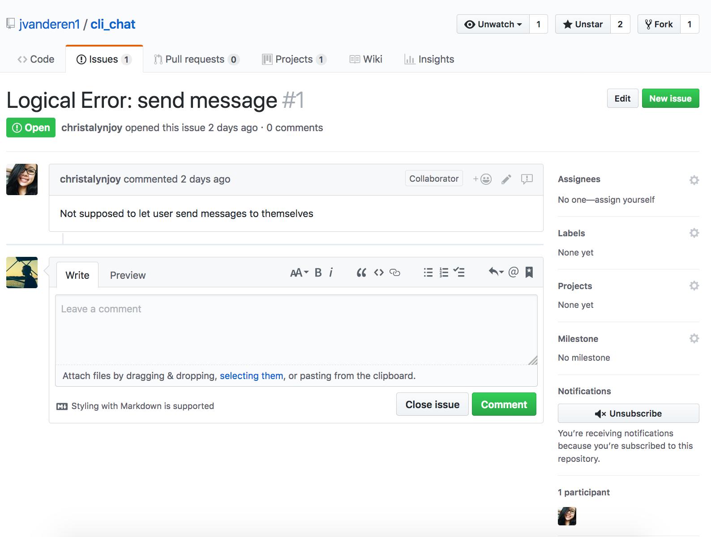  
     
     
     
     
     
     
     
     
     
     
     
     
     
     
     
     
     
     
     
     
     
     
     
     
     
     
   We have also setup a Kanban under the projects tab of our repo.  
     
   The link to our GitHub repo can be found here: <https://github.com/jvanderen1/cli_chat>  
   1. Currently our client is implemented as a CLI. In the future however, we plan to also provide a web client for interacting with our system. We plan on testing this interface using some sort of automated browser testing application which can assert that it sees certain values on the interface.
   2. We are using multiple modules to implement our client and server code. Take a look at our server code on GitHub under src/server directory.
   3. Three new features: Join Room, Leave Room, and Nicknames. Currently we have test scripts written for the join room and leave room functionality. We have deferred the nickname functionality for now due to development time being allocated toward fixing bugs and modularizing our code to synchronize our architecture to our design models.
2. 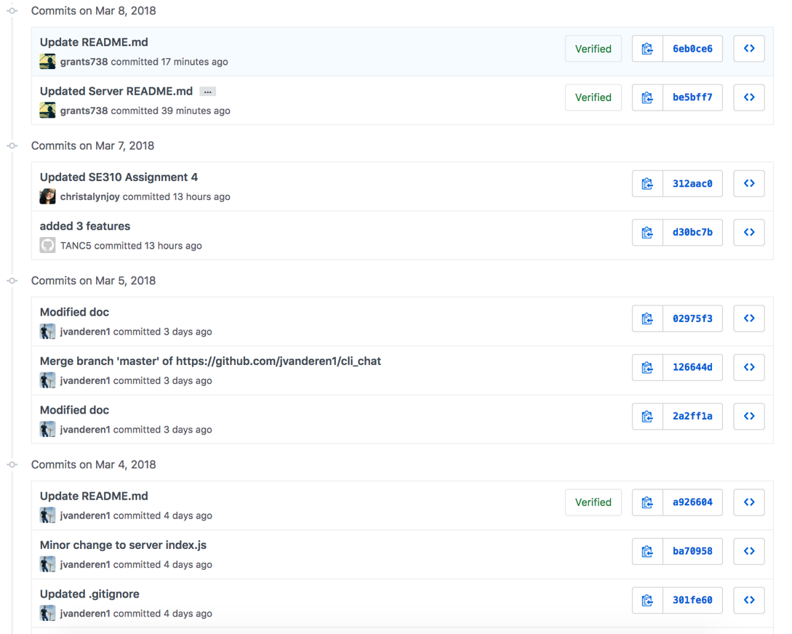Below is a screenshot of our commits to the repo:

We have also created a few Issues on Github that describe some defects in our code. They can be found under the Issues tab on the Github repo.