Proceedings of CHT-12

ICHMT International Symposium on Advances in Computational Heat Transfer

July 1-6, 2012, Bath, England

CHT-12-xxx

**HYBRID EXPERIMENTAL-NUMERICAL APPROACH TO SOLVE**

**INVERSE CONVECTION PROBLEMS**

Joseph VanderVeer and Yogesh Jaluria§

Dept. of Mech. and Aero. Eng., Rutgers University, US

§Correspondence author. Fax: +1 732 445 3124 Email: jaluria@jove.rutgers.edu

**ABSTRACT** STILL NEED TO WRITE AN ABSTRACT

# INTRODUCTION

Jets and plumes in cross flows appear in many engineering topics of interest. Topics include chimney smoke, fires, and exhaust from vehicles. Jets and plumes in cross flows have been thoroughly studied via experiments and simulations and have been reported upon by many people (e.g. Morton [1996], Rudman [1996], Carvel [2001], Mokhtarzadeh-Dehghan [2006], Hu [2009]).

While the forward problem of jets and plumes in cross flows have been exhaustively studied, the inverse problem has been relatively untouched. The inverse problem is often of more interest to environmentalists, engineers, and fire fighters. The inverse convection problem like other inverse problems is an ill-posed mathematical construct resulting in infinite non-unique solutions. Many techniques have been developed to reduce the solution set of ill-posed problems to a small subset (possibly unique) of solutions. These techniques are often similar to or derived from Tikhonov's regularization technique Tikhonov [1977], Özisik [2000], Orlande [2011].

The current research is an attempt to calculate, within acceptable error, both the location and temperature of a plume source in a cross flow using limited downstream information. The approach uses a hybrid experimental-numerical method in conjunction with traditional regularization techniques to solve for aforementioned parameters.

# EXPERIMENTS AND APPARATUS

Experiments are performed using a small wind tunnel with a test section of $54.5x305x254mm$. The main flow is generated by two 12 Volt DC brushless fans and has a velocity range of $2.0 to 50cm/s$. The fans are located at the anterior of the tunnel to reduce the turbulence induced by the spinning blades. In an attempt to generate uniform flow, four flow straighteners are used. Three straighteners are upstream of the test section and one downstream. The straighteners are a honeycomb structure with each straightener shifted out of alignment from the others. A 2D schematic of the system is shown in figure 1. All dimesions are in millimeters and depth into the page is $305mm$. The flow is from left to right.

The plume source is a 25.4mm wide electrically heated copper plate embedded in an aero-gel and ceramic base. Two such copper blocks exist in the test section separated by 25.4mm. Only the upstream block is heated in this research, however the high thermal conductivity of the 2nd copper block affects the results and needs to be explained. Two K-type thermocouples are located within the copper block approximately 1.0mm below the surface.

X

Y

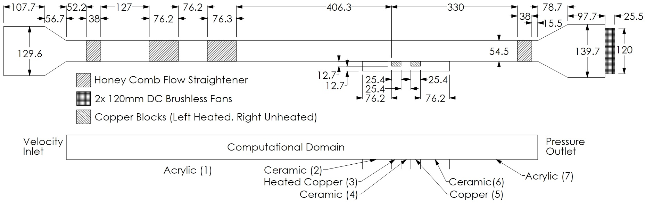

Figure 1. Wind tunnel schematic.

A Pitot-static tube located downstream of the test section is used to determine free stream velocity. The Pitot-static tube is attached to a NIST traceable differential pressure sensor from Omega, model PX655-0.1DI.

A custom thermocouple probe used for data collection is located in a 2D traversing mechanism above the centerline of the test section. The thermocouple is a standard K-type probe with an exposed tip of 40gage wire. All data is recorded using a National Instruments data acquisition board.

# SIMULATIONS

The Navier-Stokes equations were solved for air using a three-dimensional, steady state, realizable k-ε model via the software package Fluent (Fluent version 13 from Ansys). Density was approximated using the ideal gas law at constant pressure of $P_{∞}=101.6kPa$ Specific heat at constant pressure was constant at $c_{p}=1006.43J/{(kg-K)}$ In an effort to reduce the simulation error with respect to the experiment dynamic viscosity and thermal conductivity are defined by the Chapman-Enscog equations with constant Lennard-Jones parameters of $σ=3.711Å$ and $E/k=78.6K$.

The computational domain is the entire wind tunnel between the converging and diverging sections. The flow straighteners are not modeled. The three-dimensional domain is interpreted as two-dimensional with symmetric boundary conditions into and out of the page. The upstream edge of the plume source along the center line of the wind tunnel is identified as $x=0mm, y=0mm$. Domain discretization yield 130292cells. Grid spacing of $∆x$ and $∆y$ are between $0.175mm$ and $2.0mm$. Grid spacing perpendicular to the flow $∆z$ is between $0.75mm$ and $2.0mm$. The pressure and velocity are coupled. Pressure is discretized to second order, while all others are third order MUSCL.

The inflow boundary conditions are the velocity ${ U}_{∞}$, static temperature $T_{∞}$, static pressure $P_{∞}$, and zero entry turbulence. The uppermost boundary is identified as symmetric. The outlet is a pressure-outflow boundary condition. The bottom boundary condition consists of seven zones. From left to right: acrylic wall, ceramic wall, heated copper plate, ceramic wall, copper plate, ceramic wall, acrylic wall. All of the zones are treated as conjugate heat transfer of $12.7mm$ thick and outer temperature of $T_{∞}$ (except for the heated copper plate, which has a outer temperature of $T_{S}$). The material properties are constant and the ceramic has a density, specific heat, and thermal conductivity of $2320kg/m^{3}$, $1138J/{(kg-K)}$, and $0.1$ W⁄(m-K) respectively.

To use a hybrid approach to solving the inverse convection problem the numerical solutions must closely match. Therefore, a numerical-experimental validation is necessary. Table 1 contains a list of parameters used during the validation, with the experimental errors. Figure 2 is a comparison of the experiment and numerical data at a cross section of X=40mm. Figure 3 is a similar comparison at X=60mm. It is evident that closer the sampling to the x-axis the more accurate the simulation tends to be. This is very acceptable as the data near the region of interest where the bulk of the plume resides is more accurate. The maximum error is less than 2% and often less than 1%.

Table 1

Validation Test Summary

|  |  |
| --- | --- |
| Parameter | Value |
| $$U_{∞}({cm}/s)$$ | $$6.0±0.15$$ |
| $$T_{∞}(K)$$ | $$294.5±2.0$$ |
| $$P_{∞}(kPa)$$ | $$101.6±0.2$$ |
| $$T_{S}(K)$$ | $$433±2.0$$ |

# METHODOLOGY

During initial investigations into the inverse convection problem, sensitivity analysis revealed a linear relationship between local temperature and source temperature. The coefficients of this linearity are non-linear with respect to spatial coordinates and need to be recalculated for each location of interest. This presents no problems if two simulations of identical grid and free stream velocities, but differing source temperatures are available.

A priori knowledge of the free stream velocity will be assumed from this point forward. The first step is to select two appropriate simulations, the same free stream velocity and source temperatures near the unknown source temperature of interest. They will be identified as source temperature of simulation A and simulation B respectively $T_{SA}$, $T_{SB}$. Similarly, local temperatures of the simulations are $T_{A}(x,y)$ and $T_{B}\left(x,y\right).$ The second step is to select n samples from the unknown experiment (typically four), in this paper the n samples are in a line parallel to the x-axis. Since the location of the source is unknown only the relative location between samples is relevant. One sample is chosen as a datum with location at $x_{1},y_{1}$ and the other locations are identified by ${∆x}_{i},{∆y}_{i}$ relative to the datum.

|  |  |
| --- | --- |
| $$x_{i}=x_{1}+ {∆x}_{i} \\ y_{i}=y_{1} +{∆y}_{i} \\ m\left(x,y\right)=\frac{T_{SA}-T_{SB}}{T_{A}\left(x,y\right)-T_{B}\left(x,y\right)} \\ b\left(x,y\right)=T_{SA}-m\left(x,y\right)T_{A}\left(x,y\right) \\ E(x,y)=\sum_{i=2}^{n}{\begin{aligned}m\left(x+{∆x}_{i},y+{∆y}_{i}\right)T\left(x_{i},y_{i}\right)+b\left(x+{∆x}_{i},y+{∆y}_{i}\right)\end{aligned}}-m(x,y)T(x_{1},y_{1})-b(x,y)$$ | ( 1 )  ( 2 )  ( 3 ) |

# RESULTS

# CONCLUSIONS

# REFERENCES

Tikhonov, A. and Arsenin, V. [1977], *Solutions of Ill-Posed Problems*, V.H.Winston & Sons, Washington D.C.

Özisik, M. and Orlande, H. [2000], *Inverse Heat Transfer: Fundamentals and Applications*, Taylor & Francis, New York, New York.

Orlande, H. and Fudyam, O. and Maillet, D. and Cotta, R. [2011], *Thermal Measurements and Inverse Techniques*, CRC Press, Boca Raton, Florida.

Rudman, M. [1996], Simulation of the Near Field of a Jet in a Cross Flow, *Exp. Thermal and Fluid Sci.*, Vol. 12, pp 134-141.

Carvel, R.O. and Beard, A.N. and Jowitt, P.W. and Drysdale, D.D. [2001], Variation of Heat Release Rate with Forced Longitudinal Ventilation for Vehicle Fires in Tunnels, *Fire Safety J.*, Vol. 36, pp 569-596.

Mokhtarzadeh-Dehghan, M.R. and König, C.S. and Robins, A.G. [2006], Numerical Study of Single and Two Interacting Turbulent Plumes in Atmospheric Cross Flow, *Atmospheric Environment*, Vol. 40, pp 3909-3923.

Hu, L.H. andYang, D. [2009], Large Eddy Simulation of Fire-Induced Buoyance Driven Plume Dispersion in an Urban Street Canyon Under Perpendicular Wind Flow, *J. of Hazardous Materials*, Vol. 166, pp 394-406.

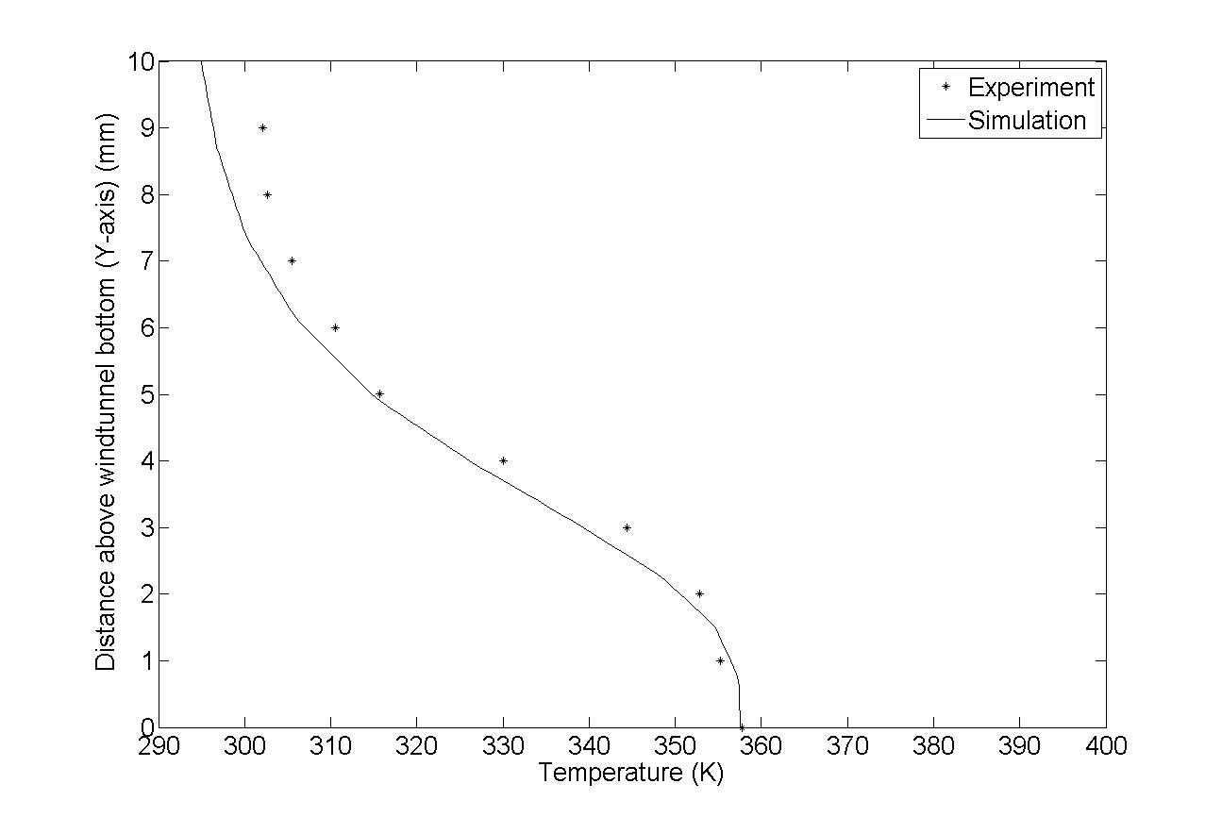

Figure 2. Experiment and numerical comparison at X=40mm.