Proceedings of CHT-12
ICHMT International Symposium on Advances in Computational Heat Transfer

July 1-6, 2012, Bath, England

CHT-12-xxx

HYBRID EXPERIMENTAL-NUMERICAL APPROACH TO SOLVE
INVERSE CONVECTION PROBLEMS

Joseph VanderVeer and Yogesh Jaluria§
Dept. of Mech. and Aero. Eng., Rutgers University Piscataway, NJ 08854, USA
§Corresponding author. Fax: +1 732 445 3124 Email: jaluria@jove.rutgers.edu

ABSTRACT A methodology is developed to utilize both experimental and numerical information in solving inverse convection problems. The method used combines an empirical relationship with a regularization scheme. The method is applied to a plume generated by an electrically heated copper block set within a small wind tunnel to provide cross flow. This approach attempts to solve for, within acceptable error, the source location and source temperature, which are not known a priori. A key factor in practicality of the approach is limited experimental sampling. Results show typical methodology errors of less than 1% for source temperature and 5% for source location. Results of combined experimental, experimental-numerical, and methodology errors were found to be typically less than 3% for source temperature and 6% for source location. The paper presents the basic methodology, typical results obtained, and the accuracy of the predictions. Practical problems, where this approach may be useful, are outlined.

INTRODUCTION

Inverse convection problems have received less attention than the similar forward problem. Such problems are typically of greater interest to environmentalists, engineers, and fire fighters. The inverse convection problem, like other inverse problems, is an ill-posed mathematical construct resulting in infinite non-unique solutions. Many techniques have been developed to reduce the solution set of ill-posed problems to a smaller subset of solutions (possibly unique) and many books have been written on the subject, see Tikhonov [1977], Tikhonov [1995], Özisik [2000], and Orlande [2011]. These techniques are often similar to or derived from Tikhonov's regularization technique (Mossi [2008], Daun [2005], Erturk [2002], Erturk [2008], Beck [1996]).

As an example, regularization techniques may be used to solve for the temperature distribution within an optical fiber drawing furnace. Temperature near the walls of a drawing furnace is difficult to measure. Temperature near the center is relatively easy to measure by means of instrumented graphite rod. Using center temperatures and a regularization technique, it is possible to predict the temperature at the wall inside the drawing furnace, Issa [1996].

Understanding the physics behind the forward problem is often very useful. For this reason, a relatively simple case of the inverse convection problem will be used, a plume in a cross flow. Fortunately, plumes in cross flows have been studied extensively both experimentally and numerically (Kolář [2007], Contini [2009], Contini [2004], Mokhtarzadeh-Dehghan [2006], Blanchard [2012] and Hu [2009]).

NOMENCLATURE

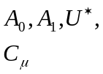 | Turbulent viscosity model parameters |  | 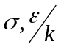 | Lennard-Jones parameters for Chapman-Enscog equations
b | y-Intercept of linear interpolation |  | 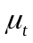 | Turbulent viscosity
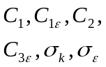 | 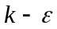Model Parameters |  | 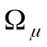 | Collision integral for viscosity
F | Objective function to be minimized |  | Subscripts
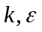 | Turbulence kinetic energy and dissipation rate |  | 1 | Datum sample
m | Slope of linear interpolation |  | A, B | Simulation A and B
N | Number of samples |  | I | Sample identifier 1 to n
L | Length of the source |  | SA, SB | Source of simulation A and B
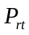 | Turbulent Prandtl number |  | S | Source to be investigated
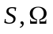 | Rate of strain and vorticity tensors |  | Superscripts
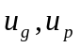 | Velocity normal to gravity and perpendicular to gravity |  | * | Mid-methodology prediction
X, Y | Non-dimensionalized coordinates |  |  | Average of the variable below
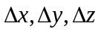 | Mesh spacing of numerical grid |  | ' | Fluctuating Term
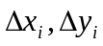 | Relative location of sample i to datum sample

A repetitive hybrid experimental-numerical approach called dynamic data driven application systems (DDDAS) has been previously applied to the jet in a cross flow problem. This approach used a response surface model to compare results from the experiment to the numerical, which would predict more experimental data points and simulation scenarios needed. This process would repeat until the predicted error fell to an acceptable level. The methodology resulted in predictions of the jet velocity to within experimental error and jet temperature to within 13% (Knight [2007], Ma [2006]). These encouraging results have encouraged this research into plumes in a cross flow.

The current research is an attempt to calculate, within acceptable error, both the location and temperature of a plume source in a cross flow using limited downstream information. The approach uses a hybrid experimental-numerical method in conjunction with traditional regularization techniques to solve for aforementioned parameters. For this methodology to be most practical, the experimental data must be limited to a few sample points.

EXPERIMENTS AND APPARATUS

Experiments are performed using a small wind tunnel with a test section of dimension 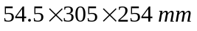. Because of the large aspect ratio of the wind tunnel 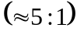, a two-dimensional flow may be assumed. The main flow is generated by two 12 Volt DC brushless fans and has a velocity range of 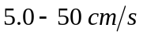. The fans are located at the anterior of the tunnel to reduce the turbulence induced by the spinning blades. In an attempt to generate uniform flow, four flow straighteners are used. Three straighteners are upstream of the test section and one downstream. The straighteners are a honeycomb structure with each straightener shifted out of alignment from the others. A 2D schematic of the system is shown in figure 1. All dimensions are in millimeters and depth into the page is 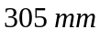. The flow is from left to right.
The plume source is a 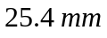 wide electrically heated copper plate. Due to the high thermal conductivity of copper, a uniform temperature is assumed. The copper plate is embedded in a ceramic form with a thermal conductivity of 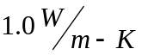. To assist in reducing the conjugate heat transfer the copper block is insulated from the ceramic with layers of aero-gel with thermal conductivity of 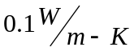. Two copper blocks exist in the test section separated by 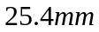. Only the upstream block is heated in this research. Two K-type thermocouples are located within the copper block approximately 1.0 mm below the surface.
Y
X

A Pitot-static tube located downstream of the test section is used to determine free stream velocity. The Pitot-static tube is attached to a NIST traceable differential pressure sensor from Omega, model PX655-0.1DI. The pressure transducer has an error of 0.05% of full scale pressure. This results in a maximum error in velocity of 4% at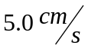.
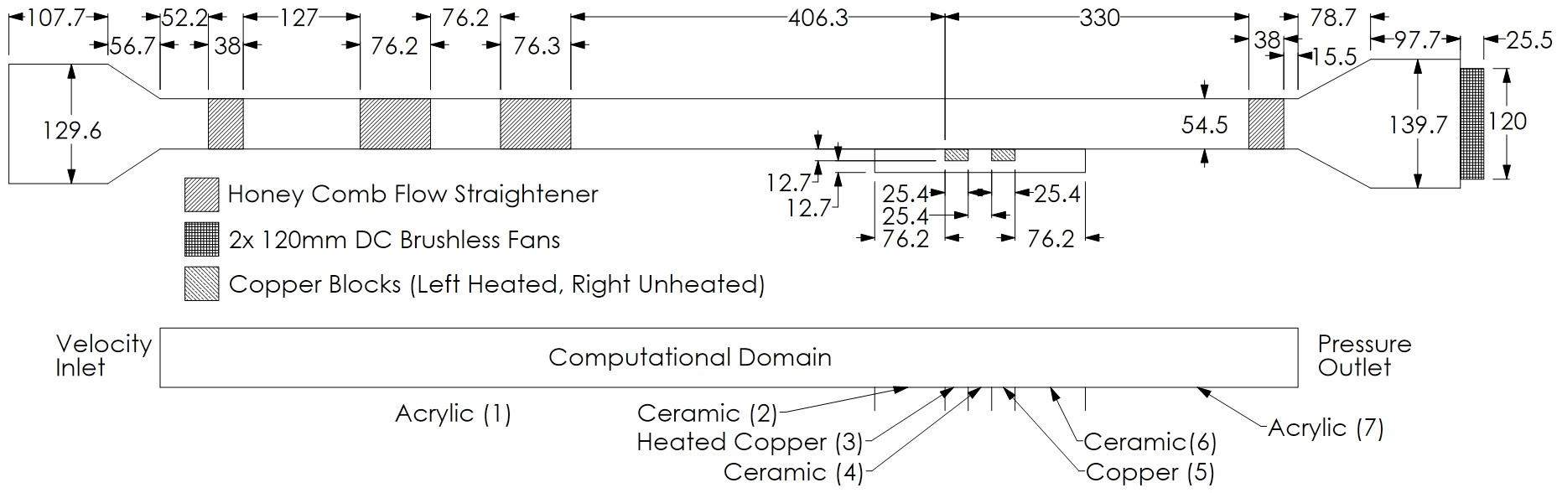

Figure 1. Wind tunnel schematic.

A custom thermocouple probe used for data collection is located in a 2D traversing mechanism above the centerline of the test section. The thermocouple is a standard K-type probe with an exposed tip of 40 gage wire. The thermocouple has been calibrated against the boiling point of distilled water and freezing point of distilled water. All data are recorded using a National Instruments data acquisition board. Multiple data samplings over many days has shown an observed repeatability error of at most 7% with the error dropping to 2% along the surface (i.e. y=0).

NUMERICAL SIMULATIONS

The Navier-Stokes equations were solved for air using a three-dimensional, steady state, realizable k-ε model with enhanced wall effects via the software package Fluent (Fluent version 13 from Ansys). Although the Reynolds number for the flow is on the order of 200, the flow still necessitates a turbulence model. This is due to a Richardson number of 6.7 and 3.8 for the two test cases at 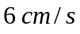 and 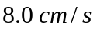 respectively. Thus the turbulence introduced by the plume is significant and needs to be modeled. The equations for mass, momentum, and energy conservation as solved are as follows:

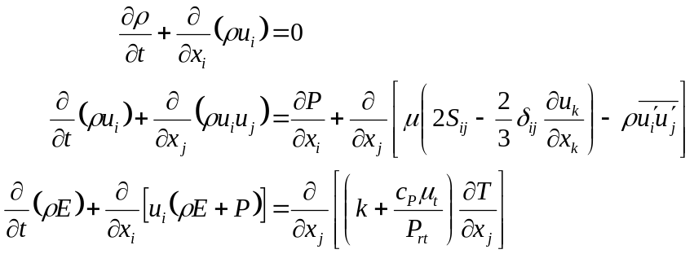 | ( 1 )  ( 2 )  ( 3 )

Where the velocity is defined as a decomposition of mean and fluctuating velocity:

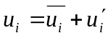 | ( 4 )

The transport equations are modeled with the following equations:

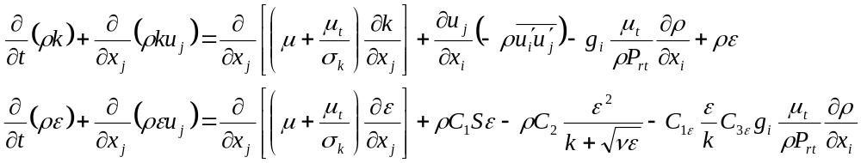 | ( 5 )  ( 6 )

With constants and coefficients of:

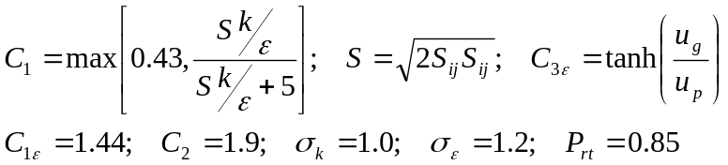 | ( 7 )  ( 8 )

Where 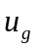 is the velocity component parallel to gravitation forces, and 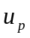 is the velocity perpendicular to the gravitational forces. The eddy viscosity and needed parameters are defined in the following equations:

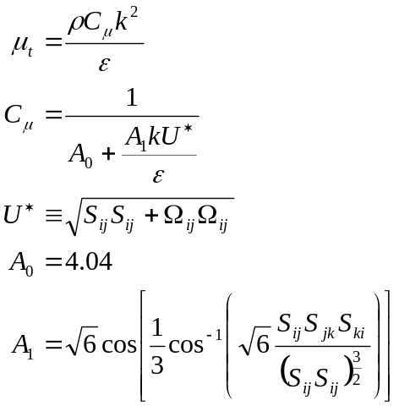 | ( 9 )  (10)  (11)  (12)  (13)

The Reynolds stresses, rate of strain tensor and vorticity tensors are defined as:

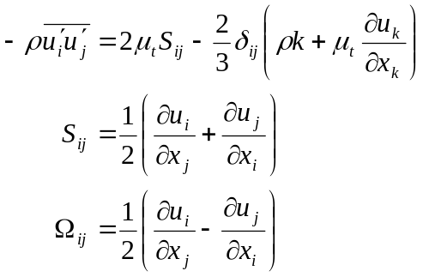 | (14)  (15)  (16)

Density was approximated using the ideal gas law at constant pressure of 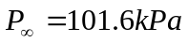 Specific heat at constant pressure was constant at 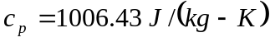. In an effort to reduce the simulation error with respect to the experiment dynamic viscosity and thermal conductivity are defined by the Chapman-Enscog equations (equations 17 and 18) with constant Lennard-Jones parameters of 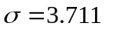Å and 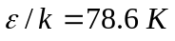. is the collision integral for viscosity, for more information see Vincenti [1965], Fluent [2010].

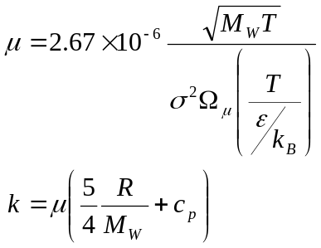 | (17)  (18)

The computational domain is the entire wind tunnel between the converging and diverging sections. The flow straighteners are not modeled. The three-dimensional domain is interpreted as two-dimensional with symmetric boundary conditions into and out of the page. The upstream edge of the plume source along the center line of the wind tunnel is identified as 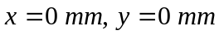. Domain discretization yield 130292 cells. Grid spacing of  and 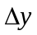 are between 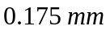 and 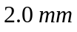. Grid spacing perpendicular to the flow 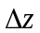 is between 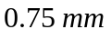 and . A grid independence study was performed using a random sampling of locations and comparing local temperatures against element counts, see table 1. The pressure and velocity are coupled. Pressure is discretized to second order, while all others are third order MUSCL.
Table 1
Grid Independence Study

 | Test Locations x,y (mm)
Element Count | 30,2 | 35,3 | 40,1 | 50,10
67399 | 360.3 | 338.5 | 352.9 | 295.6
94378 | 360.2 | 338.6 | 352.7 | 295.6
130292 | 360.2 | 338.5 | 352.7 | 295.6
153290 | 360.1 | 338.8 | 352.6 | 295.8

The inflow boundary conditions are:

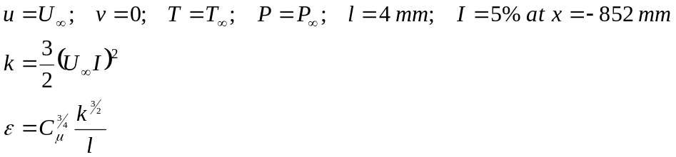 | (19)  (20)  (21)

Where and are the turbulence length scale and turbulence intensity respectively, and are used to calculate the initial turbulent kinetic energy () and turbulence dissipation rate (). The uppermost boundary is very far from the plume effects and is taken to be symmetric to simulate zero convective flux. The outlet is a pressure-outflow boundary condition

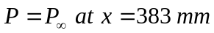 | (22)

The bottom boundary condition consists of seven zones; from left to right: acrylic wall, ceramic wall, heated copper plate, ceramic wall, copper plate, ceramic wall, acrylic wall. The material properties are constant and the ceramic/aero-gel has an effective density, specific heat, and thermal conductivity of 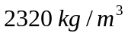, 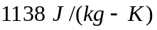, and 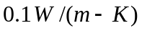 respectively. The bottom is a no slip boundary with conjugate heat transfer included. The conjugate heat transfer of thick and is solved simultaneously with the outer boundary temperature defined as 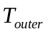.

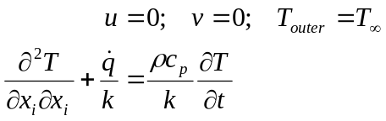 | (23)  (24)

The heated source is defined identically to the rest of the wall with the exception of outer wall temperature:

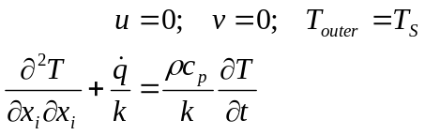 | (25)  (26)

To use a hybrid approach for solving the inverse convection problem the numerical solutions must closely match. Therefore, a numerical-experimental validation is necessary. Table 2 contains a list of parameters used during the validation, with the experimental errors. The data has been non-dimensionalized via the following equations:

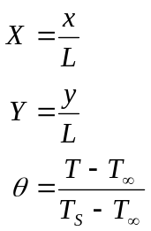 | (27)  (28)  (29)

Table 2
Validation Test Summary

Parameter | Value
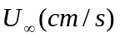 | 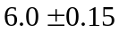
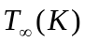 | 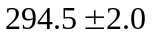
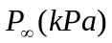 | 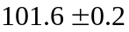
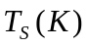 | 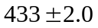

L is the length of the source, at 25.4 mm. Figure 2 is a comparison of the experiment and numerical data at a cross section of x/L=1.6 Figure 3 is a similar comparison at x/L=2.4 It is evident that closer the sampling to the x-axis, the more accurate the simulation tends to be. This is expected and quite acceptable as the data near the region of interest where the bulk of the plume resides is more accurate. The maximum error is less than 2% and often less than 1%.
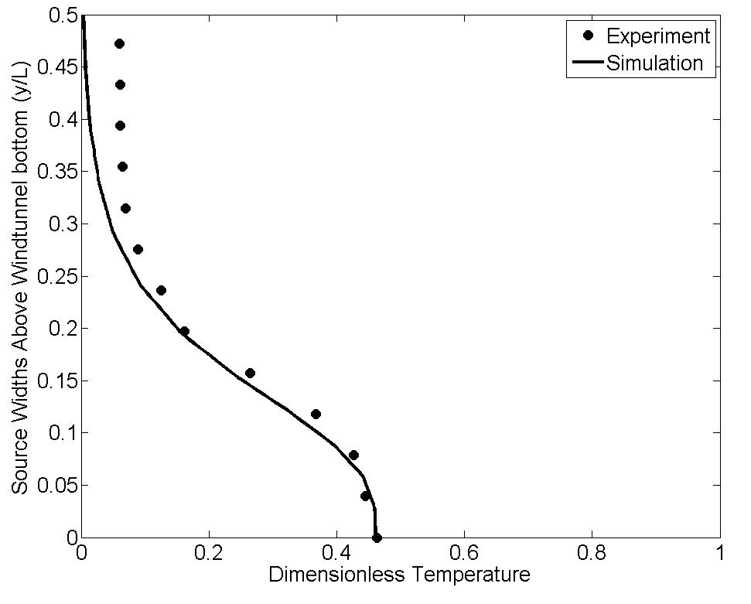
Figure 2. Experiment and numerical comparison at x/L=1.6

METHODOLOGY

During initial investigations into the inverse convection problem, sensitivity analysis revealed a linear relationship between local temperature and source temperature, for constant free stream velocity. Figure 4 is an example of a sensitivity analysis, at a random location 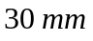 downstream from the source and 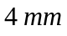 above the source (i.e.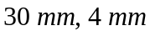), with a linear curve fit. The coefficients of this linearity are non-linear with respect to spatial coordinates and need to be recalculated for each location of interest. This presents no problems if two simulations of identical grid and free stream velocities, but differing source temperatures are available.

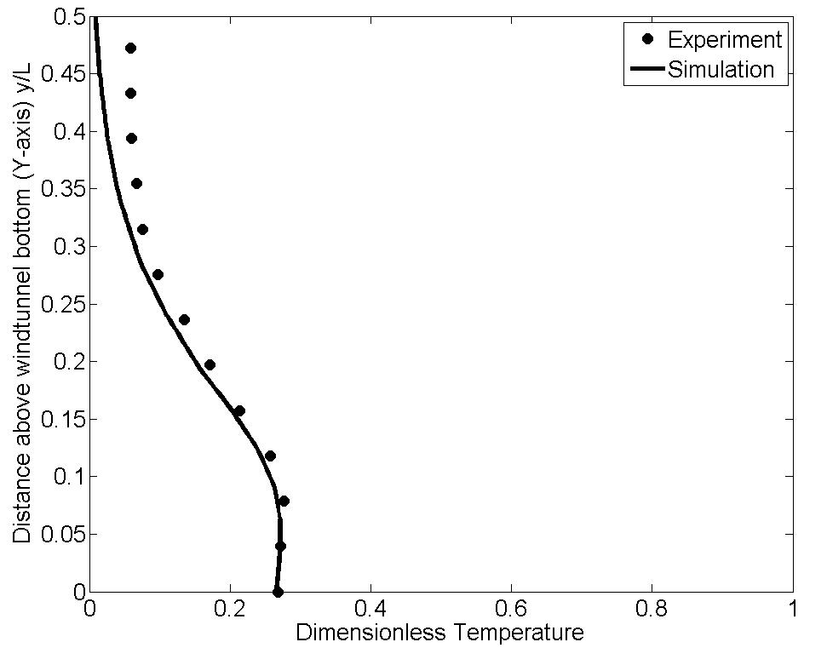

Figure 3. Experiment and numerical comparison at x/L=2.4

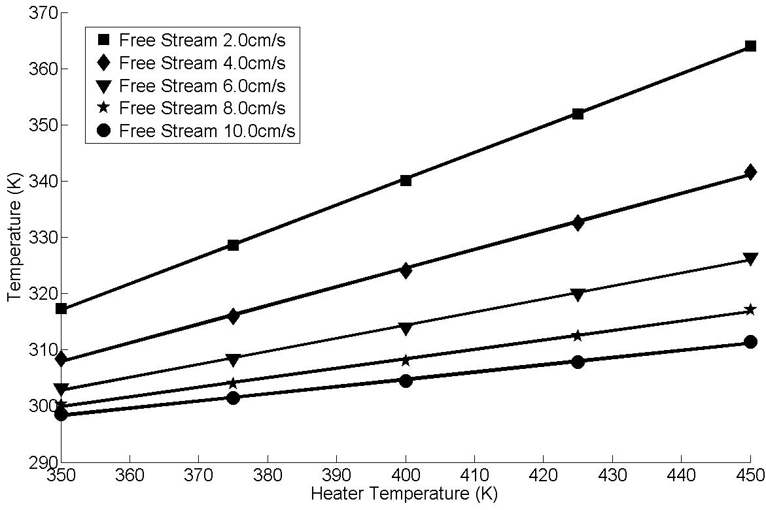

Figure 4. Sensitivity analysis of local temperature vs. source temperature

A priori knowledge of the free stream velocity will be assumed from this point forward. We start by selecting two appropriate simulations with source temperatures near the unknown source temperature of interest. They will be identified as source temperature of simulation A and simulation B respectively 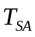, 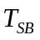. Similarly, local temperatures of the simulations are 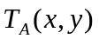 and 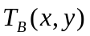 Next, we select n samples from the unknown source experiment. Since the location of the source is unknown only the relative location between samples is relevant. One sample is chosen as a datum with location at 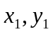 and the other locations are identified by 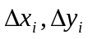 relative to the datum.

The datum relationship is as follows:

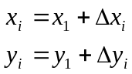 | (30)  (31)

The linear relationship between the local temperature and source can be described as:

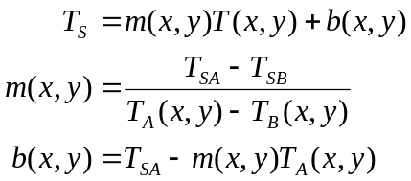 | (32)  (33)  (34)

This methodology makes the assumption that only one solution may predict identical source temperatures for a set of samples and relative locations. If this is true, and at least in the case of the plume in a cross wind it seems to be, then the sum of the errors of predicted source temperature may be used to predict one ideal solution. Minimization of the following equation leads to a least squares problem and is solved using the genetic algorithm

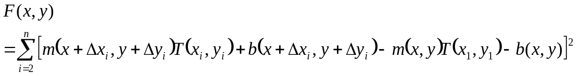 | (35)
The x and y resulting in a minimum of F are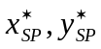. The source temperature can then be calculated by:

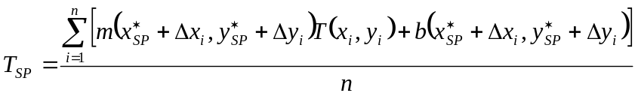 | (36)

To increase the accuracy of the predicted location this process may be repeated with new samples and a slightly modified objective function:

(37)

The genetic algorithm is used to minimize the new objective function, whose minimum occurs at
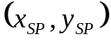

RESULTS

With no firm indication of how the experimental samples should be oriented, another sensitivity analysis was performed comparing predicted source temperature error to vertical/ horizontal orientation and spacing of samples. Similarly, predicted location error was compared to vertical/ horizontal orientation and spacing. A portion of the results are shown in figure 5a-c. From figure 5a and 5b it is clear that both orientations, any spacing, and any number of samples (greater than 3) gives acceptable temperature predictions. Horizontal spacing of four or more samples with 1.0 mm spacing gives best results for source temperature predictions. For location prediction it is evident from figure 5c that greater than 1.5 mm spacing, vertical orientation and at least four samples gives better than 10% error. Location prediction via information gained of horizontally spaced samples is erratic at best and is not considered further. It is useful to note the results shown in figure 5c are error of not 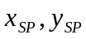.

From the sensitivity analysis the recommended samples should be at a minimum four samples arranged horizontally with 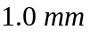 spacing to predict the source temperature and four samples arranged vertically with 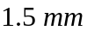 spacing to predict the location of the source. Vertical spacing of 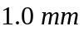 was ultimately used due to a limitation in the travel of the vertical slide of the experiment. As will be seen from the results, this does not seem to significantly affect the methodology. Assuming sample points are reusable between the first and second stage, seven samples are required to accurately predict the location and temperature of the source. The sampling shape and datum location are shown in figure 6.

To test the effectiveness of the algorithm, simulated data was first used negating the effects of experiment-numerical differences. With known free stream velocity, two temperatures were selected encompassing the expected temperature of the source. Then stage 1 of the procedure begins with a random datum point selection, as shown at the bottom of figure 7 (e.g. datum location of 25,2 is located 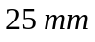 downstream of the source and 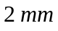 above it). Three more samples are selected (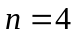) located in a horizontal line to the right of the datum with spacing. The samples are used in the minimization process of equation 35. The error of the results are shown in figure 7, with the source temperature barely noticeable on the plot as it is below 1%. The first stage location error is poor and often above 10% error. Stage 2 uses another three samples located vertically above the datum point with again with spacing. The final predicted location is calculated by the minimization of equation 37 and the error is also plotted in figure 7.

This location prediction error is less than 5% in all sampled cases. The sampled cases were generated randomly with a range of 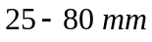 in the x direction in 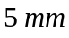 increments. The y direction 0-5 mm in 1 mm increments. The simulation parameters are shown below in table 3. The source temperature prediction error is calculated by:

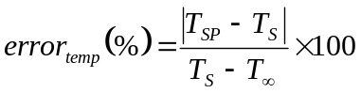 | (38)

The source location error is calculated by (location units of millimeters):

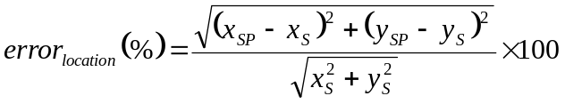 | (39)

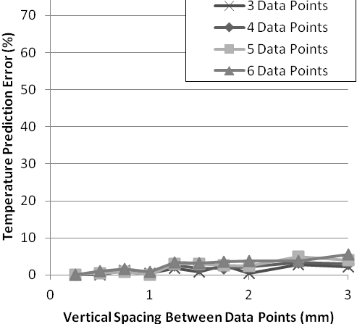  Figure 5a. Temperature prediction error vs vertical spacing between samples | 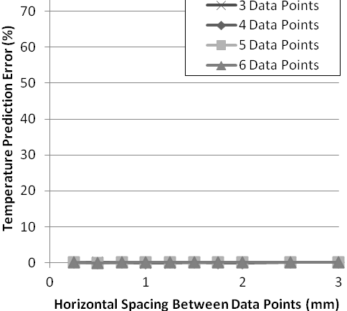  Figure 5b. Temperature prediction error vs horizontal spacing between samples
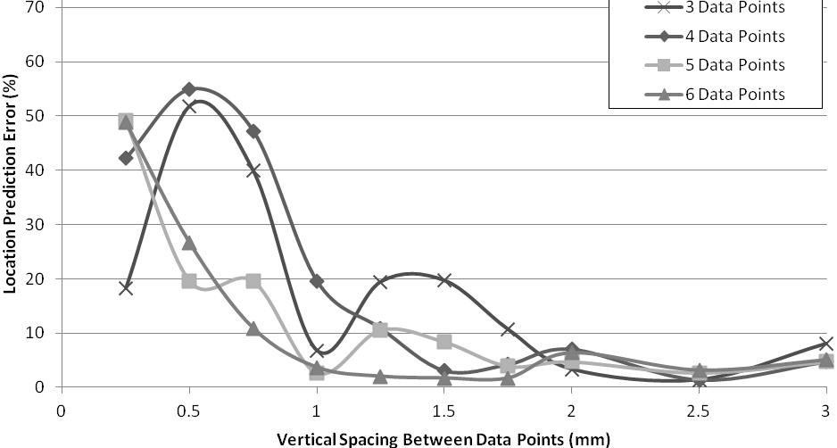

Figure 5c. Location prediction error vs vertical spacing between samples

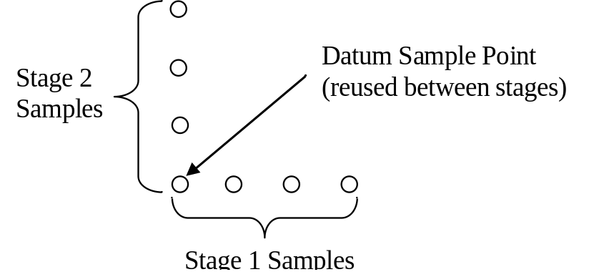

Figure 6. Sampling pattern

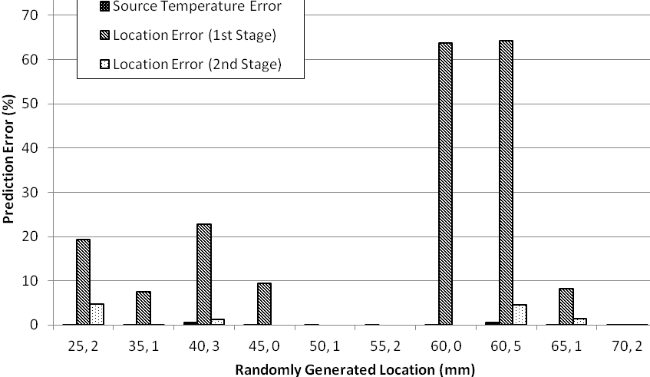

Figure 7. Prediction error of selected source locations

In a very similar fashion, the algorithm was applied to two sets of experimental measurements. Table 4 summarizes the parameters used in the first experiment; the parameters are similar to the all simulation test just discussed. The errors associated with the experiment are as expected worse than the simulation test. The source temperature error increases from less than 1% to less than 3%. The location prediction error stays the same at about 5% or less. Table 5 shows the results to the first experiment.

The second experiment changes the velocity to 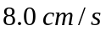 from 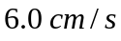. Also the location for the second test places the datum directly on the surface of the wind tunnel. The parameters for the second experiment are shown below. In this case there is a outlier for the algorithm at 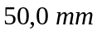. The error is significant, almost 17% for the source temperature prediction and location error is almost 10%.
Table 3
Simulated Test Parameters

Parameter | Value
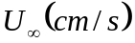 | 6.0
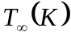 | 293
 | 101.32
 | 425
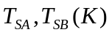 | 350, 450
Possible X range | 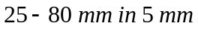increments
Possible Y range | 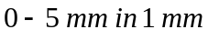increments
n stage 1 | 4
n stage 2 | 4
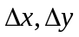 stage 1 | 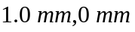
stage 2 | 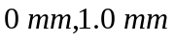

Table 4
Experiment 1 Parameters

Parameter | Value
 | 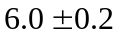
 | 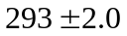
 | 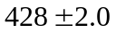
 | 350, 450
n stage 1 | 4
n stage 2 | 4
stage 1
stage 2

Table 5
Experiment 1 Results

Datum Location  x,y (mm) |  | Source Temperature  Prediction Error (%) | Location Error  First Stage (%) | Location Error  Second Stage (%)
35, 1 | 1.93 |  | 26.0 | 2.91
40, 1 | 1.76 |  | 23.8 | 5.80
45, 1 | 2.26 |  | 21.1 | 3.80
50, 1 | 0.393 |  | 3.80 | 1.13

Table 6
Experiment 2 Parameters

Parameter | Value
 | 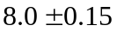
 | 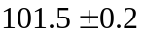
 | 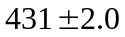
 | 350, 450
n stage 1 | 4
n stage 2 | 4
stage 1
stage 2

Table 7
Experiment 2 Results

Datum Location  x,y (mm) |  | Source Temperature  Prediction Error (%) | Location Error  First Stage (%) | Location Error  Second Stage (%)
35, 0 | 0.363 |  | 17.7 | 5.89
40, 0 | 3.18 |  | 24.0 | 1.25
45, 0 | 3.14 |  | 35.8 | 1.42
50, 0 | 16.9 |  | 42.2 | 9.73

Two possibilities as to the cause of the error are experimental data outlier and/or algorithm error from selecting spacing instead of a higher spacing. Alternative sources of this error were considered such as 2D-vs-3D effects and numerical model error. These were excluded due the other datum locations providing results within acceptable error. Otherwise the results from the second experiment are similar to the results from the first experiment.

CONCLUSIONS

A plume in a cross was used experimentally and numerically to test a methodology for solving inverse convection problems. The approach was developed from a sensitivity analysis and regularization techniques. The sensitivity analysis shows a linear relationship between source temperature and local temperature with coefficients highly dependent upon location. This allows for use of a regularization technique to solve for both source temperature and source location using a two stage minimization process.

The results from the all simulation test has source temperature prediction errors of less than 1% and source location prediction errors of less than 5%. Experimental tests of the algorithm show a slightly increased error of less than 3% and less than 6% for source temperature and location prediction respectively. The only exception from these results is most likely caused by an experimental data outlier.

As required only a small set of total sample locations is required to achieve useable results. While this case only used seven sample locations, more may be used, and as expected more sample locations the better the accuracy of prediction.

This methodology allows for many further investigations. Some such investigations are: in depth analysis on sample size, shape, and orientation; additional research on removing the a priori knowledge of free stream velocity, which has been found to be quadratically related to local temperature. Among other things, this methodology allows itself to be applied to many inverse convection problems. The empirically determined relationship between source temperature and the local temperature should apply to jets in cross flows (at least for low jet to free stream velocity ratios). Applying this methodology with modifications may lead to solutions to three dimensional problems and eventually to real world applications. Such applications are fires in tunnels , see Blanchard [2012] and fires in urban environments, see Hu [2009].

REFERENCES

Beck, J. and Blackwell, B. and Haji-Sheikh, A. [1996], Comparison of Some Inverse Heat Conduction Methods Using Experimental Data , Intl. J. of Heat and Mass Transfer, Vol. 39, No 17, pp 3649-3657.

Blanchard, E. and Boulet, P. and Desanghere, S. and Cesmat, E. and Meyrand, R. and Garo, J. and Vantelon, J. [2012], Experimental and Numerical Study of Fire in a Midscale Test Tunnel, Fire Safety J., Vol. 47, pp 18-31.

Contini, D. and Robins, A. [2004], Experiments on the Rise and Mixing in Neutral Crossflow of Plumes from Two Identical Sources for Different Wind Directions, Atmospheric Environment, Vol. 38, pp 3573-3583.

Contini, D. and Cesari, D. and Donateo, A. and Robins, A. [2009], Effects of Reynolds Number on Stack Plume Trajectories Simulated with Small Scale Models in a Wind Tunnel, J. of Wind Eng. and Industrial Aerodynamics, Vol. 97, pp 468-474.

Duan, K. and Howell, J. [2005], Inverse Design Methods for Radiative Transfer Systems, J. of Quantitative Spectroscopy & Radiative Transfer , Vol. 93, pp 43-60.

Erturk, H. and Ezekoye, O. and Howell, J. [2002], Comparison of Three Regularized Solution Techniques in a Three-Dimensional Inverse Radiation Problem, J. of Quantitative Spectroscopy & Radiative Transfer, Vol. 73, pp 307-316.

Erturk, H. and Gamba, M. and Ezekoye, O. and Howell, J. [2008], Validation of Inverse Boundary Condition Design in a Thermometry Test Bed, J. of Quantitative Spectroscopy & Radiative Transfer, Vol. 109, pp 317-326.

Fluent Technical Documents v13.0 [2010], Ansys, Inc

Hu, L.H. andYang, D. [2009], Large Eddy Simulation of Fire-Induced Buoyance Driven Plume Dispersion in an Urban Street Canyon Under Perpendicular Wind Flow, J. of Hazardous Materials, Vol. 166, pp 394-406.

Issa, J. and Yin, Z. and Polymeropoulos, C.E. and Jaluria, Y. [1996], Temperature Distribution in an Optical Fiber Draw Tower Furnace, J. of Materials Processing & Manufacturing Sci., Vol. 4, pp 221-232.

Knight, D. and Ma, Q. and Rossmann, T. and Jaluria, Y., 2007. Evaluation of Fluid-Thermal Systems by Dynamic Data Driven Application Systems – part ii. In: International Conference on Modeling Optimization of Structures, Processes and Systems 2007 University of Kwazulu-Natal, South Africa.

Kolář, V. and Savory, E. [2007], Dominant Flow Features of Twin Jets and Plumes in a Crossflow , J. of Wind Eng. and Industrial Aerodynamics, Vol. 95, pp 1199-1215.

Ma, Q. and Luo, Y. and Rossmann, T. and Knight, D. and Jaluria, Y., 2006. Diode Laser Measurements of DDDAS: Flowfield Reconstruction using Dynamica Experimental and Numerical Data. In: 25th AIAA Aerodynamic Measurement Technology and Ground Testing Conferences 2006 San Francisco, CA. American Institute of Aeronautics and Astronautics, Inc.

Mokhtarzadeh-Dehghan, M.R. and König, C.S. and Robins, A.G. [2006], Numerical Study of Single and Two Interacting Turbulent Plumes in Atmospheric Cross Flow, Atmospheric Environment, Vol. 40, pp 3909-3923.

Mossi, A. and Vielmo, H. and França, F. and Howell, J. [2008], Inverse Design Involving Combined Radiative and Turbulent Convective Heat Transfer , Intl. J. of Heat and Mass Transfer, Vol. 51, pp 3217-3226.

Orlande, H. and Fudyam, O. and Maillet, D. and Cotta, R. [2011], Thermal Measurements and Inverse Techniques, CRC Press, Boca Raton, Florida.

Özisik, M. and Orlande, H. [2000], Inverse Heat Transfer: Fundamentals and Applications, Taylor & Francis, New York, New York.

Tikhonov, A. and Arsenin, V. [1977], Solutions of Ill-Posed Problems, V.H.Winston & Sons, Washington D.C.

Tikhonov, A. and Goncharsky, A. and Stepanov, V. and Yagola, A. [1995], Numerical Methods for the Solution of Ill-Posed Problems, Kluwer Academic Publishers, Boston, Ma.

Vincenti, W. and Kruger, C. [1965], Introduction to Physical Gas Dynamics, Krieger Publishing Co., Malabar, Florida.

