Joseph Vanicek

ISTA 131 Final project figures

1. 90 day price comparison candlestick graph. **Corresponding file: candle_prices.py**

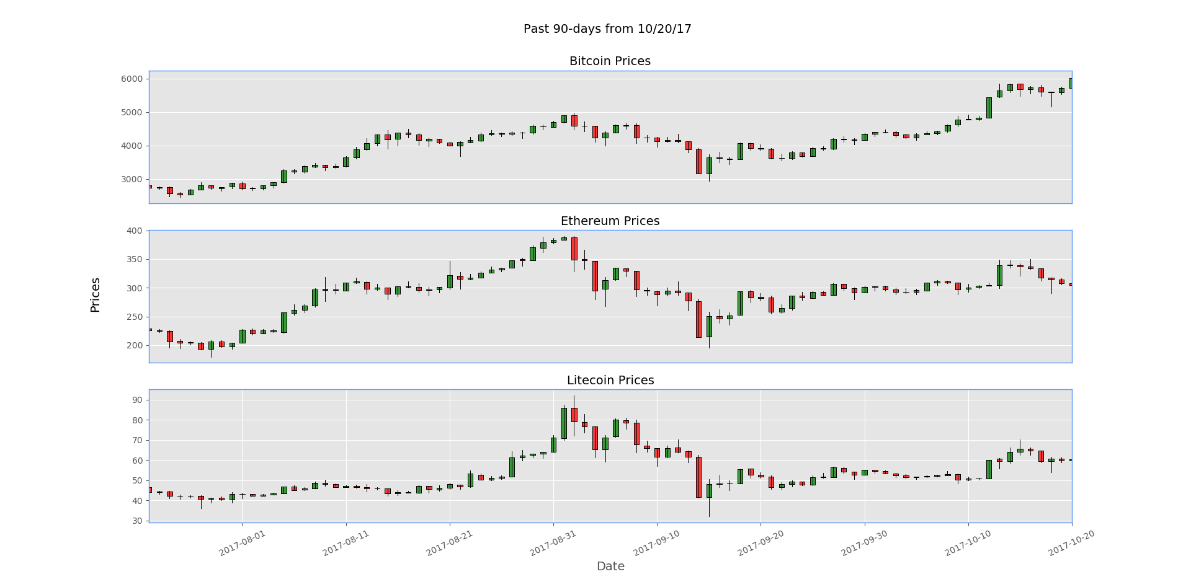

1. Bitcoin Relative strength index with the 12-day and 26 day moving averages on top of a candlestick graph for comparison. **Corresponding file: rsi.py**

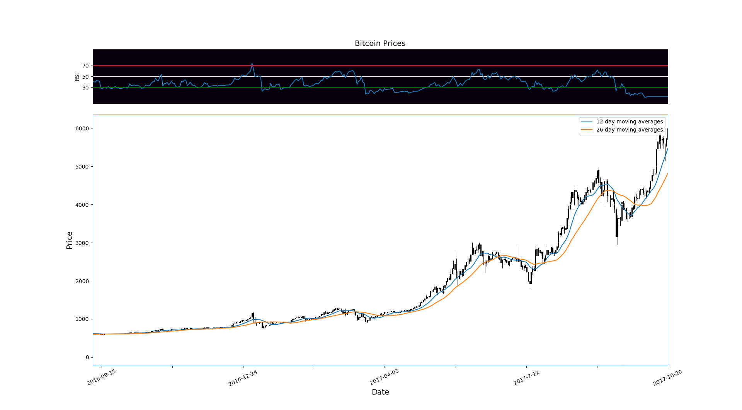

1. Correlation Matrix comparing the correlation coefficients of close prices for Bitcoin, Ethereum, Litecoin, Ripple and Dash. **Corresponding File: corr_matrix.py**

