Installation
While the clock can be hung from a single screw or nail directly, it is recommended to use the included bracket, screws, and wall plugs, as the clock is rather heavy. The wall plugs are suitable for walls made of concrete or solid drywall, using a 5mm drill bit. For wooden walls, the screws can be used directly, using a (roughly) 3mm drill bit. For plasterboard walls, you will need special plugs and screws. The holes must be placed horizontally level, 75mm apart. Small deviations can be corrected when the bracket is installed by means of the slotted holes in the bracket. Placement of the clock on the bracket should be self-explanatory.
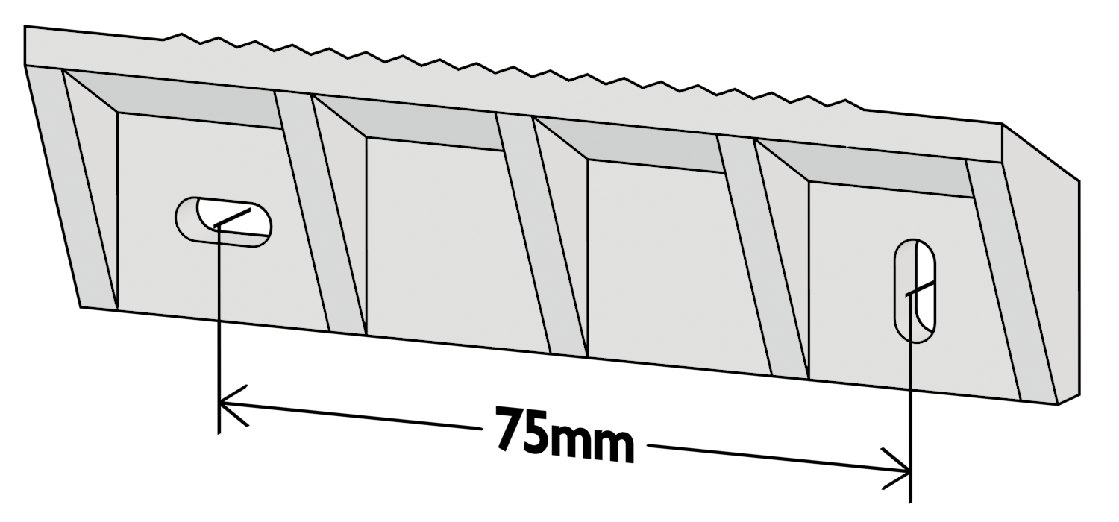

GPS antenna
The clock can use GPS for time synchronization and improved synchroscope accuracy, but needs an external antenna to do so. The antenna connects to the SMA connector at the bottom of the clock. Once connected, you must configure your timezone via the location code option in the menu to enable automatic synchronization.

Power cord
The included ~3m earthed power cord can be replaced if need be, as it is internally attached via screw terminals. Refer to the disassembly procedure for more information. Note that earthing is necessary for safety due to the exposed metal of the antenna connector.

Usage

Setting the time
When the clock is first powered on, and automatic time synchronization is disabled, the clock will start counting from midnight. The display will blink to indicate that the time has not been set yet.
To manually configure the time, use the following procedure.
- If you want to synchronize the seconds counter, press and release the “reset” button when you want the counter to read zero.
- Set both slide switches to the middle position.
- Push the slide switch for the minutes counter to the clockwise position to increment the minutes counter. If auto-increment is enabled in the settings, the minutes counter will increment when you first push the slide switch to this position, and will proceed to increment automatically if you continue to hold it there for more than one second. If auto-increment is disabled, the counter will only increment when you release the switch. When the counter reaches 59, it will roll over back to 0 when incremented, without incrementing the hours counter. Rollover of the second counter will not increment the minutes counter.
- Follow the same procedure for the hours counter.
- Once the time has been configured, push both slide switches to the counter-clockwise position. Note that failing to do so will prevent the hours counter from incrementing when the minutes counter rolls over, and prevent the minutes counter from incrementing when the seconds counter rolls over.
The display will stop blinking when the minutes or hours counter is first manually incremented. It will start blinking again when the “reset” button is pressed at any time.

Reading the date
It is possible to read the current date when the clock has had a GPS fix at any time since it was powered on. You can do so by briefly pressing the “mode” button. The date will be shown in YYMMDD format. The status LED will light up green to indicate that the date is being shown, rather than the current time. Press the “mode” button again to return to normal operation. The clock will also do this automatically after some time passes.

Distraction-free mode
If at any point you find all the blinking lights annoying, you can easily turn all single LEDs and the seconds portion of the main display off by pressing the “down” button. Only the hours and minutes fields, the colon between them, and the status LED (if applicable) remain lit. You can leave distraction-free mode by pressing the “up” button.

Customization
The behavior and aesthetics of the clock can be customized in various ways. This is done via a menu system. You can enter the menu by holding the “mode” button down for one second. The status LED will light up dark blue to indicate that the menu is open, the display will show an abbreviation for the current option on the left-hand side, its current value on the right-hand side, and the synchroscope will either be off or be used to show a status value related to the currently selected option.
While the menu is open, the buttons have the following behavior.
- Pressing the “up” button advances to the next option.
- Pressing the “down” button returns to the previous option.
- Pressing both “up” and “down” simultaneously, holding the “mode” button down for one second, or not pressing any button for some amount of time exits the menu.
- Depending on the selected option, briefly pressing the “mode” button either increments the option value directly, or enters value adjustment mode. In value adjustment mode, the status LED turns light blue, the value will blink, and the “up” and “down” buttons are used to set the value rather than to cycle through the available options. Press “mode” again to confirm the new value.
The following options are available.
- Flipflop LED brightness (“Fb”). A value from 0 to 100 to control the brightness of the 27 flipflop LEDs in the outside ring of the clock.
- Gate LED brightness (“Gb”). A value from 0 to 100 to control the brightness of the LEDs corresponding to the NAND gates.
- Synchroscope brightness (“Sb”). A value from 0 to 100 to control the brightness of the synchroscope display.
- Main display brightness (“db”). A value from 0 to 100 to control the brightness of the main 7-segment displays. While the value is configured, the display will read “888888” to allow the clock to detect worst-case power consumption of the main display.
- Main display color saturation (“dS”). A value from 0 to 100 to control the color saturation of the main 7-segment displays. 0 means grayscale, 100 means fully saturated.
- Main display color hue (“dH”). A value from 0 to 359 to control the color of the display. 0 is red, 60 is yellow, 120 is green, 180 is light blue, 240 is dark blue, 300 is magenta.
- Light-dependent resistor (“Ldr”). Selects whether the LDR should be used to automatically adjust the brightness of the main display based on ambient lighting conditions (“1”) or not (“0”).
- Seconds display enable (“Sd”). Selects whether the seconds should be shown (“1”) or not (“0”) when not in distraction-free mode.
- Synchronization/synchroscope mode (“Syn”). Selects the behavior of the synchroscope, and controls whether the clock uses the utility frequency or its own crystal oscillator as its timing source. The following options are available:
  - “1”: the clock is timed by the utility frequency, and the synchroscope display acts as a mechanical synchroscope to show how this frequency deviates from the GPS-referenced timing source. When the clock is running slow, the synchroscope “needle” rotates counter-clockwise; when it runs fast, it will rotate clockwise. A full 360-degree rotation of the needle represents a full cycle’s worth of phase shift, representing a 20ms offset for 50Hz, or a 16⅔ms offset for 60Hz. Note that the synchroscope “rolls over” every 84 degrees due to it not being a full circle in size.
  - “LL”: the clock is timed by the utility frequency, and the synchroscope display shows how much the seconds counter of the clock is currently offset compared to GPS time. If the middle two LEDs are both on, the seconds counter is perfectly in sync (but note that the minutes and hours might not be). If the “needle” moves clockwise, the clock is running fast; if it moves counter-clockwise it is running slow. If the outer two LEDs are both on, the seconds counter is exactly ±30s offset.
  - NOTE: this mode is only supported when seconds are displayed on the clock, the display is sufficiently bright, and GPS time is available.
  - “0”: the clock is timed by the utility frequency, but the synchroscope is turned off.
  - “50”: the clock is timed via a 50Hz signal derived from the internal crystal oscillator, which has significantly better short-term accuracy than the utility frequency. Accuracy should then be similar to a normal present-day digital or analog clock. The utility frequency is not used for anything, and the synchroscope is disabled.
  - “60”: as above, but generating a 60Hz signal.
- Auto-increment enable (“Ainc”). When enabled (“1”), the microcontroller embedded in the clock will make manually configuring the time a bit more user-friendly. When disabled (“0”), there is no “cheating:” the microcontroller won’t involve itself in the manual configuration process, leaving everything to the discrete-NAND-based circuit.
- Location code/timezone (“LC”). Set to the code corresponding to your timezone to enable automatic time synchronization via GPS. Set to “0” to disable automatic time synchronization. When enabled, the status LED will light up red during normal operation if no GPS fix is available.
- Daylight saving time mode (“dSt”). Only available when a location code is configured. Set to “A” to enable automatic resynchronization when DST changes. Set to “1” or “0” to manually configure DST.
- The synchroscope display will show additional information when the following options are selected.
- For “Fb” through “dH” (all LED brightness and color options), the synchroscope shows the current power consumption of the clock. Full scale is about 2.5A (at 5V). At 3A or more, the clock will automatically reduce brightness. At 3.5A or more, hardwired protection circuitry will disable the clock entirely until it is power-cycled to prevent damage. The embedded power supply is rated for 4A.
- For “Ldr,” the synchroscope shows the current (filtered) brightness level as detected by the LDR.
- For “LC,” the synchroscope shows a poor-man’s GPS signal strength indication, which may aid in finding a suitable place for the GPS antenna.

Configuration storage and resetting to defaults
The clock will save its configuration to non-volatile memory when you exit the menu (or when the clock does this automatically due to inactivity). This means that your settings will survive a power cycle. You can restore the clock to its “factory” settings by holding down the “mode” button while it is powering up.

Firmware update
It is possible to update the clock’s firmware using a computer that runs Linux and a micro-B USB cable. However, you will have to remove the support board to access the USB connector. Once removed, plug the bare support board into a wall outlet to power it up (this won’t damage the board, and as long as the high-voltage covers are installed, no live metal will be exposed) and plug the USB connector of the Teensy LC into your computer, then follow the firmware upload instructions on the GitHub repository.

Disassembly and reassembly
This section describes how the clock may be disassembled for as far as this is useful. The reassembly procedure is in the reverse order. For the initial assembly procedure, refer to the GitHub repository.
- Place the clock face down on a soft, flat surface, such as a piece of bubble wrap or a bed.
- Remove the four indicated screws, then lift off the cover. It may resist slightly due to the antenna connector and LDR insert at the bottom of the clock.
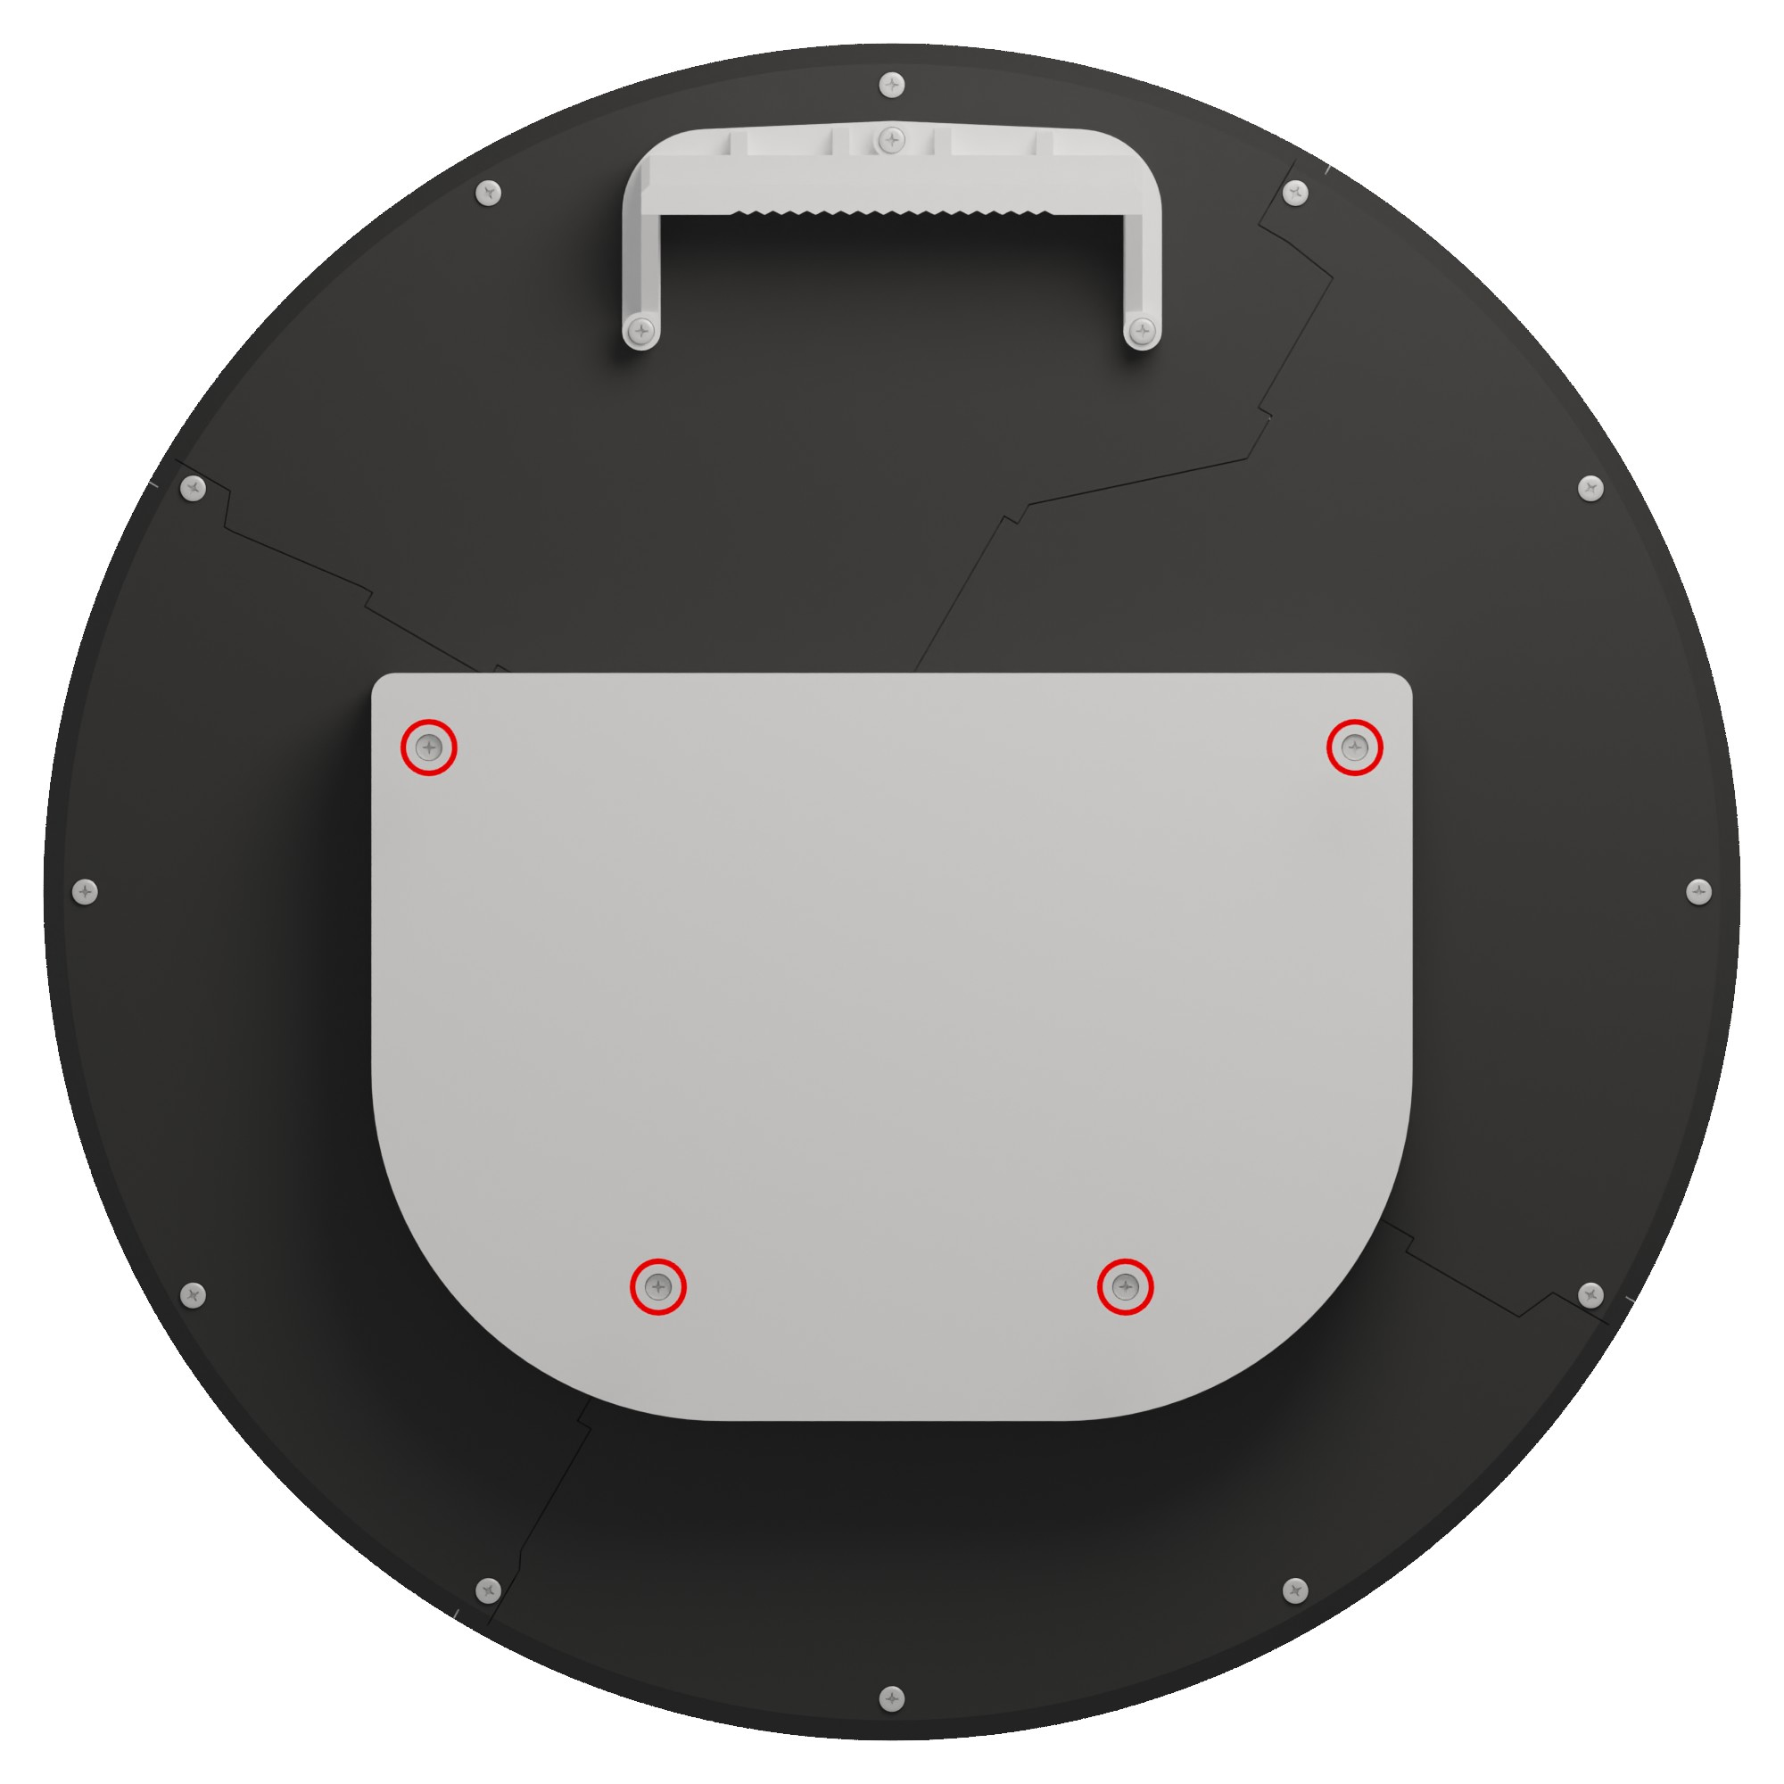
- Remove the uncovered support circuit board. It is no longer attached via screws; the four screws you just removed keep both it and the cover in place. However, there are five board-to-board connectors that connect the support board to the mainboard. These can be very stiff. You can use your fingers as levers between the white plastic part that the support board rests on and the circuit board to carefully pull the board out. Note that it is normal to see the circuit board bend slightly while you’re doing this. Alternate between the five connectors to prevent excessive torsion on the connectors when one of the connectors eventually does come loose. The board will probably jump up once all connectors are sufficiently loose.
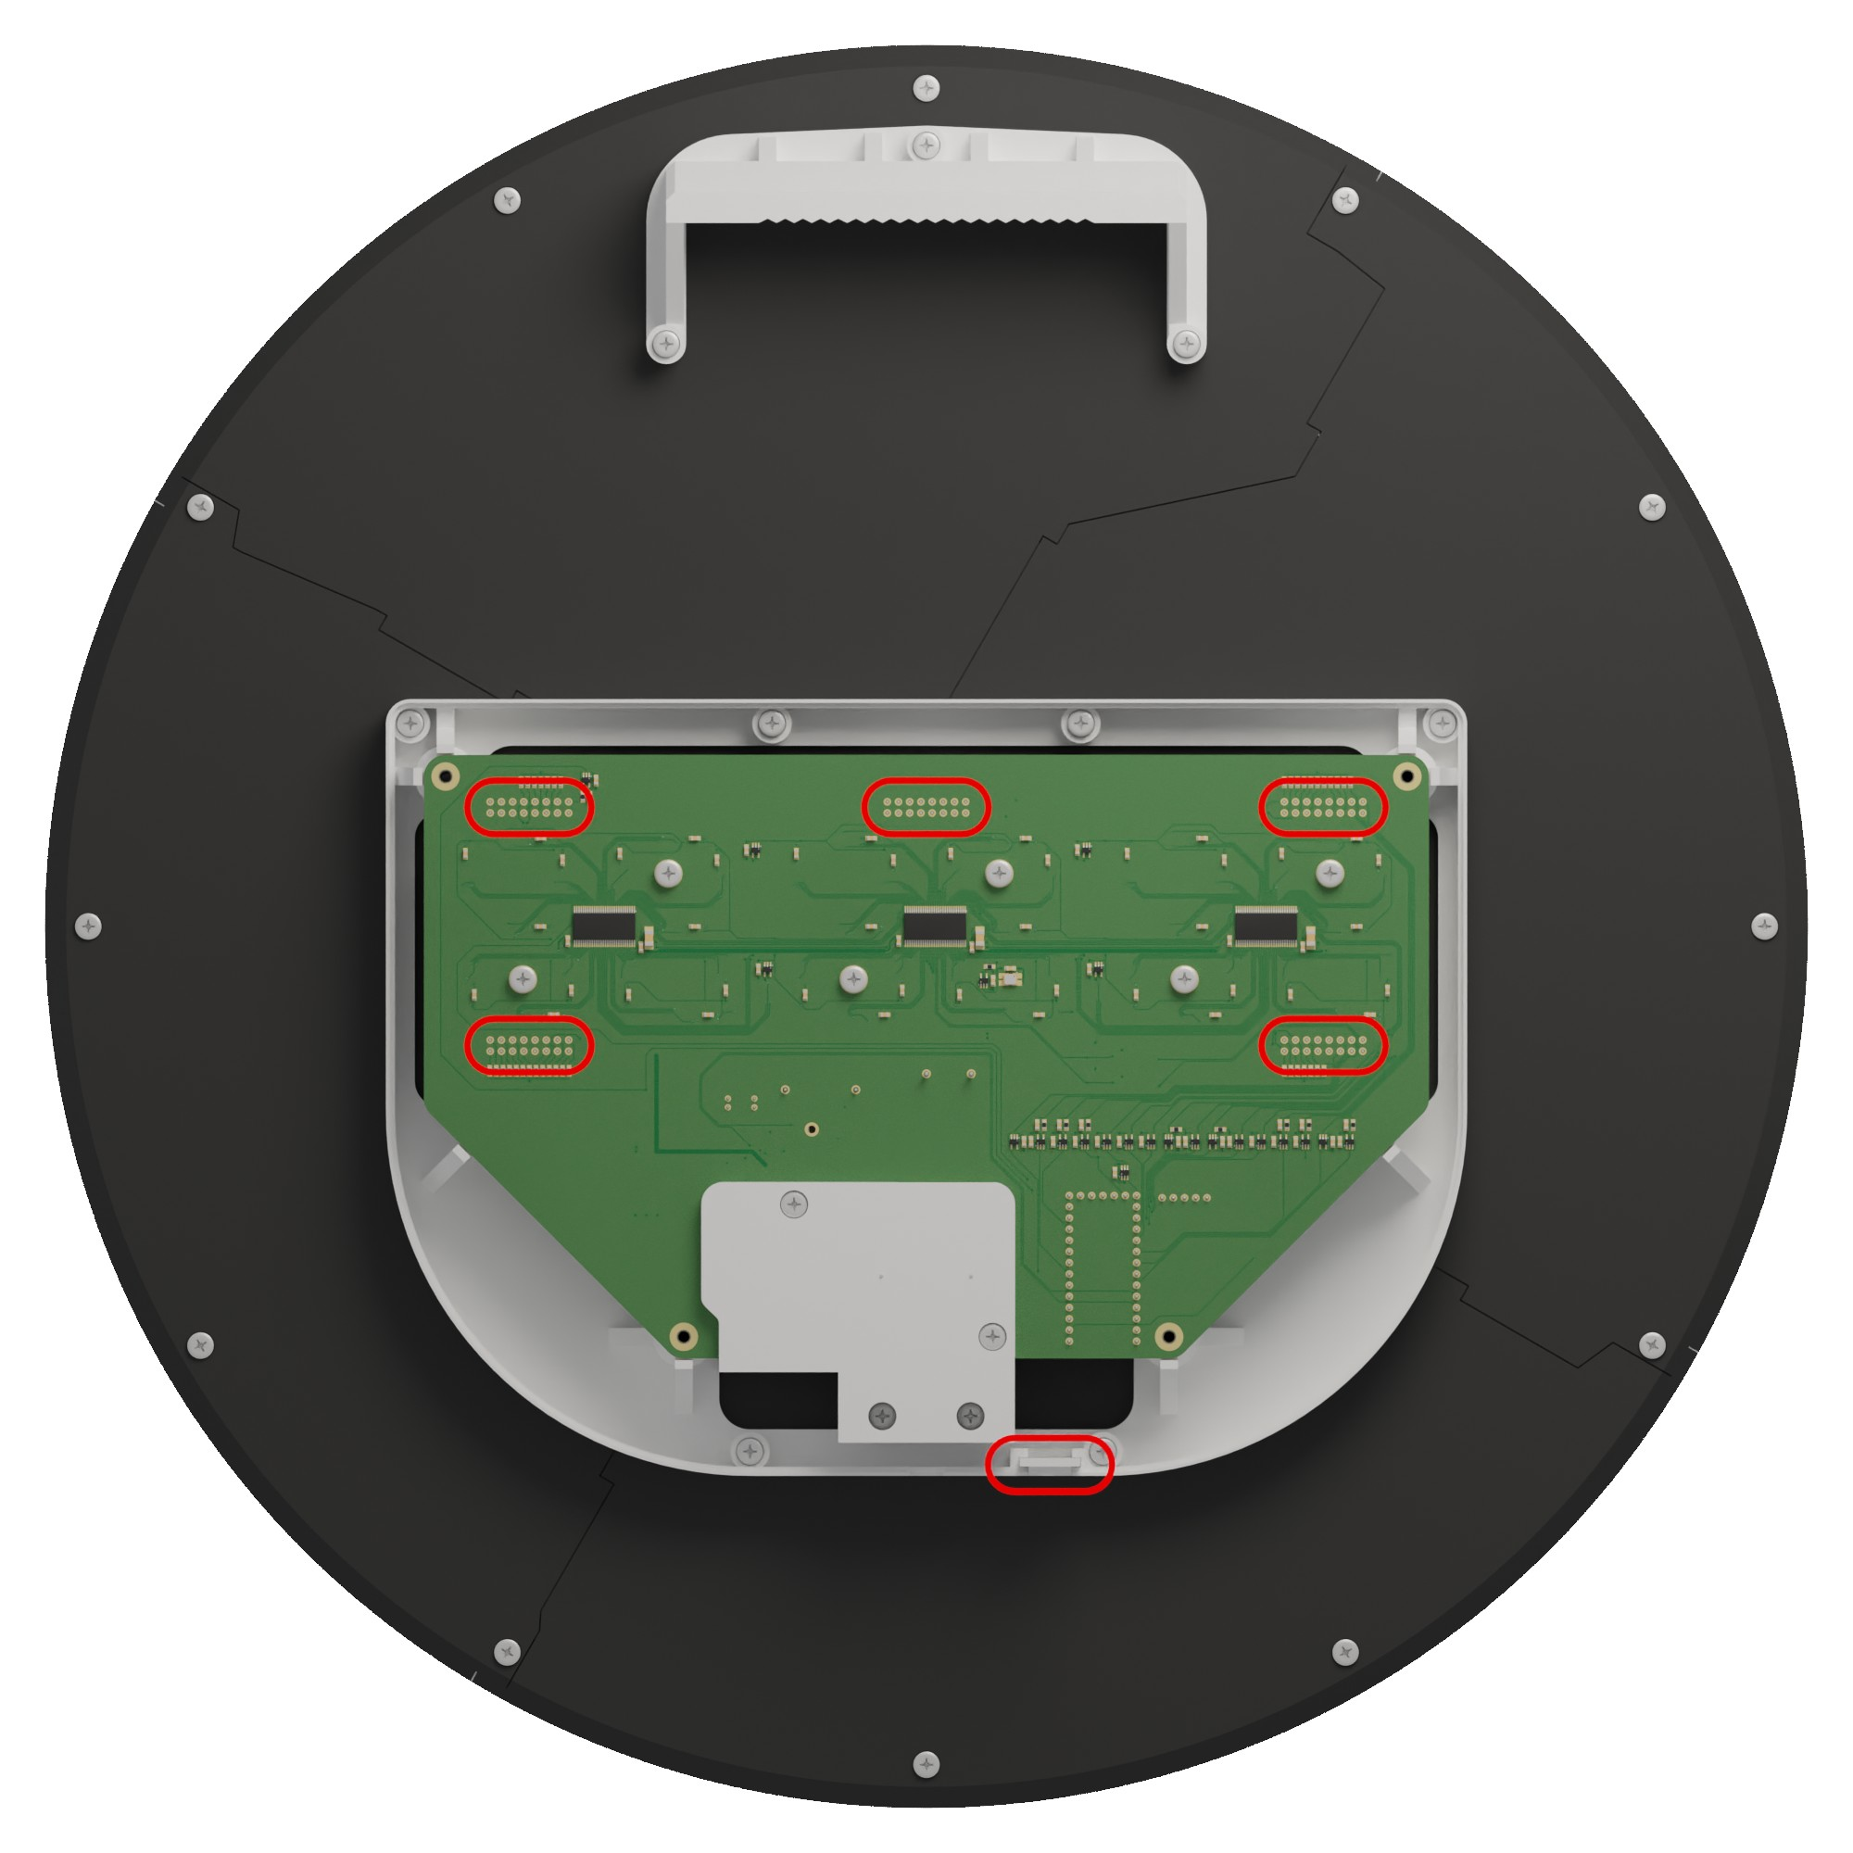
- At this point, you can lift the support board out. Note however that it will still be connected via wires to a small insert piece, also indicated above. You can simply pull this out. Be careful not to bend the pins when you set the board down!
- When reassembling, make sure that all the connectors are properly aligned to their sockets in the mainboard before pressing down. Make sure that they are all fully seated by pressing down on top of each of the five connectors before replacing the cover.
- If you want to replace the mains fuse or connect a different power cord, remove the strain relief and high-voltage cover by removing the following screws. Start with the screws marked with 1, then remove the strain relief. Then remove the screws marked with 2 to remove both the top and bottom high-voltage cover. When replacing the power cord, be careful not to over-fasten the screws in the screw terminals; you may strip the thread if you do that! The fuse should be replaced with a T1A (slow-blow 1A) fuse at most, or a fuse with a lower rating if you feel confident enough (you might have to replace it again at some point, then).
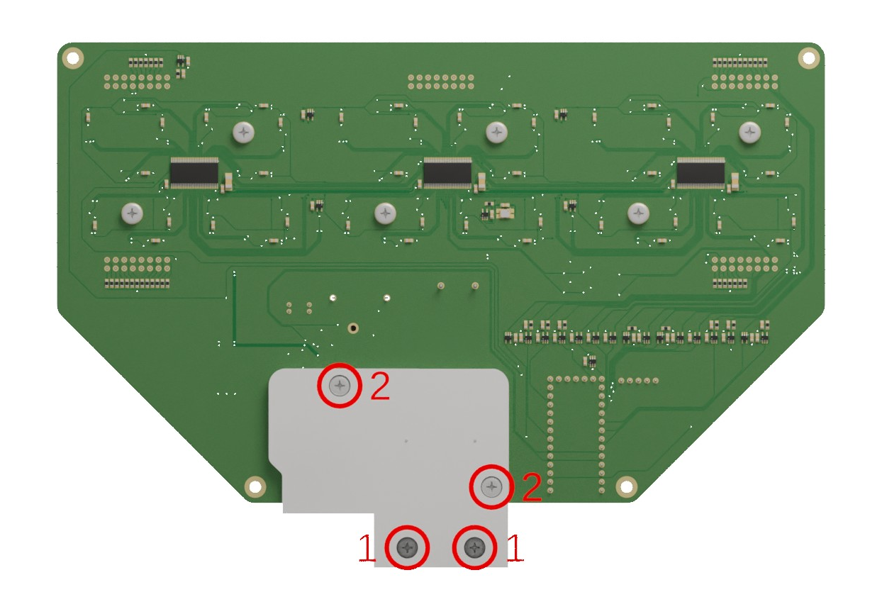
- If you want to remove the mainboard, for example to clean it or make repairs, continue by removing the 8 indicated screws that hold the white plastic piece in place, then remove this piece. You may also remove the wall mount bracket with the 3 remaining indicated screws, but you don’t have to.
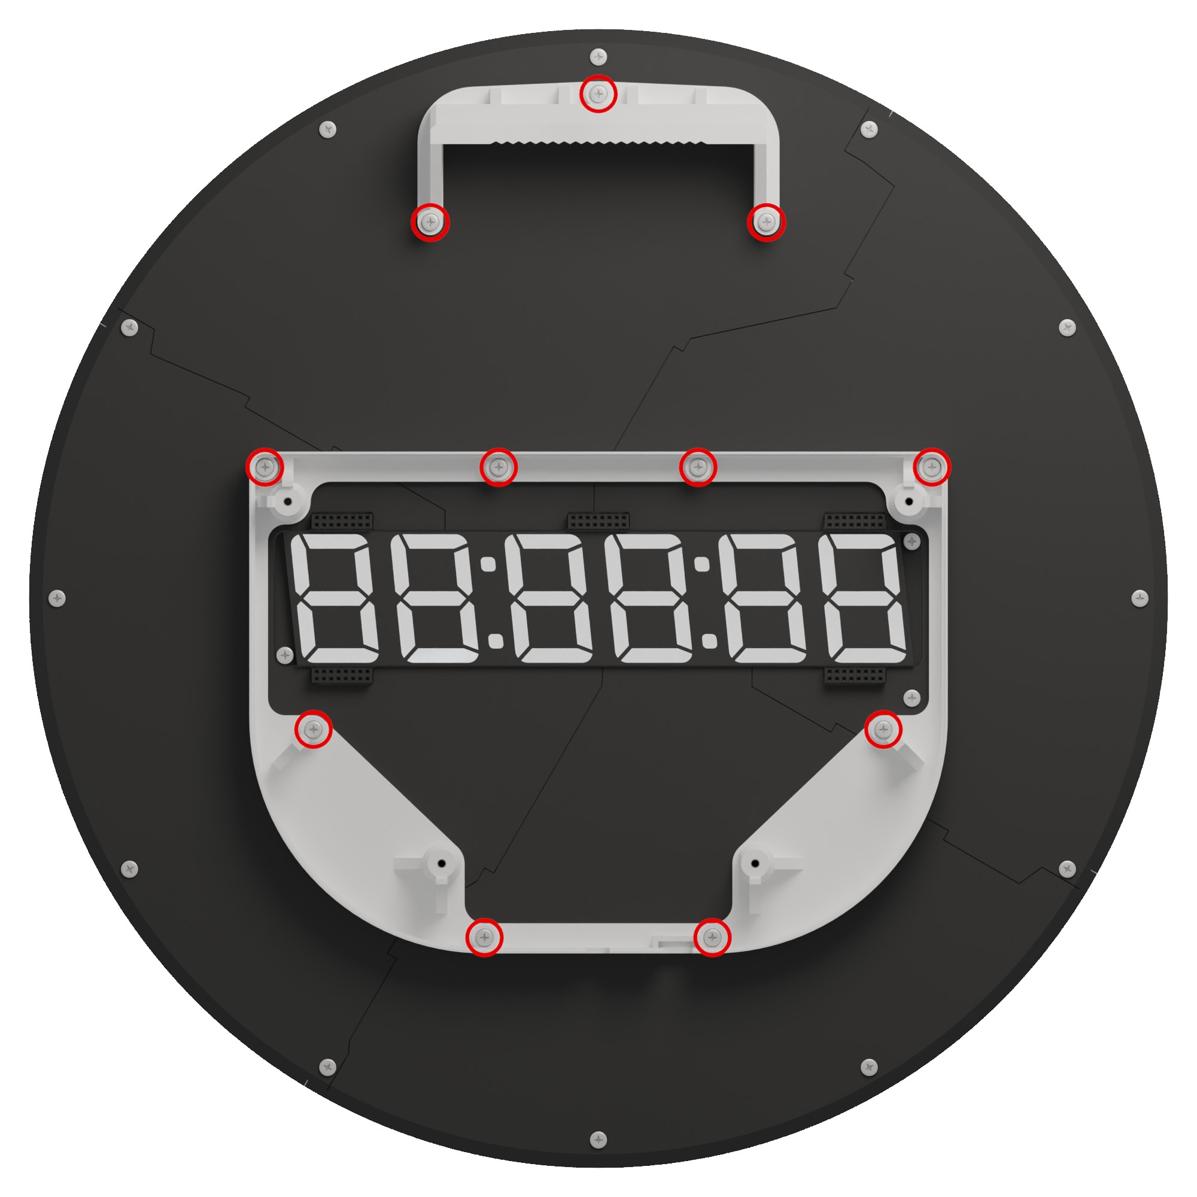
- Remove the 14 indicated screws that keep the transparent acrylic, highlight acrylic, mainboard, and plastic cover sandwiched together. The two screws in the center don’t have to be removed. Once done, the complete sandwich comes apart.
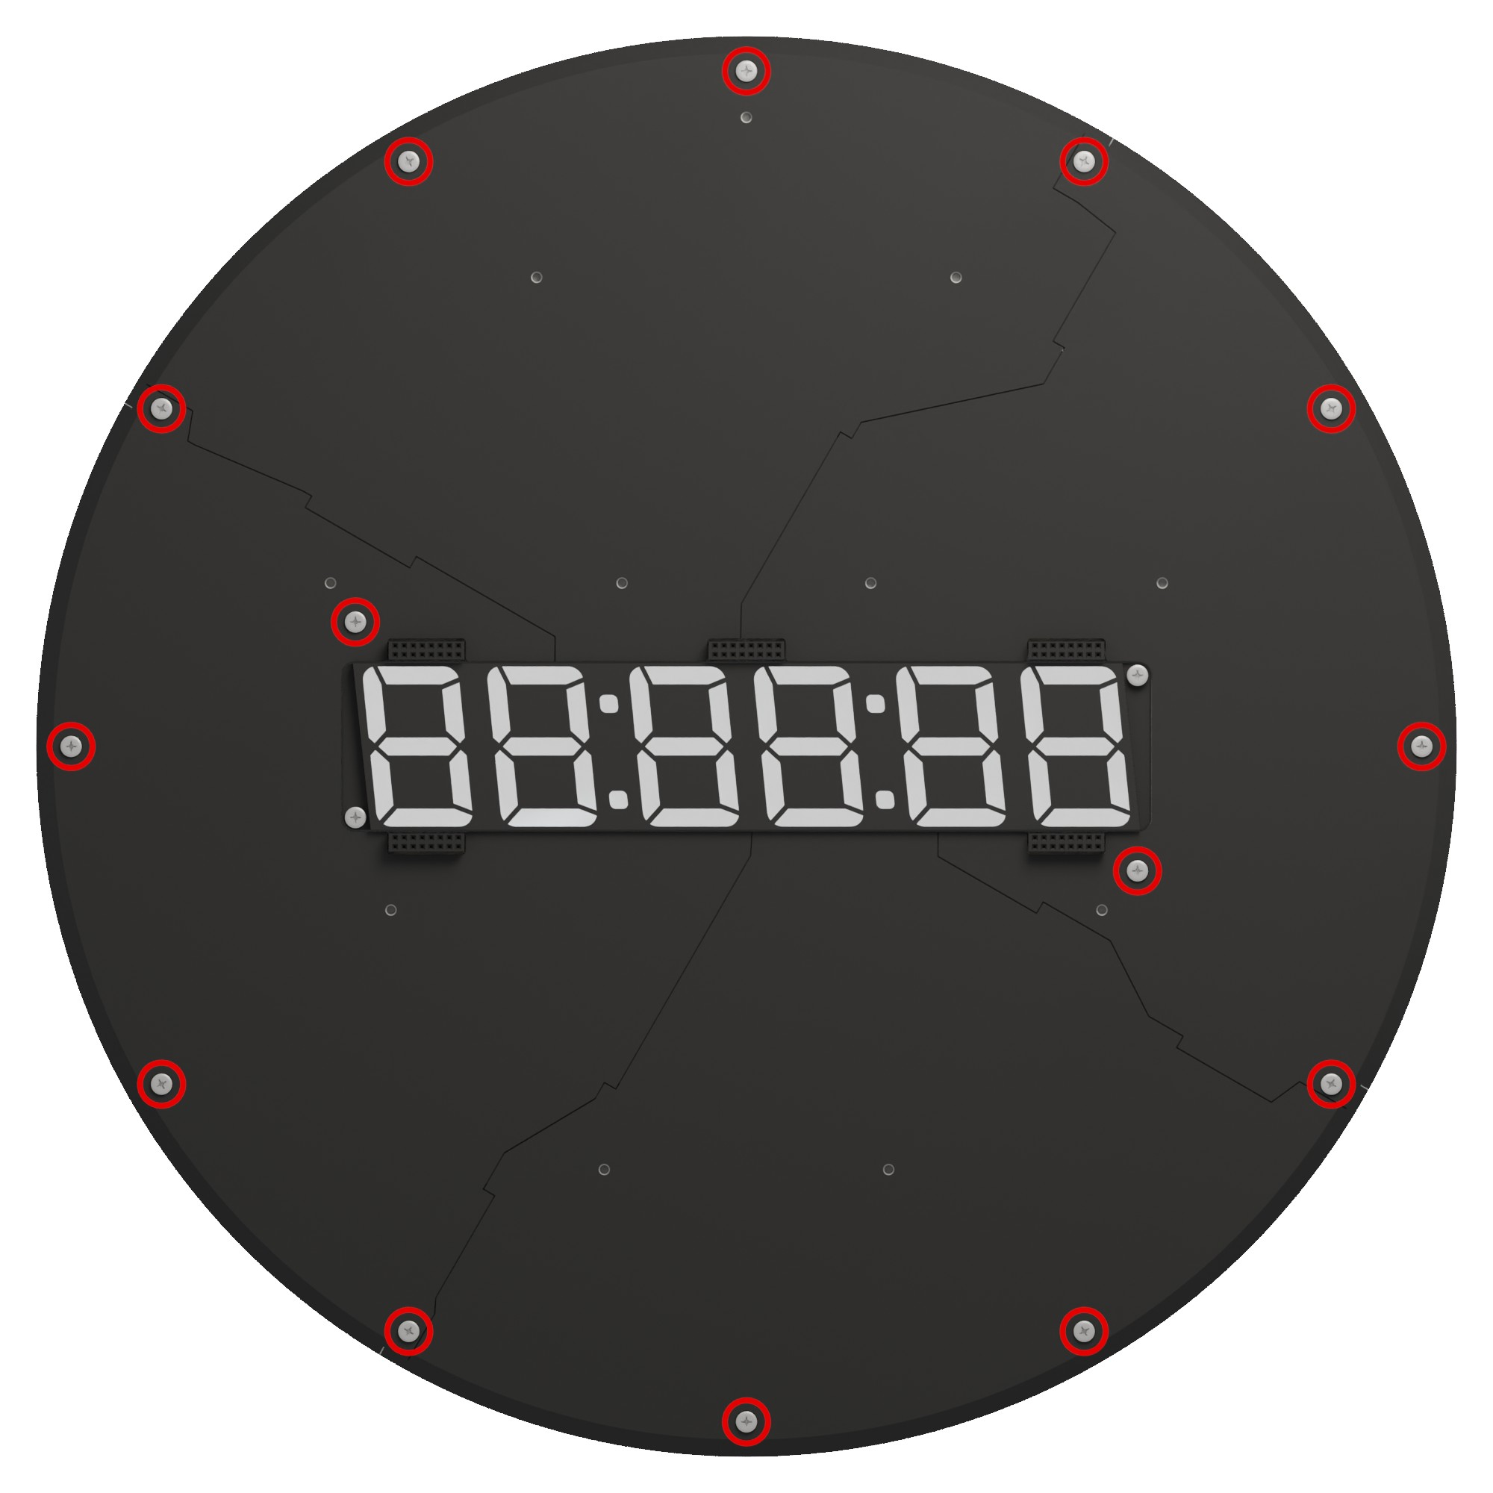
- To reassemble, make sure to replace and properly align the buttons and slide switches as indicated below, then carefully replace the mainboard. Start by aligning the minutes slide switch (at the bottom), then align the seconds slide switch (to the right, viewed from the back), and only then align the buttons. They usually snap right into place, but you may need a small screwdriver to align them manually.
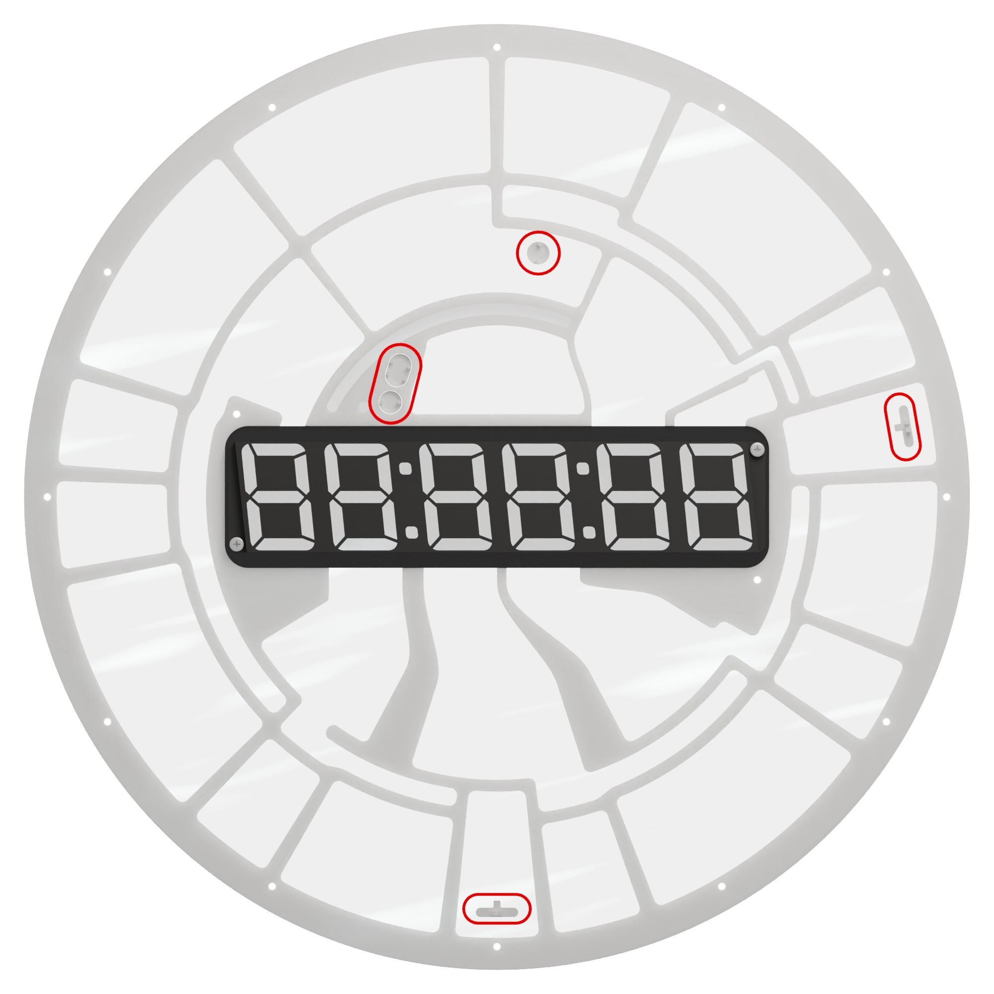

Quick start guide

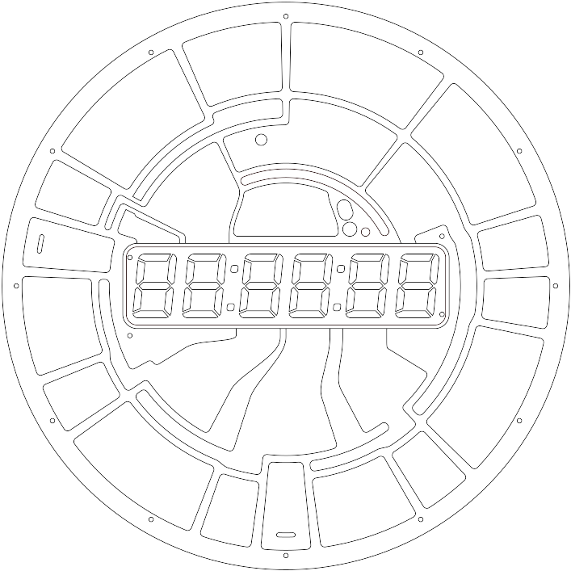

For more information, visit



https://github.com/jvanstraten/gated-clock/

Location Codes
To enable GPS synchronization and automatic daylight saving time adjustment, you need to configure a timezone code using the “LC” option in the menu. The following table lists the codes corresponding to major cities.
Afghanistan/Kabul: 40
Albania/Tirane: 7
Algeria/Algiers: 1
American Samoa/Pago Pago: 67
Andorra/Andorra: 7
Angola/Luanda: 1
Anguilla/Anguilla: 8
Antarctica/Casey: 32
Antarctica/Davis: 33
Antarctica/DumontDUrville: 34
Antarctica/Mawson: 35
Antarctica/McMurdo: 36
Antarctica/Palmer: 21
Antarctica/Rothera: 9
Antarctica/Syowa: 4
Antarctica/Troll: 37
Antarctica/Vostok: 38
Antigua and Barbuda/Antigua: 8
Argentina/Buenos Aires: 9
Argentina/Catamarca: 9
Argentina/Cordoba: 9
Argentina/Jujuy: 9
Argentina/La Rioja: 9
Argentina/Mendoza: 9
Argentina/Rio Gallegos: 9
Argentina/Salta: 9
Argentina/San Juan: 9
Argentina/San Luis: 9
Argentina/Tucuman: 9
Argentina/Ushuaia: 9
Armenia/Yerevan: 41
Aruba/Aruba: 8
Australia/Adelaide: 60
Australia/Brisbane: 34
Australia/Broken Hill: 60
Australia/Darwin: 61
Australia/Eucla: 62
Australia/Hobart: 39
Australia/Lindeman: 34
Australia/Lord Howe: 63
Australia/Macquarie: 39
Australia/Melbourne: 39
Australia/Perth: 42
Australia/Sydney: 39
Austria/Vienna: 7
Azerbaijan/Baku: 41
Åland Islands/Mariehamn: 43
Bahamas/Nassau: 10
Bahrain/Bahrain: 4
Bangladesh/Dhaka: 38
Barbados/Barbados: 8
Belarus/Minsk: 4
Belgium/Brussels: 7
Belize/Belize: 11
Benin/Porto-Novo: 1
Bermuda/Bermuda: 17
Bhutan/Thimphu: 38
Bolivia/La Paz: 8
Bonaire, Sint Eustatius and Saba/Kralendijk: 8
Bosnia and Herzegovina/Sarajevo: 7
Botswana/Gaborone: 2
Brazil/Araguaina: 9
Brazil/Bahia: 9
Brazil/Belem: 9
Brazil/Boa Vista: 8
Brazil/Campo Grande: 8
Brazil/Cuiaba: 8
Brazil/Eirunepe: 12
Brazil/Fortaleza: 9
Brazil/Maceio: 9
Brazil/Manaus: 8
Brazil/Noronha: 13
Brazil/Porto Velho: 8
Brazil/Recife: 9
Brazil/Rio Branco: 12
Brazil/Santarem: 9
Brazil/Sao Paulo: 9
British Indian Ocean Territory/Chagos: 38
Brunei Darussalam/Brunei: 42
Bulgaria/Sofia: 43
Burkina Faso/Ouagadougou: 3
Burundi/Bujumbura: 2
Cabo Verde/Cape Verde: 58
Cambodia/Phnom Penh: 33
Cameroon/Douala: 1
Canada/Atikokan: 12
Canada/Blanc-Sablon: 8
Canada/Cambridge Bay: 14
Canada/Creston: 15
Canada/Dawson: 16
Canada/Dawson Creek: 15
Canada/Edmonton: 14
Canada/Fort Nelson: 15
Canada/Glace Bay: 17
Canada/Goose Bay: 17
Canada/Halifax: 17
Canada/Inuvik: 14
Canada/Iqaluit: 10
Canada/Moncton: 17
Canada/Nipigon: 10
Canada/Pangnirtung: 10
Canada/Rainy River: 18
Canada/Rankin Inlet: 18
Canada/Regina: 11
Canada/Resolute: 18
Canada/St Johns: 19
Canada/Swift Current: 11
Canada/Thunder Bay: 10
Canada/Toronto: 10
Canada/Vancouver: 20
Canada/Whitehorse: 16
Canada/Winnipeg: 18
Canada/Yellowknife: 14
Cayman Islands/Cayman: 12
Central African Republic/Bangui: 1
Chad/Ndjamena: 1
Chile/Easter: 68
Chile/Punta Arenas: 21
Chile/Santiago: 22
China/Shanghai: 42
China/Urumqi: 38
Christmas Island/Christmas: 33
Cocos (Keeling) Islands/Cocos: 52
Colombia/Bogota: 12
Comoros/Comoro: 4
Congo/Brazzaville: 1
Congo/Kinshasa: 1
Congo/Lubumbashi: 2
Cook Islands/Rarotonga: 69
Costa Rica/Costa Rica: 11
Croatia/Zagreb: 7
Cuba/Havana: 23
Curaçao/Curacao: 8
Cyprus/Famagusta: 43
Cyprus/Nicosia: 43
Czechia/Prague: 7
Côte d'Ivoire/Abidjan: 3
Denmark/Copenhagen: 7
Djibouti/Djibouti: 4
Dominica/Dominica: 8
Dominican Republic/Santo Domingo: 8
Ecuador/Galapagos: 11
Ecuador/Guayaquil: 12
Egypt/Cairo: 2
El Salvador/El Salvador: 11
Equatorial Guinea/Malabo: 1
Eritrea/Asmara: 4
Estonia/Tallinn: 43
Eswatini/Mbabane: 2
Ethiopia/Addis Ababa: 4
Falkland Islands/Stanley: 9
Faroe Islands/Faroe: 59
Fiji/Fiji: 70
Finland/Helsinki: 43
France/Paris: 7
French Guiana/Cayenne: 9
French Polynesia/Gambier: 71
French Polynesia/Marquesas: 72
French Polynesia/Tahiti: 69
French Southern Territories/Kerguelen: 35
Gabon/Libreville: 1
Gambia/Banjul: 3
Georgia/Tbilisi: 41
Germany/Berlin: 7
Germany/Busingen: 7
Ghana/Accra: 3
Gibraltar/Gibraltar: 7
Greece/Athens: 43
Greenland/Danmarkshavn: 3
Greenland/Nuuk: 24
Greenland/Scoresbysund: 25
Greenland/Thule: 17
Grenada/Grenada: 8
Guadeloupe/Guadeloupe: 8
Guam/Guam: 34
Guatemala/Guatemala: 11
Guernsey/Guernsey: 59
Guinea-Bissau/Bissau: 3
Guinea/Conakry: 3
Guyana/Guyana: 8
Haiti/Port-au-Prince: 10
Holy See/Vatican: 7
Honduras/Tegucigalpa: 11
Hong Kong/Hong Kong: 42
Hungary/Budapest: 7
Iceland/Reykjavik: 3
India/Kolkata: 44
Indonesia/Jakarta: 33
Indonesia/Jayapura: 45
Indonesia/Makassar: 42
Indonesia/Pontianak: 33
Iran/Tehran: 46
Iraq/Baghdad: 4
Ireland/Dublin: 64
Isle of Man/Isle of Man: 59
Israel/Jerusalem: 47
Italy/Rome: 7
Jamaica/Jamaica: 12
Japan/Tokyo: 45
Jersey/Jersey: 59
Jordan/Amman: 48
Kazakhstan/Almaty: 38
Kazakhstan/Aqtau: 49
Kazakhstan/Aqtobe: 35
Kazakhstan/Atyrau: 49
Kazakhstan/Oral: 49
Kazakhstan/Qostanay: 50
Kazakhstan/Qyzylorda: 35
Kenya/Nairobi: 4
Kiribati/Enderbury: 73
Kiribati/Kiritimati: 74
Kiribati/Tarawa: 55
Kuwait/Kuwait: 4
Kyrgyzstan/Bishkek: 50
Laos/Vientiane: 33
Latvia/Riga: 43
Lebanon/Beirut: 51
Lesotho/Maseru: 2
Liberia/Monrovia: 3
Libya/Tripoli: 2
Liechtenstein/Vaduz: 7
Lithuania/Vilnius: 43
Luxembourg/Luxembourg: 7
Macao/Macau: 42
Madagascar/Antananarivo: 4
Malawi/Blantyre: 2
Malaysia/Kuala Lumpur: 42
Malaysia/Kuching: 42
Maldives/Maldives: 35
Mali/Bamako: 3
Malta/Malta: 7
Marshall Islands/Kwajalein: 55
Marshall Islands/Majuro: 55
Martinique/Martinique: 8
Mauritania/Nouakchott: 3
Mauritius/Mauritius: 41
Mayotte/Mayotte: 4
Mexico/Bahia Banderas: 26
Mexico/Cancun: 12
Mexico/Chihuahua: 27
Mexico/Hermosillo: 15
Mexico/Matamoros: 18
Mexico/Mazatlan: 27
Mexico/Merida: 26
Mexico/Mexico City: 26
Mexico/Monterrey: 26
Mexico/Ojinaga: 14
Mexico/Tijuana: 20
Micronesia/Chuuk: 34
Micronesia/Kosrae: 56
Micronesia/Pohnpei: 56
Moldova/Chisinau: 65
Monaco/Monaco: 7
Mongolia/Choibalsan: 42
Mongolia/Hovd: 33
Mongolia/Ulaanbaatar: 42
Montenegro/Podgorica: 7
Montserrat/Montserrat: 8
Morocco/Casablanca: 5
Mozambique/Maputo: 2
Myanmar/Yangon: 52
Namibia/Windhoek: 2
Nauru/Nauru: 55
Nepal/Kathmandu: 53
Netherlands/Amsterdam: 7
New Caledonia/Noumea: 56
New Zealand/Auckland: 36
New Zealand/Chatham: 75
Nicaragua/Managua: 11
Niger/Niamey: 1
Nigeria/Lagos: 1
Niue/Niue: 67
Norfolk Island/Norfolk: 76
North Korea/Pyongyang: 45
North Macedonia/Skopje: 7
Northern Mariana Islands/Saipan: 34
Norway/Oslo: 7
Oman/Muscat: 41
Pakistan/Karachi: 35
Palau/Palau: 45
Palestine/Gaza: 54
Palestine/Hebron: 54
Panama/Panama: 12
Papua New Guinea/Bougainville: 56
Papua New Guinea/Port Moresby: 34
Paraguay/Asuncion: 28
Peru/Lima: 12
Philippines/Manila: 42
Pitcairn/Pitcairn: 77
Poland/Warsaw: 7
Portugal/Azores: 25
Portugal/Lisbon: 59
Portugal/Madeira: 59
Puerto Rico/Puerto Rico: 8
Qatar/Qatar: 4
Romania/Bucharest: 43
Russia/Anadyr: 55
Russia/Astrakhan: 41
Russia/Barnaul: 33
Russia/Chita: 45
Russia/Irkutsk: 42
Russia/Kaliningrad: 2
Russia/Kamchatka: 55
Russia/Khandyga: 45
Russia/Kirov: 4
Russia/Krasnoyarsk: 33
Russia/Magadan: 56
Russia/Moscow: 4
Russia/Novokuznetsk: 33
Russia/Novosibirsk: 33
Russia/Omsk: 38
Russia/Sakhalin: 56
Russia/Samara: 41
Russia/Saratov: 41
Russia/Srednekolymsk: 56
Russia/Tomsk: 33
Russia/Ulyanovsk: 41
Russia/Ust-Nera: 34
Russia/Vladivostok: 34
Russia/Volgograd: 66
Russia/Yakutsk: 45
Russia/Yekaterinburg: 35
Rwanda/Kigali: 2
Réunion/Reunion: 41
Saint Barthélemy/St Barthelemy: 8
Saint Helena, Ascension and Tristan da Cunha/St Helena: 3
Saint Kitts and Nevis/St Kitts: 8
Saint Lucia/St Lucia: 8
Saint Martin (French part)/Marigot: 8
Saint Pierre and Miquelon/Miquelon: 29
Saint Vincent and the Grenadines/St Vincent: 8
Samoa/Apia: 78
San Marino/San Marino: 7
Sao Tome and Principe/Sao Tome: 3
Saudi Arabia/Riyadh: 4
Senegal/Dakar: 3
Serbia/Belgrade: 7
Seychelles/Mahe: 41
Sierra Leone/Freetown: 3
Singapore/Singapore: 42
Sint Maarten (Dutch part)/Lower Princes: 8
Slovakia/Bratislava: 7
Slovenia/Ljubljana: 7
Solomon Islands/Guadalcanal: 56
Somalia/Mogadishu: 4
South Africa/Johannesburg: 2
South Georgia and the South Sandwich Islands/South Georgia: 13
South Korea/Seoul: 45
South Sudan/Juba: 6
Spain/Canary: 59
Spain/Ceuta: 7
Spain/Madrid: 7
Sri Lanka/Colombo: 44
Sudan/Khartoum: 2
Suriname/Paramaribo: 9
Svalbard and Jan Mayen/Longyearbyen: 7
Sweden/Stockholm: 7
Switzerland/Zurich: 7
Syria/Damascus: 57
Taiwan, Province of China/Taipei: 42
Tajikistan/Dushanbe: 35
Tanzania/Dar es Salaam: 4
Thailand/Bangkok: 33
Timor-Leste/Dili: 45
Togo/Lome: 3
Tokelau/Fakaofo: 73
Tonga/Tongatapu: 73
Trinidad and Tobago/Port of Spain: 8
Tunisia/Tunis: 1
Turkey/Istanbul: 4
Turkmenistan/Ashgabat: 35
Turks and Caicos Islands/Grand Turk: 10
Tuvalu/Funafuti: 55
USA/Adak: 30
USA/Anchorage: 31
USA/Boise: 14
USA/Chicago: 18
USA/Denver: 14
USA/Detroit: 10
USA/Honolulu: 69
USA/Indiana/Indianapolis: 10
USA/Indiana/Knox: 18
USA/Indiana/Marengo: 10
USA/Indiana/Petersburg: 10
USA/Indiana/Tell City: 18
USA/Indiana/Vevay: 10
USA/Indiana/Vincennes: 10
USA/Indiana/Winamac: 10
USA/Juneau: 31
USA/Kentucky/Louisville: 10
USA/Kentucky/Monticello: 10
USA/Los Angeles: 20
USA/Menominee: 18
USA/Metlakatla: 31
USA/Midway: 67
USA/New York: 10
USA/Nome: 31
USA/North Dakota/Beulah: 18
USA/North Dakota/Center: 18
USA/North Dakota/New Salem: 18
USA/Phoenix: 15
USA/Sitka: 31
USA/Wake: 55
USA/Yakutat: 31
Uganda/Kampala: 4
Ukraine/Kiev: 43
Ukraine/Simferopol: 4
Ukraine/Uzhgorod: 43
Ukraine/Zaporozhye: 43
United Arab Emirates/Dubai: 41
United Kingdom/London: 59
Uruguay/Montevideo: 9
Uzbekistan/Samarkand: 35
Uzbekistan/Tashkent: 35
Vanuatu/Efate: 56
Venezuela/Caracas: 8
Viet Nam/Ho Chi Minh: 33
Virgin Islands (British)/Tortola: 8
Virgin Islands (U.S.)/St Thomas: 8
Wallis and Futuna/Wallis: 55
Western Sahara/El Aaiun: 5
Yemen/Aden: 4
Zambia/Lusaka: 2
Zimbabwe/Harare: 2

