EGR 283 - Project 6

After the array, perhaps the most important data structure is the stack. A stack structure restricts dramatically how elements are inserted, retrieved, and removed: The most recently inserted element in the stack is the only one that can be retrieved or removed. (Thus, if you wish to retrieve an element inserted long ago, you must first remove all the elements that were inserted after the desired one.) This strategy of removal and retrieval is sometimes called, “last in, first out.”

A good real-life example of a stack is the pile of dinner plates that you encounter when you eat at the local cafeteria: When you remove a plate from the pile, you take the plate on the top of the pile. But this is exactly the plate that was added (“inserted”) most recently to the pile by the dishwasher. If you want the plate at the bottom of the pile, you must remove all the plates on top of it to reach it. Another, sadder, example of a stack is the slogan, “last hired, first fired,” which is typically utilized when a company reduces its work force.

Some other real-life examples are:
1. Recursion
2. To convert decimal number to binary
3. Waiter serving orders one after another
4. Truck loaded with wooden boxes
5. To convert infix expression to postfix
6. Truck/Container with only 1 access to the freight area

Many computer algorithms work best with stacks --- stacks are used for remembering partially completed tasks, and undoing (backtracking from) an action.

To keep it simple, think about how we might translate an infix arithmetic expression, like ((3 + 2) * 4) / (5 - 1), into a postfix format, 3 2 + 4 * 5 1 - /. This time, the stack holds operator symbols (rather than the operands); the postfix algorithm goes like this:

begin with an empty stack and an input string
while there is more input, do:
read the next input symbol;
if it's a numeral,
then print it to the output string;
if it's an operator,
then push it onto the stack;
if it's a '(',
then discard it;
if it's a ')', // marks the end of an expression!
then pop an operator from the stack and print it
end while;
You can see from the algorithm that the parentheses (especially the right one) play a critical role in directing stack pops and translation. This is not an accident --- stacks are used to translate so-called bracket languages, and both arithmetic and Java are examples of bracket languages.
A stack is the ideal data structure for evaluating an arithmetic expression written in postfix notation. Recall again that the postfix version of ((3 + 2) * 4) / (5 - 1) is 3 2 + 4 * 5 1 - /.
To evaluate an arithmetic expression written in postfix notation, the symbols of the input expression are read, one by one; numerals are inserted onto the “top” of the stack; and operators retrieve the top two numerals from the stack, perform the operation, and insert the result onto the stack.
This evaluation is simple and mechanical, and it is easy to write a computer algorithm that does the steps:
begin with an empty stack and an input string.
while there is more input to read, do:
read the next input symbol;
if it's a numeral,
then push it onto the stack;
if it's an operator
then pop two numerals from the stack;
perform the operation on the numerals;
push the result;
end while;

// the answer of the expression is waiting for you in the stack:
pop the answer;
Expand on the (1)DLLNode, (2)DLL code given to create a (3)Stack class implementing the Stack ADT, based on the UML diagram on page 153 from Chapter 7. Finally create an (4)ArithmeticEvaluator class. The ArithmeticEvaluator class consists of two parts (the format into postfix notation part (method which takes in a String and returns a String) and the evaluation part (method which takes in a String and returns an int)). Reminder, the stack will be a linked list comprised of DLLNodes, not an array, not a Vector, not an ArrayList and not a SLL. A (5)ArithmeticEvaluatorDriver class consists of a main method to test the two methods of the ArithmeticEvaluator class.
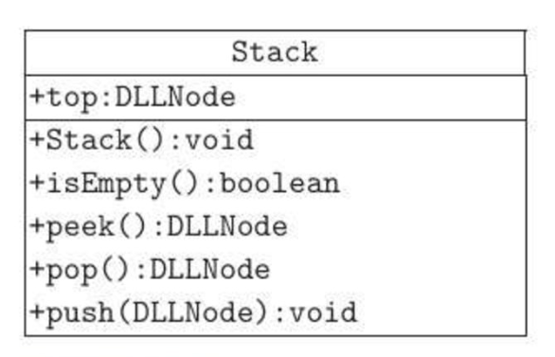
As always, don’t forget to include your name, the date, the project number and a description of the program as part of your javadoc comments at the top of your program file. Also be sure to use good variable names and appropriate javadoc comments throughout the code. Please send your .java file(s) to the dropbox. Also turn in a printed copy of your .java file(s).

