

Power Strip Analysis and Smart Modification Design

Ephraim

Vug/sen/21/….

SEN 383

Embedded system

Date
28-04-2025

1. Power Strip Components

Hardware Components:
- Housing/casing (typically plastic)
- Input power cable with plug (typically 2-3 prong)
- Multiple outlet sockets (typically 4-8)
- Internal metal conductors/bus bars
- Circuit breaker or fuse for overload protection
- ON/OFF switch (mechanical)
- Surge protection components (in surge protectors):
  - Metal Oxide Varistors (MOVs)
  - Thermal fuses
  - Gas Discharge Tubes (in some models)
- Ground fault circuit interrupter (in some models)
- Indicator lights (power/surge protection status)
- Mounting holes/brackets (in some models)

Software Components:
Standard power strips have no software components, as they are purely electrical/mechanical devices.

2. Use, Functions and Applications

Primary Functions:
A power strip serves several essential functions in modern electrical setups:
- Power Distribution: The fundamental purpose of a power strip is to expand a single wall outlet into multiple outlets, allowing several devices to be powered from one source. This is particularly valuable in older buildings with limited wall outlets.
- Centralized Power Control: The master ON/OFF switch allows users to simultaneously control power to all connected devices, enabling easy powering down of entire setups with a single switch.
- Surge Protection: Many power strips include surge protection components that safeguard connected equipment from voltage spikes, which can damage sensitive electronics. These components (typically Metal Oxide Varistors) absorb excess voltage during power surges.
- Overload Protection: Built-in circuit breakers or fuses prevent the power strip from delivering more current than it's rated for, protecting against fire hazards and circuit overloads.
- Cable Management: Power strips help organize power cables in cluttered spaces, reducing cable mess and potential trip hazards.

Applications:
Power strips are versatile tools used across numerous settings:
Home Use
- Entertainment Centers: Powering TVs, gaming consoles, sound systems, and streaming devices
- Home Offices: Supporting computers, printers, monitors, and other peripherals
- Kitchen Counters: Providing power for small appliances like blenders, toasters, and coffee makers
- Bedrooms: Charging phones, powering lamps, alarm clocks, and other bedside devices
- Workshops/Garages: Supplying power to tools and equipment in spaces with limited outlets
Commercial/Professional Settings
- Office Workspaces: Powering computers, monitors, desk lamps, and charging devices
- Conference Rooms: Supporting presentation equipment, laptops, and mobile device charging
- Retail Point-of-Sale: Powering cash registers, card readers, and related equipment
- Medical Facilities: Supporting non-critical equipment in clinical settings
- Educational Environments: Powering classroom technology and allowing students to charge devices
Specialized Applications
- Server Rooms: Providing organized power distribution with monitoring capabilities
- Audio/Visual Productions: Supporting equipment for stage performances and productions
- Trade Shows/Exhibitions: Delivering power to booth demonstrations and displays
- Construction Sites: Providing temporary power distribution for tools (using appropriate outdoor-rated models)
- Recording Studios: Powering audio equipment with clean, filtered power
Travel and Mobile Use
- Hotel Rooms: Expanding limited outlets for travelers with multiple devices
- Remote Work Setups: Creating functional workspaces in temporary locations
- Educational Presentations: Supporting mobile technology needs for instructors
- Mobile Offices: Enabling power distribution in temporary work environments
- Event Photography/Videography: Powering equipment for on-location shoots
Power strips have become essential infrastructure in our increasingly device-dependent world, serving as the interface between fixed power systems and our growing collection of electronic devices. Their versatility and utility make them one of the most common and practical electrical accessories in modern life.

3. Functionality Diagrams
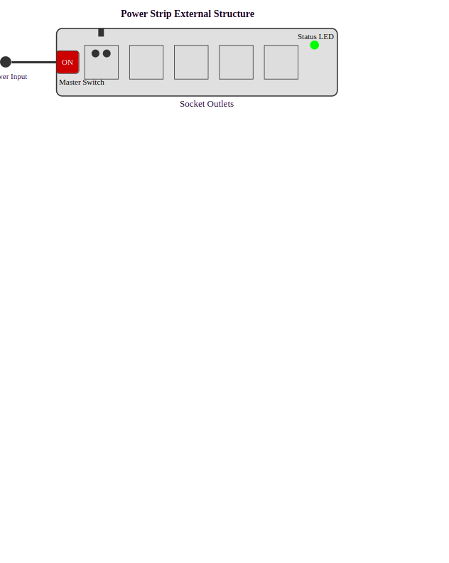
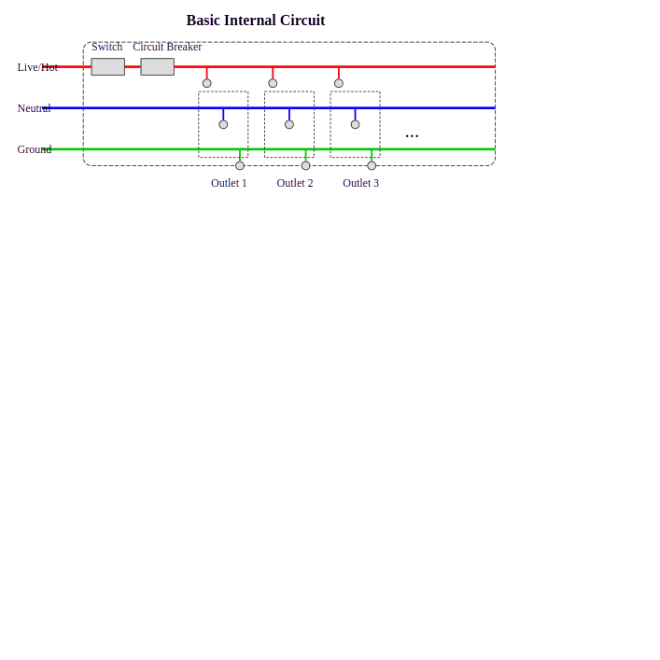
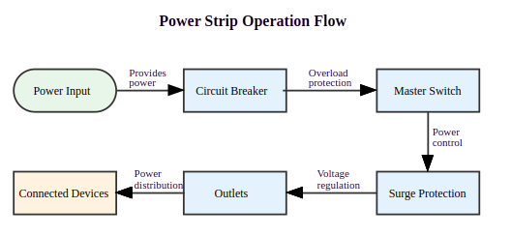Figure 1: Power strip Flowchart

4. Flow of Operation
The operation of a standard power strip follows this sequence:
- Power Input: Electricity enters through the main power cord from a wall outlet
- Circuit Protection: Current passes through overcurrent protection (fuse or circuit breaker)
- Master Switch: The main ON/OFF switch controls power to all outlets simultaneously
- Surge Protection: In surge protectors, MOVs and other components divert excess voltage to ground
- Power Distribution: Current is distributed via internal bus bars to each outlet
- Status Indication: LED indicators show power status and surge protection status (if equipped)
Operation Mechanism:
- Switch Operation: Manual mechanical switch toggles between connecting/disconnecting the live wire
- Surge Response: When voltage spikes occur, MOVs automatically reduce their resistance, diverting excess current to ground
- Overload Response: If current exceeds rated capacity, the circuit breaker trips or fuse blows, disconnecting power

5. Three Ways to Convert to a Smart Device

Option 1: WiFi-Enabled Smart Power Control
Transform the power strip into a device that can be controlled remotely via smartphone app or voice commands with monitoring capabilities.
Key Features:
- Individual outlet control
- Power consumption monitoring
- Remote access and scheduling
- Voice assistant integration
- Overload and surge alerts

Option 2: Energy Management System
Focus on energy efficiency with advanced monitoring and automated power management.
Key Features:
- Real-time power consumption analytics
- Vampire power detection and auto-shutoff
- Usage pattern learning and optimization
- Energy cost tracking and reporting
- Peak usage alerts and demand response

Option 3: Device-Aware Smart Power Hub
Create an intelligent power center that recognizes connected devices and optimizes power delivery.
Key Features:
- Device recognition and profiling
- Priority power allocation during outages
- Customized protection profiles per outlet
- Sequential power-up sequencing for AV/computing equipment
- USB fast-charging ports with device detection

6. Components for Prototyping

Common Components for All Options:
- Microcontroller (ESP32 or similar WiFi-enabled MCU)
- Relay modules (5V, rated for AC power)
- Current/voltage sensors (ACS712 or similar)
- Power supply circuit (5V DC)
- WiFi antenna
- PCB for control circuitry
- Terminal blocks and connectors
- Project enclosure (flame-retardant)

Option 1 - WiFi Power Control:
- Additional LEDs for status indication
- MQTT broker for communication
- Small OLED display (optional)
- Zero-crossing detection circuit for safe switching

Option 2 - Energy Management:
- Higher precision power monitoring ICs (like INA219)
- Non-volatile memory for data logging
- RTC (real-time clock) module
- Temperature sensors for thermal monitoring

Option 3 - Device-Aware Hub:
- MCU with more processing power
- Higher capacity memory for device profiles
- RFID/NFC module (optional for device tagging)
- USB power delivery controller IC
- Additional power filtering components

7. Flowcharts and Circuit Compositions
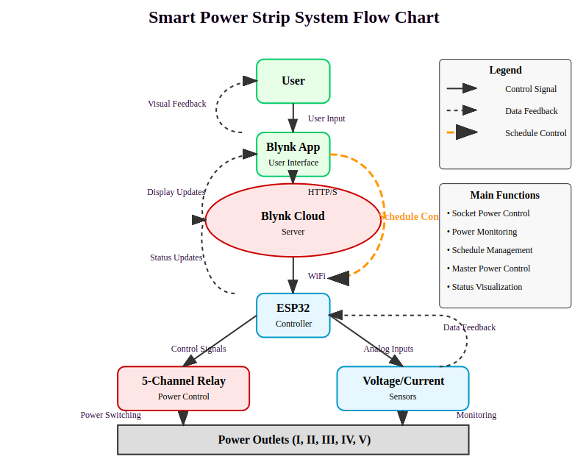
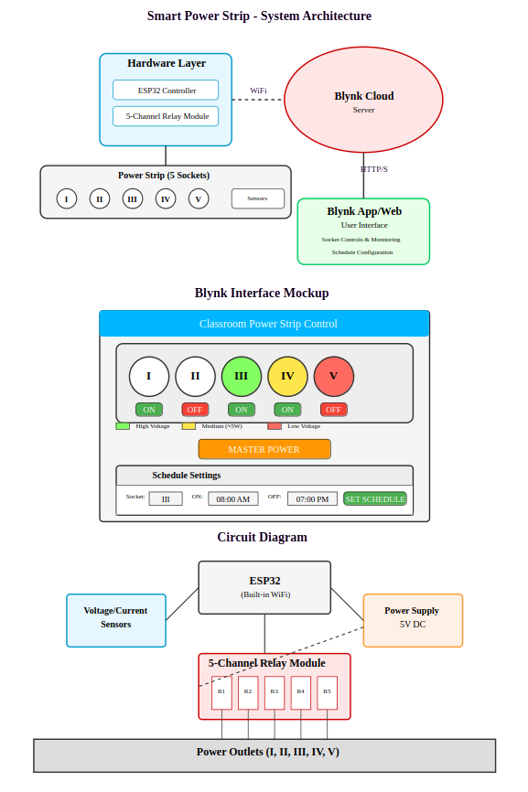

8. Potential Issues and Considerations

Technical Challenges:
- Safety Concerns: Working with mains electricity requires proper isolation between high and low voltage circuits
- Certification Requirements: Smart power devices need to meet UL, CE, or equivalent safety certifications
- Heat Management: Adding electronics increases heat generation within the enclosure
- Signal Interference: Power switching can create electrical noise affecting WiFi/sensor readings
- Firmware Security: Connected devices can be vulnerable to hacking if not properly secured

Cost Considerations:
- Component Costs: $40-100 for components (depending on feature set)
- Development Time: 80-120 hours for hardware/software development
- Certification Costs: $3,000-10,000 for safety certification depending on market
- Manufacturing Setup: Tooling and production setup costs for scaled manufacturing
- Ongoing Server Costs: Cloud services for remote access may require subscription model

Environmental Considerations:
- Electronic Waste: Converting basic power strips creates e-waste from discarded components
- Increased Power Consumption: Smart features add 0.5-2W of standby power consumption
- Battery Usage: Some designs might incorporate batteries with disposal concerns
- Material Usage: More complex circuitry requires additional resources and rare metals
- Product Lifetime: Electronics may shorten the overall product lifespan compared to passive devices

User Experience Issues:
- Complexity: Added features may make the device more difficult for some users
- Network Dependency: Reliance on WiFi/cloud services creates additional points of failure
- Privacy Concerns: Power usage data can reveal user habits and home occupancy patterns
- Setup Difficulty: Initial configuration might be challenging for non-technical users
- Maintenance Requirements: Firmware updates and troubleshooting add user burden

Mitigation Strategies:
- Implement proper isolation transformers and optocouplers for safety
- Use energy-efficient components to minimize standby power
- Design for repairability and component upgradeability
- Create intuitive user interfaces with fallback manual controls
- Build in local operation capability that works without internet connection
- Use modular design to allow partial upgrades rather than complete replacement

