Student Housing and Housing Cost in a College Town

Prepared for

Dr. Gregorio Caetano

Economics 5900

Fall 2021

Prepared by

John Carolin

jvcarolin@gmail.com

12/02/2021

Abstract

In 2017, Athens-Clarke County introduced more restrictive land use rules in an effort to manage the growth of student housing developments in downtown Athens. I hypothesize that this land use regulation that is specifically targeted at student housing will result in increased housing costs, much like other, less targeted regulations tend to cause. Using administrative records of property sales, I examine the impact that this policy change has had on the local property and housing markets. I do not find evidence of significant price changes resulting from this policy shift. My research suggests that regulations targeted specifically at student housing may not result in significant impacts to housing or property markets in the short term. Policymakers may face few short-term downsides to limited use of these policies.

Student Housing and Housing Cost in a College Town

In the fall of 2016, the Athens-Clarke County Commission commissioned a study to investigate the health and safety of the downtown Athens, GA area. The authors of the study examined and proposed measures to address a number of concerns that the Commission had raised about the downtown area. One of these concerns was that the growing number of large, student-oriented housing developments threatened the character of the area and could reduce the diversity of the local housing market. To facilitate their work, the firm hired to conduct the study requested that a temporary moratorium be placed on the approval of new multifamily housing projects in the area. The Athens-Clarke Commission granted this request. Ultimately, the report recommended the introduction of one of several types of new land use regulation that would limit the density and student-oriented nature of new residential construction, particularly in the downtown area. The Athens-Clarke County implemented one of the recommended policies.

It is likely that both the temporary permitting freeze and new land use restriction had the effect of reducing the quantity of new housing built in the area. I anticipate that this supply restriction has resulted in an increase in housing costs in the downtown Athens area. While I cannot directly observe the rental price of local housing, I can collect data regarding property sales in the area. I expect that this policy shift has had two impacts that may be observable in property sale data. First, demand will fall for property that is subject to the permitting moratorium and new land use regulations. This will be reflected in lower sales prices for land. Second, firms and individuals anticipate that these policy changes will result in less housing being constructed in downtown Athens. Expectations of a smaller housing stock will lead to increases in the sale price for housing units both in downtown and in neighboring areas.

The permitting moratorium imposed by the Athens-Clarke County Commission lasted from 02/07/2017 to 02/07/2018 and covered the entirety of the Commercial-Downtown (C-D) zoning district (Rosser Team 2017, 123). The change to the zoning ordinance recommended by the Downtown Health and Safety Study was implemented on 12/04/2018. The moratorium was not extended to cover this period, but there do not appear to have been any major projects approved during this time. The new ordinance includes a clause that states that “no more than 25% of the dwellings within a multifamily development shall have four or more bedrooms per dwelling unit.” (*Ordinance of Multifamily Dwellings*, 2018) While this change technically applies to all categories of commercial zoning, it is likely to be felt significantly more strongly by developers building in C-D zoned areas as all other zoning districts were already subject to strict bedroom density caps.

**I. Literature Review**

The literature is largely in agreement that imposing additional land use regulations on an area will tend to reduce the amount of new housing produced in that area. There is also broad agreement that stricter land use regulation tends to increase local housing prices, although this relationship is more nuanced than the relationship between regulation and housing supply. Both of these trends are quite broad, though, and may not accurately describe the effects of a particular regulation on a particular area. Looking at specific cases helps to illustrate some of the nuances of these trends.

Glaeser (2009) looks at the 187 cities and towns that make up Greater Boston and how their wide range of land use regulation influences housing price and supply. As expected, an examination of the individual towns and cities in the study area reveals a very strong correlation between increased levels of regulation and reduced levels of development. Their analysis produces one surprising result, though. They show only a very weak correlation between the residential density of a town and housing cost. Glaeser attributes this to the fact that each town only governs a relatively small part of the housing market. While additional regulation may be the cause of a large share of the increase in housing costs over the last several decades, the regulations introduced by any single town are responsible for very little of it.

Lin (2020) looks at this phenomenon in more detail. They argue that this regulatory spillover causes other analyses to dramatically understate the true costs of land use regulation. A significant share of the costs of a new ordinance is distributed over nearby areas that aren’t subject to the regulation. This portion of the costs may be ignored by traditional analyses of regulation that only look at costs within the area where the regulation is applied. Applying the method that they developed to data from California produces a mean cost of regulation that is roughly 80% higher than the typical cost reported in the literature. They additionally find that a regulation imposed over a larger area tends to produce significantly higher costs, both within the area and in neighboring areas, than a regulation imposed over a smaller area.

The literature looking specifically at student-oriented housing or college towns is slightly thinner, but still useful. Most studies in this area are structured as case studies looking at a single town or university. Langlett (2013) uses Brookings, SD to show that college towns may develop slightly differently than other towns. The price gradient for a town typically decreases as one moves away from the central business district. Langlett finds that the college campus may substitute for the central business district in college towns. Kashian (2020) takes advantage of a zoning change in Whitewater, WI to show that the housing preferences of college students differ substantially from the housing preferences of non-students. In particular, they report that college students show a higher demand for housing with 4 or more bedrooms than non-students. Unfortunately, the limited sample available for this study results in many, but not all, of its results not quite reaching statistical significance.

Munneke (2014) exploits a change in enforcement of Brigham Young University’s honor code to show that a relatively small shift in the student housing supply can have a meaningful impact on the housing costs borne by students. Their analysis doesn’t show any evidence of a significant effect on non-student housing costs. Additionally, they show that there are significant externalities to student housing. Students appear to value living around students and would prefer to concentrate themselves in student-dominated neighborhoods. Non-students tend to prefer not to live around students, although the strength of this preference varies highly across neighborhoods.

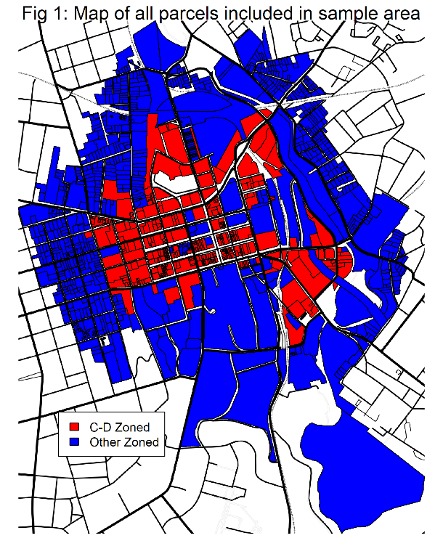**II. Data**

Using the website of the Athens-Clarke County Board of Tax Assessors (<https://www.qpublic.net/ga/clarke>), I was able to download the shapefiles for all parcels in Athens zoned C-D. I additionally downloaded shapefiles of all parcels located within 1000 feet of any C-D zoned parcel. Figure 1 shows all parcels included in the analysis, colored by zoning. Note that there are several parcels that appear to be missing. These omissions appear to be the result of errors in the database maintained by the Board of Tax Assessors. There are 1719 total parcels inside the survey area.

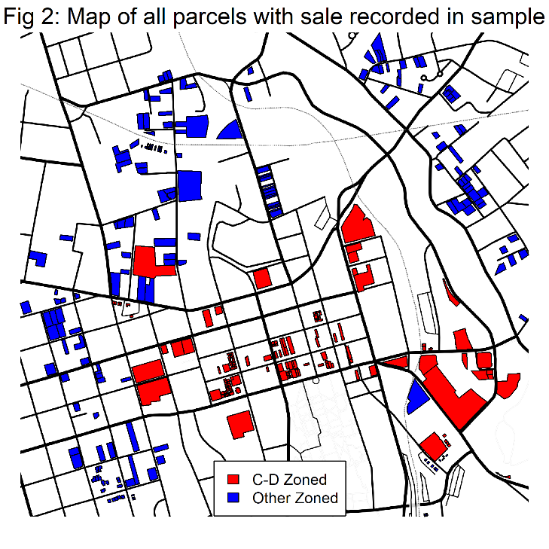Continuing to use the Board of Tax Assessors website, I accessed data on all market-rate housing sales conducted within Athens-Clarke County in the period running from January 1, 2014 through September 9th, 2021. Figure 2 shows all parcels with sale data included in the analysis, again colored by zoning. The sample contains a total of 529 sales of 419 unique parcels. 343 of these sales were conducted after the moratorium was first put into place on February 7th, 2017.

The sale data provided by the Board of Tax Assessors includes several pieces of relevant information in addition to the sale price and parcel ID. It includes the sale date, listed reason for sale, basic information about land and structures included in the sale (if any), and a very general description of the class of property sold. Certain types of sales, such as the sale of a condominium, may not include any actual land. Sales of vacant lots do not contain any information on structures.

The data hosted by the Board of Tax Assessors has several flaws. Each sale only contains information on up to one structure on the property. Nearly 50 of the sales in my sample involve property that contains two or more structures. I was able to largely address this issue by collecting building records from the Board of Tax Assessors. I am unable to correct some of the other issues with the data, however, and must exclude some sales from my analysis. Three sales seem to have been improperly categorized as market rate sales. The property containing the Hyatt hotel was sold twice while the building was under construction. I do not have any information about the construction status at the time of either sale.

**III. Model**

I conduct two analyses. The first analysis measures the impact of the moratorium and ordinance change on land values in general. The second analysis focuses specifically on how the moratorium and ordinance change relates to the values of housing units.

*A. Sales of Land*

I use ordinary least squares regression to estimate property value. As is typically the case with property values, the distribution of sale prices appears to follow a log-normal distribution. I apply a log transformation to the variable before regressing on it. I conduct several regressions. I begin by looking at all properties included in the sample. I then look only at parcels that contain at least ¼ acre of land. The variables used to estimate sale price are acreage, distance to the UGA arch, an indicator variable for C-D zoning, an indicator variable for whether the moratorium has been enacted, and the interaction term for the two indicator variables. Acreage follows a log-normal distribution, so I apply a log transformation to it. Next, I add information about structures on each property to the above regressions. This includes the total number of structures within the parcel, the total square footage of all structures within the parcel, and the average year in which structures located on the parcel were built. Any structures built after the sale took place are excluded from this analysis. Finally, I conduct the same set of regressions again on the subset of sales that are of parcels indicated to be commercial.

*B. Sales of Housing Units*

I am again using ordinary least squares regression to estimate property value. All of the regressions that I perform in this analysis are limited to the parcels classified as residential. I perform both regressions from above on the entire set of residential property sales. I continue to apply log transformations to both sale price and acreage.

The next regression that I conduct focuses on the set of properties that were sold that I classify as condominiums or condominium-equivalents. Properties that fit this definition are all properties that contain structures classified as a condominium in the building records as well as all properties that contain a structure and are labeled to be residential but contain less than 0.05 acres of land. In addition to true condominiums, this set of properties includes apartments, some townhomes, and some duplexes. There are a total of 277 sales of properties that fall into this category. The regression that I perform on these sales is slightly different than the prior ones. These properties all contain very little land, if any, so acreage is dropped as a predictor. I am not interested in measuring the direct effect of the moratorium on these properties, either, so the interaction term between C-D zoning and moratorium status has been dropped as well. This regression includes the square footage and year of construction terms from the earlier regressions but drops the number of structures term. All of these sales only covered a single building or housing unit.

**IV. Results**

*A. Sales of Land*

Table 1 contains the results of my analysis of sales of all parcels. None of the four models report a statistically significant coefficient in our variable of interest, the interaction term between C-D

| Table 1 - All Parcels | | | | |
| --- | --- | --- | --- | --- |
|  | **Without Structure Information** | | **Includes Structure Information** | |
|  | **All Parcels** | **≥ 0.25 Acres** | **All Parcels** | **≥ 0.25 Acres** |
| (Intercept) | 14.285*** | 14.856*** | 15.234*** | 20.680*** |
|  | (0.274) | (0.669) | (1.442) | (4.173) |
| ln(Acres) | 0.379*** | 1.114*** | 0.283*** | 0.484* |
|  | (0.027) | (0.182) | (0.025) | (0.200) |
| C-D Zoned | 0.005 | 0.390 | -0.172 | 0.294 |
|  | (0.190) | (0.510) | (0.146) | (0.472) |
| Distance to Arch | -0.001*** | -0.001* | -0.001*** | -0.002** |
|  | (0.000) | (0.001) | (0.000) | (0.001) |
| Moratorium | 0.200 | -0.052 | 0.278** | 0.269 |
|  | (0.116) | (0.283) | (0.092) | (0.211) |
| C-D Zoned AND Moratorium | 0.107 | 0.408 | 0.025 | -0.323 |
|  | (0.158) | (0.492) | (0.121) | (0.419) |
| Total # of Structures |  |  | 0.397*** | 0.207* |
|  |  |  | (0.040) | (0.088) |
| Total Square Footage |  |  | 0.000*** | 0.000*** |
|  |  |  | (0.000) | (0.000) |
| Year Built |  |  | -0.001 | -0.003 |
|  |  |  | (0.001) | (0.002) |
| R2 | 0.355 | 0.605 | 0.595 | 0.801 |
| Adj. R2 | 0.348 | 0.579 | 0.588 | 0.767 |
| Num. obs. | 521 | 82 | 467 | 56 |
| ***p < 0.001; **p < 0.01; *p < 0.05 --- Data collected from website of Athens Clarke County Board of Tax Assessors | | | | |

zoning and the introduction of the ordinance. All but the first of the models reported in the table have a reasonable explanatory value but show few significant coefficients.

I report regression diagnostic plots for the regressions on parcels of all sizes in Appendix 1. There is a slight non-linear trend present in the residuals vs fitted plot for the regression that does not include building information. The Q-Q plot for that regression also indicates that the residuals are not normally distributed and exhibit some left skew. The model that includes the structure information shows less nonlinearity in the residuals vs fitted plot, but shows similar left skew in the distribution of residuals. This model also features a highly influential outlier. The plots for the models that focus on large properties largely appear similar.

| Table 2 - Commercial Parcels | | | | |
| --- | --- | --- | --- | --- |
|  | **Without Structure Information** | | **Includes Structure Information** | |
|  | **All Parcels** | **≥ 0.25 Acres** | **All Parcels** | **≥ 0.25 Acres** |
| (Intercept) | 15.947*** | 15.698*** | 14.833** | 15.442 |
|  | (0.486) | (0.878) | (4.395) | (10.704) |
| ln(Acres) | 0.619*** | 1.067*** | 0.406*** | 0.285 |
|  | (0.050) | (0.216) | (0.052) | (0.353) |
| C-D Zoned | -0.542 | 0.061 | -0.936** | -0.506 |
|  | (0.387) | (0.617) | (0.342) | (0.737) |
| Distance to Arch | -0.002*** | -0.002* | -0.002*** | -0.003* |
|  | (0.000) | (0.001) | (0.000) | (0.001) |
| Moratorium | 0.294 | 0.314 | 0.330 | 0.035 |
|  | (0.312) | (0.595) | (0.249) | (0.523) |
| C-D Zoned AND Moratorium | 0.120 | 0.063 | -0.163 | -0.043 |
|  | (0.370) | (0.699) | (0.304) | (0.690) |
| Total # of Structures |  |  | 0.298*** | 0.258 |
|  |  |  | (0.048) | (0.135) |
| Total Square Footage |  |  | 0.000** | 0.000* |
|  |  |  | (0.000) | (0.000) |
| Year Built |  |  | 0.000 | 0.000 |
|  |  |  | (0.002) | (0.006) |
| R2 | 0.620 | 0.537 | 0.782 | 0.791 |
| Adj. R2 | 0.605 | 0.465 | 0.766 | 0.692 |
| Num. obs. | 127 | 38 | 114 | 26 |
| ***p < 0.001; **p < 0.01; *p < 0.05 --- Data collected from website of Athens Clarke County Board of Tax Assessors | | | | |

Table 2 contains the results of my analysis of sales of parcels labeled as commercial. Again, none of the four models report a significant coefficient on the variable of interest. These models continue to explain a fair amount of the variance in sale price.

The diagnostic plots for the model that does not include housing information looks healthier for the commercial properties than it does for all properties. There is evidence of some

heteroskedasticity in the residuals vs fitted plot, but the residuals appear to be distributed more-or-less normally and there are no impactful outliers. The diagnostics for the model that includes building information largely resembles the diagnostics for the equivalent model fit to sales of all properties

The significant outliers in these plots tend to be the same types of large, multi-family, student-oriented housing developments that the ordinance is targeted towards. The market for these types of properties appears to be significantly different than the market for more reasonably

sized properties. There aren’t enough of them in the study area to effectively fit a model to that niche of the market.

*B. Sales of Housing Units*

Table 3 reports the results from the three regressions that I ran on residential sales. Again, the coefficients for the variables of interest do not attain statistical significance. The model that does not include any structure information performs particularly poorly, likely because it is trying to model sales that are mostly of condos or condo-equivalents without any information on the buildings themselves.

The diagnostic plot for that model also look strange. While there isn’t significant evidence of nonlinearity or heteroskedasticity, the residuals vs fitted plot shows a strange banding pattern. This is repeated in the scale-location plot. The Q-Q plot continues to show some evidence of left skew. The diagnostic plot for the remaining two models are both similar. There is a nonlinear relationship between the residuals, which appears to be driven by a few highly influential outliers.

| Table 3 - Residential Parcels | | | |
| --- | --- | --- | --- |
|  | **Without Structure Information** | **Includes Structure Information** | |
|  | **All Parcels** | **All Parcels** | **Condos** |
| (Intercept) | 12.082*** | 6.952*** | 2.238 |
|  | (0.296) | (1.180) | (1.280) |
| ln(Acres) | 0.053 | 0.076*** |  |
|  | (0.032) | (0.021) |  |
| C-D Zoned | 0.281 | 0.601*** | 0.994*** |
|  | (0.181) | (0.112) | (0.084) |
| Distance to Arch | 0.000 | 0.000 | 0.000** |
|  | (0.000) | (0.000) | (0.000) |
| Moratorium | 0.201 | 0.264*** | -0.106 |
|  | (0.102) | (0.065) | (0.071) |
| C-D Zoned AND Moratorium | 0.091 | 0.052 |  |
|  | (0.147) | (0.087) |  |
| Total # of Structures |  | -0.387** |  |
|  |  | (0.139) |  |
| Total Square Footage |  | 0.001*** | 0.001*** |
|  |  | (0.000) | (0.000) |
| Year Built |  | 0.002*** | 0.001* |
|  |  | (0.001) | (0.001) |
| R2 | 0.074 | 0.529 | 0.607 |
| Adj. R2 | 0.062 | 0.518 | 0.598 |
| Num. obs. | 394 | 353 | 277 |
| ***p < 0.001; **p < 0.01; *p < 0.05 --- Data collected from website of Athens Clarke County Board of Tax Assessors | | | |

**V. Discussion**

None of the analysis that I have conducted has produced compelling evidence in support of my hypothesis. Even if it is correct, though, I’m not sure if I would be able to show convincing evidence in favor of it when looking at this isolated case. While Glaeser (2009) and Lin (2020) find evidence that increased land use regulation leads to higher housing costs in the long run, they looked at dozens of policies across an entire metropolitan area. Additionally, both note that local land use policies tend not to have very strong effects on local housing costs. The change that the Athens-Clarke Commission imposed was targeted on such a small area that even a somewhat drastic regulation may not have shown much immediate impact on local housing or land prices.

This policy was not only largely targeted at the small area of downtown Athens, but it was also targeted specifically at managing the growth of student housing developments. This also limits the immediate impact that it can have on housing prices. If policymakers wish to shape housing growth patterns, enacting policies that are tightly tailored to their concerns likely will minimize the spillover costs. It won’t eliminate them, though. Even if the costs are small enough to be barely noticeable, they can add up.

Future work should be directed towards finding better methods of detecting and measuring the costs of small-scale land use regulation. Lin (2020) shows that it is possible to better measure the spillover effects of local regulations. Extending this methodology to housing markets smaller than that of Greater Los Angeles is an important step to take. Expanding access to high-quality housing data will play an integral role in this process. A disproportionate number of the data quality issues that I experienced in my analysis involved very large, high-leverage sales. Additionally, there is no nonproprietary, high-quality, high-resolution database of rental properties. Additional research on the rental housing market will become increasingly necessary as many Americans feel that homeownership is becoming an increasingly distant dream. Even if homeownership wasn’t a concern for many people, there are certain types of housing markets that are dominated by rental properties, such as college towns.

Preliminary Reference List:

Glaeser, Edward L., and Bryce A. Ward. 2009. “The Causes and Consequences of Land Use Regulation: Evidence from Greater Boston.” *Journal of Urban Economics* 65 (3): 265–78. <https://doi.org/10.1016/j.jue.2008.06.003>.

Gyourko, Joseph, Jonathan Hartley, and Jacob Krimmel. 2019. “The Local Residential Land Use Regulatory Environment Across U.S. Housing Markets: Evidence from a New Wharton Index.” Working Paper 26573. National Bureau of Economic Research. <https://nber.org/papers/w26573>.

Gyourko, Joseph, and Jacob Krimmel. 2021. “The Impact of Local Residential Land Use Restrictions on Land Values Across and Within Single Family Housing Markets.” Working Paper 28993. Working Paper Series. National Bureau of Economic Research. <https://doi.org/10.3386/w28993>.

Kashian, Russ, Ronald Tittle, and Summer Cliff. 2020. “The Impact of Density Rezoning in a Small College Town.” *The Journal of Real Estate Finance and Economics* 61 (2): 275–87. <https://doi.org/10.1007/s11146-019-09738-4>.

Langelett, George, Kuo-Liang Chang, Ekaterina Koromyslova, and Charles Appiah. 2013a. “Rent Gradient of a College Town.” *Economics Staff Paper Series*, Economics Staff Paper Series, 2013 (1). <https://openprairie.sdstate.edu/econ_staffpaper/202>.

———. 2013b. “Rent Gradient of a College Town.” In *Economics Staff Paper Series*, Paper 202:17.

Mast, Evan. 2019. “The Effect of New Market-Rate Housing Construction on the Low-Income Housing Market.” SSRN Scholarly Paper ID 3426103. Rochester, NY: Social Science Research Network. <https://doi.org/10.2139/ssrn.3426103>.

*Ordinance of Multifamily Dwellings*. 2018. <https://library.municode.com/ga/athens-clarke_county/ordinances/code_of_ordinances?nodeId=931039>.

Rosser Team. 2017. “Athens Downtown Health and Safety Study - Report.” Rosser. <https://www.accgov.com/DocumentCenter/View/71466/Athens-Downtown-Health-and-Safety-Study---Final?bidId=>.

Thompson, Jim. 2017. “Athens-Clarke Commissioners Approve Moratoria on Most New Downtown Bars, Apartments.” Athens Banner-Herald. February 7, 2017. <https://www.onlineathens.com/local-news/2017-02-07/athens-clarke-commissioners-approve-moratoria-most-new-downtown-bars>.

Ward, Bryce. 2016. “Curse of the College Town.” *Montana Business Quarterly* 54 (2): 16–19.

Appendix 1: Regression Diagnostic Plots



