Anticipation of verbal suffixed based on lexical stress in Spanish by L1 Mandarin and L1 English speakers

Laura Fernández Arroyo1, Nuria Sagarra1, & Cristina Lozano Argüelles2

1 Rutgers University

2 John Jay College of Criminal Justice

Author note

Correspondence concerning this article should be addressed to Laura Fernández Arroyo, Rutgers University - Department of Spanish and Portuguese, 15 Seminary Place, New Brunswick, NJ 08904, USA . E-mail: [laura.fdeza@rutgers.edu](mailto:laura.fdeza@rutgers.edu)

Anticipation of verbal suffixed based on lexical stress in Spanish by L1 Mandarin and L1 English speakers

# 1. Introduction

One way humans learn is through association. This type of learning is essential in language and second language (L2) acquisition. The activation of associations allows speakers to anticipate incoming information, reducing the cognitive processing load and facilitating comprehension. Decades of transfer research have informed how cross-linguistic effects impact L2 representations, but the impact on the creation of L2 associations is an emerging field. Understanding the effects of transfer on anticipatory associations, especially on those implicitly learned such as morphophonological associations, is crucial because it can explain the difficulty that L2 speakers have to process the linguistic phenomena involved, as happens with morphology.

Here we investigate cross-linguistic effects on the creation of L2 morphophonological associations. For that purpose, we examine verb tense suffix anticipation based off lexical stress in adult Spanish monolinguals and English and Mandarin Chinese intermediate and advanced learners of Spanish. Mandarin, English and Spanish have all lexical stress. However, lexical stress in English is more similar to lexical stress in Spanish than lexical stress in Chinese. Choosing these three languges allows to observe transfer effects from different distances in a continuum. Besides, English and Chinese are both morphologically poor in terms of verb morphology. Different levels of proficiency were included because language experience is essential in shaping the linguistic system (Bybee, 2006) and so it can shift what a speaker can pay attention to and inhibit in the input.

# 2. Background

## 2.1. Transfer

Cognitive models of L2 acquisition consider that the existing L1 system influences the acquisition and processing of the L2 (e.g., Competition Model, Li & MacWhinney, 2012; MacWhinney & Bates, 1987; Full Transfer/Full Access Hypothesis, Schwartz & Sprouse, 1996). This influence is called transfer or cross-linguistic influence (Lado, 1957). In instances in which the L1 system facilitates acquisition of the L2 system, transfer is said to be positive. For example, in cases in which the L1 and the L2 both mark noun number overtly (Luk & Shirai, 2009). In cases in which the L1 system hinders or blocks the acquisition of an element in the L2, transfer is said to be negative. For example, when the L1 does not explicitly mark noun number but the L2 does, L2 speakers struggle in acquiring the noun number representation (Luk & Shirai, 2009). Positive transfer of similar cross-linguistic structures thus accelerates the L2 acquisition process, and negative transfer may impede L2 acquisition because of differing cross-linguistic structures (Melby-Lervåg & Lervåg, 2011), or at least slow it down.

Importantly for this study, L1 transfer may affect phonology (Yang, Cooc, & Sheng, 2017) and morphology (Sagarra & Ellis, 2013; Yang, Cooc, & Sheng, 2017). There are also other factors interacting with transfer to bear in mind. In phonological transfer, the magnitude of the effects varies across proficiency (Jun & Oh, 2000), such that transfer effects decrease as proficiency increases. Phonological transfer also varies according to the structure being acquired (Simon, 2010). Dutch L1 speakers assimilate syllable- and word-final obstruents before voiced stops more often than before sonorant consonants in L2 English, following Dutch phonological rules instead of English rules. In terms of prosody, L1 structures like lexical stress may affect processing and production of different L2 structures like lexical tones, with effects discernible at advanced levels of proficiency (Shih & Lu, 2010). Finally, L2 speakers transfer necessary skills to segment, analyze, manipulate, and assemble speech sounds (Yang, Cooc, & Sheng, 2017). These results suggest that there may be cross-linguistic effects of phonological knowledge at different levels, namely segments and intonation. In addition, these results suggest that transfer effects vary according to proficiency, or that other factors may be conditioning how visible transfer effects are at different stages of L2 acquisition.

Inflectional morphology processing research also suggests that L1 transfer effects are subject to the presence of other factors. Again, proficiency is one such factor. Most research indicates that transfer at beginner stages is not strong (Rast, 2010) or even null (Sagarra, 2008), probably because of learners choosing the least taxing interpretation of a message regardless of whether their L1 has a linguistic phenomenon or not (Sagarra, 2008). However, transfer has proven helpful in prediction of morphosyntactic structures like gender agreement when the L1 and the L2 encode the structure similarly (Dussias, Kroff, Tamargo, & Gerfen, 2013). This finding reveals that transfer may still be possible at beginner stages of L2 acquisition when the L1 has conditioned the speaker to pay attention to specific information also relevant in the L2 (e.g., Ellis, 2008; Ellis & Sagarra, 2010). Similarly, other factors apart from language similarity can also condition transfer during processing at beginner stages, such as working memory (Sagarra, 2008) or target language input (Rast, 2010). Transfer starts to affect L2 processing more stably at intermediate levels (see Sagarra, 2020, for a review) and continues to do so until the learner is very advanced or has reached a near-native level of proficiency (Hopp, 2010).

Taken together, research on phonological and morphological transfer show that cross-linguistic effects may start early in the acquisition process, but the effects grow stronger as proficiency increases. The characteristics of each language involved in the process will condition the extent of the effects as well as its helpfulness. One important aspect of previous studies is that they have focused on one specific linguistic component. While elucidating the effects of transfer on processing within each specific component is key in our understanding and language and cognition, we also need to understand transfer in a more global context in which component processing does not happen in isolation, but as part of a whole interconnected system. So far, most transfer research has failed to account for the interaction and the association between components and for the effects of transfer on that interaction and association during linguistic processing, even though association is a fundamental learning strategy in cognitive perspectives of L2 acquisition, (e.g., Competition Model, MacWhinney, 1997; Associative-Cognitive CREED, Ellis, 2006).

The associations that cognitive perspectives on L2 acquisition have referred to most commonly are form-meaning associations (e.g., suffix *-a* in Spanish corresponds to feminine grammatical gender). However, associations between different elements in phrases, sentences and discourse is also necessary to facilitate language processing (Sagarra & Ellis, 2013). Associating already heard elements in the speech stream with incoming information allows for the prediction of the incoming information. This kind of associations are mostly acquired implicitly in the case of the L1. In the case of the L2, they are sometimes overtly explained, like is the case of gender agreement or case declination in a noun phrase, and other times they are never taught, such as a morphophonological association. The L2 speaker must therefore pick up the associations that lead to prediction. An important aspect to take into account in cognitive perspectives of L2 acquisitionis not only the characteristics of the input in enabling the creation of L2 associations, but also the effect of a pre-existing linguistic system on the creation of those associations. Exploring the cross-linguistic effects on acquisition of implicit associations and on L2 processing of these associations will clarify 1) whether the learning mechanisms underlying first and second language acquisition are similar, 2) whether they can be transferred to learn other languages and to facilitate their processing, and 3) whether the information that the L1 requires paying attention to conditions biases the creation of L2 associations through transfer.

## 2.2. Linguistic prediction

Prediction is a cognitive mechanism deployed by the brain to process all the input it receives. Predictions are based on probabilistic associations (Clark, 2013) between a cue and an outcome that are learned unconsciously (Cohen & Squire, 1980). The cue and outcome may belong to the same linguistic component (e.g., semantic, Altmann & Kamide, 1999) or to different ones (e.g., phonology-morphology, Sagarra & Casillas, 2018). Because of their probabilistic nature, the associations are acquired gradually according to their frequency and consistency (Competition Model, Bates & MacWhinney, 1982; Bates, MacWhinney, & MacWhinney, 1987; Associative-Cognitive CREED, Ellis, 2006). An association will be stronger the more examples there are of it (high availability) and the more regular it is (high reliability). These associations are crucial for language acquisition (Bates & MacWhinney, 1982; MacWhinney, 1997; Romberg & Saffran, 2010) and prediction (Kuperberg & Jaeger, 2016).

L1 and L2 speakers do not predict to the same extent. L1 speakers use semantic (Altmann & Kamide, 1999), semantic-morphosyntactic (Altmann & Kamide, 2007), morphosyntactic (Grüter, Takeda, Rohde, & Schafer, 2016; Huettig & Mani, 2016; Lew-Williams & Fernald, 2010), morphophonological (Roll, Horne, & Lindgren, 2010; Roll, Söderström, & Horne, 2013) associations for prediction. Relevantly for the study, morphophonological associations are varied. Among the possible options, we find pitch accent associated to noun and verb suffixes (Roll, Horne, & Lindgren, 2011; Schremm et al., 2017), lexical stress to verb suffixes and to noun endings (Sagarra & Casillas, 2018; Lozano-Arguelles et al., 2019), and vowel duration to active and passive voice (Rehrig, 2017). Such variety reflects that morphophonological associations are recurrent across languages.

L2 speakers are not as consistent in their ability to make predictions as L1 speakers. Online research on L2 speakers’ ability to anticipate incoming linguistic information has focused mostly on morphosyntactic anticipation (e.g., Lew-Williams & Fernald, 2010; Dussias et al., 2013). Findings suggest that L2 speakers may not be able to apply associations in all contexts. That inability to anticipate may be a source of L2 speakers’ difficulty in comprehending speech. There has been some research on L2 morphological anticipation as well. This anticipation relies on morphophonological associations, as it does in L1 speakers. In contrast to L1 speakers, L2 speakers are unable to fully exploit these associations to help linguistic processing (Perdomo & Kaan, 2019). A possible reason for the increased variability among L2 speakers in using morphophonological associations for prediction is that this type of association is not taught in class and thus need to be acquired implicitly.

The studies covering the implicit acquisition of the within-word association between phonological cues and morphological outcomes have focused on pitch accent and lexical stress as cues, corresponding to Central and South Swedish and to Spanish. Schremm, Söderström, Horne, and Roll (2016) were the first ones to study this acquisition. They examined acquisition of the association between pitch accent and verb tense suffixes. In Central Swedish, Accent 1 cues present tense (*skrämme* ‘I scare’), and Accent 2 cues past tense (*skrämde* ‘I scared’). Non-tonal L1 speakers learning L2 Central Swedish at a self-reported intermediate proficiency in an immersion context completed an identification task in which response time was measured. Response times were faster for validly cued suffixes. Surprisingly, the L2 speakers were also faster than the control L1 group. The L1 Swedish speakers were also faster at recognizing validly cued suffixes, although the difference in response time between validly and invalidly cued suffixes was larger in the L1 group than in the L2 group. These results suggest that L2 intermediate learners were unconciously using the accents to predict grammatical suffixes, just as native speakers were doing. Since the participants in Schremm, Söderström, Horne, and Roll (2016) were intermediate to upper-intermediate, Gosselke Berthelsen, Horne, Brännström, Shtyrov, and Roll (2018) tested the pitch accent-suffix association in L2 beginners. They made two modifications. They tested processing with an online technique, EEG. Instead of using verb suffixes, they used noun number suffixes. The participants, L1 German-L2 Central Swedish speakers, could not pre-activate number suffixes based on pitch accent yet. The findings from these two studies suggest that the accent-suffix association was not established in low proficiency speakers yet, but intermediate speakers had already created it. Lastly, Gosselke Berthelsen, Horne, Shtyrov, and Roll (2020) is the only study that has explored the effects of L1 transfer with respect to prediction based on morphophonological associations. They compared anticipation of number and gender suffixes in pseudo-nouns cued through pitch accent in a group of South Swedish speakers and in a group of German speakers as reflected by ERPs. Findings suggest that brain activity was different across groups, and that the Swedish speakers were making use of their knowledge of pitch accent in Swedish to process pitch accent in the pseudowords. These findings indicate that the Swedish speakers were not only transferring their acoustic abilities from the L1, but also the cuing function associated to accents in their L1.

*I DON’T THINK THESE TWO FOLLOWING STUDIES ARE RELEVANT* As this type of association is not explicitly taught in language classes, two studies measured effectiveness of training (Hed, Schremm, Horne, & Roll, 2019; Schremm, Novén, Horne, & Roll, 2017) Schremm, Novén, Horne, and Roll (2017) used a perception game that participants from diverse L1s played over a period of two weeks. Their results indicate that the association could be learned and strengthened through the game and extrapolated to production, although their conclusions are based solely on accuracy and response times. Hed, Schremm, Horne, and Roll (2019) did collect brain activity data to measure training effects. In their case, the L1s of the speakers were also varied and the L2 was South Swedish, which follows the same pitch accent structure as Central Swedish. The ERP data suggest that speakers at upper-intermediate proficiency can learn through training to pre-activate suffixes according to pitch accent, especially accent 1, although their brain activity does not completely resemble that of native speakers of South Swedish and they still rely more on the suffixes when performing grammaticality judgments. Lower proficiency speakers did not benefit from the training. The results from these two studies reveal that acquisition of the associations is possible, and what is more, the acquisition process can be affected by external factors.

Regarding lexical stress, Sagarra and Casillas (2018) investigated the role of proficiency and verbal working memory in the integration of lexical stress in the stem of verbs as a cue to present and past tense suffixes in Spanish. In Spanish, lexically stressed syllables in Spanish cue present tense (*FIRma* ‘s/he signs’), while lexically unstressed syllables cue past tense (*firMÓ* ‘s/he signed’) in verbs consisting of two syllables. They recruited Spanish monolinguals and English-Spanish late bilinguals, whose proficiency was assessed with a standard measure. In contrast to the Swedish learners, these speakers did not live in an L2 context. Eye-tracking data revealed that advanced L2 speakers of Spanish and monolinguals could predict tense based on lexically stressed and unstressed syllables, but intermediate speakers could not. In addition, the advanced L2 speakers could only do so when the stem syllable structure was CVC. Working memory did not affect integration of lexical stress and prediction of verb tense suffixes, suggesting that working memory does not affect processing of morphophonological associations when the speaker has already had some experience with the language. In the search for other factors constraining morphophonological prediction, Lozano-Argüelles, Sagarra, and Casillas (2019) investigated whether anticipatory experience could affect anticipation performance for the same type of association, for which they added a group of English-Spanish interpreters. As in Sagarra and Casillas (2018), CVC stem was a more reliable cue for the L2 groups than CV. Anticipatory experience did have a positive effect in some cases (CVC stem + past tense), allowing interpreters to predict faster, although not necessarily earlier, than monolinguals did. The findings from these two studies indicate that morphophonological associations are not only restricted to pitch accent, but also to other phonological phenomena, and that they can be activated in non-immersion contexts. Importantly, they also indicate that there are factors constraining the acquisition of anticipatory associations, but the nature of these factors is still unclear.

Finally, Lozano-Arguelles et al. (under review) expanded the scope of the associations and examined whether monolinguals and L2 speakers can use associations of lexical stress to non-morphological endings (*PApa* ‘potato’ vs *paPÁ* ‘dad, Pope’) for prediction. In a similar study to Sagarra and Casillas (2018) and Lozano-Argüelles, Sagarra, and Casillas (2019), Lozano-Arguelles et al. (under review) found out that the ability to use lexical stress-word endings association does extend to non-morphological endings. This finding led the authors to conclude that the association may not be so much a phonology-morphology association, but rather a phonology-meaning association. In sum, the studies on lexical stress extend previous findings on pitch accent to more phonological structures, at the same time that they open the possibility of needing to conceptualize associations in a different way, where form is not only connected to form, but also to meaning. These studies point towards the fundamental effects of L2 development in L2 prediction, a phenomenon that affects all L2 learners independently of their L1, but more information is necessary on the effect of the L1 cues on L2 associative predictions. Some of these studies recruited in fact L2 speakers from multiple L1s, with L3s or even L4s, or the design did not allow for comparison of cross-linguistic effects. Additionally, comparison across studies is not always possible as participants in some studies lived immersed in the L1 and in others in the L2, proficiency measures were not always standardized, or the studies focused on different levels of proficiency, on different outcomes, or mixed outcomes (noun and verb suffixes). Moreover, some studies focused on brain activity but not on anticipation performance necessarily, or the performance was only measured via reaction times. These limitations are problematic because we cannot make sure how the L1 affects L2 prediction, if the speakers really knew had the same proficiency, if they are bogged down by difficulty processing only the cue in the association or also the outcome, or if the brain activity prediction translates into performance.

To tease apart the effects of L2 proficiency and of L1 transfer on linguistic prediction, we investigate anticipation abilities of English and Mandarin Chinese native speakers in L2 Spanish. The association tested was lexical stress-verb tense suffixes. Performance was measured through eye-tracking, allowing to observer processing in real time without the need for the brain to command a hand movement to measure reaction time. Participants’ proficiency was measured with a standardized test to make sure they all were at the same development stage. English and Mandarin Chinese were chosen for two reasons, the first one being that they have poor morphology for verb tense. The second reason is that English and Mandarin Chinese are located at different distances from Spanish in how they encode lexical stress and the purpose it serves. All three languages encode lexical stress, but the nature, frequency and sensitivity to it varies across the three languages, where English is more similar to Spanish than Mandarin Chinese.

## 2.4. Linguistic phenomena

The cue-outcome association tested in this study is lexical stress-verb tense suffix. In order to study different possible degrees of transfer of association, English and Mandarin Chinese were selected as the L1s and Spanish as the L2.

### 2.4.1. Cue.

Lexical stress is the emphasis of a syllable relative to the rest of the syllables in a word (Hualde, 2005). English and Spanish encode lexical stress, and Mandarin Chinese is likely to do so as well. In English and Spanish, lexical stress has no fixed position, playing a phonologically contrastive function at the lexical level depending on its location. This contrastive function is more prominent in Spanish than in English. In English, lexical stress is used predominantly to distinguish heteronyms or pairs of verb-noun that have no segmental differences (to “proDUCE,” verb vs “PROduce,” noun). In Spanish, lexical stress differentiates all kinds of word categories and information, such as verbal tense and person (*CANto* “I sing” vs *canTÓ* “s/he sang”), or nouns (*PApa* “potato” vs *paPÁ* “dad”), or nouns from verbs (*TÉRmino* “term” vs. *terMIno* “I finish” vs *termiNÓ* “s/he finished”).

Different acoustic correlates, their importance or weight, and how they combine cause the acoustic realization of lexical stress in each specific language to vary. In Spanish, the most reliable cues to stress are pitch (F0), duration and intensity (Hualde, 2005; Ortega-Llebaria, 2006; Ortega-Llebaria & Prieto, 2007, 2009). Pitch is higher for stressed syllables and lower for unstressed syllables, and stressed syllables sound louder and are usually slightly longer. The main cues in English are vowel duration and quality (Cooper, Cutler, & Wales, 2002; Cutler, 1986). Other cues contribute to marking a lexically stressed syllable, among which pitch height should be mentioned (Fry, 1955, 1958).

Lexical stress facilitates lexical activation in L1 Spanish (Soto-Faraco, Sebastián-Gallés, & Cutler, 2001), such that a prosodically matching cue to the target (*prinCI* > *prinCIpio*, “start”) results in shorter and more accurate activation times, when compared to mismatching cues (*PRINci* > *prinCIpio* ‘start’). These results suggest that speakers use lexical stress to activate a lexical item, which may result in anticipation of a word ending based on it (Lozano-Argüelles, Sagarra, & Casillas, 2019; Sagarra & Casillas, 2018). L1 English speakers, in contrast, did not use placement of lexical stress to activate a word in comparison to competitors with different stress patterns, only when more than one syllable of the word has already been heard (Cooper, Cutler, & Wales, 2002). These results indicate that L1 English speakers do not rely on lexical stress as much as L1 Spanish speakers do for word activation. However, even L1 English speakers use lexical stress for word prediction (Perdomo & Kaan, 2019).

Lexical stress in Mandarin Chinese is harder to classify. Some scholars have in fact described Mandarin Chinese as a language without stress (Hyman, 1977). While other scholars do accept that Mandarin Chinese may have some realization of lexical stress (e.g., Duanmu, 2007), it is unclear how the realization is represented in speakers’ minds, as some speakers of Mandarin Chinese may have no judgment on stress, for example, Shanghai Chinese speakers (Selkirk & Shen, 1990). Research on the phonetic realization of Mandarin Chinese lexical stress has revealed that it relies on similar acoustic correlates as in English. Thus, Mandarin lexical stress is marked through duration, vowel quality, and pitch height (Lin & Yan, 1980). The problem in locating and studying stress and unstressed syllables comes from Chinese being a tonal language and most Chinese words being monosyllabic (Duanmu, 2007). Most words being monosyllabic will cause the variability of stress patterns to reduce in size. The tones may interact with stress possibly confounding speakers as to what part of pitch is signalling stress and what part tones.

Tones are the pitch contour patterns of the voiced part in syllables (Chao, 1968). Many languages use tones, or changes in pitch-contour, at a phrasal level for pragmatic purposes. However, only a few use tones contrastively at a lexical level. The acoustic correlates for tones vary across languages: some use only pitch (e.g., most Mandarin Chinese dialects), whereas others also use length and/or register (e.g., Cantonese Chinese). Relevant to this with Mandarin Chinese speakers, in most Mandarin Chinese dialects (e.g., from Beijing and Tianjin), the main and oftentimes only acoustic correlate for tones is changes in pitch (F0) contour or changes in pitch height within a syllable (Gandour & Fromkin, 1978; Zhu & Wang, 2015). Mandarin tones facilitate word recognition (Malins and Joanisse (2010)), although segmental cues are the primary activator, especially vowels (Hu, Gao, Ma, & Yao, 2012; Sereno & Lee, 2015; Wiener & Turnbull, 2016). The role of tones in Mandarin for activation and word ending anticipation therefore does not completely overlap with the role of lexical stress in Spanish. Mandarin speakers need to pay attention to the pitch variations in order to assign the correct tone to the word they are hearing.

### 2.4.2. Outcome.

The outcome is verb tense suffix. The three languages differ in if and how they mark tense. Spanish is a morphologically rich language. Spanish uses suffixes to indicate tense along with other information such as aspect, person and number (*lavó* ‘s/he wash-ed~3 SG Past Perfect~’). Perfective tenses require the modal verb *haber*, which carries the conjugation information, while the main verb appears in past participle. All tenses and all persons require their own suffix, usually different from each other, and each verb needs to be conjugated even if the time frame and person have already been established.

English is a morphologically poorer language than Spanish. English indicates some information with bound morphemes, such as past tense (-ed) or 3rd person singular in the present tense (-s). English indicates some tenses with independent morphemes, like future (will) or conditional (would), but these morphemes do not vary according to person or number.

Finally, Mandarin Chinese does not have bound morphology to indicate tense. The same word is used for all tenses (吃 /chī/ ‘eat’). Thus Mandarin Chinese is located further from Spanish than English in the continuum of verb inflectional morphology. Mandarin Chinese can, however, indicate tense through other resources. Some resources may be shared with English and Spanish, such as adding lexical items (e.g., “yesterday”) that indicate time. Other resources are not shared. Mandarin Chinese has some particles that may indicate time. For instance, completeness or near future (了 /le/) or a past experience in an unspecified past (過 or 过 /guò/). These particles do not change depending on the person the verb refers to. These particles share with lexical items that they can oftentimes be omitted once the time frame has been established, unlike suffixes in Spanish or English or modal verbs that need to be re-stated.

# 3. This study

Within-word morphophonological associations are essential for language comprehension. These associations are typically learned implicitly and processed unconciously, making them more prone to suffering cross-linguistic effects. Studies on transfer have a large history on cross-linguistic effects within components, but have not explored yet biases in the creation of L2 associations caused by the L1. However, understanding the acquisition of within-word morphophonological associations is crucial to explain why L2 speakers oftentimes find it difficult to process morphology. Previous research on the acquisition of within-word morphophonological associations are not comparable because they used different cues (pitch accent vs lexical stress) in different contexts (immersion vs non-immersion, respectively), because some measured brain activity while others performance, and performance was sometimes online (eye movements) and sometimes not (reaction times), because speakers self-reported their proficiency, had mixed L1s or also spoke third and even fourth languages, or because the studies mixed nominal and verbal morphology. Furthermore, only one study has investigated transfer effects on association acquisition (Gosselke Berthelsen, Horne, Shtyrov, & Roll, 2020). This study only provides evidence of transfer from two extremes (transfer either was not possible at all or the overlap was complete) but does not take into account that languages may be placed in a continuum of how much transfer there can be. Moreover, any conclusion we could draw from that study is based on the use of pseudowords as stimuli.

The present study fills several of the gaps left by the previous studies on the association between phonology-morphology for prediction. We address the issue of transfer considering phonological overlap as a continuum rather than separate categories. To that end, we test online prediction performance through eye-tracking in bilingual speakers who can transfer different degrees of phonological knowledge from their L1 (English or Mandarin Chinese) to their L2 (Spanish) to anticipate present and past tense suffixes based on lexically stressed or unstressed stem CVC syllables. We test transfer effects at different levels of proficiency, and thus acquisition stages, that were assessed with standard measures and control for possible individual differences by keeping verbal working memory homogeneous. The specific research questions are:

*1. Do Spanish monolinguals, and intermediate and advanced Mandarin and English learners of Spanish use lexical stress to anticipate verbal suffixes in Spanish?*  
We predict that monolingual Spanish speakers will anticipate verb tense when cued by stressed and unstressed syllables (Lozano-Argüelles, Sagarra, & Casillas, 2019; Sagarra & Casillas, 2018). Advanced-Spanish English speakers will generate the predictions at advanced levels of proficiency. This type of bilinguals predicted when in an L1 context (Lozano-Argüelles, Sagarra, & Casillas, 2019; Sagarra & Casillas, 2018), and adding up the behavioral findings related to the Swedish bilinguals who start anticipating at intermediate levels of proficiency when immersed in the L2 (Schremm, Söderström, Horne, & Roll, 2016), we hypothesize that the English-advanced Spanish bilinguals should have no problem in generating predictions. Following Sagarra and Casillas (2018), we do not expect intermediate English speakers to anticipate, even if they are immersed. Given there is no previous research for the Mandarin speakers, our following predictions and the prediction for the next question are based mostly on logical thinking. We predict advanced Mandarin speakers to be able to anticipate due to their linguistic experience with the L2, and because advanced speakers predict in other studies (Lozano-Argüelles, Sagarra, & Casillas, 2019; Sagarra & Casillas, 2018; Schremm, Söderström, Horne, & Roll, 2016). We do not believe intermediate speakers will anticipate.

*2. How does anticipation performance compare across L1s within proficiency level?*  
Comparing intermediate bilingual groups and advanced bilingual groups, we predict English speakers will show earlier tendencies towards anticipation than Mandarin speakers. We base this prediction in the closer similarity of lexical stress in English and Spanish, and in its more common use in those two languages than in Mandarin Chinese.

# 4. Methods

## 4.1. Participants

30 monolingual speakers of Spanish (20 females), 42 L2 Spanish L1 English speakers (30 females), and 43 L2 Spanish L1 Mandarin speakers (33 females) participated in the study. All participants were living in Madrid, Spain at the time of data collection. English L1 speakers had been in a Spanish-speaking country for a mean of 31.5 months ( *SD* = 28.6) and the L1 Mandarin speakers for a mean of 43.9 months ( *SD* = 43.6). All speakers were raised in monolingual families in monolingual communities of their L1. The monolingual Spanish speakers were local to the Madrid area and spoke no other language fluently nor had lived abroad. The participants belonging to all L2 groups started learning Spanish after age 12. At the time of data collection, the L1 Mandarin speakers used Spanish a mean of 47.3% of the week ( *SD* = 21.2) and the L1 English speakers a mean of 34.4% ( *SD* = 16.6). The age range for all groups was 18-45 (Spanish: mean = 26.2, *SD* = 8.82, English: mean = 25.7, *SD* = 4.27; Mandarin: mean = 24.5, *SD* = 4.39). All participants had normal to corrected-to-normal hearing and vision, and no motor disability.

## 4.2. Materials

### 4.2.1. Screening tasks.

A proficiency test was administered to the L2 participants to screen them and to assign them a level of proficiency. The proficiency test was a shortened version (Sagarra & Herschensohn, 2010) of the *Diploma de Español como Lengua Extranjera* (‘Certificate of Spanish as a Foreign Language,’ by Instituto Cervantes). The test consisted of 56 questions: 16 on grammar, 10 on vocabulary, and 20 on reading comprehension. Each question was worth one point. Participants who scored below 25 were disqualified for the study.  
Participants were interviewed and completed a language background questionnaire, to make sure that they qualified for the study. The background questionnaire contained questions related to their age, handedness, what language they spoke in their household while growing up, how old they were when they started learning Spanish, how long they had lived in Spanish-speaking countries, how much they used each language per week at the time of data collection, and other languages that they spoke fluently.  
Participants also completed a vocabulary test with some of the words from the linguistic anticipation task. This test was a multiple-choice test with 17 screens with 8 words each. For each word in Spanish, they had to choose between 8 possible meanings in the participants’ L1. An extra option was provided to mark in case they did not know the meaning of the word in Spanish.

### 4.2.2. Linguistic materials.

A visual-world paradigm was used to asses participants’ abilities to associate verbal suffixes with stressed or unstressed syllables. The eye-movements during the task were recorded through an EyeLink 1000 Plus desktop mount eye-tracker from SR Research (sampling rate: 1k Hz; spatial resolution was less than .05o; averaged calibration error: .25-.5o). Participants read two verbs on a computer screen side by side ( *salta* ‘s/he jumps,’ *saltó* ‘s/he jumped’) and heard a sentence containing one of the two verbs ( *El ladrón saltó la valla* ‘the thief jumped over the fence’). Their task consisted of selecting the verb they had heard as fast as possible by pressing the right- or left-shift key. When they made their selection, a green rectangle appeared around the selected verb. There were 4 practice sentences, 16 experimental sentences, and 80 fillers. The verbs were the present tense and preterit tense 3rd person singular forms of regular -ar verbs. Spanish regular verbs have 2 cues to tense: initial syllable stress and word ending morphology. Stressed initial syllables indicate that the tense is present ( *salta* ‘s/he jumps’), and unstressed initial syllables indicate that the tense is past (preterit, *saltó* ‘s/he jumped’). Regarding morphology, the verb suffix indicates tense, person and aspect. In total there were 16 verbs, so 16 pairs of present and preterit verbs, 16 in each condition, 32 final forms. All verbs had two syllables in both conditions: the first syllable had a CVC structure and the second syllable a CV structure. Participants never heard the two conditions for a single verb. The number of verbs in tense on each side of the screen was counterbalanced across trials and across participants.  
The aural sentences were 5 words long with a neutral structure NPSUBJ-V-NPOBJ. The sentences for each condition within a pair were the same. The sentences were distributed into blocks by means of a Latin square design. There were 8 blocks. Each block contained 2 experimental sentences, one of each type, and 6 filler sentences. The blocks appeared in a randomized order. Within and across the blocks, the sentences were pseudo-randomized to avoid two experimental sentences of the same condition appearing one after the other.

### 4.2.3. Verbal WM materials.

An aural version of Unsworth, Heitz, Schrock, and Engle (2005)’s Operation Span task (OSpan) was used to measure verbal WM capacities. This task generates measures of storage and processing speed. In a single trial, participants heard first a word and then a simple mathematical problem that could be either true (2 + 2 = 4) or false (2 + 2 = 5). Along the mathematical problem, they saw the words TRUE and FALSE on the screen. They had to select as fast as possible the correct word depending on whether what they heard was true or false by pressing the left- or right-shift key corresponding to the side on which their response was. This sequence of word-mathematical problem would repeat a certain number of times until a set was complete. At the end of each set, participants were prompted to write down the individual words they had heard before each problem in the same order they had heard them.  
There were two practice trials of 3 words and simple mathematical problems, and three experimental sets of three, four, five and six words and mathematical problems. The words and mathematical problems that participants heard in the sets appeared in a fixed order across participants. The words TRUE and FALSE that participants needed to select in response to the mathematical problems appeared counterbalanced on each side across participants. No feedback was provided. The whole task was administered in the participant’s L1.

## 4.3. Procedure

Data collection was conducted in a single session with each participant individually. Each session lasted around 1 hour and 15 minutes and participants could take breaks between tasks anytime they wanted. Only the researcher accompanied the participant during this time and all interactions happened in Spanish. The room was isolated from external noise and light. Participants completed the tasks in this order: Spanish proficiency test (only L2 learners; 15-20 minutes), language background questionnaire (10 minutes), eye-tracking task (25 minutes), OSpan (15 minutes), and a vocabulary test (10 minutes). First, participants listened to an overview of the tasks and signed the consent form. Participants provided oral responses for the language background questionnaire. They completed the remaining tasks on a computer.  
*Visual-world paradigm.* For the visual-world paradigm, participants rested their head on a chin rest, completed an 11-point grid calibration task, and received task instructions both orally and in writing. Then, they completed the practice trials and were given the opportunity to ask questions. Afterwards, they performed the task. Both the practice and the task trials followed this order. First, participants looked at a fixation sign in the middle of the screen for 250 ms. This fixation sign allowed the researcher to recalibrate manually when necessary. Then, two words appeared in the screen side to side. Once the words had been on the screen for 1000 ms., the sentence started playing and continued until reaching the last word. That is, the sentence did not stop when participants selected the word they heard. Participants were instructed to select the word on the screen they heard on the sentence as fast as possible by pressing the right- or left-shift keys. A green rectangle appeared on the screen around the selected word when participants pressed the key to make their choice. Response recording was set up to be registered only when the press happened after the start of the verb in the sentence. Previous presses where not recorded so the setting forced participants to press again until they saw the green rectangle appear. No feedback was provided. See Figure 1 for an example of an experimental trial.

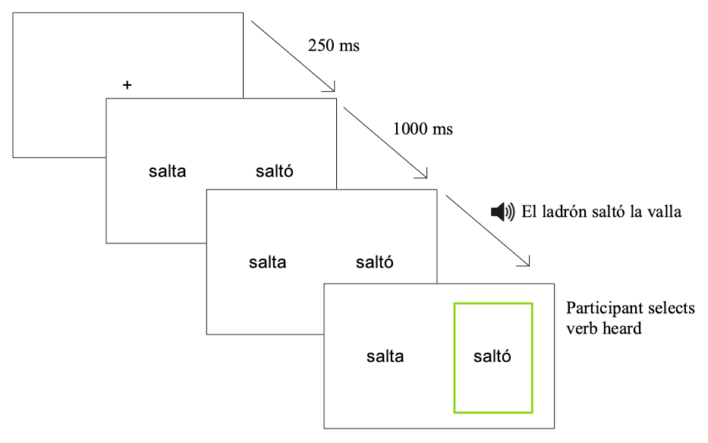

*Figure* *1:*. Sample trial of the visual-world paradigm

*OSpan* The OSpan task was divided into practice and experimental trials. For each trial, participants first heard a word and then heard a simple mathematical problem, all in their L1. During the equation, participants saw the words TRUE or FALSE on each side of the screen, and they had to press the corresponding key (left-shift key for the word on the left, right-shift key for the word on the right) depending on whether the problem was correct or not. After each problem, they saw a fixation point for 500 ms. and another word-equation pair was presented. This process was repeated until the word RECALL or a linguistic equivalent in the L1 of the participant was shown on the screen, at which moment participants had to write on a piece of paper the words they had heard for that set in the order they were presented. The task started with three sets of three trials, then three sets of four trials, and so on until the third set of six trials. Figure 6 shows a sample trial.

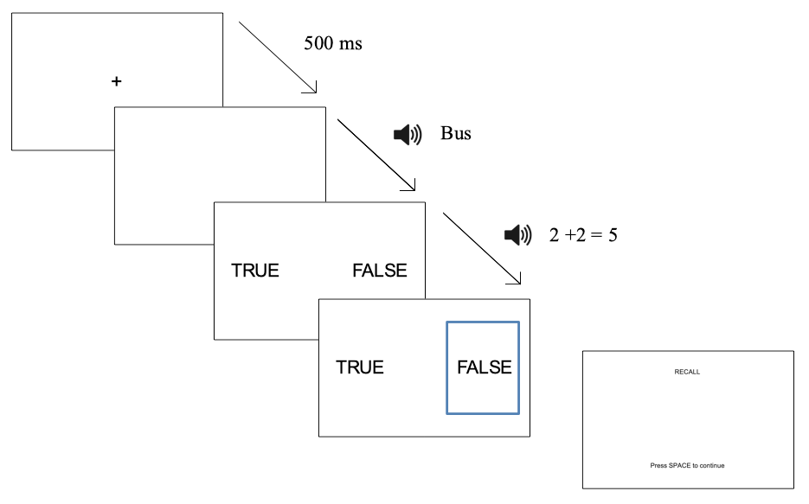

*Figure* *2:*. Sample trial of the OSpan

## 4.3. Statistical analysis

Statistical analyses were conducted on R (R Core Team, 2019) using the packages lme4 (D. Bates, Mächler, Bolker, & Walker, 2014) and multcomp (Hothorn et al., 2016). The gaze-fixation data was shifted 200 ms. to account for the time it takes to plan and launch a saccade (e.g., Fischer, 1992; Saslow, 1967), downsampled to 10 ms. and 50 ms. bins and centered at the onset of the last syllable of target items. The empirical logit transformation was applied to binary responses (fixations on target or distractor; Barr, 2008). The 10 ms. bins were run through independent t-tests to find out whether participants were anticipating the correct verbal tense upon hearing a stressed or unstressed initial syllable. The 50 ms. bins were used to model a growth curve analysis (Mirman, 2016) to observe how the pattern of gaze fixations changed as suprasegmental and segmental information became available. The models with the time course were implemented by using linear, quadratic, and cubic orthogonal polynomials with the independent variables group and lexical stress. The monolinguals served as baseline. Lexical stress had been sum-coded. By-subject and by-item random effects were also tested. Nested model comparisons were implemented to assess main effects and interactions. For the OSpan, reaction times to the mathematical problems were averaged and used as score, since different languages have differnt memory score and therefore are not comparable. The proficiency was analyzed as a continuous scale. OSpan scores were used as homogeneity measure.

**5. Results**

Spanish speakers’ results are presented first, followed by comparisons between L2 groups. The summary for the full model of the Growth Curve Analysis is in the Appendices 2 and 3. The model also estimated the probability of fixations on the target at the offset of the first syllable in the verb; the probabilities were estimated for each group in both lexical stress conditions (see Table 1; stressed syllable = present, unstressed syllable = preterit). These probabilities are contained in Table 1.

The model intercept estimates the log odds of SS fixating their gaze on the target averaging across lexical stress condition and time course (*γ*00 = 1.717, SE = 0.149. *t* = 11.488, *p* = < .001) with a probability of 0.86 (LB = 0.83, UB = 0.89) in the present tense and of probability = 0.86 (LB = 0.83, UB = 0.89) in the preterit tense. The value for the intercept along with the probabilities suggest that SS were anticipating correctly.

There was a main effect of group indicating that L2 speakers predicted less than SS (AE: *γ*01 = −0.698, SE = 0.178. *t* = −3.921, *p* = < .001; AM: *γ*11 = −0.620, SE = 0.178. *t* = −3.480, *p* = < .001; IE: *γ*21 = −0.732, SE = 0.177. *t* = −4.138, *p* = < .001; IM: *γ*31 = −1.198, SE = 0.178. *t* = −6.730, *p* = < .001). The two fit plots in Figure 3 reflect this trend in both tenses. The estimates for the intercept demonstrate that IM was the group that most differed from SS in their ability to anticipate. As seen in Figure 3, the fixation log odds for SS crosses the intercept at a higher point than the log odds for the L2 groups, indicating that SS were fixating more on the target verb at the offset of the first syllable. The estimated probabilities suggest nonetheless that all L2 groups were still anticipating, except for IM in the present tense (AE x present: probability = 0.57, LB = 0.51, UB = 0.62; AE x preterit: probability = 0.71, LB = 0.66, UB = 0.76; AM x present: probability = 0.72, LB = 0.67, UB = 0.76; AM x preterit: probability = 0.62, LB = 0.56, UB = 0.67; IE x present: probability = 0.64, LB = 0.59, UB = 0.70; IE x preterit: probability = 0.63, LB = 0.57, UB = 0.68; IM x present: probability = 0.50, LB = 0.44, UB = 0.56; IM x preterit: probability = 0.56, LB = 0.51, UB = 0.62).

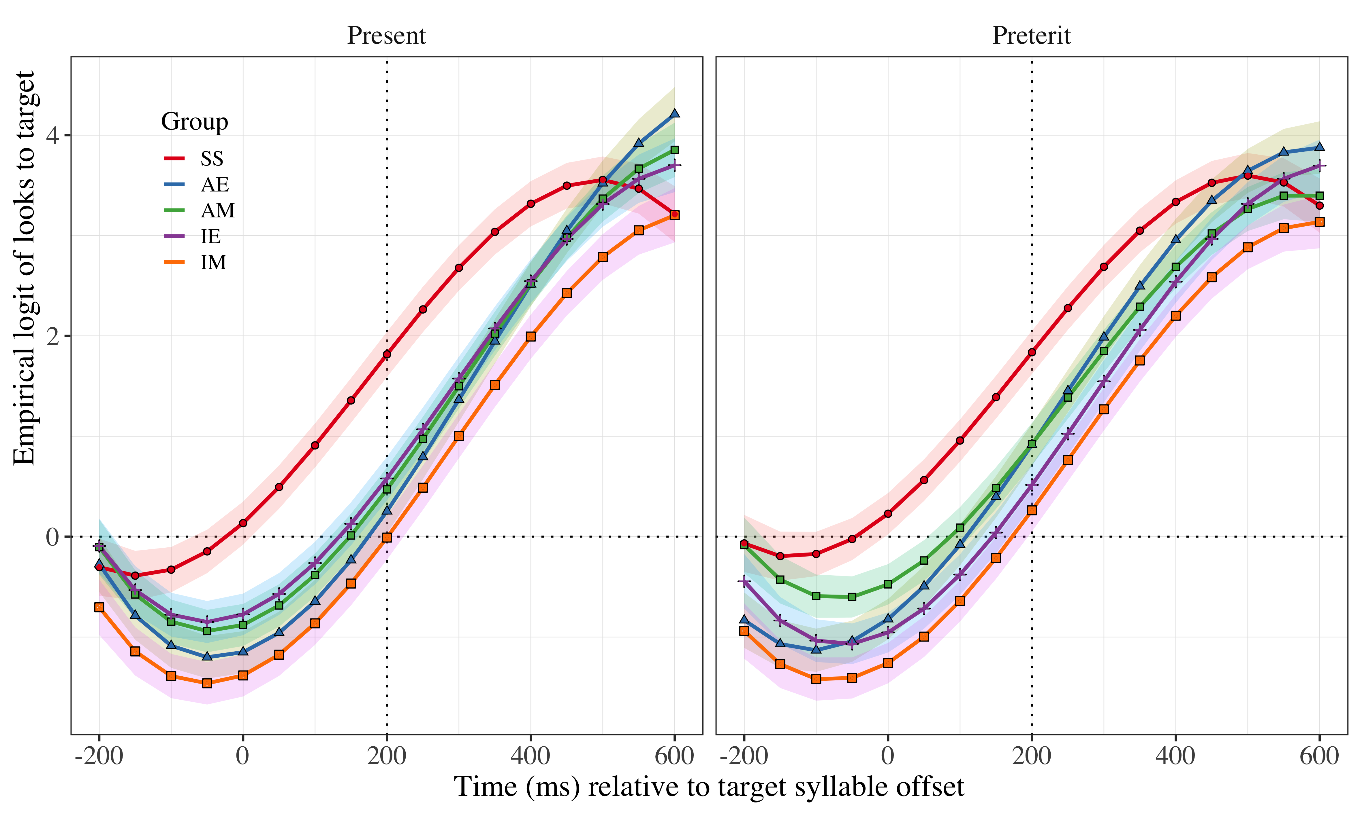

*Figure* *3*. Growth curve analysis estimates of fixations on the target as a function of lexical stress for each group during the analysis window. Symbols and lines represent model estimates, and the ribbons represent ±SE. Empirical logit values on y-axis correspond to proportions of 0.12, 0.50, 0.88, and 0.98. The horizontal dotted line represents the 50% probability of fixating on the targets. The vertical dotted line indicates 200 ms after the offset of the target syllable

There was also a main effect of the linear term and of the cubic term (*γ*10 = 5.856, SE = 0.440. *t* = 13.312, *p* = < .001; *γ*30 = −1.343, SE = 0.182. *t* = −7.382, *p* = < .001, respectively). These two effects indicate that the slopes were bowed differently across groups—slopes were steeper and bows more closed in the L2 groups (see Fig. 3). The interactions in the linear and cubic polynomial time terms reflect the sigmoid shape of the time course and were retained in the model because they improved the model fit (*β* = 16.939, *df* = 4, *p* = .002). Keeping these interactions yielded an effect caused by the group AE in the linear term (*γ*12 = 1.455, SE = 0.512. *t* = 2.844, *p* = .004), revealing that AE increased their gaze fixations on the target faster than any other group once they started anticipating (see Fig. 3). There was also an effect of all groups in the quadratic term (AE: *γ*13 = 1.997, SE = 0.417. *t* = 4.795, *p* = < .001; AM: *γ*23 = 1.861, SE = 0.417. *t* = 4.466, *p* = < .001; AE: *γ*33 = 1.997, SE = 0.414. *t* = 4.825, *p* = < .001; AM: *γ*04 = 1.830, SE = 0.417. *t* = 4.391, *p* = < .001) that indicates that the quadratic curve was more bowed for the L2 speakers, reflecting that all L2 groups predicted later than SS.

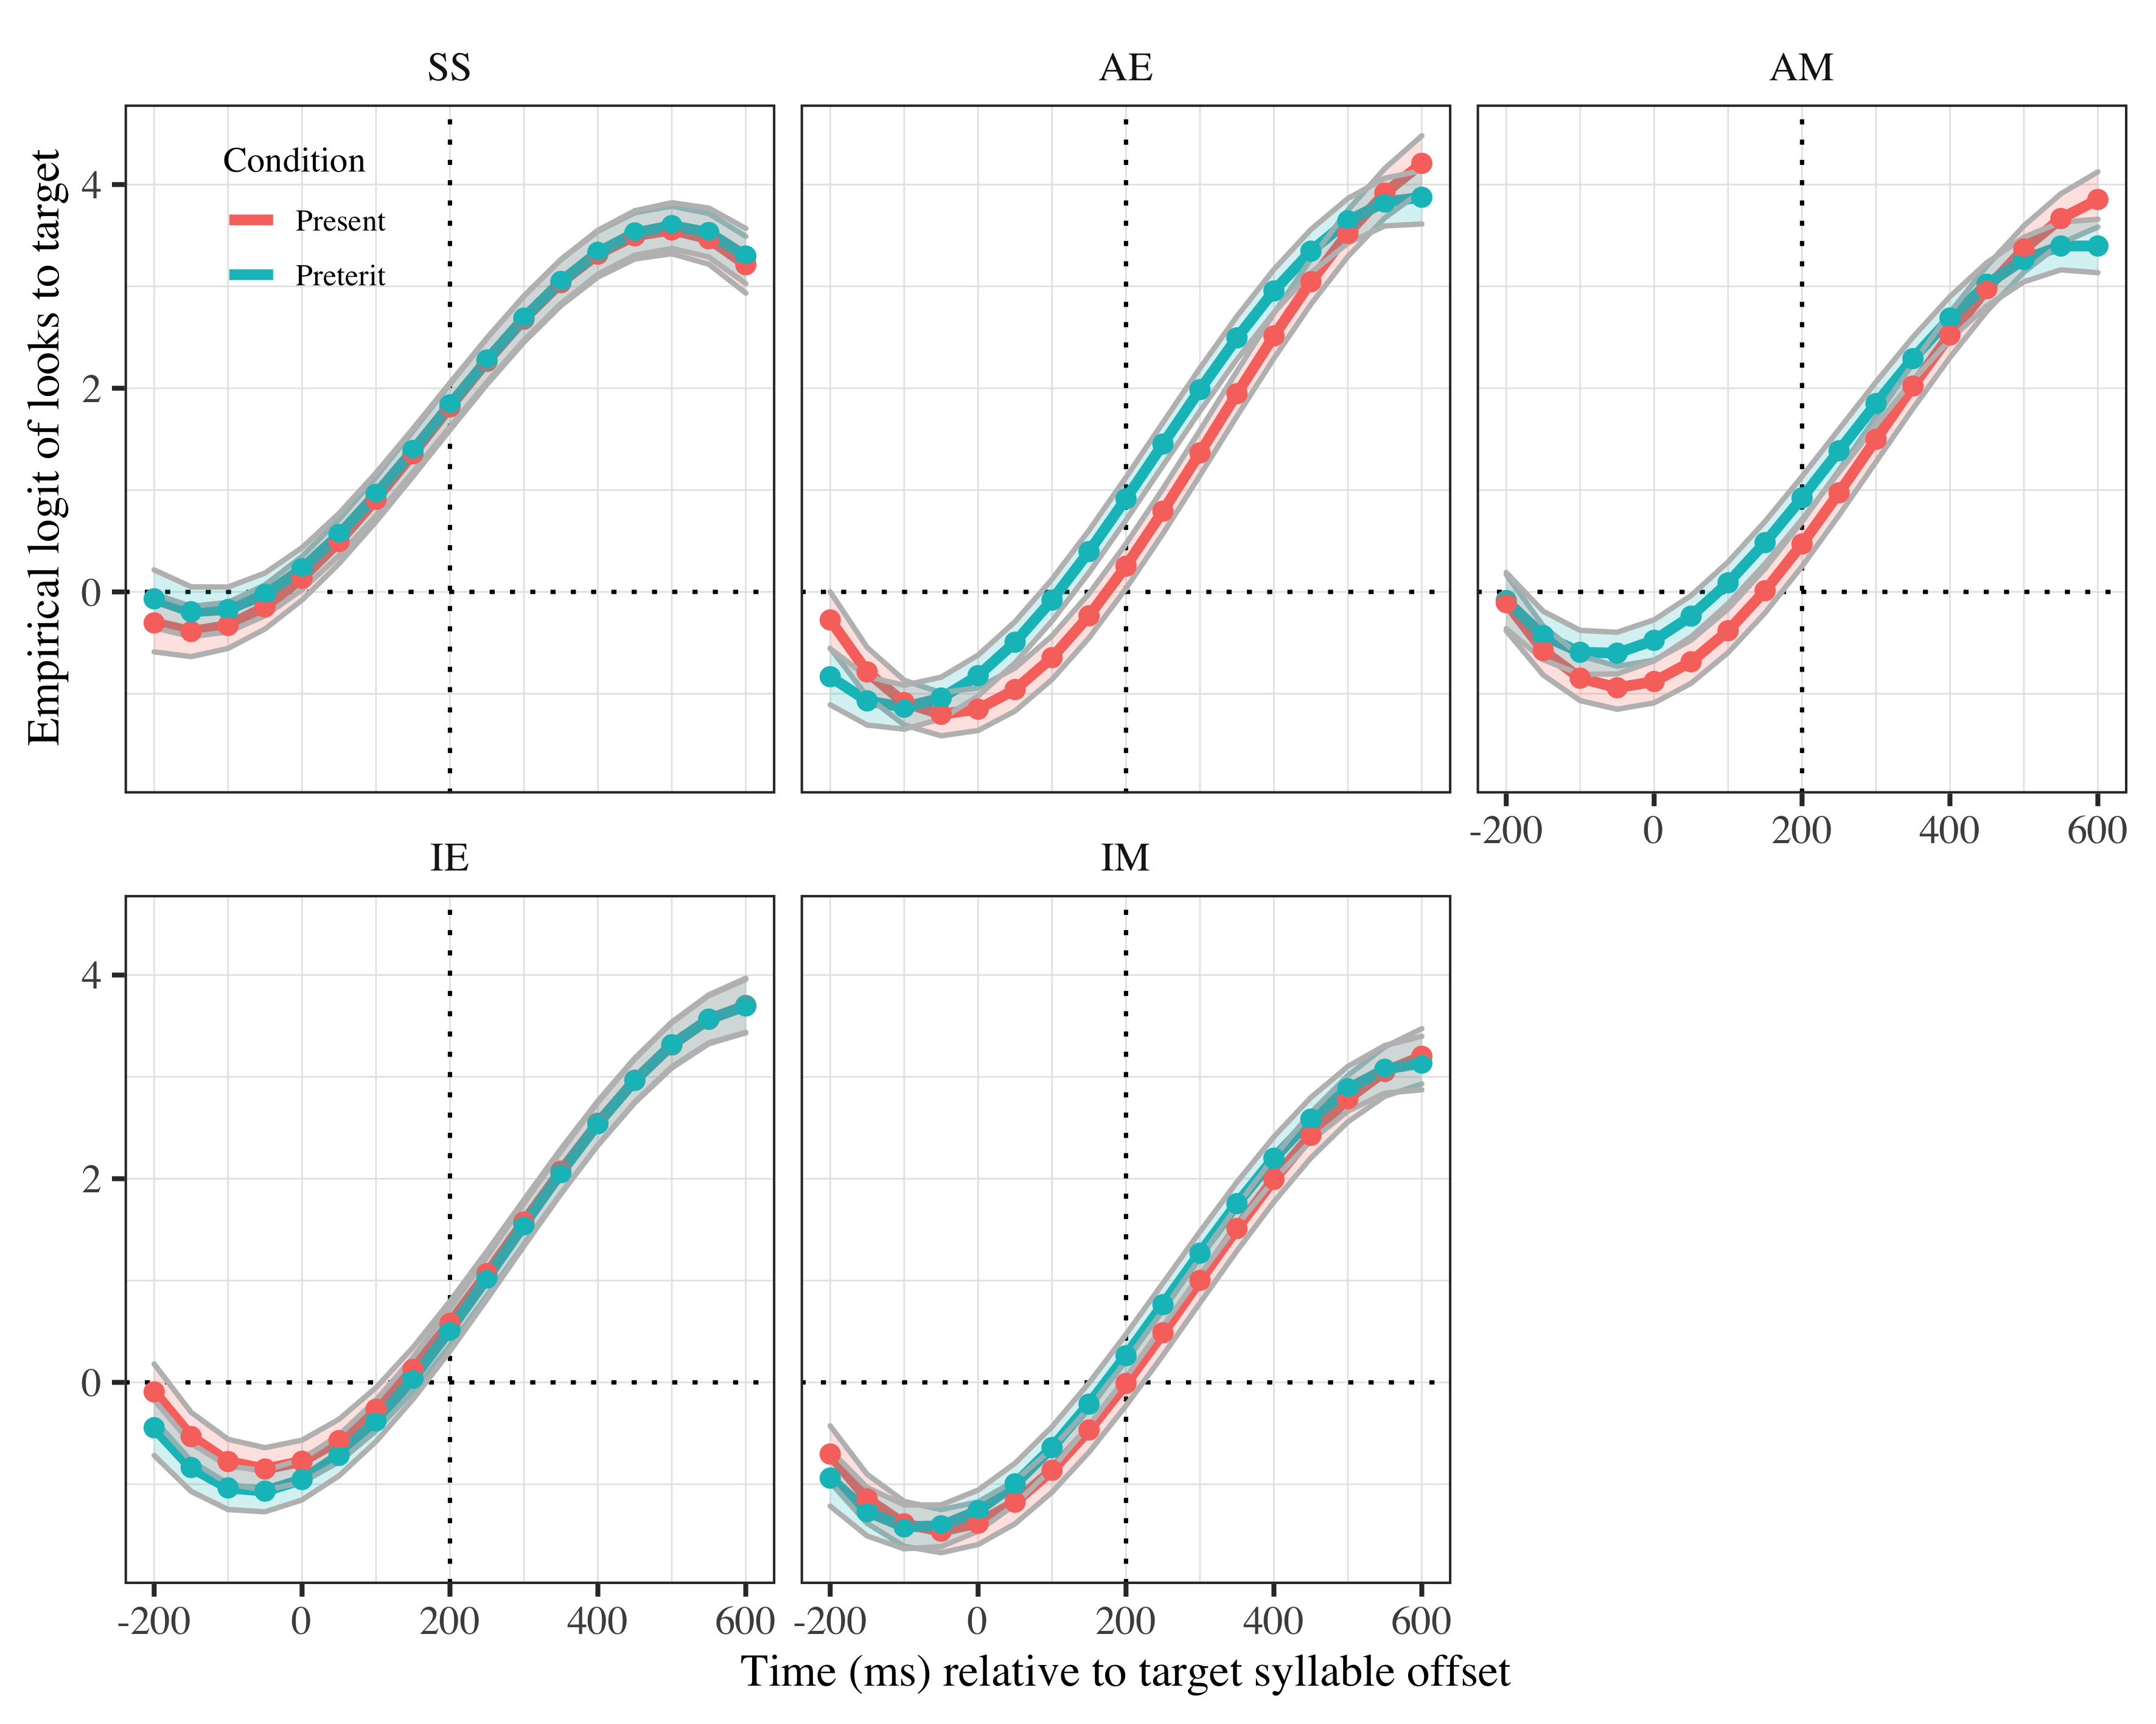

*Figure* *4*. Growth curve analysis estimates of fixations on target as a function of lexical stress for each group during the analysis window. Lines represent model estimates, and the transparent ribbons represent ±SE. Empirical logit values on y-axis correspond to proportions of 0.12, 0.50, 0.88, and 0.98. The horizontal dotted line represents the 50% probability of fixating on the targets. The vertical dotted line indicates 200 ms after the offset of the target syllable.

Keeping the term interactions also yielded a more complex interaction effect in the quadratic term between AE and lexical stress (*γ*36 = 0.174, SE = 0.241. *t* = 0.720, *p* = .471) and between AM and lexical stress (GroupAM x Lexical stress: *γ*00 = 0.386, SE = 0.243. *t* = 1.592, *p* = .111). This interaction shows that advanced L2 learners fixated more on the target in the preterit tense than they did in the present tense (see Fig. 4). This increased number of fixations reveals that preterit tense may be easier to anticipate than present tense. Figure 4 reflects the anticipation abilities difference in the advanced groups in the preterit tense towards the present tense. This difference consists of earlier increased fixations on the target verb in the preterit tense upon hearing a lexically unstressed syllable and is represented in the figure by the shift of the preterit tense line to the left in comparison to the present tense line.

Pairwise comparisons analyze performance across L2 groups. The pairwise comparisons are in Appendices 4 (advanced groups), 5 (intermediate groups), 6 (English groups) and 7 (Mandarin groups). Comparing speakers of the same L1 across proficiency, there is only a difference in the quadratic term for the L1 English speakers (*γ*19 = −0.685, SE = 0.237. *t* = −2.887, *p* = .004), such that IE anticipate less than AE in the preterit tense. As for L1 Mandarin Chinese speakers, there is only an effect on the intercept, where IM is shown to predict less than AM averaging across time course and stress conditions (*γ*08 = −0.579, SE = 0.175. *t* = −3.304, *p* = < .001). That is, AM predict better overall than IM. Comparing speakers of different L1s with similar proficiency, there was a significant effect on the intercept between IE and IM, such that IE had a higher fixation rate on the target than IM, indicating higher prediction in IE (*γ*08 = −0.467, SE = 0.174. *t* = −2.685, *p* = .007). At advanced proficiency, there was an effect of group on the linear term, demonstrating that AM increased their fixations on the target less steeply than AE in both stress conditions (−1.113, SE = 0.503. *t* = −2.210, *p* = .027).

The data in this study revealed that all groups except IM anticipated. SS was the group that anticipated most and the earliest. Within-group performance was similar across tense conditions for the intermediate groups and SS. For both advanced groups, preterit tense was easier to anticipate than present. Over proficiency, Mandarin speakers improved their prediction ability; English speakers improved overall although the anticipation performance difference is smaller.

# 6. Discussion

In this project, we investigated the effect of L1 transfer on Mandarin and English L2 learners of Spanish’s ability to anticipate verbal tense morphology based on lexical stress. For that purpose, participants completed a visual-world paradigm in Spanish and we compared them to a monolingual group of Spanish. Results revealed that monolingual speakers and advanced L2 Spanish speakers from both L1s were able to generate the correct predictions. Advanced speakers did not reach monolingual-like prediction performance. Intermediate English speakers were also able to predict verb tense based on lexical stress, but intermediate Mandarin speakers were not. While Mandarin speakers’ ability to predict improved over proficiency, English speakers’ ability did not improve significantly. These results suggest that L1 transfer took place at both intermediate and advanced levels of proficiency, although cross-linguistic effects affected the populations differently. We discuss our findings following our research questions.

*1. Do Spanish monolinguals, and intermediate and advanced Mandarin and English learners of Spanish use lexical stress to anticipate verbal suffixes in Spanish?*

We had predicted that monolingual speakers and advanced speakers of both L1s would generate anticipations, but intermediate speakers would not. Our results confirm that monolingual and advanced L2 speakers were able to anticipate and intermediate Mandarin speakers would not. Against our predictions, intermediate English speakers were able to anticipate.

Monolingual and advanced English speakers’ ability to anticipate tense suffixes according to lexical stress matches previous findings regarding morphophonological associations, at least when the cue is contained in a CVC syllable (e.g., Lozano-Argüelles, Sagarra, & Casillas, 2019; Sagarra & Casillas, 2018). With respect to advanced Mandarin speakers, this is the first study to show that they can generate predictions in an L2 based on morphophonological associations. It should be noted, nonetheless, that they may need longer to create the associations in comparison to native speakers of other languages, probably due to cross-linguistic effects, as our results with intermediate speakers suggest. In any case, anticipation performance at advanced levels did not reach monolingual-like levels, adding to the evidence that L2 speakers will rarely be as efficient as in their L1 (Perdomo & Kaan, 2019).

For the advanced groups, preterit tense is easier to anticipate than present tense. A possible explanation is that they are initially unsure as to what the meaning of stress really is in the present tense, whether it carries only lexical information or has other intonational and pragmatic meaning. In the preterit tense, however, there is no room for different alternatives as there is no stress, leading into an earlier use of the lexically unstressed syllable to anticipate word ending. The data also suggest that English speakers improve at anticipating the preterit tense over proficiency but remain approximately the same in the present tense. The initial advantage in the present tense might be caused by a more typical use of present tense, providing them with more frequent examples to create associations for this tense.

Another point worth mentioning about the advanced English speakers is that they anticipate faster than any other group, monolinguals included. This finding contrasts with Lozano-Arguelles et al. (2019), who found that it was interpreters who anticipated faster, and not non-interpreters. This contrast can be explained if anticipation can be facilitated by more than one factor, rather than only anticipatory experience. In the present study, immersion could be a factor contributing to a faster increase of fixations on the target in the advanced English group. The fact that immersion did not allow advanced Mandarin speakers to increase their eye fixations as fast is because the associations in the advanced Mandarin group contain more noise than in the advanced English group. The faster increase in English speakers in comparison to monolinguals may be explained through a larger effort in the L2 group. That is, monolingual speakers need to recruit fewer cognitive resources to process the association, while the advanced English group is investing more resources in the processing, resulting in an ‘over-achievement’.

Intermediate Mandarin speakers could not make morphophonological predictions, but intermediate English speakers did. Intermediate Mandarin speakers’ inability to anticipate may be due to two reasons. One, that they still have not acquired the association. Two, that the associations are not stable and therefore cannot be applied for prediction during language processing. The present results do not allow to ascertain for sure why they are not anticipating. Future research should focus in teasing apart the development of morphophonological associations.

The performance of the intermediate English speakers herein contrasts with intermediate speakers’ anticipatory performance in previous studies, in which intermediate speakers did not anticipate (Sagarra & Casillas, 2018). This difference can be explained through linguistic context. The L2 speakers in the current study were living immersed in the L2, while the L2 speakers in Sagarra and Casillas (2018)’s were not. We should note, however, that target syllables in Sagarra and Casillas (2018) could be either CV or CVC, while here they were only CVC, potentially facilitating anticipation by reducing the number of options to process. Future studies should explore whether immersed L2 speakers can generate predictions with CV syllables too, or whether the beneficial effects of immersion is reduced to CVC syllables only. The possible beneficial effect of linguistic context in creating anticipatory associations is corroborated by similar studies demonstrating that intermediate L2 speakers of Central Swedish do use tones as cues to verb suffixes when living immersed in the L2 (Hed, Schremm, Horne, & Roll, 2019; Schremm, Söderström, Horne, & Roll, 2016) and that activation of linguistic elements is faster in immersion contexts (Beatty-Martı́nez et al., 2019). Given that the present study did not include L2 groups to analyze linguistic context as a predictor, it is impossible to ascertain whether there would also be differences between advanced L2 groups living in L1 or L2 contexts.

*2. How does anticipation performance compare across L1s within proficiency level?*

We had hypothesized that English speakers would develop anticipatory associations earlier than Mandarin speakers because of the closer proximity between English and Spanish than Mandarin and Spanish. The results confirm our prediction. Intermediate Mandarin speakers did not use lexical stress as a cue to morphology, especially in the present tense. In contrast, intermediate English speakers did generate anticipations. At advanced proficiency, Mandarin speakers do provide evidence of such ability.

The different levels of struggle revealed at intermediate stages may be explained through cross-linguistic effects. The earlier creation of anticipatory association in English speakers may be buttressed by their knowledge of lexical contrastive function in English. These speakers may be using their knowledge of lexical stress in English to contrast present and preterit tense in Spanish as well. In their case, transfer would be positive. Transfer can also explain why they anticipate similarly both tenses. The successful application of lexical stress knowledge along with the need to use any resource to process a language in which they are not proficient may be making the English intermediate speakers hyper-aware of phonological processes. This hyper-awareness would be the cause of the similar anticipation abilities in both conditions.

Intermediate Mandarin speakers could not generate predictions reliable or successfully. In their case, knowledge of lexical stress in the L1, if they have it (Selkirk & Shen, 1990), may be confused with tone representation, making it impossible for them to transfer lexical stress knowledge successfully. They would be suffering negative L1 transfer. In order to overcome the effects of negative transfer, Mandarin speakers would therefore need longer exposure to the L2 to offset the initial blocking imposed by the transfer and create anticipatory associations. The similar performance of advanced Mandarin and English speakers suggests that there is an exposure or a developmental threshold such that, once it has been crossed, cross-linguistic effects diminish and speakers process linguistic information equally regardless of their L1.

The anticipatory ability in advanced speakers may be due to an increased exposure to the L2. Having reached a threshold of exposure as mentioned before may in fact have allowed them to overcome the anticipatory struggle they reflect at intermediate stages and to perform equally well as English learners. The fact that both advanced groups start anticipating at the same time suggests that mappings are stable in the lexicon to the same degree. However, the fact that English speakers anticipate faster once the association is activated reveals that the properties of the representation are different. The transfer they suffered at lower levels of proficiency may remain in the associations that allow them to predict as “noise.” If this were the case, the associations in the Chinese speakers would contain more noise from the cross-linguistic effects than associations in the English speakers. This reason also aligns with the performance the corresponding intermediate groups show, in that intermediate English speakers are benefited by transfer while intermediate Mandarin speakers are not. Furthermore, if we accept that the associations have ‘noise,’ it is possible to explain why the advanced groups do not anticipate as early as monolinguals. The noise caused by transfer would be preventing the early activation. Future studies may examine whether explicit instruction, or at least focused instruction (Hed, Schremm, Horne, & Roll, 2019; Schremm, Novén, Horne, & Roll, 2017), may help in getting rid of the noise or preventing its inclusion in the first place.

# 7. Conclusion

This study explored transfer in the creation of anticipatory associations within-words. Mandarin Chinese and English speakers completed a visual-world paradigm that measured their abilities to predict tense suffixes through lexical stress cues. Intermediate English speakers and advanced speakers could make predictions, but intermediate Mandarin speakers could not. Our findings thus demonstrate that within-word associations can be acquired implicitly, although this acquisition will be biased by cross-linguistic effects from the L1. A more similar structure will result in positive influence, while a more distant encoding will result in negative transfer. Cross-linguistic effects in associations are likely to fade as proficiency increases. These findings thus provide a reason why second language speaker may have difficulties in processing a second language. If they suffer from transfer that reflects in the associations they use for language processing, their comprehension will be hindered inasmuch the transfer impedes the creation of the association and is contained in it.

# References

Altmann, G. T., & Kamide, Y. (1999). Incremental interpretation at verbs: Restricting the domain of subsequent reference. *Cognition*, *73*(3), 247–264.

Altmann, G. T., & Kamide, Y. (2007). The real-time mediation of visual attention by language and world knowledge: Linking anticipatory (and other) eye movements to linguistic processing. *Journal of Memory and Language*, *57*(4), 502–518.

Barr, D. J. (2008). Analyzing ‘visual world’eyetracking data using multilevel logistic regression. *Journal of Memory and Language*, *59*(4), 457–474.

Bates, D., Mächler, M., Bolker, B., & Walker, S. (2014). Fitting linear mixed-effects models using lme4. *arXiv Preprint arXiv:1406.5823*.

Bates, E., & MacWhinney, B. (1982). Language acquisition: The state of the art. In E. Wanner & L. Gleitman (Eds.) (pp. 173–218). New York: Cambridge University Press.

Bates, E., MacWhinney, B., & MacWhinney, B. (1987). Competition, variation, and language learning. *Mechanisms of Language Acquisition*, 157–193.

Beatty-Martı́nez, A. L., Navarro-Torres, C. A., Dussias, P. E., Bajo, M. T., Guzzardo Tamargo, R. E., & Kroll, J. F. (2019). Interactional context mediates the consequences of bilingualism for language and cognition. *Journal of Experimental Psychology: Learning, Memory, and Cognition*.

Bybee, J. (2006). From usage to grammar: The mind’s response to repetition. *Language*, *82*(4), 711–733. Retrieved from <http://www.jstor.org/stable/4490266>

Chao, Y. R. (1968). A grammar of spoken chinese.

Clark, A. (2013). Whatever next? Predictive brains, situated agents, and the future of cognitive science. *Behavioral and Brain Sciences*, *36*(3), 181–204.

Cohen, N. J., & Squire, L. R. (1980). Preserved learning and retention of pattern-analyzing skill in amnesia: Dissociation of knowing how and knowing that. *Science*, *210*(4466), 207–210.

Cooper, N., Cutler, A., & Wales, R. (2002). Constraints of lexical stress on lexical access in english: Evidence from native and non-native listeners. *Language and Speech*, *45*(3), 207–228.

Cutler, A. (1986). Forbear is a homophone: Lexical prosody does not constrain lexical access. *Language and Speech*, *29*(3), 201–220.

Duanmu, S. (2007). *The phonology of standard chinese*. OUP Oxford.

Dussias, P. E., Kroff, J. R. V., Tamargo, R. E. G., & Gerfen, C. (2013). When gender and looking go hand in hand: Grammatical gender processing in L2 spanish. *Studies in Second Language Acquisition*, *35*(2), 353–387.

Ellis, Nick C. (2006). Cognitive perspectives on SLA: The associative-cognitive CREED. *Aila Review*, *19*(1), 100–121.

Ellis, Nick C. (2008). *Usage-based and form-focused language acquisition: The associative learning of constructions, learned attention, and the limited L2 endstate.* Routledge/Taylor & Francis Group.

Ellis, Nick C., & Sagarra, N. (2010). The bounds of adult language acquisition: Blocking and learned attention. *Studies in Second Language Acquisition*, *32*(4), 553–580. <https://doi.org/10.1017/S0272263110000264>

Fischer, B. (1992). Saccadic reaction time: Implications for reading, dyslexia, and visual cognition. In *Eye movements and visual cognition* (pp. 31–45). Springer.

Fry, D. B. (1955). Duration and intensity as physical correlates of linguistic stress. *The Journal of the Acoustical Society of America*, *27*(4), 765–768.

Fry, D. B. (1958). Experiments in the perception of stress. *Language and Speech*, *1*(2), 126–152.

Gandour, J. T., & Fromkin, V. (1978). The perception of tone in tone: A linguistic survey.

Gosselke Berthelsen, S., Horne, M., Brännström, K. J., Shtyrov, Y., & Roll, M. (2018). Neural processing of morphosyntactic tonal cues in second-language learners. *Journal of Neurolinguistics*, *45*, 60–78.

Gosselke Berthelsen, S., Horne, M., Shtyrov, Y., & Roll, M. (2020). Different neural mechanisms for rapid acquisition of words with grammatical tone in learners from tonal and non-tonal backgrounds: ERP evidence. *Brain Research*, *1729*, 146614.

Grüter, T., Takeda, A., Rohde, H., & Schafer, A. J. (2016). L2 listeners show anticipatory looks to upcoming discourse referents. In *Poster presented at the 41st annual boston university conference on language development, boston university* (pp. 4–6).

Hed, A., Schremm, A., Horne, M., & Roll, M. (2019). Neural correlates of second language acquisition of tone-grammar associations. *The Mental Lexicon*, *14*(1), 98–123.

Hopp, H. (2010). Ultimate attainment in L2 inflection: Performance similarities between non-native and native speakers. *Lingua*, *120*(4), 901–931.

Hothorn, T., Bretz, F., Westfall, P., Heiberger, R. M., Schuetzenmeister, A., Scheibe, S., & Hothorn, M. T. (2016). Package ‘multcomp.’ *Simultaneous Inference in General Parametric Models. Project for Statistical Computing, Vienna, Austria*.

Hu, J., Gao, S., Ma, W., & Yao, D. (2012). Dissociation of tone and vowel processing in m andarin idioms. *Psychophysiology*, *49*(9), 1179–1190.

Hualde, J. I. (2005). *The sounds of spanish with audio CD*. Cambridge University Press.

Huettig, F., & Mani, N. (2016). Is prediction necessary to understand language? Probably not. *Language, Cognition and Neuroscience*, *31*(1), 19–31.

Hyman, L. (1977). On the nature of linguistic stress. *Studies in Stress and Accent*, *4*, 37–82.

Jun, S.-A., & Oh, M. (2000). Acquisition of second language intonation. *The Journal of the Acoustical Society of America*, *107*, 2802.

Kaan, E. (2014). Predictive sentence processing in L2 and L1: What is different? *Linguistic Approaches to Bilingualism*, *4*(2), 257–282.

Kuperberg, G. R., & Jaeger, T. F. (2016). What do we mean by prediction in language comprehension? *Language, Cognition and Neuroscience*, *31*(1), 32–59.

Lado, R. (1957). *Linguistics across cultures: Applied linguistics for language teachers*. University of Michigan press.

Lew-Williams, C., & Fernald, A. (2010). Real-time processing of gender-marked articles by native and non-native spanish speakers. *Journal of Memory and Language*, *63*(4), 447–464.

Li, P., & MacWhinney, B. (2012). Competition model. *The Encyclopedia of Applied Linguistics*.

Lin, M., & Yan, J. (1980). Beijinghua qingshen de shengxue xingzhi [acoustic characteristics of neutral tone in beijing mandarin]. *Fangyan*, *3*, 166–178.

Lozano-Argüelles, C., Sagarra, N., & Casillas, J. V. (2019). Slowly but surely: Interpreting facilitates L2 morphological anticipation based on suprasegmental and segmental information. *Bilingualism: Language and Cognition*, 1–11.

Luk, Z. P., & Shirai, Y. (2009). Is the acquisition order of grammatical morphemes impervious to L1 knowledge? Evidence from the acquisition of plural-s, articles, and possessive’s. *Language Learning*, *59*(4), 721–754.

MacWhinney, B. (1997). Second language acquisition and the competition model. *Tutorials in Bilingualism: Psycholinguistic Perspectives*, *113*, 142.

MacWhinney, B., & MacWhinney, B. (1987). The competition model. *Mechanisms of Language Acquisition*, 249–308.

Malins, J. G., & Joanisse, M. F. (2010). The roles of tonal and segmental information in mandarin spoken word recognition: An eyetracking study. *Journal of Memory and Language*, *62*(4), 407–420.

Melby-Lervåg, M., & Lervåg, A. (2011). Cross-linguistic transfer of oral language, decoding, phonological awareness and reading comprehension: A meta-analysis of the correlational evidence. *Journal of Research in Reading*, *34*(1), 114–135.

Mirman, D. (2016). *Growth curve analysis and visualization using r*. CRC press.

Ortega-Llebaria, M. (2006). Phonetic cues to stress and accent in spanish. In *Selected proceedings of the 2nd conference on laboratory approaches to spanish phonetics and phonology* (pp. 104–118). Cascadilla Proceedings Project Somerville, MA.

Ortega-Llebaria, M., & Prieto, P. (2007). Disentangling stress from accent in spanish: Production patterns of the stress contrast in deaccented syllables. *Amsterdam Studies in the Theory and History of Linguistic Science Series 4*, *282*, 155.

Ortega-Llebaria, M., & Prieto, P. (2009). Perception of word stress in castilian spanish. *Phonetics and Phonology: Interactions and Interrelations*, *306*, 35.

Perdomo, M., & Kaan, E. (2019). Prosodic cues in second-language speech processing: A visual world eye-tracking study. *Second Language Research*, 0267658319879196.

R Core Team. (2019). *R: A language and environment for statistical computing*. Vienna, Austria: R Foundation for Statistical Computing. Retrieved from <https://www.R-project.org/>

Rast, R. (2010). The role of linguistic input in the first hours of adult language learning. *Language Learning*, *60*, 64–84.

Rehrig, G. L. (2017). *Acoustic correlates of syntax in sentence production and comprehension* (PhD thesis). Rutgers University-School of Graduate Studies.

Roll, M., Horne, M., & Lindgren, M. (2010). Word accents and morphology—ERPs of swedish word processing. *Brain Research*, *1330*, 114–123.

Roll, M., Horne, M., & Lindgren, M. (2011). Activating without inhibiting: Left-edge boundary tones and syntactic processing. *Journal of Cognitive Neuroscience*, *23*(5), 1170–1179.

Roll, M., Söderström, P., & Horne, M. (2013). Word-stem tones cue suffixes in the brain. *Brain Research*, *1520*, 116–120.

Romberg, A. R., & Saffran, J. R. (2010). Statistical learning and language acquisition. *Wiley Interdisciplinary Reviews: Cognitive Science*, *1*(6), 906–914.

Sagarra, N. (2008). Understanding second language process. In Z. Han (Ed.) (pp. 133–147). Multilingual Matters Clevedon.

Sagarra, N. (2020). Research on second language processing and processing instruction: Studies in honor of bill VanPatten. In G. D. K. Michael J. Leeser & W. Wong (Eds.) (pp. 126–150). John Benjamins Publishing Company.

Sagarra, N., & Casillas, J. V. (2018). Suprasegmental information cues morphological anticipation during L1/L2 lexical access. *Journal of Second Language Studies*, *1*(1), 31–59.

Sagarra, N., & Ellis, N. C. (2013). From seeing adverbs to seeing verbal morphology: Language experience and adult acquisition of L2 tense. *Studies in Second Language Acquisition*, *35*(2), 261–290.

Sagarra, N., & Herschensohn, J. (2010). The role of proficiency and working memory in gender and number agreement processing in L1 and L2 spanish. *Lingua*, *120*(8), 2022–2039.

Salverda, A. P., Kleinschmidt, D., & Tanenhaus, M. K. (2014). Immediate effects of anticipatory coarticulation in spoken-word recognition. *Journal of Memory and Language*, *71*(1), 145–163.

Saslow, M. (1967). Effects of components of displacement-step stimuli upon latency for saccadic eye movement. *Josa*, *57*(8), 1024–1029.

Schremm, A., Novén, M., Horne, M., & Roll, M. (2017). The influence of the cortical thickness of planum temporale on word tone processing in swedish native speakers. In *Cognitive neuroscience society annual meeting 2017*.

Schremm, A., Söderström, P., Horne, M., & Roll, M. (2016). Implicit acquisition of tone-suffix connections in L2 learners of swedish. *The Mental Lexicon*, *11*(1), 55–75.

Schwartz, B. D., & Sprouse, R. A. (1996). L2 cognitive states and the full transfer/full access model. *Second Language Research*, *12*(1), 40–72.

Selkirk, E., & Shen, T. (1990). Prosodic domains in shanghai chinese. *The Phonology-Syntax Connection*, *313*.

Sereno, J. A., & Lee, H. (2015). The contribution of segmental and tonal information in mandarin spoken word processing. *Language and Speech*, *58*(2), 131–151.

Shih, C., & Lu, H.-Y. D. (2010). Prosody transfer and suppression: Stages of tone acquisition. In *Speech prosody 2010-fifth international conference*.

Simon, E. (2010). Phonological transfer of voicing and devoicing rules: Evidence from L1 Dutch and L2 English conversational speech. *Language Sciences*, *32*(1), 63–86.

Simon, E. (2010). Phonological transfer of voicing and devoicing rules: Evidence from L1 Dutch and L2 English conversational speech. *Language Sciences*, *32*(1), 63–86.

Soto-Faraco, S., Sebastián-Gallés, N., & Cutler, A. (2001). Segmental and suprasegmental cues for lexical access in spanish. *Journal of Memory and Language*, *45*, 412–432.

Unsworth, N., Heitz, R. P., Schrock, J. C., & Engle, R. W. (2005). An automated version of the operation span task. *Behavior Research Methods*, *37*(3), 498–505.

Wiener, S., & Turnbull, R. (2016). Constraints of tones, vowels and consonants on lexical selection in mandarin chinese. *Language and Speech*, *59*(1), 59–82.

Yang, M., Cooc, N., & Sheng, L. (2017). An investigation of cross-linguistic transfer between chinese and english: A meta-analysis. *Asian-Pacific Journal of Second and Foreign Language Education*, *2*(1), 1–21.

Zhu, X., & Wang, C. (2015). The oxford handbook of chinese linguistics. In W. S. Wang & C. Sun (Eds.). Oxford University Press.