The title

The title

# Brain: Language and Cognition article (stress, natives and late advanced and intermediate EN y Ma Ch,

# auditory anticipation of pitch and rhythm

## Overview

This document contains updates to the statistical analysis for vision experiment. Last updated on 2021-02-06. The results section can be copied and pasted into the corresponding google doc. The tables can also be copied and pasted where appropriate.

# Plots

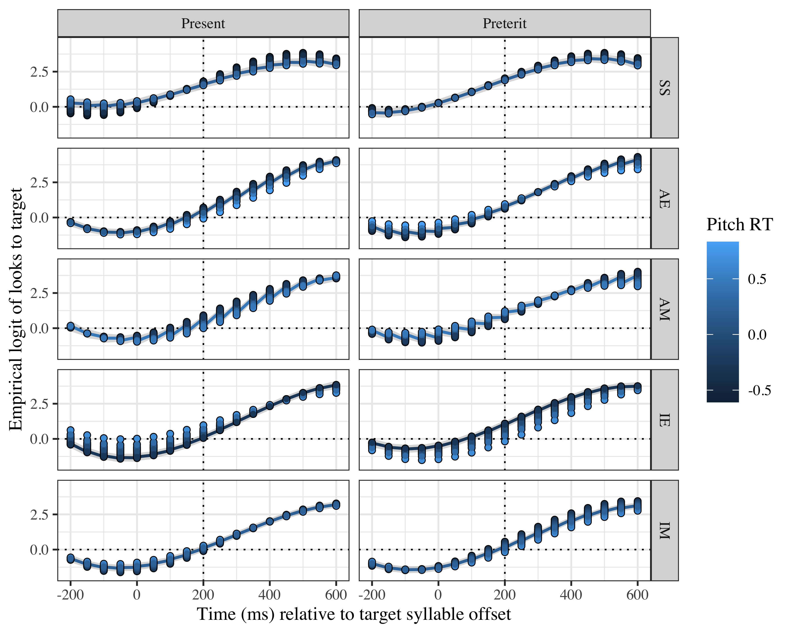

*Figure* *1:*. Growth curve estimates of target fixations as a function of pitch anticipatory abilities for each group and lexical stress pattern during the analysis window. Symbols and lines represent model estimates, and the transparent ribbons represent ±SE. Empirical logit values on y-axis correspond to proportions of 0.12, 0.50, 0.88, and 0.98. The horizontal dotted line represents the 50% probability of fixating on the target. The vertical dotted line indicates 200 ms after the offset of the target syllable. Smaller pitch values represent earlier processing of pitch changes; 0 in the legend represents the mean of all participants.

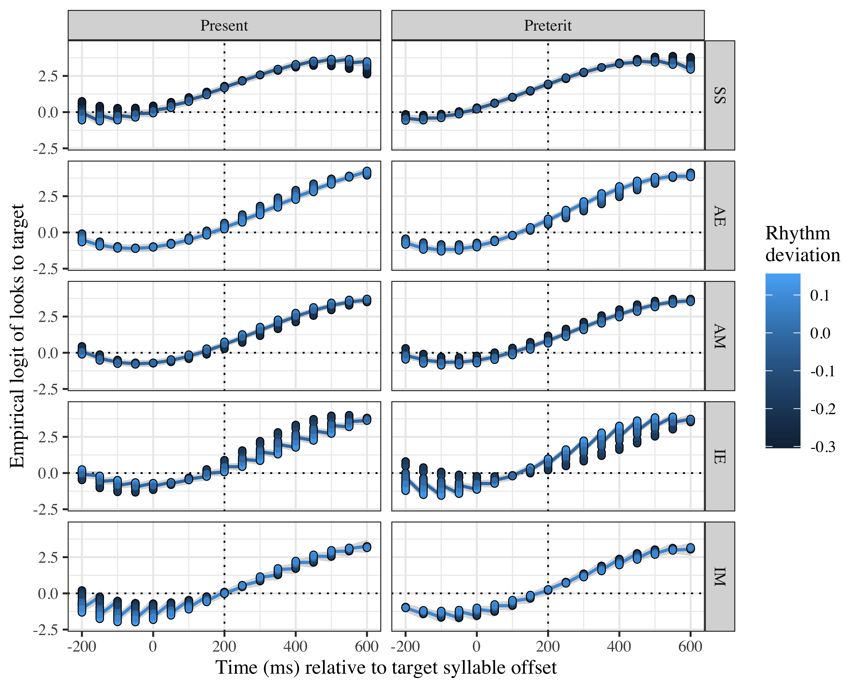

*Figure* *2:*. Growth curve estimates of target fixations as a function of rhythm synchronization abilities for each group and lexical stress patternn during the analysis window. Symbols and lines represent model estimates, and the transparent ribbons represent ±SE. Empirical logit values on y-axis correspond to proportions of 0.12, 0.50, 0.88, and 0.98. The horizontal dotted line represents the 50% probability of fixating on the target. The vertical dotted line indicates 200 ms after the offset of the target syllable. O in rhythm represents ms when imperative beat starts; negative values represent key presses before that ms, positive values posterior presses.

# Tables PITCH

## Model estimates at target syllable offset

Table 1:

| Group | Lexical stress | Pitch (min, max) | Probability | LB | UB |
| --- | --- | --- | --- | --- | --- |
| SS | paroxytone | -0.6078727 | 0.8589752 | 0.8093221 | 0.8973386 |
|  | paroxytone | 0.5416010 | 0.8215942 | 0.7627392 | 0.8683691 |
|  | oxytone | -0.6078727 | 0.8834713 | 0.8420905 | 0.9151014 |
|  | oxytone | 0.5416010 | 0.8681650 | 0.8226447 | 0.9033743 |
| AE | paroxytone | -0.4264489 | 0.6701563 | 0.6057030 | 0.7287913 |
|  | paroxytone | 0.8316417 | 0.4801956 | 0.3696202 | 0.5927459 |
|  | oxytone | -0.4264489 | 0.6508705 | 0.5867399 | 0.7099685 |
|  | oxytone | 0.8316417 | 0.7212709 | 0.6251839 | 0.8005824 |
| AM | paroxytone | -0.3536792 | 0.7138207 | 0.6542289 | 0.7668030 |
|  | paroxytone | 0.5760505 | 0.4988856 | 0.4128645 | 0.5849726 |
|  | oxytone | -0.3536792 | 0.6540493 | 0.5899333 | 0.7130173 |
|  | oxytone | 0.5760505 | 0.7712242 | 0.7072201 | 0.8247046 |
| IE | paroxytone | -0.3336479 | 0.5156783 | 0.4495236 | 0.5812882 |
|  | paroxytone | 0.6545214 | 0.7255127 | 0.6375675 | 0.7988505 |
|  | oxytone | -0.3336479 | 0.7485827 | 0.6967284 | 0.7941899 |
|  | oxytone | 0.6545214 | 0.4552025 | 0.3599321 | 0.5538689 |
| IM | paroxytone | -0.3251569 | 0.4729742 | 0.4032824 | 0.5437353 |
|  | paroxytone | 0.6543619 | 0.5693976 | 0.4804235 | 0.6541052 |
|  | oxytone | -0.3251569 | 0.6365351 | 0.5680347 | 0.6999114 |
|  | oxytone | 0.6543619 | 0.4537374 | 0.3717720 | 0.5382899 |

*Table 1*: Model estimates for probability of target fixations ±SE at 200 ms after the target syllable offset when pitch anticipation abilities taken into account.

## Fixed effects

|  |  |  |  |  |  |
| --- | --- | --- | --- | --- | --- |
| effect | Parameter | Estimate | SE | *t* | *p* |
| fixed | Intercept (γ00) | 1.701 | 0.152 | 11.183 | < .001 |
| fixed | stress_sum (γ10) | −0.055 | 0.073 | −0.763 | .445 |
| fixed | pitch_dev (γ20) | −0.151 | 0.219 | −0.691 | .489 |
| fixed | Time1 (γ30) | 5.703 | 0.444 | 12.849 | < .001 |
| fixed | Time2 (γ01) | −0.381 | 0.324 | −1.174 | .241 |
| fixed | Time3 (γ11) | −1.336 | 0.183 | −7.301 | < .001 |
| fixed | GroupAE (γ21) | −0.682 | 0.179 | −3.803 | < .001 |
| fixed | GroupAM (γ31) | −0.597 | 0.181 | −3.306 | < .001 |
| fixed | GroupIE (γ02) | −0.742 | 0.178 | −4.164 | < .001 |
| fixed | GroupIM (γ12) | −1.156 | 0.185 | −6.232 | < .001 |
| fixed | stress_sum × pitch_dev (γ22) | 0.085 | 0.352 | 0.241 | .810 |
| fixed | stress_sum × Time1 (γ32) | −0.212 | 0.192 | −1.100 | .271 |
| fixed | stress_sum × Time2 (γ03) | 0.333 | 0.118 | 2.821 | .005 |
| fixed | stress_sum × Time3 (γ13) | −0.026 | 0.142 | −0.185 | .854 |
| fixed | pitch_dev × Time1 (γ23) | −1.294 | 0.723 | −1.791 | .073 |
| fixed | pitch_dev × Time2 (γ33) | 0.115 | 0.511 | 0.225 | .822 |
| fixed | pitch_dev × Time3 (γ04) | 0.386 | 0.394 | 0.979 | .328 |
| fixed | Time1 × GroupAE (γ14) | 1.545 | 0.511 | 3.022 | .003 |
| fixed | Time1 × GroupAM (γ24) | 0.512 | 0.515 | 0.995 | .320 |
| fixed | Time1 × GroupIE (γ34) | 0.742 | 0.508 | 1.459 | .145 |
| fixed | Time1 × GroupIM (γ05) | 0.970 | 0.529 | 1.834 | .067 |
| fixed | Time2 × GroupAE (γ15) | 1.963 | 0.421 | 4.667 | < .001 |
| fixed | Time2 × GroupAM (γ25) | 1.825 | 0.423 | 4.309 | < .001 |
| fixed | Time2 × GroupIE (γ35) | 2.008 | 0.418 | 4.805 | < .001 |
| fixed | Time2 × GroupIM (γ06) | 1.771 | 0.435 | 4.072 | < .001 |
| fixed | stress_sum × pitch_dev:Time1 (γ16) | −0.878 | 0.662 | −1.326 | .185 |
| fixed | stress_sum × pitch_dev:Time2 (γ26) | 0.532 | 0.661 | 0.804 | .421 |
| fixed | stress_sum × pitch_dev:Time3 (γ36) | 0.093 | 0.283 | 0.330 | .742 |
| fixed | stress_sum × pitch_dev:GroupAE (γ00) | −0.372 | 0.468 | −0.795 | .427 |
| fixed | stress_sum × pitch_dev:GroupAM (γ10) | −0.478 | 0.487 | −0.982 | .326 |
| fixed | stress_sum × pitch_dev:GroupIE (γ20) | 0.729 | 0.501 | 1.454 | .146 |
| fixed | stress_sum × pitch_dev:GroupIM (γ30) | 0.314 | 0.491 | 0.640 | .522 |
| fixed | stress_sum × pitch_dev:Time1:GroupAE (γ01) | 1.500 | 0.881 | 1.702 | .089 |
| fixed | stress_sum × pitch_dev:Time1:GroupAM (γ11) | 1.748 | 0.917 | 1.906 | .057 |
| fixed | stress_sum × pitch_dev:Time1:GroupIE (γ21) | −0.421 | 0.944 | −0.446 | .656 |
| fixed | stress_sum × pitch_dev:Time1:GroupIM (γ31) | 1.181 | 0.927 | 1.275 | .202 |
| fixed | stress_sum × pitch_dev:Time2:GroupAE (γ02) | 0.043 | 0.879 | 0.049 | .961 |
| fixed | stress_sum × pitch_dev:Time2:GroupAM (γ12) | 0.979 | 0.916 | 1.069 | .285 |
| fixed | stress_sum × pitch_dev:Time2:GroupIE (γ22) | −1.595 | 0.943 | −1.691 | .091 |
| fixed | stress_sum × pitch_dev:Time2:GroupIM (γ32) | −1.191 | 0.927 | −1.286 | .199 |

Appendix 1: Growth curve model fixed effects when pitch is a predictor.

## Random effects

|  |  |  |  |  |  |  |  |  |
| --- | --- | --- | --- | --- | --- | --- | --- | --- |
| Group | Parameter | Variance | SD | Correlations |  |  |  |  |
| Participant | Intercept | 0.440 | 0.664 | 1.00 |  |  |  |  |
|  | stress_sum | 0.208 | 0.456 | .09 |  |  |  | 1.00 |
|  | Time1 | 4.634 | 2.153 | .10 | 1.00 |  |  | −.05 |
|  | Time2 | 1.797 | 1.341 | −.29 | −.12 | 1.00 |  | −.08 |
|  | Time3 | 0.857 | 0.926 | −.08 | −.83 | −.10 | 1.00 | .14 |
| Item | Intercept | 0.192 | 0.439 | 1.00 |  |  |  |  |
|  | Time1 | 1.536 | 1.239 | −.42 | 1.00 |  |  |  |
|  | Time2 | 0.358 | 0.598 | −.83 | −.04 | 1.00 |  |  |
|  | Time3 | 0.712 | 0.844 | .39 | −.97 | −.03 | 1.00 |  |
| Residual |  | 14.551 | 3.815 |  |  |  |  |  |

Appendix 2: Growth curve model random effects.

## Pairwise comparisons

|  |  |  |  |  |  |
| --- | --- | --- | --- | --- | --- |
| effect | Parameter | Estimate | SE | *t* | *p* |
| fixed | GroupIE (γ08) | −0.060 | 0.174 | −0.343 | .731 |
| fixed | Time1 × GroupIE (γ18) | −0.804 | 0.496 | −1.622 | .105 |
| fixed | Time2 × GroupIE (γ28) | 0.046 | 0.407 | 0.112 | .911 |
| fixed | stress_sum × pitch_dev:GroupIE (γ38) | 1.100 | 0.480 | 2.290 | .022 |
| fixed | stress_sum × pitch_dev:Time1:GroupIE (γ09) | −1.920 | 0.906 | −2.121 | .034 |
| fixed | stress_sum × pitch_dev:Time2:GroupIE (γ19) | −1.638 | 0.901 | −1.819 | .069 |

Appendix 3: Pairwise comparisons between EN learner groups (AE reference) when pitch is a predictor.

|  |  |  |  |  |  |
| --- | --- | --- | --- | --- | --- |
| effect | Parameter | Estimate | SE | *t* | *p* |
| fixed | GroupIM (γ08) | −0.559 | 0.177 | −3.159 | .002 |
| fixed | Time1 × GroupIM (γ18) | 0.457 | 0.504 | 0.907 | .365 |
| fixed | Time2 × GroupIM (γ28) | −0.054 | 0.415 | −0.130 | .896 |
| fixed | stress_sum × pitch_dev:GroupIM (γ38) | 0.792 | 0.471 | 1.680 | .093 |
| fixed | stress_sum × pitch_dev:Time1:GroupIM (γ09) | −0.566 | 0.889 | −0.637 | .524 |
| fixed | stress_sum × pitch_dev:Time2:GroupIM (γ19) | −2.171 | 0.889 | −2.441 | .015 |

Appendix 4: Pairwise comparisons between MA learner groups (AM reference) when pitch is a predictor.

|  |  |  |  |  |  |
| --- | --- | --- | --- | --- | --- |
| effect | Parameter | Estimate | SE | *t* | *p* |
| fixed | GroupAM (γ08) | 0.085 | 0.176 | 0.484 | .628 |
| fixed | Time1 × GroupAM (γ18) | −1.033 | 0.503 | −2.056 | .040 |
| fixed | Time2 × GroupAM (γ28) | −0.138 | 0.413 | −0.334 | .738 |
| fixed | stress_sum × pitch_dev:GroupAM (γ38) | −0.106 | 0.460 | −0.231 | .817 |
| fixed | stress_sum × pitch_dev:Time1:GroupAM (γ09) | 0.248 | 0.865 | 0.287 | .774 |
| fixed | stress_sum × pitch_dev:Time2:GroupAM (γ19) | 0.936 | 0.865 | 1.083 | .279 |

Appendix 5: Pairwise comparisons between advanced learner groups when pitch is a predictor (AE reference).

|  |  |  |  |  |  |
| --- | --- | --- | --- | --- | --- |
| effect | Parameter | Estimate | SE | *t* | *p* |
| fixed | GroupIM (γ08) | −0.414 | 0.179 | −2.310 | .021 |
| fixed | Time1 × GroupIM (γ18) | 0.228 | 0.511 | 0.446 | .655 |
| fixed | Time2 × GroupIM (γ28) | −0.238 | 0.420 | −0.565 | .572 |
| fixed | stress_sum × pitch_dev:GroupIM (γ38) | −0.414 | 0.501 | −0.827 | .408 |
| fixed | stress_sum × pitch_dev:Time1:GroupIM (γ09) | 1.602 | 0.947 | 1.693 | .091 |
| fixed | stress_sum × pitch_dev:Time2:GroupIM (γ19) | 0.404 | 0.945 | 0.428 | .669 |

Appendix 6: Pairwise comparisons between intermediate learner groups when pitch is a predictor (IE reference).

# Results

Probability estimates in both the pitch and the rhythm GCA models suggest that all groups were fixating on the target at target syllable offset, except for IM, who were at chance level. We will first explain the results for the model containing pitch anticipation ability as a predictor. Appendix X contains the full summary for the pitch GCA model. Interactions up to the quadratic term were maintained for the final model (*β*(4) = 11.5755, *p* = 0.021).

The log odds of fixating on the target for the SS at the intercept were *γ*00 = 1.701, SE = 0.152, *t* = 11.183, *p* = < .001, suggesting that SS were anticipating the tense suffix at target syllable offset. There were main effects of the linear (*γ*30 = 5.703, SE = 0.444, *t* = 12.849, *p* = < .001) and cubic terms (*γ*11 = −1.336, SE = 0.183, *t* = −7.301, *p* = < .001). These values indicate that L2 groups tended to anticipate less in advanced than SS and that there was variability in how fast they increased gaze fixations on the target form once they could anticipate. There was a main effect across groups (AE: *γ*21 = −0.682, SE = 0.179, *t* = −3.803, *p* = < .001; AM: *γ*31 = −0.597, SE = 0.181, *t* = −3.306, *p* = < .001; IE: *γ*02 = −0.742, SE = 0.178, *t* = −4.164, *p* = < .001; IM: *γ*12 = −1.156, SE = 0.185, *t* = −6.232, *p* = < .001), demonstrating that all L2 groups anticipated less than SS. These trend is reflected on the curve for each group in Figure X. There was a main effect of stress on the quadratic time term (*γ*03 = 0.333, SE = 0.118, *t* = 2.821, *p* = .005), meaning that the bowness of the curve between both tense conditions differs. The different bowness suggests that preterit was easier to anticipate, as Figure X shows. There was also an effect of group AE on the linear term (*γ*14 = 1.545, SE = 0.511, *t* = 3.022, *p* = .003). The positive value indicates that the slope for that group was steeper. A steeper value suggests it was primarily AE who anticipated more abruptly. That is, AE increased fixations on the target after starting to anticipate faster than any other group. There was also an effect of group AE on the quadratic term (*γ*15 = 1.963, SE = 0.421, *t* = 4.667, *p* = < .001) but also of the other L2 groups (AM: *γ*25 = 1.825, SE = 0.423, *t* = 4.309, *p* = < .001; IE: *γ*35 = 2.008, SE = 0.418, *t* = 4.805, *p* = < .001; IM: *γ*15 = 1.771, SE = 0.435, *t* = 4.072, *p* = < .001). The positive values indicate the curve is more bowed for the L2 groups, which means they started anticipating later than SS.

Similar to the lack of pitch processing effects in the model estimates, pairwise comparisons showed no effect of pitch abilities across L1s. In the intermediate groups, there was only a difference in the intercept (*γ*08 = −0.414, SE = 0.179, *t* = −2.310, *p* = .021), suggesting that IM anticipated less than IE. In the advanced groups there was only an effect of group in the linear term (*γ*18 = −1.033, SE = 0.503, *t* = −2.056, *p* = .040), indicating that AM increased gaze fixations on the target verb slower than AE did.

While there is a lack of a main effect of pitch when L2 groups are compared to the SS baseline and across L1s, pairwise comparisons across proficiency do reveal that pitch abilities may result in anticipation ability differences at different proficiency stages. Across proficiency, there was an interaction of pitch abilities x lexical stress in the L1 English group (*γ*38 = 1.100, SE = 0.480, *t* = 2.290, *p* = .022), such that IE with better pitch processing abilities anticipated better the preterit and worse the preterit. In contrast, AE with better pitch processing abilities anticipated the present better, but performed similarly to less skilled individuals for pitch in the preterit tense. In the L1 English group there was also an interaction lexical stress x pitch in the linear term (*γ*09 = −1.920, SE = 0.906, *t* = −2.121, *p* = .034). This interaction suggests that the slope of fixations on the target was steeper in AE than in IE, especially in the present tense, where the anticipation abilities were related to pitch processing abilities in opposite directions. The model curves in Figure X reflect more clearly that individuals of all pitch abilities in AE had a similar slope steepness, but individuals in IE had a steeper slope if they had lower pitch processing abilities. The L1 Mandarin Chinese groups also reveal some differences in terms of pitch. Before that, however, we should note that IM anticipated less than AM (*γ*08 = −0.559, SE = 0.177, *t* = −3.159, *p* = .002). The interaction of pitch in this L1 happened with lexical stress in the quadratic term (*γ*19 = −2.171, SE = 0.889, *t* = −2.441, *p* = .015). This interaction points that IM anticipated more smoothly, especially in the present tense. In the preterit tense there was more variability in IM, where higher pitch processing abilities was associated with higher speech anticipation abilities were associated with slower pitch processing. AM, in contrast, reveals an opposite tendency, as shown in Figure X. The tendencies in the present tense were the contrary. Slower pitch processing was linked to earlier anticipation in the present tense in AM, but IM showed little variability.

Lastly, the probabilities in the model reflect the trends offered by the estimates: SS’s probabilities are quite homogeneous for all pitch scores in both tenses. The longer AE and AM need to process pitch, the lower the probability for present tense prediction and the higher for preterit tense prediction. IE and IM, in contrast, show the reverse relationship.

# Tables RHYTHM

## Model estimates at target syllable offset

Table 2:

| Group | Lexical stress | Rhythm | Probability | LB | UB |
| --- | --- | --- | --- | --- | --- |
| SS | paroxytone | -0.30398211 | 0.8576120 | 0.8097703 | 0.8949822 |
|  | paroxytone | 0.12037957 | 0.8407391 | 0.7979787 | 0.8758568 |
|  | oxytone | -0.30398211 | 0.8661409 | 0.8222084 | 0.9005309 |
|  | oxytone | 0.12037957 | 0.8756973 | 0.8408335 | 0.9037982 |
| AE | paroxytone | -0.09849154 | 0.6578168 | 0.5917062 | 0.7183188 |
|  | paroxytone | 0.14231118 | 0.5562196 | 0.4833933 | 0.6267075 |
|  | oxytone | -0.09849154 | 0.6321780 | 0.5640367 | 0.6954201 |
|  | oxytone | 0.14231118 | 0.7196554 | 0.6591603 | 0.7731093 |
| AM | paroxytone | -0.21647910 | 0.5675575 | 0.4569695 | 0.6717994 |
|  | paroxytone | 0.10763344 | 0.6808156 | 0.6167516 | 0.7387076 |
|  | oxytone | -0.21647910 | 0.7634209 | 0.6749487 | 0.8337444 |
|  | oxytone | 0.10763344 | 0.6570421 | 0.5924379 | 0.7163093 |
| IE | paroxytone | -0.17999492 | 0.7091328 | 0.6325243 | 0.7754406 |
|  | paroxytone | 0.13819372 | 0.5169778 | 0.4469745 | 0.5863212 |
|  | oxytone | -0.17999492 | 0.5514865 | 0.4652967 | 0.6346909 |
|  | oxytone | 0.13819372 | 0.7300377 | 0.6728506 | 0.7804895 |
| IM | paroxytone | -0.23059917 | 0.5223978 | 0.4341282 | 0.6092902 |
|  | paroxytone | 0.15600869 | 0.4927020 | 0.4196147 | 0.5661026 |
|  | oxytone | -0.23059917 | 0.5499209 | 0.4636160 | 0.6333223 |
|  | oxytone | 0.15600869 | 0.5686989 | 0.4967689 | 0.6378428 |

*Table 1*: Model estimates for probability of target fixations ±SE at 200 ms after the target syllable offset when rhythm anticipation abilities are taken into account.

## Fixed effects

|  |  |  |  |  |  |
| --- | --- | --- | --- | --- | --- |
| effect | Parameter | Estimate | SE | *t* | *p* |
| fixed | Intercept (γ00) | 1.677 | 0.160 | 10.469 | < .001 |
| fixed | stress_sum (γ10) | −0.039 | 0.074 | −0.528 | .597 |
| fixed | rhythm_dev (γ20) | −0.410 | 0.601 | −0.681 | .496 |
| fixed | Time1 (γ30) | 5.988 | 0.467 | 12.831 | < .001 |
| fixed | Time2 (γ01) | −0.505 | 0.344 | −1.466 | .143 |
| fixed | Time3 (γ11) | −1.335 | 0.184 | −7.253 | < .001 |
| fixed | GroupAE (γ21) | −0.636 | 0.197 | −3.232 | .001 |
| fixed | GroupAM (γ31) | −0.569 | 0.189 | −3.002 | .003 |
| fixed | GroupIE (γ02) | −0.690 | 0.191 | −3.615 | < .001 |
| fixed | GroupIM (γ12) | −1.161 | 0.185 | −6.265 | < .001 |
| fixed | stress_sum × rhythm_dev (γ22) | 0.030 | 0.620 | 0.048 | .962 |
| fixed | stress_sum × Time1 (γ32) | −0.045 | 0.195 | −0.230 | .818 |
| fixed | stress_sum × Time2 (γ03) | 0.273 | 0.120 | 2.273 | .023 |
| fixed | stress_sum × Time3 (γ13) | −0.079 | 0.147 | −0.539 | .590 |
| fixed | rhythm_dev × Time1 (γ23) | 2.435 | 1.962 | 1.241 | .215 |
| fixed | rhythm_dev × Time2 (γ33) | −1.301 | 1.405 | −0.926 | .354 |
| fixed | rhythm_dev × Time3 (γ04) | 0.166 | 1.026 | 0.162 | .871 |
| fixed | Time1 × GroupAE (γ14) | 1.200 | 0.560 | 2.142 | .032 |
| fixed | Time1 × GroupAM (γ24) | 0.173 | 0.539 | 0.321 | .748 |
| fixed | Time1 × GroupIE (γ34) | 0.423 | 0.544 | 0.777 | .437 |
| fixed | Time1 × GroupIM (γ05) | 0.571 | 0.528 | 1.083 | .279 |
| fixed | Time2 × GroupAE (γ15) | 2.150 | 0.460 | 4.672 | < .001 |
| fixed | Time2 × GroupAM (γ25) | 1.968 | 0.443 | 4.443 | < .001 |
| fixed | Time2 × GroupIE (γ35) | 2.147 | 0.447 | 4.806 | < .001 |
| fixed | Time2 × GroupIM (γ06) | 1.912 | 0.433 | 4.412 | < .001 |
| fixed | stress_sum × rhythm_dev:Time1 (γ16) | 3.069 | 1.142 | 2.688 | .007 |
| fixed | stress_sum × rhythm_dev:Time2 (γ26) | 1.047 | 1.141 | 0.917 | .359 |
| fixed | stress_sum × rhythm_dev:Time3 (γ36) | 0.703 | 1.141 | 0.616 | .538 |
| fixed | stress_sum × rhythm_dev:GroupAE (γ00) | −0.945 | 1.397 | −0.676 | .499 |
| fixed | stress_sum × rhythm_dev:GroupAM (γ10) | 1.120 | 1.541 | 0.726 | .468 |
| fixed | stress_sum × rhythm_dev:GroupIE (γ20) | −0.919 | 1.249 | −0.736 | .462 |
| fixed | stress_sum × rhythm_dev:GroupIM (γ30) | −0.596 | 1.047 | −0.570 | .569 |
| fixed | stress_sum × rhythm_dev:Time1:GroupAE (γ01) | −5.621 | 2.579 | −2.179 | .029 |
| fixed | stress_sum × rhythm_dev:Time1:GroupAM (γ11) | −1.823 | 2.851 | −0.640 | .522 |
| fixed | stress_sum × rhythm_dev:Time1:GroupIE (γ21) | −14.501 | 2.309 | −6.281 | < .001 |
| fixed | stress_sum × rhythm_dev:Time1:GroupIM (γ31) | 1.758 | 1.937 | 0.908 | .364 |
| fixed | stress_sum × rhythm_dev:Time2:GroupAE (γ02) | 1.911 | 2.579 | 0.741 | .459 |
| fixed | stress_sum × rhythm_dev:Time2:GroupAM (γ12) | −2.529 | 2.851 | −0.887 | .375 |
| fixed | stress_sum × rhythm_dev:Time2:GroupIE (γ22) | 4.980 | 2.309 | 2.157 | .031 |
| fixed | stress_sum × rhythm_dev:Time2:GroupIM (γ32) | −2.200 | 1.936 | −1.136 | .256 |
| fixed | stress_sum × rhythm_dev:Time3:GroupAE (γ03) | 3.337 | 2.579 | 1.294 | .196 |
| fixed | stress_sum × rhythm_dev:Time3:GroupAM (γ13) | −1.463 | 2.851 | −0.513 | .608 |
| fixed | stress_sum × rhythm_dev:Time3:GroupIE (γ23) | 3.893 | 2.309 | 1.686 | .092 |
| fixed | stress_sum × rhythm_dev:Time3:GroupIM (γ33) | −3.201 | 1.936 | −1.653 | .098 |

Appendix 1: Growth curve model fixed effects when rhythm is a predictor.

## Random effects

|  |  |  |  |  |  |  |  |  |
| --- | --- | --- | --- | --- | --- | --- | --- | --- |
| Group | Parameter | Variance | SD | Correlations |  |  |  |  |
| Participant | Intercept | 0.441 | 0.664 | 1.00 |  |  |  |  |
|  | stress_sum | 0.216 | 0.465 | .06 |  |  |  | 1.00 |
|  | Time1 | 4.645 | 2.155 | .12 | 1.00 |  |  | −.02 |
|  | Time2 | 1.786 | 1.336 | −.30 | −.11 | 1.00 |  | −.05 |
|  | Time3 | 0.866 | 0.931 | −.09 | −.83 | −.10 | 1.00 | .15 |
| Item | Intercept | 0.192 | 0.439 | 1.00 |  |  |  |  |
|  | Time1 | 1.561 | 1.250 | −.42 | 1.00 |  |  |  |
|  | Time2 | 0.360 | 0.600 | −.83 | −.04 | 1.00 |  |  |
|  | Time3 | 0.723 | 0.850 | .38 | −.97 | −.01 | 1.00 |  |
| Residual |  | 14.532 | 3.812 |  |  |  |  |  |

Appendix 2: Growth curve model random effects

## Pairwise comparisons

|  |  |  |  |  |  |
| --- | --- | --- | --- | --- | --- |
| effect | Parameter | Estimate | SE | *t* | *p* |
| fixed | GroupIE (γ08) | −0.054 | 0.174 | −0.310 | .757 |
| fixed | Time1 × GroupIE (γ18) | −0.778 | 0.496 | −1.566 | .117 |
| fixed | Time2 × GroupIE (γ28) | −0.003 | 0.408 | −0.008 | .994 |
| fixed | stress_sum × rhythm_dev:GroupIE (γ38) | 0.025 | 1.575 | 0.016 | .987 |
| fixed | stress_sum × rhythm_dev:Time1:GroupIE (γ48) | −8.880 | 2.909 | −3.053 | .002 |
| fixed | stress_sum × rhythm_dev:Time2:GroupIE (γ09) | 3.068 | 2.909 | 1.055 | .292 |
| fixed | stress_sum × rhythm_dev:Time3:GroupIE (γ19) | 0.557 | 2.909 | 0.191 | .848 |

Appendix 3: Pairwise comparisons between EN learner groups when rhythm is a predictor (AE reference).

|  |  |  |  |  |  |
| --- | --- | --- | --- | --- | --- |
| effect | Parameter | Estimate | SE | *t* | *p* |
| fixed | GroupIM (γ08) | −0.593 | 0.176 | −3.372 | < .001 |
| fixed | Time1 × GroupIM (γ18) | 0.398 | 0.500 | 0.796 | .426 |
| fixed | Time2 × GroupIM (γ28) | −0.056 | 0.411 | −0.135 | .893 |
| fixed | stress_sum × rhythm_dev:GroupIM (γ38) | −1.716 | 1.640 | −1.047 | .295 |
| fixed | stress_sum × rhythm_dev:Time1:GroupIM (γ48) | 3.582 | 3.035 | 1.180 | .238 |
| fixed | stress_sum × rhythm_dev:Time2:GroupIM (γ09) | 0.329 | 3.034 | 0.108 | .914 |
| fixed | stress_sum × rhythm_dev:Time3:GroupIM (γ19) | −1.738 | 3.034 | −0.573 | .567 |

Appendix 7: Pairwise comparisons between MA learner groups when rhythm is a predictor (AM reference).

|  |  |  |  |  |  |
| --- | --- | --- | --- | --- | --- |
| effect | Parameter | Estimate | SE | *t* | *p* |
| fixed | GroupAM (γ08) | 0.068 | 0.176 | 0.385 | .700 |
| fixed | Time1 × GroupAM (γ18) | −1.027 | 0.502 | −2.046 | .041 |
| fixed | Time2 × GroupAM (γ28) | −0.182 | 0.412 | −0.442 | .658 |
| fixed | stress_sum × rhythm_dev:GroupAM (γ38) | 2.064 | 1.822 | 1.133 | .257 |
| fixed | stress_sum × rhythm_dev:Time1:GroupAM (γ48) | 3.797 | 3.367 | 1.128 | .259 |
| fixed | stress_sum × rhythm_dev:Time2:GroupAM (γ09) | −4.440 | 3.367 | −1.319 | .187 |
| fixed | stress_sum × rhythm_dev:Time3:GroupAM (γ19) | −4.799 | 3.367 | −1.425 | .154 |

Appendix 8: Pairwise comparisons between advanced learner groups when rhythm is a predictor (AE reference).

|  |  |  |  |  |  |
| --- | --- | --- | --- | --- | --- |
| effect | Parameter | Estimate | SE | *t* | *p* |
| fixed | GroupIM (γ08) | −0.471 | 0.175 | −2.685 | .007 |
| fixed | Time1 × GroupIM (γ18) | 0.149 | 0.500 | 0.298 | .766 |
| fixed | Time2 × GroupIM (γ28) | −0.235 | 0.410 | −0.574 | .566 |
| fixed | stress_sum × rhythm_dev:GroupIM (γ38) | 0.324 | 1.367 | 0.237 | .813 |
| fixed | stress_sum × rhythm_dev:Time1:GroupIM (γ48) | 16.256 | 2.529 | 6.428 | < .001 |
| fixed | stress_sum × rhythm_dev:Time2:GroupIM (γ09) | −7.175 | 2.529 | −2.838 | .005 |
| fixed | stress_sum × rhythm_dev:Time3:GroupIM (γ19) | −7.100 | 2.529 | −2.808 | .005 |

Appendix 9: Pairwise comparisons between intermediate learner groups when rhythm is a predictor (IE reference).

# Results

We will now move on the model with rhythic scores. The full model summary of the GCA for rhythm is in the Appendix X. At the intercept, the model estimates the log odds of SS fixating on the target to be *γ*00 = 1.701, SE = 0.152, *t* = 11.183, *p* = < .001. Thus, this model also estimates that SS were anticipating at the onset of the verb suffix. In this model there is again an effect of the linear (*γ*30 = 5.988, SE = 0.467, *t* = 12.831, *p* = < .001) and cubic terms (*γ*11 = −1.335, SE = 0.184, *t* = −7.253, *p* = < .001). The linear term therefore suggests again that the slope for SS is not at steep, which translates into a slower increment of fixations on the target over time. The cubic term suggests that overall SS anticipated more and earlier than the L2 groups. In the rhythm model there is also an effect of groups, such that all L2 groups started anticipating later than SS (AE: *γ*21 = −0.636, SE = 0.197, *t* = −3.232, *p* = .001; AM: *γ*31 = −0.569, SE = 0.189, *t* = −3.002, *p* = .003; IE: *γ*02 = −0.690, SE = 0.191, *t* = −3.615, *p* = < .001; IM: *γ*12 = −1.161, SE = 0.185, *t* = −6.265, *p* = < .001).

In the GCA analysis with rhythm, interactions were kept up to the cubic time term (*β*(4) = 10.303, *p* = 0.036). There was an effect of stress in the quadratic term (*γ*03 = 0.273, SE = 0.120, *t* = 2.273, *p* = .023), which indicates that it generally took longer to anticipate the present tense forms. This delay can also be observed in the fits of the model in Figure X. Group AE also caused an effect in the linear term (*γ*14 = 1.200, SE = 0.560, *t* = 2.142, *p* = .032), which replicates the result of the pitch model that AE increased gaze fixations on the target faster than anyone else. There was an interaction of all groups in the quadratic term (AE: *γ*15 = 2.150, SE = 0.460, *t* = 4.672, *p* = < .001; AM: *γ*25 = 1.968, SE = 0.443, *t* = 4.443, *p* = < .001: IE: *γ*35 = 2.147, SE = 0.447, *t* = 4.806, *p* = < .001; IM: *γ*06 = 1.912, SE = 0.433, *t* = 4.412, *p* = < .001), signaling that the curve was more bowed for all L2 groups as compared to that of the SS, pointing they started to anticipate later.

Contrary to the pitch model, there is an effect of rhythm in its interaction with stress in the linear term (*γ*16 = 3.069, SE = 1.142, *t* = 2.688, *p* = .007). These results demonstrate that the steepness of the increase of gaze fixations on the target in each tense differed across individuals with varying rhythm synchronization abilities. As we can see in Figure X, this variability is different across L1s and proficiency. There is also an interaction in the linear term of lexical stress x AE (*γ*01 = −5.621, SE = 2.579, *t* = −2.179, *p* = .029) and lexical stress x IE (*γ*21 = −14.501, SE = 2.309, *t* = −6.281, *p* = < .001). These two interactions indicate that the main effect on the linear term of pitch x lexical stress was probably driven by the L1 English speakers. In the L1 English groups, both advanced and intermediate, individuals who synchronized better tend to have a steeper slope in the preterit tense and a flatter one in the present tense. In the case of IE, there was also an interaction of stress x rhythm in the quadratic term (*γ*22 = 4.980, SE = 2.309, *t* = 2.157, *p* = .031). This interaction points that IE who waited longer to tap in rhythm synchronization identify preterit earlier, and those who waited shorter anticipate present earlier.

Pairwise comparisons reveal that the influence of rhythmic abilities is larger than that of pitch abilities. Within L1s, there is an interaction of stress x rhythm in the linear term in L1 English learners (*γ*48 = −8.880, SE = 2.909, *t* = −3.053, *p* = .002). This estimate signals that the slope for IE is flatter than the slope of AE, meaning that IE increase their fixations slower than AE and that rhythmic abilities play a greater role in the intermediate group, such that better synchronization abilities contribute to better anticipation abilities in the preterit tense, but to slower anticipation in the present tense. Although AE follows a similar pattern, variability is less. In the L1 Mandarin Chinese group, however, rhythm plays no role. In this L1, there is only a main effect of group at the intercept (*γ*08 = −0.593, SE = 0.176, *t* = −3.372, *p* = < .001), which translates into IM anticipating less overall than AM. When comparing L1s, the only effect at an advanced proficiency was of group in linear term (*γ*18 = −1.027, SE = 0.502, *t* = −2.046, *p* = .041). This value can be explained through AM increasing their fixations on the targets more gently as compared to AE. Lastly, the effects of rhythm at intermediate stages were significant in several ways. To start with, there was an effect on the intercept (*γ*08 = −0.471, SE = 0.175, *t* = −2.685, *p* = .007), which replicates the trend so far that IM anticipated less than IM. There was also an effect of rhythm x stress in all time terms (linear: *γ*48 = 16.256, SE = 2.529, *t* = 6.428, *p* = < .001; quadratic; *γ*09 = −7.175, SE = 2.529, *t* = −2.838, *p* = .005; cubic: *γ*19 = −7.100, SE = 2.529, *t* = −2.808, *p* = .005). The effect in all time terms suggests that the slope for IE was steeper than for IM, especially in the present for individuals who waited shorter to tap in the rhythmic task and in the preterit for individuals who waited longer. Figure X reflects these tendencies and the more homogeneity in IM than in IE in terms of effects of rhythmic abilities.

Finally, the probabilities for the model suggest that the influence of rhythmic abilities on speech anticipation was low, as suggested by the reduced probability variability. That the longer it takes AE, IE and IM to synchronize to a rhythm before anticipation of the beat turns into reaction, the lower the probability of anticipation in the present tense but the longer in the preterit tense. In comparison, the longer AM waits, the higher the probability of anticipation in the present tense but the lower in the preterit tense.

To sum up, pitch anticipation abilities only affected anticipation of suffixes based on lexical stress in L2 speakers of the same L1 across proficiency, although the effect was different depending on the tense. The influence of rhythmic anticipation abilities on speech anticipation is evident across proficiency and L1s, although the influence varied depending on the group analyzed.