The title

The title

## Warning: package 'dplyr' was built under R version 3.6.2

## Warning: package 'tidyr' was built under R version 3.6.2

## Warning: package 'purrr' was built under R version 3.6.2

## Warning: package 'ggplot2' was built under R version 3.6.2

## Warning: package 'broom' was built under R version 3.6.2

## Warning: package 'broom.mixed' was built under R version 3.6.2

## Warning in checkMatrixPackageVersion(): Package version inconsistency detected.  
## TMB was built with Matrix version 1.2.18  
## Current Matrix version is 1.2.17  
## Please re-install 'TMB' from source using install.packages('TMB', type = 'source') or ask CRAN for a binary version of 'TMB' matching CRAN's 'Matrix' package

## Warning: package 'TMB' was built under R version 3.6.2

## Warning: package 'lme4' was built under R version 3.6.2

## Warning: package 'AICcmodavg' was built under R version 3.6.2

## Warning: package 'patchwork' was built under R version 3.6.2

# Journal of Memory and Language article (stress, natives and late advanced and intermediate EN y Ma Ch

## Overview

This document contains updates to the statistical analysis for stress_unrelated experiment (draft for ISB). Last updated on 2020-12-03. The results section can be copied and pasted into the corresponding google doc. The tables can also be copy and pasted where appropriate.

## Main changes

**Participants**

**Analyses**

# Plots

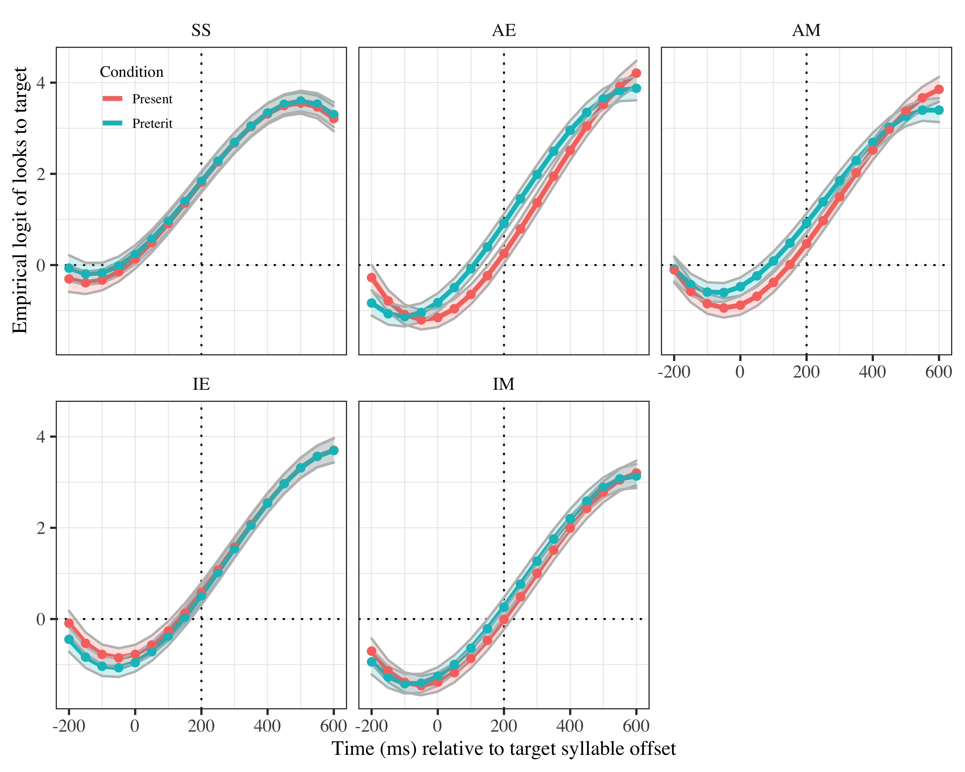

*Figure* *1:*. Growth curve analysis estimates of fixations on target as a function of lexical stress for each group during the analysis window. Lines represent model estimates, and the transparent ribbons represent ±SE. Empirical logit values on y-axis correspond to proportions of 0.12, 0.50, 0.88, and 0.98. The horizontal dotted line represents the 50% probability of fixating on the targets. The vertical dotted line indicates 200 ms. after the offset of the target syllable.

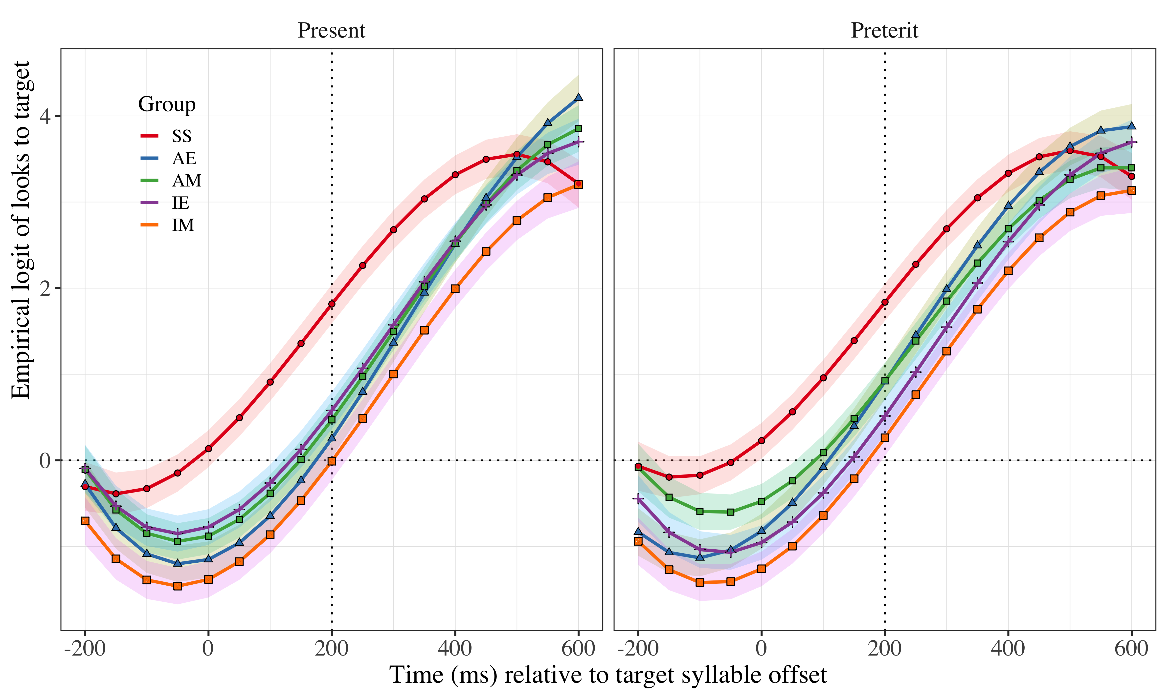

*Figure* *2:*. Growth curve analysis estimates of fixations on the target as a function of lexical stress for each group during the analysis window. Symbols and lines represent model estimates, and the ribbons represent ±SE. Empirical logit values on y-axis correspond to proportions of 0.12, 0.50, 0.88, and 0.98. The horizontal dotted line represents the 50% probability of fixating on the targets. The vertical dotted line indicates 200 ms. after the offset of the target syllable.

# Tables

## Model estimates at target syllable offset

Table 1:

| Group | Lexical stress | Probability | LB | UB |
| --- | --- | --- | --- | --- |
| SS | present | 0.8612882 | 0.8299301 | 0.8876472 |
|  | preterit | 0.8618758 | 0.8319273 | 0.8872113 |
| AE | present | 0.5653278 | 0.5068207 | 0.6220699 |
|  | preterit | 0.7128605 | 0.6643810 | 0.7568996 |
| AM | present | 0.6182037 | 0.5612590 | 0.6720758 |
|  | preterit | 0.7152918 | 0.6670310 | 0.7590841 |
| IE | present | 0.6438652 | 0.5887647 | 0.6954024 |
|  | preterit | 0.6255260 | 0.5716954 | 0.6764203 |
| IM | present | 0.5008632 | 0.4422083 | 0.5594944 |
|  | preterit | 0.5644489 | 0.5081990 | 0.6190874 |

*Table 1*: Model estimates for probability of target fixations ±SE at 200 ms after the target syllable offset. (LB = lower bound; UP = upper bound)

## Fixed effects

|  |  |  |  |  |  |
| --- | --- | --- | --- | --- | --- |
| effect | Parameter | Estimate | SE | *t* | *p* |
| fixed | Intercept (γ00) | 1.717 | 0.149 | 11.488 | < .001 |
| fixed | Time1 (γ10) | 5.856 | 0.440 | 13.312 | < .001 |
| fixed | Time2 (γ20) | −0.408 | 0.319 | −1.279 | .201 |
| fixed | Time3 (γ30) | −1.343 | 0.182 | −7.382 | < .001 |
| fixed | GroupAE (γ01) | −0.698 | 0.178 | −3.921 | < .001 |
| fixed | GroupAM (γ11) | −0.620 | 0.178 | −3.480 | < .001 |
| fixed | GroupIE (γ21) | −0.732 | 0.177 | −4.138 | < .001 |
| fixed | GroupIM (γ31) | −1.198 | 0.178 | −6.730 | < .001 |
| fixed | Lexical stress (γ02) | −0.028 | 0.110 | −0.254 | .799 |
| fixed | Time1 × GroupAE (γ12) | 1.455 | 0.512 | 2.844 | .004 |
| fixed | Time1 × GroupAM (γ22) | 0.342 | 0.512 | 0.669 | .504 |
| fixed | Time1 × GroupIE (γ32) | 0.652 | 0.508 | 1.282 | .200 |
| fixed | Time1 × GroupIM (γ03) | 0.685 | 0.512 | 1.338 | .181 |
| fixed | Time2 × GroupAE (γ13) | 1.997 | 0.417 | 4.795 | < .001 |
| fixed | Time2 × GroupAM (γ23) | 1.861 | 0.417 | 4.466 | < .001 |
| fixed | Time2 × GroupIE (γ33) | 1.997 | 0.414 | 4.825 | < .001 |
| fixed | Time2 × GroupIM (γ04) | 1.830 | 0.417 | 4.391 | < .001 |
| fixed | Time1 × Lexical stress (γ14) | −0.102 | 0.202 | −0.505 | .613 |
| fixed | Time2 × Lexical stress (γ24) | −0.094 | 0.196 | −0.478 | .633 |
| fixed | GroupAE × Lexical stress (γ34) | −0.087 | 0.131 | −0.661 | .508 |
| fixed | GroupAM × Lexical stress (γ05) | −0.064 | 0.131 | −0.491 | .623 |
| fixed | GroupIE × Lexical stress (γ15) | 0.089 | 0.130 | 0.685 | .493 |
| fixed | GroupIM × Lexical stress (γ25) | −0.020 | 0.131 | −0.154 | .878 |
| fixed | Time1 × GroupAE:Lexical stress (γ35) | −0.232 | 0.242 | −0.956 | .339 |
| fixed | Time1 × GroupAM:Lexical stress (γ06) | 0.212 | 0.243 | 0.874 | .382 |
| fixed | Time1 × GroupIE:Lexical stress (γ16) | −0.304 | 0.241 | −1.262 | .207 |
| fixed | Time1 × GroupIM:Lexical stress (γ26) | −0.193 | 0.243 | −0.795 | .427 |
| fixed | Time2 × GroupAE:Lexical stress (γ36) | 0.858 | 0.242 | 3.543 | < .001 |
| fixed | Time2 × GroupAM:Lexical stress (γ00) | 0.560 | 0.243 | 2.310 | .021 |
| fixed | Time2 × GroupIE:Lexical stress (γ10) | 0.174 | 0.241 | 0.720 | .471 |
| fixed | Time2 × GroupIM:Lexical stress (γ20) | 0.386 | 0.243 | 1.592 | .111 |

Appendix 1: Growth curve model fixed effects

## Random effects

|  |  |  |  |  |  |  |  |  |
| --- | --- | --- | --- | --- | --- | --- | --- | --- |
| Group | Parameter | Variance | SD | Correlations |  |  |  |  |
| Participant | Intercept | 0.439 | 0.663 | 1.00 |  |  |  |  |
|  | Lexical stress | 0.215 | 0.464 | .08 | 1.00 |  |  |  |
|  | Time1 | 4.760 | 2.182 | .11 | −.01 | 1.00 |  |  |
|  | Time2 | 1.786 | 1.336 | −.29 | −.04 | −.13 | 1.00 |  |
|  | Time3 | 0.867 | 0.931 | −.09 | .12 | −.83 | −.10 | 1.00 |
| Item | Intercept | 0.191 | 0.437 | 1.00 |  |  |  |  |
|  | Time1 | 1.540 | 1.241 | −.41 |  | 1.00 |  |  |
|  | Time2 | 0.389 | 0.624 | −.83 |  | −.05 | 1.00 |  |
|  | Time3 | 0.700 | 0.837 | .39 |  | −.97 | −.02 | 1.00 |
| Residual |  | 14.525 | 3.811 |  |  |  |  |  |

Appendix 2: Growth curve model random effects

## Pairwise comparisons

|  |  |  |  |  |  |
| --- | --- | --- | --- | --- | --- |
| effect | Parameter | Estimate | SE | *t* | *p* |
| fixed | GroupAM (γ08) | 0.078 | 0.175 | 0.448 | .654 |
| fixed | Time1 × GroupAM (γ18) | −1.113 | 0.503 | −2.210 | .027 |
| fixed | Time2 × GroupAM (γ28) | −0.136 | 0.410 | −0.332 | .740 |
| fixed | GroupAM × Lexical stress (γ38) | 0.022 | 0.129 | 0.173 | .863 |
| fixed | Time1 × GroupAM:Lexical stress (γ09) | 0.444 | 0.238 | 1.861 | .063 |
| fixed | Time2 × GroupAM:Lexical stress (γ19) | −0.298 | 0.238 | −1.250 | .211 |

Appendix 3a: Pairwise comparisons between advanced learner groups (AE reference).

|  |  |  |  |  |  |
| --- | --- | --- | --- | --- | --- |
| effect | Parameter | Estimate | SE | *t* | *p* |
| fixed | GroupIM (γ08) | −0.579 | 0.175 | −3.304 | < .001 |
| fixed | Time1 × GroupIM (γ18) | 0.343 | 0.504 | 0.681 | .496 |
| fixed | Time2 × GroupIM (γ28) | −0.031 | 0.410 | −0.076 | .939 |
| fixed | GroupIM × Lexical stress (γ38) | 0.044 | 0.129 | 0.343 | .732 |
| fixed | Time1 × GroupIM:Lexical stress (γ09) | −0.405 | 0.239 | −1.696 | .090 |
| fixed | Time2 × GroupIM:Lexical stress (γ19) | −0.174 | 0.239 | −0.729 | .466 |
| Appendix | 3b: Pairwise comparisons between Mandarin Chinese learner groups | (AM reference) | . |  |  |

|  |  |  |  |  |  |
| --- | --- | --- | --- | --- | --- |
| effect | Parameter | Estimate | SE | *t* | *p* |
| fixed | GroupIE (γ08) | −0.033 | 0.174 | −0.193 | .847 |
| fixed | Time1 × GroupIE (γ18) | −0.803 | 0.500 | −1.606 | .108 |
| fixed | Time2 × GroupIE (γ28) | −0.000 | 0.407 | −0.000 | 1.000 |
| fixed | GroupIE × Lexical stress (γ38) | 0.176 | 0.128 | 1.374 | .169 |
| fixed | Time1 × GroupIE:Lexical stress (γ09) | −0.073 | 0.237 | −0.308 | .758 |
| fixed | Time2 × GroupIE:Lexical stress (γ19) | −0.685 | 0.237 | −2.887 | .004 |
| Appendix | 3c: Pairwise comparisons between EN learners (AE reference). |  |  |  |  |

|  |  |  |  |  |  |
| --- | --- | --- | --- | --- | --- |
| effect | Parameter | Estimate | SE | *t* | *p* |
| fixed | GroupIM (γ08) | −0.467 | 0.174 | −2.685 | .007 |
| fixed | Time1 × GroupIM (γ18) | 0.033 | 0.500 | 0.067 | .947 |
| fixed | Time2 × GroupIM (γ28) | −0.167 | 0.407 | −0.411 | .681 |
| fixed | GroupIM × Lexical stress (γ38) | −0.110 | 0.128 | −0.854 | .393 |
| fixed | Time1 × GroupIM:Lexical stress (γ09) | 0.112 | 0.237 | 0.470 | .638 |
| fixed | Time2 × GroupIM:Lexical stress (γ19) | 0.212 | 0.237 | 0.895 | .371 |
| Appendix | 3d: Pairwise comparisons between intermediate learner groups (IE | reference). |  |  |  |

# 5. Results

The summary for the full model of the Growth Curve Analysis is in the Appendices 2 and 3, and the results are plotted in Figures 3 and 4. In the plots, the x-axis in these plots represents time (ms.) in the trial and the y-axis represents the logit probability of fixation on the target. Figure 3 represents the model fit for each group in both conditions. Figure 4 represents the model fit for each verbal tense across groups. The vertical line at 200 ms. represents the offset of the first syllable in the target verbs.

These plots indicate that SS start anticipating earlier than the L2 groups. The higher crossing point of the 200 ms. line also indicates that they are anticipating more than the L2 groups. Within groups, SS, IE and to some extent IM anticipate present and preterit tense similarly. In the case of AE and AM, preterit tense appears to be easier to anticipate than present tense.

For reporting the results of the growth curve model, SS and present tense were taken as baseline. The results for these speakers are presented first. Comparisons between L2 groups according to L1 and to L2 proficiency come afterwards. The model intercept estimates the log odds of SS fixating their gaze on the target averaging across lexical stress condition and time course (*γ*00 = 1.717, SE = 0.149. *t* = 11.488, *p* = < .001). This value for the intercept suggests that SS were anticipating correctly. The linear and cubic polynomial time terms captured the sigmoid shape of the time course and were retained in the model (linear: *γ*10 = 5.856, SE = 0.440. *t* = 13.312, *p* = < .001; cubic: *γ*30 = −1.343, SE = 0.182. *t* = −7.382, *p* = < .001). There was no effect of lexical stress (*γ*02 = −0.028, SE = 0.110. *t* = −0.254, *p* = .799)), but there was a main effect of group on the intercept which corroborates the plots in that L2 speakers predicted less than SS (AE: *γ*01 = −0.698, SE = 0.178. *t* = −3.921, *p* = < .001; AM: *γ*11 = −0.620, SE = 0.178. *t* = −3.480, *p* = < .001; AE: *γ*21 = −0.732, SE = 0.177. *t* = −4.138, *p* = < .001; AM: *γ*31 = −1.198, SE = 0.178. *t* = −6.730, *p* = < .001). The estimates for the intercept also demonstrate that IM were the ones that anticipated less in comparison with the SS. There was also an effect caused by the group AE in the linear term (*γ*12 = 1.455, SE = 0.512. *t* = 2.844, *p* = .004), which reveals that the slope for this group is steeper than for SS. This steeper slope means that AE tended to increased its fixations on the target more abruptly than SS. That is, AE anticipated more abruptly. The lack of an interaction between the linear term and the other L2 groups reveal that they followed a more similar pattern of prediction to SS in terms of steepness. There was an effect of all groups in the quadratic term with higher estimates for L2 groups (AE: *γ*13 = 1.997, SE = 0.417. *t* = 4.795, *p* = < .001; AM: *γ*23 = 1.861, SE = 0.417. *t* = 4.466, *p* = < .001; AE: *γ*33 = 1.997, SE = 0.414. *t* = 4.825, *p* = < .001; AM: *γ*04 = 1.830, SE = 0.417. *t* = 4.391, *p* = < .001) that indicates that the quadratic curve was more bowed for the L2 speakers, reflecting their delay with respect to SS in predicting. Lastly, there was an interaction effect in the quadratic term between AE and lexical stress (*γ*36 = 0.174, SE = 0.241. *t* = 0.720, *p* = .471) and between AM and lexical stress (GroupAM x Lexical stress: *γ*00 = 0.386, SE = 0.243. *t* = 1.592, *p* = .111). This interaction confirms the information advanced by plots in Figures 3 and 4 in that advanced L2 learners fixated more on the target in the preterit tense than they did in the present tense. This increased number of fixations reveals that preterit tense may be easier to anticipate than present tense.

Pairwise comparisons extend the results on performance differences across L2 groups. The pairwise comparisons are in Appendices 4, 5, 6 and 7. In terms of L1, there is only a slightly difference in the quadratic term for the L1 English speakers (*γ*19 = −0.685, SE = 0.237. *t* = −2.887, *p* = .004), such that IE anticipate less than AE in the preterit tense. This finding contrasts with their performance in the present tense, where IE anticipate more than AE, although the prediction difference there between the two groups does not reach significance. As for L1 Mandarin Chinese speakers, AM and IM only differ in the intercept, where IM is shown to predict less than AM averaging across time course and stress conditions (*γ*08 = −0.579, SE = 0.175. *t* = −3.304, *p* = < .001). That is, AM predict better overall than IM. Regarding L2 proficiency, IE and IM only differ in the intercept too, which reveals that IE anticipate more than IM averaging across time course and stress conditions (*γ*08 = −0.467, SE = 0.174. *t* = −2.685, *p* = .007). At advanced proficiencies, AM and AE only differ in the linear term (−1.113, SE = 0.503. *t* = −2.210, *p* = .027). This estimate suggests that the increase of fixations on the target in the AM group is less steep than in the AE group. In other words, AM predict more smoothly than AE in both stress conditions.

The model estimated probability of fixations on the target above 50% chance in lexical stress conditions across all groups at the offset of the first syllable in the verb (SS x present: probability = 0.86, LB = 0.83, UB = 0.89; SS x preterit: probability = 0.86, LB = 0.83, UB = 0.89; AE x present: probability = 0.57, LB = 0.51, UB = 0.62; AE x preterit: probability = 0.71, LB = 0.66, UB = 0.76; AM x present: probability = 0.72, LB = 0.67, UB = 0.76; AM x preterit: probability = 0.62, LB = 0.56, UB = 0.67; IE x present: probability = 0.64, LB = 0.59, UB = 0.70; IE x preterit: probability = 0.63, LB = 0.57, UB = 0.68; IM x present: probability = 0.50, LB = 0.44, UB = 0.56; IM x preterit: probability = 0.56, LB = 0.51, UB = 0.62). These probabilities are contained in Table 1. These probabilities indicate that all groups are likely to anticipate above chance except for IM. They also indicate that prediction probability in SS speakers is higher than in the L2 groups. The probabilities also reflect the striking performance of AE, in the sense that their anticipation probability in present tense decreases from intermediate proficiency levels. In contrast, the probabilities for the Mandarin speakers suggest that they improve more in anticipation performance in this tense over proficiency.

The data in this study revealed that Mandarin speakers generally improved over proficiency, as evidenced by increased gaze fixations on the target verb upon hearing the lexically stressed initial syllable. English speakers improved in the preterit tense condition but not in the present tense condition, where they in fact got worse. IE anticipated better than IM, but at advanced levels AM catch up with AE SS anticipated better than the L2 speakers. Stress condition yielded overall no significant differences.