The title

First Author1 & Ernst-August Doelle1,2

1 Wilhelm-Wundt-University

2 Konstanz Business School

Author note

The authors made the following contributions. First Author: Conceptualization, Writing - Original Draft Preparation, Writing - Review & Editing; Ernst-August Doelle: Writing - Review & Editing.

Correspondence concerning this article should be addressed to First Author, Postal address. E-mail: [my@email.com](mailto:my@email.com)

Abstract

*Keywords:* keywords

*Word count:* X

The title

# 1 Methods

## 1.1 Statistical analyses

We used R [Version 4.1.0; R Core Team (2021)] and the R-package *papaja* [Version 0.1.0.9997; Aust and Barth (2020)] for all our analyses.

# 2 Results

Figure 1 shows stuff.

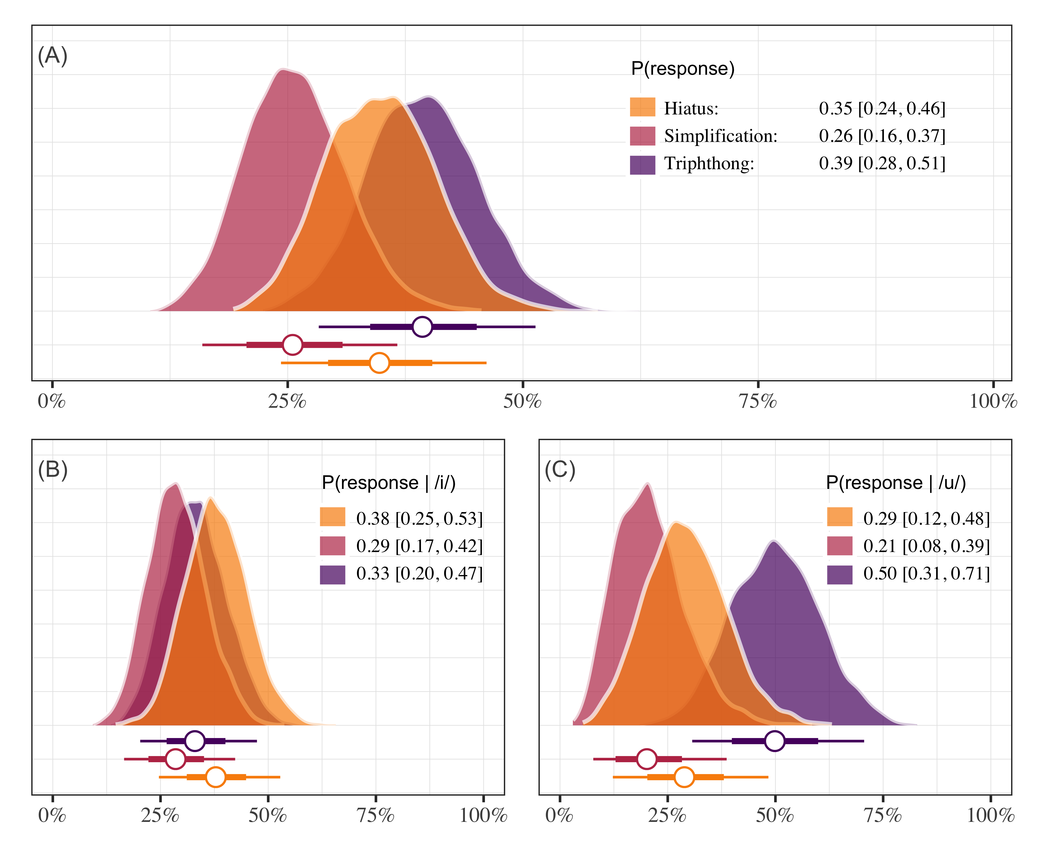

*Figure* *1.*  This is a figure caption.

# 3 References

Aust, F., & Barth, M. (2020). *papaja: Create APA manuscripts with R Markdown*. Retrieved from <https://github.com/crsh/papaja>

R Core Team. (2021). *R: A language and environment for statistical computing*. Vienna, Austria: R Foundation for Statistical Computing. Retrieved from <https://www.R-project.org/>