Practice makes perfect: Interpreting facilitates L2 morphological anticipation

Abstract

Statistical analyses for BLC article

*Keywords:* keywords

Word count: X

Practice makes perfect: Interpreting facilitates L2 morphological anticipation

# Overview

# Results

Output for growth curve model fits for effect of group and syllable structure during analysis window. Symbols and point ranges indicate mean ± SE. Lines represent model fits.

# Plots

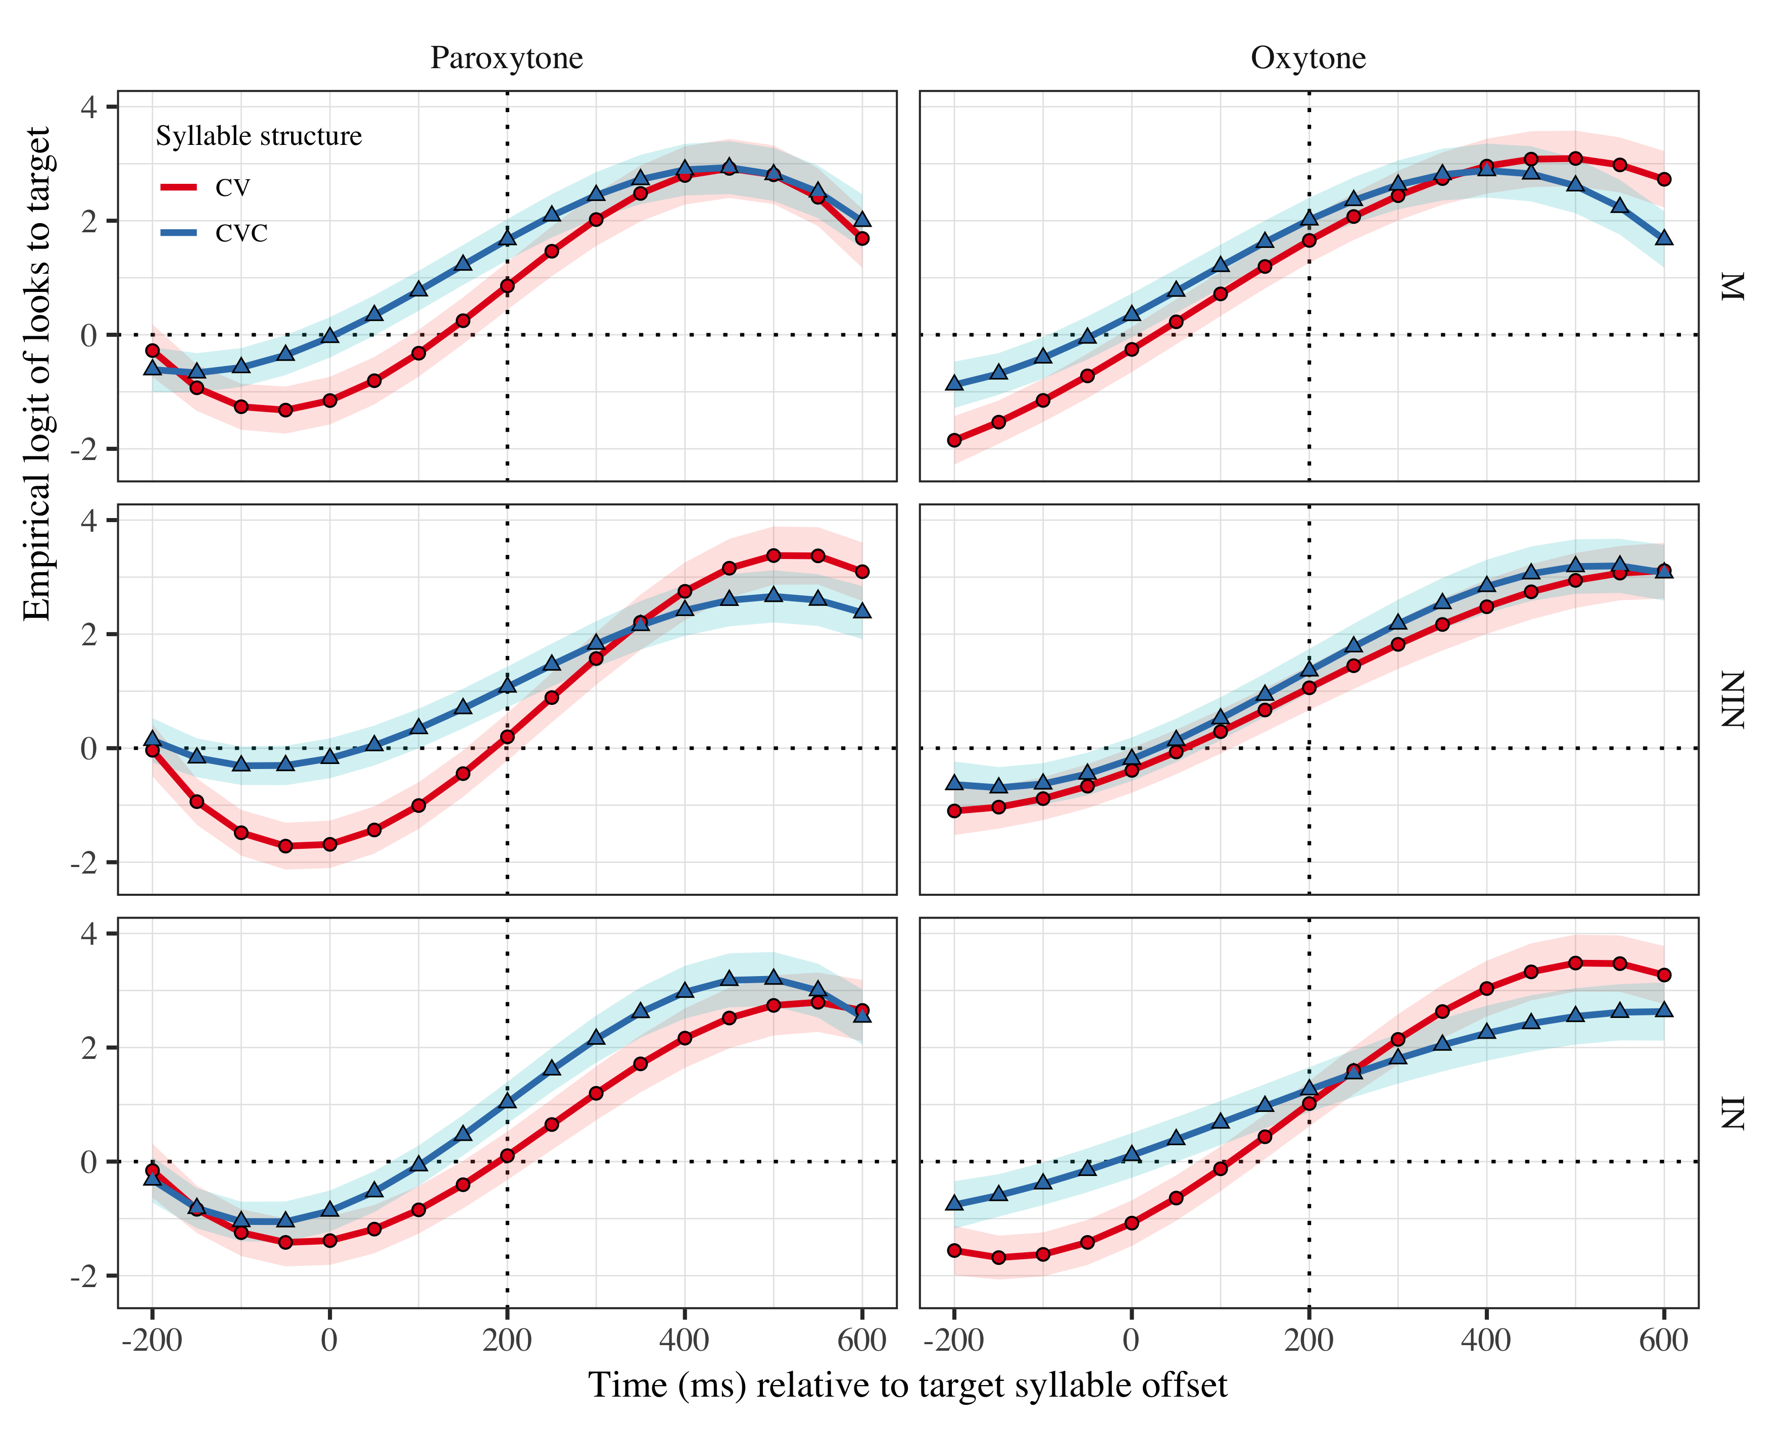

Figure 1: Growth curve estimates of target fixations as a function of lexical stress and syllable structure for each group during the analysis window. Symbols and lines represent model estimates, and the transparent ribbons represents ±SE. Empirical logit values on y-axis correspond to proportions of 0.12 0.50 0.88 0.98. The horizontal dotted line represents the 50% probability of fixating on the target. The vertical dotted line indicates 200 ms after the offset of the target syllable.

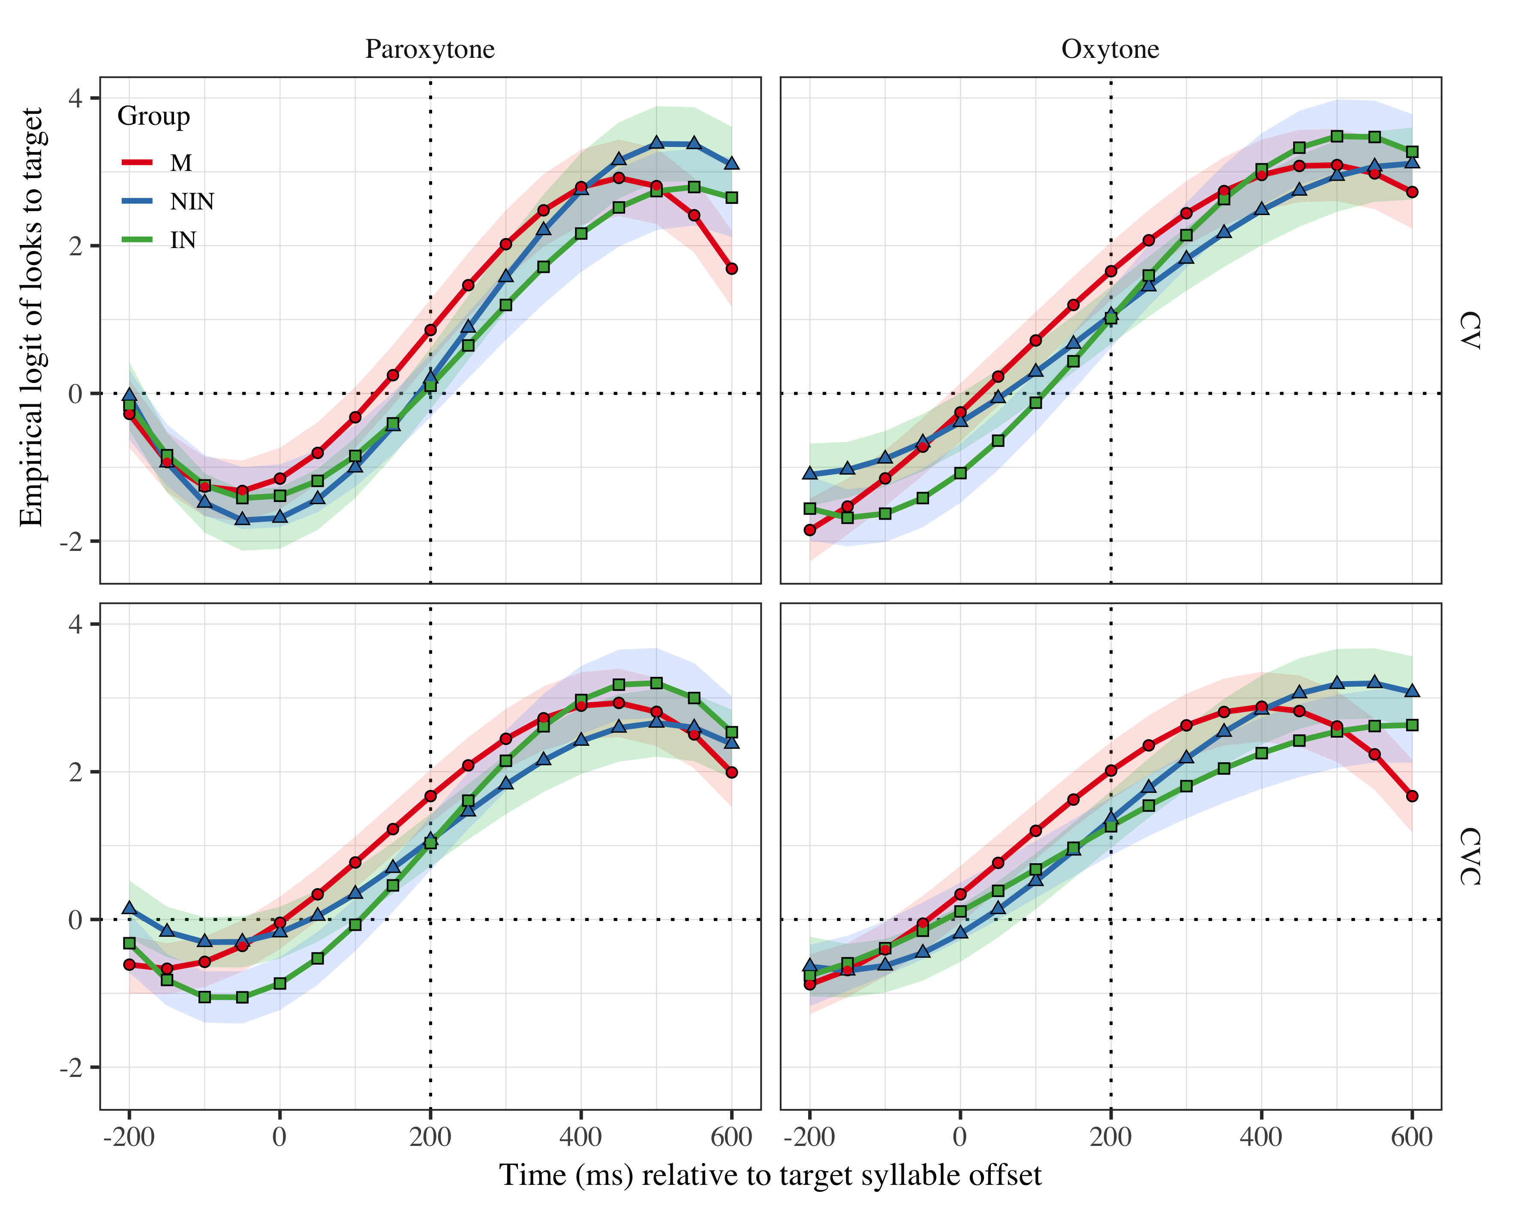

Figure 2: Growth curve estimates of target fixations as a function of lexical stress and syllable structure for each group during the analysis window. Symbols and lines represent model estimates, and the transparent ribbons represents ±SE. Empirical logit values on y-axis correspond to proportions of 0.12 0.50 0.88 0.98. The horizontal dotted line represents the 50% probability of fixating on the target. The vertical dotted line indicates 200 ms after the offset of the target syllable.

# Tables

| Group | Syllable structure | Lexical stress | Probability | LB | UB |
| --- | --- | --- | --- | --- | --- |
| M | CV | Paroxytone | 0.702 | 0.608 | 0.782 |
| M | CV | Oxytone | 0.839 | 0.779 | 0.886 |
| M | CVC | Paroxytone | 0.842 | 0.787 | 0.884 |
| M | CVC | Oxytone | 0.882 | 0.836 | 0.917 |
| NIN | CV | Paroxytone | 0.550 | 0.446 | 0.649 |
| NIN | CV | Oxytone | 0.742 | 0.661 | 0.810 |
| NIN | CVC | Paroxytone | 0.745 | 0.672 | 0.807 |
| NIN | CVC | Oxytone | 0.795 | 0.726 | 0.851 |
| IN | CV | Paroxytone | 0.526 | 0.420 | 0.629 |
| IN | CV | Oxytone | 0.735 | 0.650 | 0.805 |
| IN | CVC | Paroxytone | 0.738 | 0.661 | 0.802 |
| IN | CVC | Oxytone | 0.779 | 0.704 | 0.840 |

Table 1: Probability of target fixations ±SE at 200 ms after the target syllable offset.

## Fixed effects

|  |  |  |  |  |
| --- | --- | --- | --- | --- |
| Parameter | Estimate | SE | *t* | *p* |
| Intercept (γ00) | 1.177 | 0.220 | 5.363 | < .001 |
| Time1 (γ10) | 5.567 | 0.744 | 7.483 | < .001 |
| Time2 (γ20) | −1.365 | 0.383 | −3.568 | < .001 |
| Time3 (γ30) | −1.652 | 0.300 | −5.511 | < .001 |
| Syllable structure (γ01) | −0.178 | 0.116 | −1.539 | .124 |
| Time1 × Syllable structure (γ11) | 0.712 | 0.371 | 1.918 | .055 |
| Time2 × Syllable structure (γ21) | 0.424 | 0.235 | 1.804 | .071 |
| Time3 × Syllable structure (γ31) | −0.240 | 0.162 | −1.484 | .138 |
| Lexical stress (γ02) | −0.126 | 0.143 | −0.878 | .380 |
| Time1 × Lexical stress (γ12) | −0.141 | 0.371 | −0.381 | .704 |
| Time2 × Lexical stress (γ22) | 0.586 | 0.235 | 2.494 | .013 |
| Time3 × Lexical stress (γ32) | −0.586 | 0.162 | −3.627 | < .001 |
| Group NIN (γ03) | −0.131 | 0.277 | −0.472 | .637 |
| Time1 × Group NIN (γ13) | 0.365 | 0.912 | 0.401 | .689 |
| Time2 × Group NIN (γ23) | 1.819 | 0.448 | 4.060 | < .001 |
| Time3 × Group NIN (γ33) | 0.124 | 0.385 | 0.323 | .747 |
| Group IN (γ04) | −0.255 | 0.287 | −0.889 | .374 |
| Time1 × Group IN (γ14) | 0.668 | 0.942 | 0.709 | .478 |
| Time2 × Group IN (γ24) | 1.615 | 0.462 | 3.496 | < .001 |
| Time3 × Group IN (γ34) | 0.022 | 0.396 | 0.056 | .956 |
| Syllable structure × Lexical stress (γ05) | −0.073 | 0.105 | −0.697 | .486 |
| Time1 × Syllable structure × Lexical stress (γ15) | −0.381 | 0.404 | −0.943 | .346 |
| Time2 × Syllable structure × Lexical stress (γ25) | 0.146 | 0.282 | 0.517 | .605 |
| Time3 × Syllable structure × Lexical stress (γ35) | −0.405 | 0.224 | −1.811 | .070 |
| Syllable structure × Lexical stress × Group NIN (γ06) | 0.028 | 0.067 | 0.425 | .671 |
| Time1 × Syllable structure × Lexical stress × Group NIN (γ16) | 1.004 | 0.271 | 3.708 | < .001 |
| Time2 × Syllable structure × Lexical stress × Group NIN (γ26) | 0.219 | 0.269 | 0.815 | .415 |
| Time3 × Syllable structure × Lexical stress × Group NIN (γ36) | −0.034 | 0.267 | −0.127 | .899 |
| Syllable structure × Lexical stress × Group IN (γ07) | −0.014 | 0.069 | −0.199 | .842 |
| Time1 × Syllable structure × Lexical stress × Group IN (γ17) | −0.507 | 0.278 | −1.821 | .069 |
| Time2 × Syllable structure × Lexical stress × Group IN (γ27) | 0.166 | 0.277 | 0.600 | .548 |
| Time3 × Syllable structure × Lexical stress × Group IN (γ37) | 0.773 | 0.275 | 2.816 | .005 |

Table 2: Growth curve model fixed effects (must reduce font size and single space).

## Random effects

Table 1: Model random effects

|  |  |  |  |  |  |  |  |  |  |
| --- | --- | --- | --- | --- | --- | --- | --- | --- | --- |
| Group | Parameter | Variance | SD | Correlations |  |  |  |  |  |
| participant | Intercept | 0.911 | 0.954 | 1.00 |  |  |  |  |  |
|  | Syllable structure | 0.275 | 0.524 | −.20 | 1.00 |  |  |  |  |
|  | Lexical stress | 0.789 | 0.888 | −.07 | .31 | 1.00 |  |  |  |
|  | Time1 | 9.548 | 3.090 | .42 | −.17 | .02 | 1.00 |  |  |
|  | Time2 | 1.640 | 1.281 | −.14 | .22 | .08 | .31 | 1.00 |  |
|  | Time3 | 0.980 | 0.990 | −.40 | .08 | −.18 | −.83 | −.14 | 1.00 |
| target | Intercept | 0.264 | 0.514 | 1.00 |  |  |  |  |  |
|  | Time1 | 3.831 | 1.957 | .28 |  |  | 1.00 |  |  |
|  | Time2 | 1.304 | 1.142 | −.74 |  |  | −.37 | 1.00 |  |
|  | Time3 | 0.415 | 0.644 | .19 |  |  | −.86 | −.14 | 1.00 |
| Residual |  | 13.507 | 3.675 |  |  |  |  |  |  |

# References