# BLC article (stress, natives, late advanced learners and interpreters)

## Overview

This document contains updates to the statistical analysis for BLC article (3rd revisions). Last updated on 2019-06-06. The results section can be copied and pasted into the corresponding google doc. The tables can also be copy and pasted where appropriate.

## Main changes

**Participants**

The updated analysis includes more participants in the interpreter (IN) group and a few different participants in the monolingual (M) and advanced learner non-interpreter (NIN) groups.

**Analyses**

The analysis has been simplified to in 2 major ways: by **removing the t-test and GLMM analyses**. The motivation behind using the t-tests was to see if participants fixated on targets above chance levels (50%) at the offset of the first syllable of the target items. The problem with this analysis is that is reduced a lot of data to approximately 50 data points (and 10ish in the IN group). This forced us to run multiple tests and correct for family-wise error using a Bonferroni adjustment (and killing our power). This was particularly troubling because it was apparent that there was a stress effect (oxytones consistently had higher fixation rates), but we refrained from testing syllable structure to avoid (1) further correcting alpha and (2) harking. In place of the t-tests I have included model estimates from the growth curve analysis at the target syllable offset ± SE. This is not a formal test against chance, but is clearly more reliable than the t-tests. It also includes the 50ms bin, which I believe will make one of the reviewers happy. The downside is that it inevitably includes some acoustic information from slightly after the initial syllable. We don’t know how much, but we can examine the time course to see how close target fixations are to chance before and after the relevant bin (bin #4, 4 x 50 = 200 ms). With regard to the GLMMs, I believe we can obtain the same information (and more) from the GCA.

## Main findings

The most important change regarding the findings is the **significant effect of lexical stress**. I believe the power increase due to additional participants is the principle explanation for this. I was able to get the most complex (maximal) random effects structure to converge. The story seems to be the following: native speakers anticipate target suffixes in all conditions, though certain conditions seem to facilitate processing. Specifically, if we consider paroxytone words with open syllables to be the default (the most common syllable in Spanish), we see earlier target fixations with the addition of the coda and with a shift of stress to the final syllable, but the effects are not compounding. For example, an unstressed penult is associated more looks to target, but the addition of a coda doesn’t help that much more.

# Plots

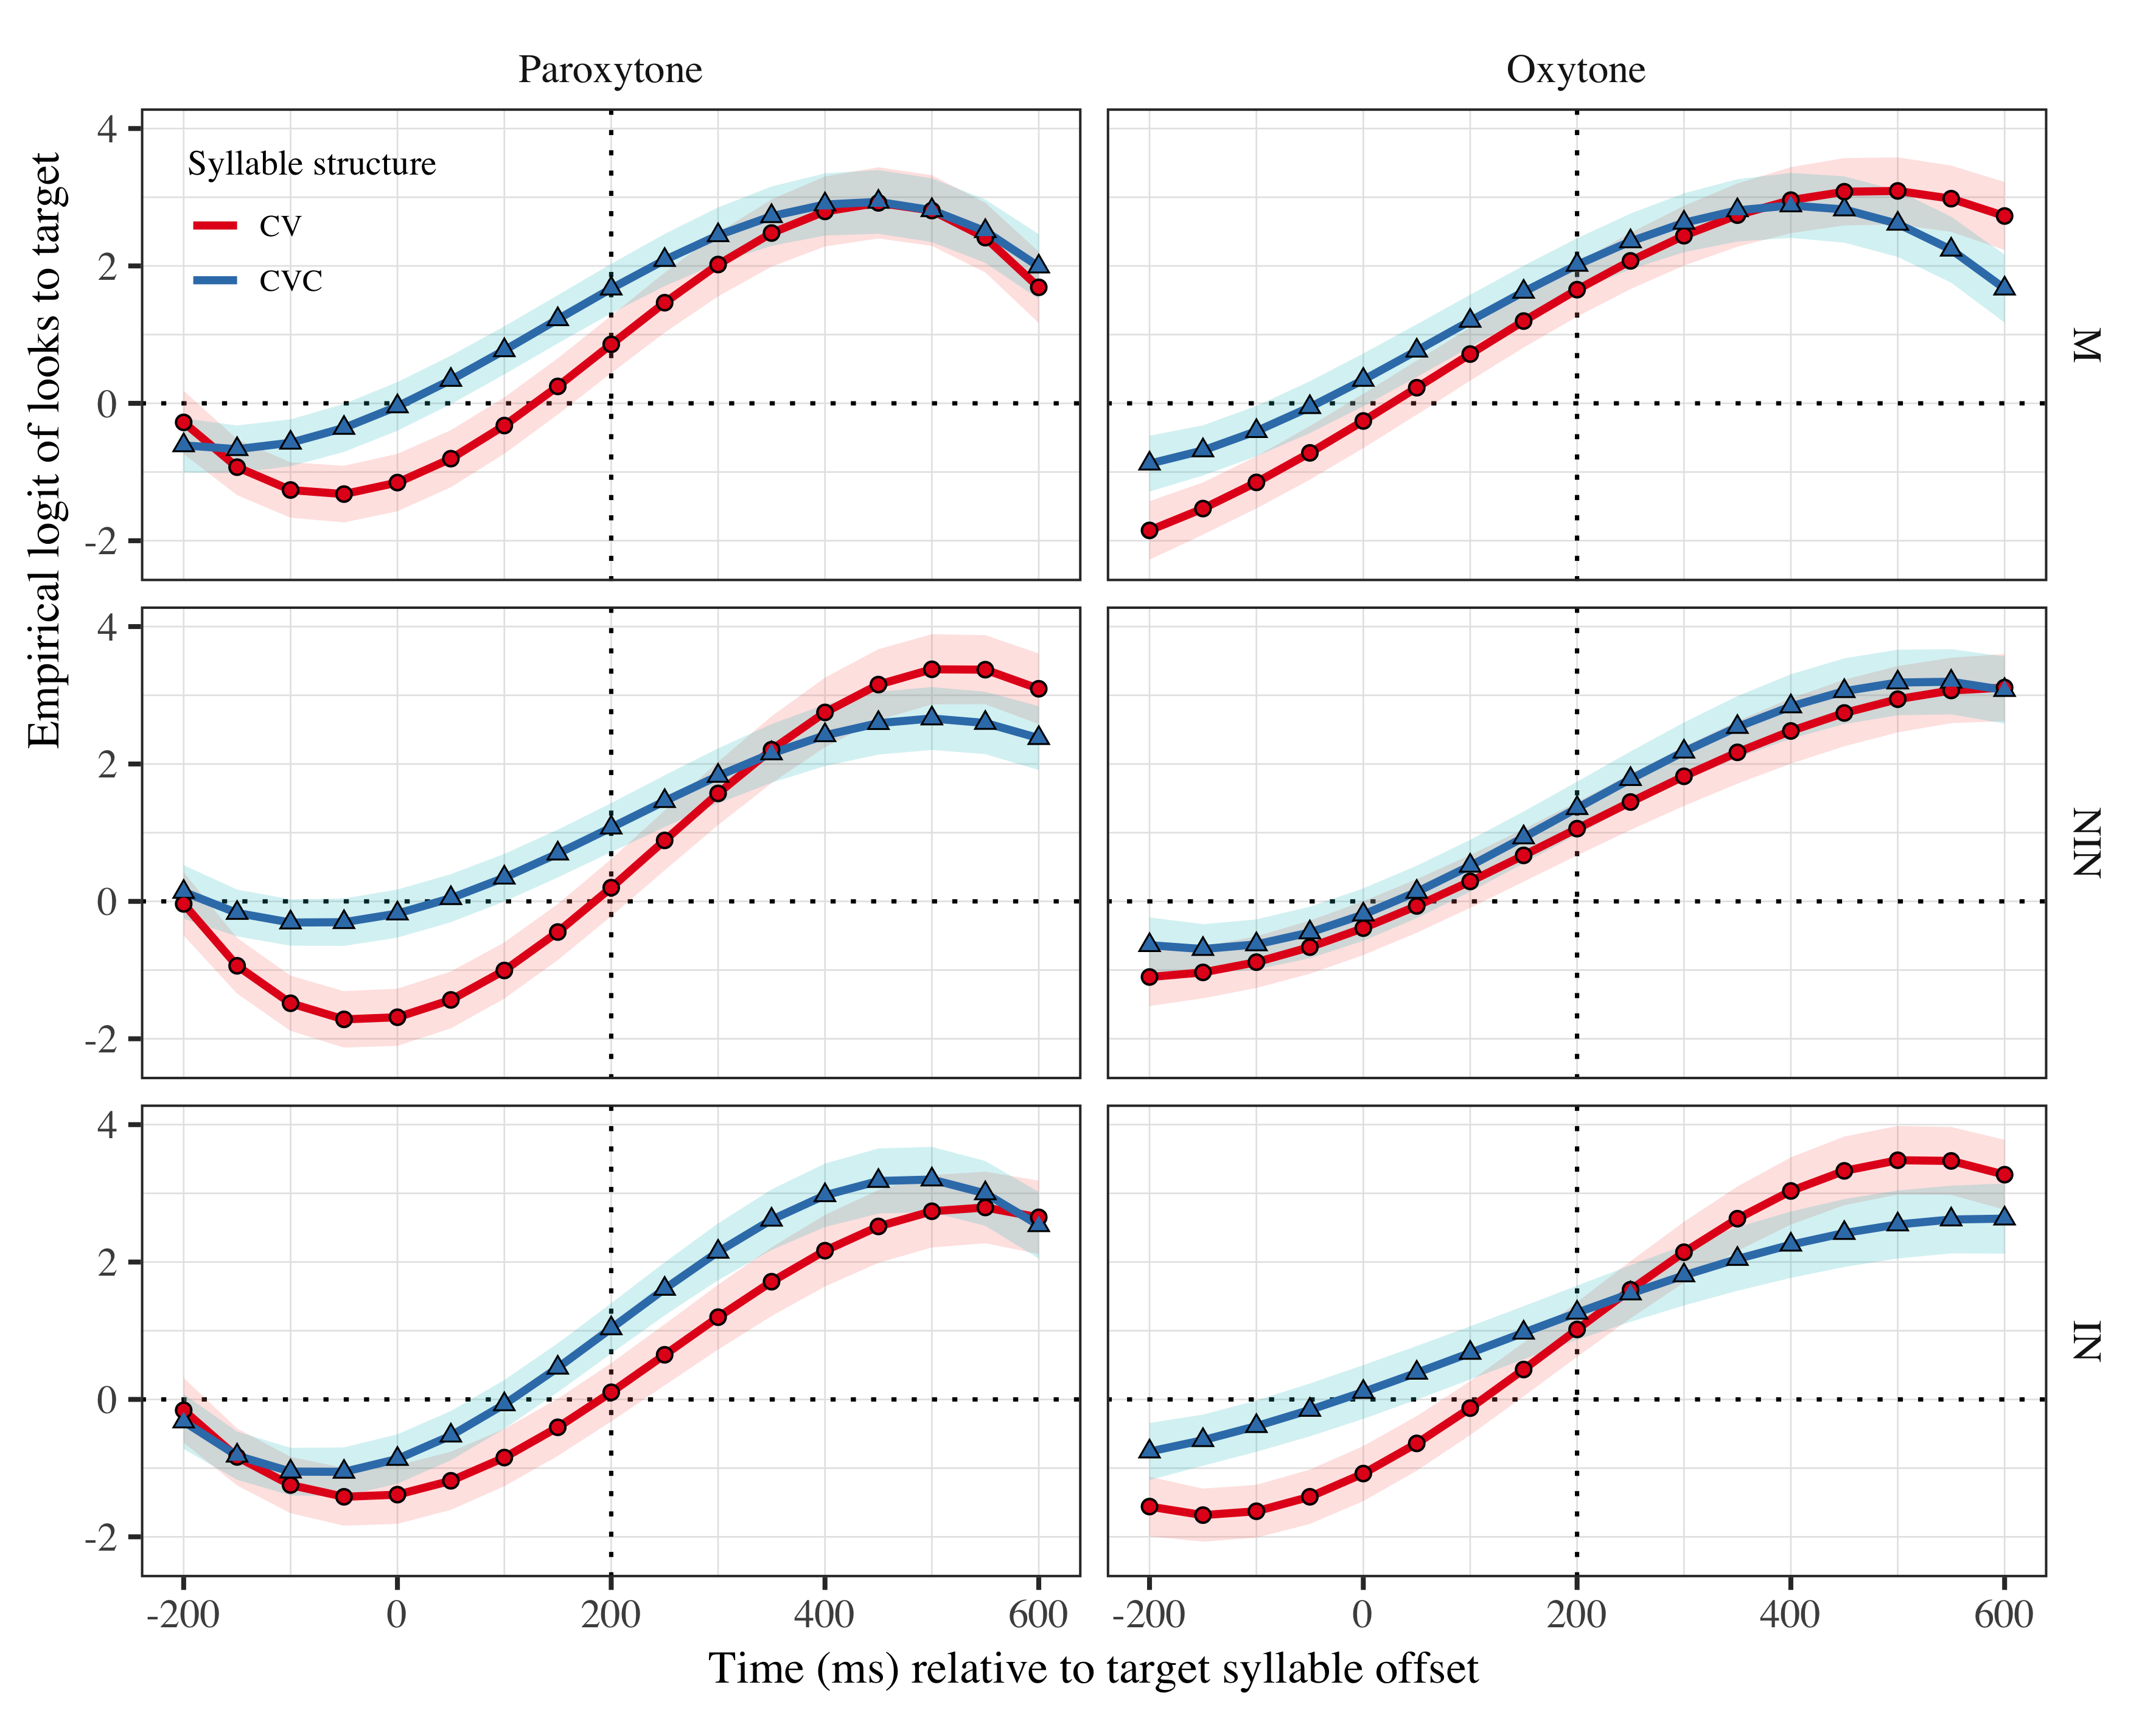

Figure 1: Growth curve estimates of target fixations as a function of lexical stress and syllable structure for each group during the analysis window. Symbols and lines represent model estimates, and the transparent ribbons represents ±SE. Empirical logit values on y-axis correspond to proportions of 0.12, 0.50, 0.88, and 0.98. The horizontal dotted line represents the 50% probability of fixating on the target. The vertical dotted line indicates 200 ms after the offset of the target syllable.

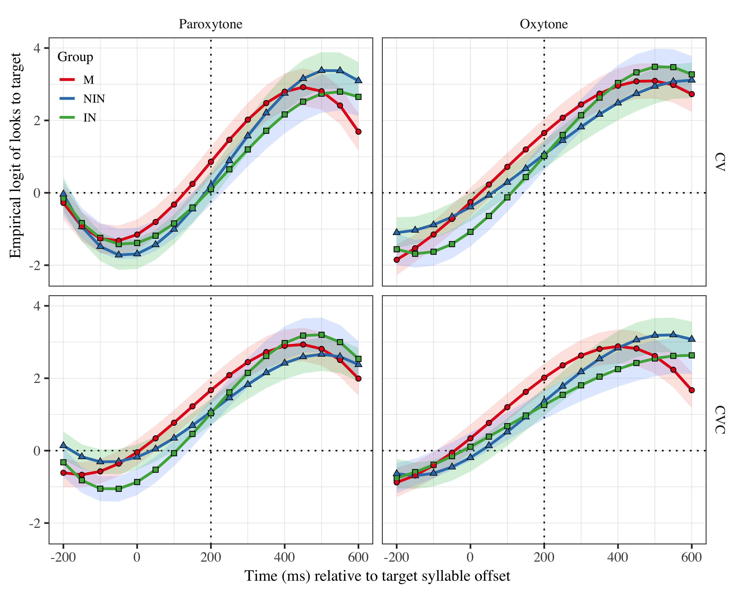

Figure 2: Growth curve estimates of target fixations as a function of lexical stress and syllable structure for each group during the analysis window. Symbols and lines represent model estimates, and the transparent ribbons represents ±SE. Empirical logit values on y-axis correspond to proportions of 0.12, 0.50, 0.88, and 0.98. The horizontal dotted line represents the 50% probability of fixating on the target. The vertical dotted line indicates 200 ms after the offset of the target syllable.

# Tables

## Model estimates at target syllable offset

| Group | Lexical stress | Syllable structure | Probability | LB | UB |
| --- | --- | --- | --- | --- | --- |
| M | Paroxytone | CV | 0.702 | 0.608 | 0.782 |
|  | Oxytone |  | 0.839 | 0.779 | 0.886 |
|  | Paroxytone | CVC | 0.842 | 0.787 | 0.884 |
|  | Oxytone |  | 0.882 | 0.836 | 0.917 |
| NIN | Paroxytone | CV | 0.550 | 0.446 | 0.649 |
|  | Oxytone |  | 0.742 | 0.661 | 0.810 |
|  | Paroxytone | CVC | 0.745 | 0.672 | 0.807 |
|  | Oxytone |  | 0.795 | 0.726 | 0.851 |
| IN | Paroxytone | CV | 0.526 | 0.420 | 0.629 |
|  | Oxytone |  | 0.735 | 0.650 | 0.805 |
|  | Paroxytone | CVC | 0.738 | 0.661 | 0.802 |
|  | Oxytone |  | 0.779 | 0.704 | 0.840 |

*Table 1*: Model estimates for probability of target fixations ±SE at 200 ms after the target syllable offset.

## Fixed effects

|  |  |  |  |  |
| --- | --- | --- | --- | --- |
| Parameter | Estimate | SE | *t* | *p* |
| Intercept (γ00) | 1.167 | 0.306 | 3.810 | < .001 |
| Time1 (γ10) | 5.704 | 1.042 | 5.476 | < .001 |
| Time2 (γ20) | −1.373 | 0.423 | −3.246 | .001 |
| Time3 (γ30) | −1.711 | 0.367 | −4.658 | < .001 |
| Syllable structure (γ01) | −0.074 | 0.203 | −0.365 | .715 |
| Time1 × Syllable structure (γ11) | 0.772 | 0.621 | 1.243 | .214 |
| Time2 × Syllable structure (γ21) | 0.571 | 0.310 | 1.842 | .066 |
| Time3 × Syllable structure (γ31) | −0.594 | 0.260 | −2.283 | .022 |
| Lexical stress (γ02) | −0.092 | 0.246 | −0.373 | .709 |
| Time1 × Lexical stress (γ12) | 0.125 | 0.616 | 0.203 | .839 |
| Time2 × Lexical stress (γ22) | 0.666 | 0.305 | 2.184 | .029 |
| Time3 × Lexical stress (γ32) | −0.325 | 0.256 | −1.269 | .204 |
| Group NIN (γ03) | −0.131 | 0.277 | −0.472 | .637 |
| Time1 × Group NIN (γ13) | 0.365 | 0.912 | 0.401 | .689 |
| Time2 × Group NIN (γ23) | 1.819 | 0.448 | 4.060 | < .001 |
| Time3 × Group NIN (γ33) | 0.124 | 0.385 | 0.323 | .747 |
| Group IN (γ04) | −0.255 | 0.287 | −0.889 | .374 |
| Time1 × Group IN (γ14) | 0.668 | 0.942 | 0.709 | .478 |
| Time2 × Group IN (γ24) | 1.615 | 0.462 | 3.496 | < .001 |
| Time3 × Group IN (γ34) | 0.022 | 0.396 | 0.056 | .956 |
| Syllable structure × Lexical stress (γ05) | −0.029 | 0.126 | −0.233 | .816 |
| Time1 × Syllable structure × Lexical stress (γ15) | −1.047 | 0.464 | −2.255 | .024 |
| Time2 × Syllable structure × Lexical stress (γ25) | 0.146 | 0.282 | 0.517 | .605 |
| Time3 × Syllable structure × Lexical stress (γ35) | −0.405 | 0.224 | −1.811 | .070 |
| Syllable structure × Lexical stress × Group NIN (γ06) | 0.028 | 0.067 | 0.425 | .671 |
| Time1 × Syllable structure × Lexical stress × Group NIN (γ16) | 1.004 | 0.271 | 3.708 | < .001 |
| Time2 × Syllable structure × Lexical stress × Group NIN (γ26) | 0.219 | 0.269 | 0.815 | .415 |
| Time3 × Syllable structure × Lexical stress × Group NIN (γ36) | −0.034 | 0.267 | −0.127 | .899 |
| Syllable structure × Lexical stress × Group IN (γ07) | −0.014 | 0.069 | −0.199 | .842 |
| Time1 × Syllable structure × Lexical stress × Group IN (γ17) | −0.507 | 0.278 | −1.821 | .069 |
| Time2 × Syllable structure × Lexical stress × Group IN (γ27) | 0.166 | 0.277 | 0.600 | .548 |
| Time3 × Syllable structure × Lexical stress × Group IN (γ37) | 0.773 | 0.275 | 2.816 | .005 |

*Appendix 1*: Growth curve model fixed effects

## Random effects

|  |  |  |  |  |  |  |  |  |  |
| --- | --- | --- | --- | --- | --- | --- | --- | --- | --- |
| Group | Parameter | Variance | SD | Correlations |  |  |  |  |  |
| Participant | Intercept | 0.911 | 0.954 | 1.00 |  |  |  |  |  |
|  | Syllable structure | 0.275 | 0.524 | −.20 | 1.00 |  |  |  |  |
|  | Lexical stress | 0.789 | 0.888 | −.07 | .31 | 1.00 |  |  |  |
|  | Time1 | 9.548 | 3.090 | .42 | −.17 | .02 | 1.00 |  |  |
|  | Time2 | 1.640 | 1.281 | −.14 | .22 | .08 | .31 | 1.00 |  |
|  | Time3 | 0.980 | 0.990 | −.40 | .08 | −.18 | −.83 | −.14 | 1.00 |
| Item | Intercept | 0.264 | 0.514 | 1.00 |  |  |  |  |  |
|  | Time1 | 3.831 | 1.957 | .28 |  |  | 1.00 |  |  |
|  | Time2 | 1.304 | 1.142 | −.74 |  |  | −.37 | 1.00 |  |
|  | Time3 | 0.415 | 0.644 | .19 |  |  | −.86 | −.14 | 1.00 |
| Residual |  | 13.507 | 3.675 |  |  |  |  |  |  |

*Appendix 2*: Growth curve model random effects

## Pairwise comparisons

|  |  |  |  |  |
| --- | --- | --- | --- | --- |
| Parameter | Estimate | SE | *t* | *p* |
| IN - NIN (γ08) | 0.124 | 0.283 | 0.436 | .663 |
| Time1 × IN - NIN (γ18) | −0.302 | 0.931 | −0.325 | .745 |
| Time2 × IN - NIN (γ28) | 0.204 | 0.457 | 0.447 | .655 |
| Time3 × IN - NIN (γ38) | 0.102 | 0.393 | 0.260 | .795 |
| Syllable structure × Lexical stress × IN - NIN (γ09) | 0.042 | 0.069 | 0.615 | .538 |
| Time1 × Syllable structure × Lexical stress × IN - NIN (γ19) | 1.511 | 0.277 | 5.463 | < .001 |
| Time2 × Syllable structure × Lexical stress × IN - NIN (γ29) | 0.053 | 0.275 | 0.194 | .846 |
| Time3 × Syllable structure × Lexical stress × IN - NIN (γ39) | −0.807 | 0.273 | −2.954 | .003 |

*Appendix 3*: Pairwise comparisons between learner groups.

# Statistical Analysis

The time course data from the eye-tracking task were analyzed using weighted empirical-logit growth curve analysis (GCA, Mirman, 2016). We used GCA to model how the probability of fixating on target items changed over time and under different suprasegmental and segmental conditions. We downsampled the data to bins of 50 ms which were centered at the offset of the first syllable of target items. The empirical logit transformation (Barr, 2008) was applied to the binary responses (fixations to the target or the distractor). The time course of fixation ranged from 200 ms before target syllable offset to 600 ms after. We chose this window because it captured the portion of the time course in which target fixations began to steadily increase from chance. The empirical logit transformation (Barr, 2008) was applied to the binary responses (fixations to the target or the distractor). We modeled the time course using linear, quadratic, and cubic orthogonal polynomials with fixed effects of group, lexical stress, and syllable structure on all time terms. For the group predictor M was set as the baseline, thus the IN and NIN parameters described how the growth curve of the learners differed from that of the native controls. Lexical stress and syllable structure were sum coded such that parameter estimates represent effect sizes of change from CV to CVC syllables and paroxytone to oxytone stress. All models included by-subject random effects on all time terms and the syllable structure and lexical stress predictors, as well as by-item random effects on all time terms. Main effects and higher order interactions were assessed using nested model comparisons. The analysis was conducted in R (R Core Team, 2019) and the GCA models were fit using lme4 (Bates, Mächler, Bolker, & Walker, 2009). Pairwise comparisons between learners groups were conducted using the R package multcomp (Hothorn, Bretz, & Westfall, 2008).

# Results

Figure 1 plots the model estimates from the GCA and the full model summary is available in Appendices 1 and 2. We report the results for the M group and then provide comparisons with and between the learner groups. The model intercept estimates the log odds of M fixating on the target, averaging over the time course, lexical stress and syllable structure. The log odds were *γ*00 = 1.17 (proportion: .76). The linear, quadratic, and cubic polynomial time terms captured the sigmoid shape of the time course and were retained in the model (γ10 = 5.704; SE = 1.042; *t* = 5.476; *p* = .001; γ20 = −1.373; SE = 0.423; *t* = −3.246; *p* = .001; γ30 = −1.711; SE = 0.367; *t* = −4.658; *p* = .001).

<INSERT FIGURE 1 HERE>

There was a main effect of lexical stress on the quadratic time term (*χ*2(1) = 4.4, *p* = .036). Averaging over syllable structure, a change from paroxytonic (e.g. LAva) to oxytonic (e.g. laVÓ) stress decreased the bowing of the trajectory at the center of the time course (γ22 = 0.666; SE = 0.305; *t* = 2.184; *p* = .029) indicating that M fixated on oxytonic targets earlier than paroxytonic targets. There was also a main effect of syllable structure on the cubic time term (*χ*2(1) = 4.4, *p* = .037), as well as a syllable structure × lexical stress interaction on the linear time term (*χ*2(1) = 4.6, *p* = .032), such that the effect of lexical stress decreased the overall slope (γ31 = −0.594; SE = 0.260; *t* = −2.283; *p* = .022) and the bowing of the vertices (i.e., turning points) of closed, paroxytonic syllables (γ15 = −1.047; SE = 0.464; *t* = −2.255; *p* = .024).

Focusing on the offset of the target syllable, the model estimated target fixations above 50% in all conditions (Paroxytone CV: Probability = 0.702; LB = 0.608; UB = 0.782; Paroxytone CVC: Probability = 0.842; LB = 0.787; UB = 0.884; Oxytone CV: Probability = 0.839; LB = 0.779; UB = 0.886; Oxytone CVC: Probability = 0.882; LB = 0.836; UB = 0.917). Table 1 provides estimates ±SE for all groups in all conditions. Taken together, the analysis indicated that the M group anticipated target suffixes in all conditions, though certain conditions seem to facilitate prediction. Specifically, defaulting from a paroxytone with a CV penult (e.g. LAva), one observes earlier target fixations with the addition of a coda and with a shift of stress to the final syllable (e.g. firMÓ), suggesting that marked sequences facilitate lexical access in native speakers.

<INSERT TABLE 1 HERE>

With regard to IN and NIN, there was a simple interaction of the quadratic time term on the intercept for the NIN group (γ23 = 1.819; SE = 0.448; *t* = 4.060; *p* = .001). That is, the NIN had a more bowed trajectory at the offset of the target syllable than M, indicating that, overall, NIN fixated on targets later than M. Additionally, there was a lexical stress × syllable structure interaction on the linear slope (γ23 = 1.819; SE = 0.448; *t* = 4.060; *p* = .001), such that NIN had a steeper slope than M in CV syllables of paroxtone words. This indicates that NIN fixated on targets later the default condition (i.e., LAva), but earlier in other conditions (i.e., laVÓ, FIRma, firMÓ). For the IN group, there was also a simple interaction of the quadratic time term on the intercept (γ24 = 1.615; SE = 0.462; *t* = 3.496; *p* = .001). Thus, with regard to M, IN also fixated later on targets overall. Finally, there was a lexical stress × syllable structure interaction with IN on the cubic time term (γ37 = 0.773; SE = 0.275; *t* = 2.816; *p* = .005), indicative of sharper vertices for CV oxytone targets.

<INSERT FIGURE 2 HERE>

To sum up, both learner groups showed later target fixations in the default, CV paroxytone condition (i.e., LAva). This assertion is corroborated by examining the NIN and INs’ proportion of target fixations at the target syllable offset (see Table 1). Specifically, the model estimates suggest that NIN did not anticipate with CV paroxytones (Probability = 0.55; LB = 0.446; UB = 0.649), but did so at a higher rate in all other conditions (Paroxytone CVC: Probability = 0.745; LB = 0.672; UB = 0.807; Oxytone CV: Probability = 0.742; LB = 0.661; UB = 0.81; Oxytone CVC: Probability = 0.882; LB = 0.836; UB = 0.917). The same was true for the IN group (Paroxytone CV: Probability = 0.526; LB = 0.42; UB = 0.629; Paroxytone CVC: Probability = 0.738; LB = 0.661; UB = 0.802; Oxytone CV: Probability = 0.735; LB = 0.65; UB = 0.805; Oxytone CVC: Probability = 0.779; LB = 0.704; UB = 0.84). Importantly, pairwise comparisons (see Appendix 3) showed that the learner groups also differed from each other. Specifically, there was a lexical stress × syllable structure interaction on the linear and cubic time terms (γ19 = 1.51; SE = 0.28; *t* = 5.46; *p* < .001; γ39 = −0.81; SE = 0.27; *t* = −2.95; *p* = .003, respectively). Figure 2 shows that the learners have nearly identical trajectories for CV paroxytones. In all other conditions IN have steeper slopes with more bowed vertices, indicating later target fixations with regard to NIN. That said, in all conditions the IN group fixated on targets in equal proportion to NIN at the offset of the target syllable (the dotted vertical lines), suggesting IN fixate on targets later but at a faster rate.[1]

1. The range of participant ages was wider for IN (see Table 1). Specifically, the three groups were comparable regarding minimum age, but the max age (76) exceeded that of the other groups. To address this possible confound we fit an additional model to the IN data including age as a continuous predictor. There was no effect of age on the intercept (*χ*2(1) = 0.13, *p* = .721), nor on any of the orthogonal polynomial time terms (Time1 × Age: *χ*2(1) = 0.21, *p* = .648; Time2 × Age: *χ*2(1) = 1.4, *p* = .23; Time3 × Age: *χ*2(1) = 0.24, *p* = .621). Thus, we found no evidence suggesting that the probability of fixating on targets was modulated by age in the IN group, and, to the extent possible, we discard the possibility that variations in the time courses of IN and NIN can be explained by age-related processing differences.