# Language learning article (stress and working memory with natives, late advanced learners and interpreters)

Intercept (γ00) 1.174 | 0.214 | 5.483 | < .001 |

Time1 (γ10) 5.413 | 0.746 | 7.253 | < .001 |

Time2 (γ20) −1.374 | 0.396 | −3.470 | < .001 |

Time3 (γ30) −1.666 | 0.297 | −5.614 | < .001 |

Linear quadratic and cubic time term polynomials captured the functional sigmoid shape of the data

Time1 × Syllable structure (γ11) 0.819 0.375 2.183 .029

Time2 × Lexical stress (γ22) | 0.605 | 0.241 | 2.516 | .012 |

Time3 × Lexical stress (γ32) | −0.577 | 0.161 | −3.587 | < .001 |

Time3 × Syllable structure × Lexical stress (γ35) | −0.492 | 0.226 | −2.179 | .029 |

Time1 × Lexical stress × Working memory (γ16) | 0.263 | 0.112 | 2.347 | .019 |

Time2 × Lexical stress × Working memory (γ26) | −0.264 | 0.112 | −2.364 | .018 |

Time1 × Syllable structure × Working memory (γ17) | 0.231 | 0.113 | 2.041 | .041 |

# Monolingual group

* There was a main effect of syllabic structure on the linear term, indicating that a change from CV to CVC increased the steepness of the slope.
* A main effect of lexical stress was found on the quadratic and cubic time terms. A changed from paroxytone to oxytone increased…. However,

Time2 × Group NIN (γ23) 1.828 0.470 3.888 < .001

Time1 × Syllable structure × Lexical stress × Group NIN (γ18) 0.893 0.277 3.222 .001

Time2 × Group IN (γ24) 1.624 0.480 3.384 < .001

Time1 × Syllable structure × Lexical stress × Group IN (γ19) −0.681 0.281 −2.419 .016

Time3 × Syllable structure × Lexical stress × Group IN (γ39) 0.843 0.277 3.039 .002

# Plots

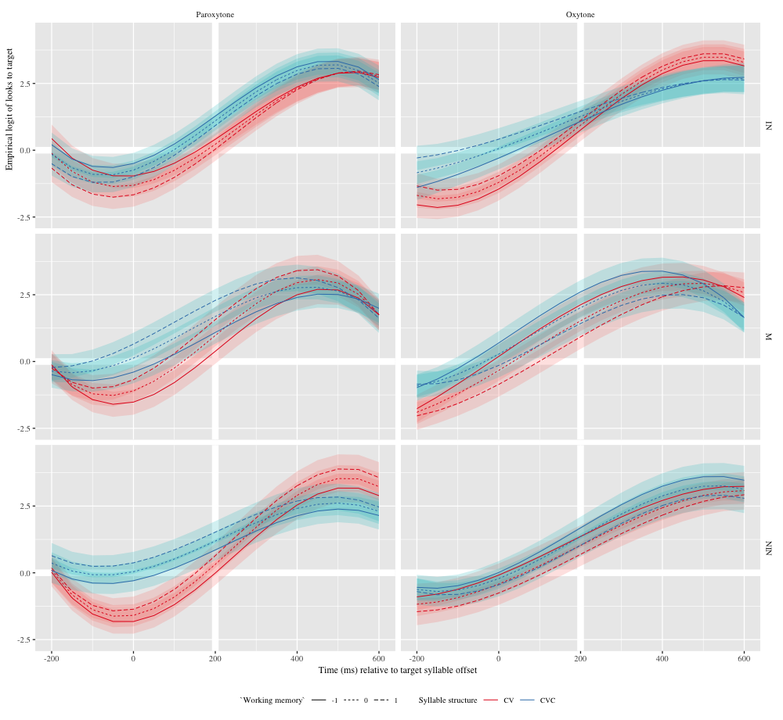

Figure 1: Growth curve estimates of target fixations as a function of lexical stress and syllable structure and working memory for each group during the analysis window. Lines represent model estimates at -1, 0, and 1 standard deviations of working memory. The transparent ribbons represents ±SE. Empirical logit values on the y-axis correspond to proportions of 0.12, 0.50, 0.88, and 0.98. The thick horizontal white line represents the 50% probability of fixating on the target. The thick vertical white line indicates 200 ms after the offset of the target syllable.

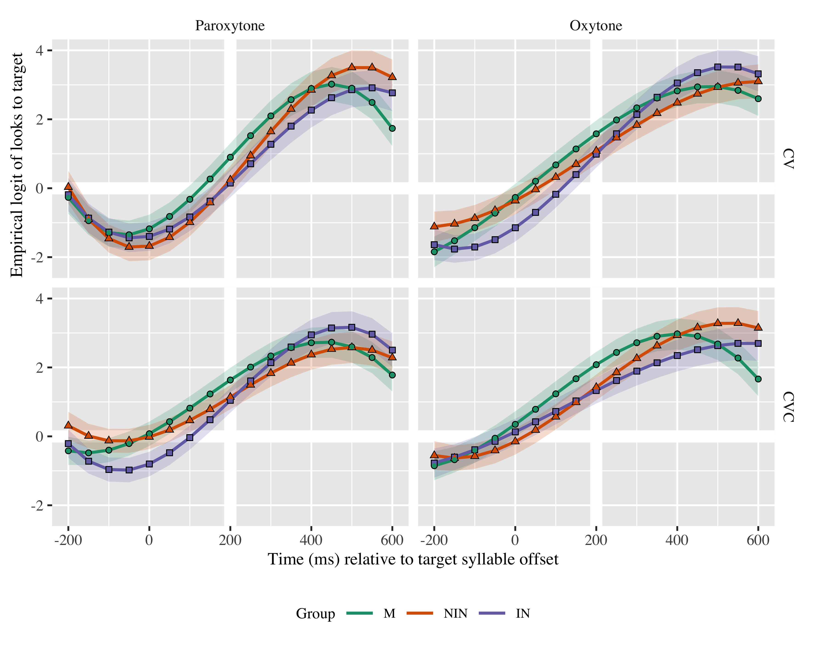

Figure 2: Growth curve estimates of target fixations as a function of lexical stress and syllable structure for each group during the analysis window. Symbols and lines represent model estimates at mean working memory, and the transparent ribbons represents ±SE. Empirical logit values on the y-axis correspond to proportions of 0.12, 0.50, 0.88, and 0.98. The thick horizontal white line represents the 50% probability of fixating on the target. The thick vertical white line indicates 200 ms after the offset of the target syllable.

## Qualitative description - GCA + WM

* Graphs on the left reflect looks towards paroxytone (more common, FIRma) targets
* Graphs on the right reflect looks towards oxytone (less common, firMÓ) targets
* Red curves are for CV (more common)
* Blue curves are for CVC (less common)
* Solid line indicates participants with lower WM
* Dotted line indicates participants with avareage WM
* Dashed line indicates participants with higher WM

Overall tendencies: - We see that blue curves are above red curves for all groups in both stress conditions, indicating an overall higher proportion of fixation in CVC than in CV targets.

1. Monolinguals

* For paroxytones (FIRma), we see that monolinguals with higher WM were able to anticipate at a higher rate in both CV and CVC (even higher with CVC) than monolinguals with average and lower WM. It seems like monolinguals with low WM (red solid line) are not anticipating above chance at the offset of the target syllable. WM seems to be an important factor here, there is more space between the lines (solid, dotted, dashed). There seems to be an interaction (CV and CVC curves intersect), but later in the time course??
* For oxytones (firMÓ), we see the opposite pattern. Participants with lower WM (solid line), are anticipating at a higher rate than those with average (dotted line) or higher (dashed line) WM. CVC targets are predicted at a higher rate. Both CV and CVC curves seem to follow the same trajectory.

1. Non-interpreters

* For paroxytones (FIRma), we see that non-interpreters with higher WM were able to anticipate at a higher rate in both CV and CVC (even higher with CVC) than non-intepreters with average and lower WM. For CV targers, it seems like they are not anticipating, although those with higher WM could be doing it above chance (dashed curve is above chance). There seems to be an interaction (CV and CVC curves intersect).
* For oxytones (firMÓ), we see again the opposite pattern. Non-interpreters with lower WM (solid line), are anticipating at a higher rate than those with average (dotted line) or higher (dashed line) WM. Differences due to WM are smaller (dotted, dashed and solid lines are closer together). Both CV and CVC curves seem to follow the same trajectory.

1. Interpreters

* For paroxytones (FIRma), we see that interpreters with lower WM are anticipating at a higher rate in both CVC and CV conditions. For the CV condition (red line), it seems like they are not anticipating above chance at the offset of the targer syllable. Both CV and CVC curves seem to follow the same trajectory.
* For oxytones (firMÓ), we see the opposite pattern, interpreters with higher WM (dashed line) are anticipating at a higher rate than those with average (dotted line) and lower (solid line) WM, for both CV and CVC. There seems to be an interaction (CV and CVC curves intersect).
* WM seems to play a smaller role among interpreters, lines are closer together for all conditions.

## Qualitative description - GCA + Phonotatic frequency

* Graphs on the left reflect looks towards paroxytone (more common, FIRma) targets
* Graphs on the right reflect looks towards oxytone (less common, firMÓ) targets
* Red curves are for CV (more common)
* Blue curves are for CVC (less common)
* Solid line indicates participants with lower WM
* Dotted line indicates participants with avareage WM
* Dashed line indicates participants with higher WM

Overall tendencies:

1. Monolinguals

* For paroxytones (FIRma),
* For oxytones (firMÓ),

1. Non-interpreters

* For paroxytones (FIRma),
* For oxytones (firMÓ),

1. Interpreters

* For paroxytones (FIRma),
* For oxytones (firMÓ),

# Tables

## Model estimates at target syllable offset

| Group | Lexical stress | Syllable structure | Probability | LB | UB |
| --- | --- | --- | --- | --- | --- |
| IN | Paroxytone | CV | 0.556 | 0.453 | 0.654 |
|  | Oxytone |  | 0.718 | 0.634 | 0.790 |
|  | Paroxytone | CVC | 0.750 | 0.678 | 0.811 |
|  | Oxytone |  | 0.780 | 0.709 | 0.838 |
| M | Paroxytone | CV | 0.726 | 0.639 | 0.799 |
|  | Oxytone |  | 0.821 | 0.758 | 0.871 |
|  | Paroxytone | CVC | 0.844 | 0.792 | 0.885 |
|  | Oxytone |  | 0.882 | 0.838 | 0.916 |
| NIN | Paroxytone | CV | 0.578 | 0.477 | 0.673 |
|  | Oxytone |  | 0.736 | 0.656 | 0.803 |
|  | Paroxytone | CVC | 0.767 | 0.698 | 0.823 |
|  | Oxytone |  | 0.795 | 0.729 | 0.849 |

*Table 1*: Model estimates at mean working memory for probability of target fixations ±SE at 200 ms after the target syllable offset.

## Fixed effects

|  |  |  |  |  |
| --- | --- | --- | --- | --- |
| Parameter | Estimate | SE | *t* | *p* |
| Intercept (γ00) | 1.176 | 0.214 | 5.497 | < .001 |
| Time1 (γ10) | 5.421 | 0.746 | 7.262 | < .001 |
| Time2 (γ20) | −1.372 | 0.396 | −3.464 | < .001 |
| Time3 (γ30) | −1.677 | 0.297 | −5.644 | < .001 |
| Syllable structure (γ01) | −0.185 | 0.105 | −1.773 | .076 |
| Time1 × Syllable structure (γ11) | 0.819 | 0.375 | 2.183 | .029 |
| Time2 × Syllable structure (γ21) | 0.424 | 0.240 | 1.769 | .077 |
| Time3 × Syllable structure (γ31) | −0.251 | 0.161 | −1.553 | .121 |
| Lexical stress (γ02) | −0.063 | 0.135 | −0.463 | .644 |
| Time1 × Lexical stress (γ12) | −0.270 | 0.376 | −0.720 | .472 |
| Time2 × Lexical stress (γ22) | 0.575 | 0.241 | 2.386 | .017 |
| Time3 × Lexical stress (γ32) | −0.579 | 0.161 | −3.587 | < .001 |
| Group NIN (γ03) | −0.081 | 0.276 | −0.294 | .768 |
| Time1 × Group NIN (γ13) | 0.441 | 0.923 | 0.477 | .633 |
| Time2 × Group NIN (γ23) | 1.823 | 0.471 | 3.871 | < .001 |
| Time3 × Group NIN (γ33) | 0.149 | 0.383 | 0.389 | .698 |
| Group IN (γ04) | −0.229 | 0.283 | −0.811 | .417 |
| Time1 × Group IN (γ14) | 0.889 | 0.944 | 0.942 | .346 |
| Time2 × Group IN (γ24) | 1.615 | 0.480 | 3.360 | < .001 |
| Time3 × Group IN (γ34) | 0.028 | 0.391 | 0.072 | .943 |
| Syllable structure × Lexical stress (γ05) | −0.027 | 0.100 | −0.268 | .789 |
| Time1 × Syllable structure × Lexical stress (γ15) | −0.120 | 0.410 | −0.292 | .771 |
| Time2 × Syllable structure × Lexical stress (γ25) | 0.104 | 0.289 | 0.360 | .719 |
| Time3 × Syllable structure × Lexical stress (γ35) | −0.491 | 0.226 | −2.172 | .030 |
| Lexical stress × Working memory (γ06) | 0.362 | 0.219 | 1.649 | .099 |
| Time1 × Lexical stress × Working memory (γ16) | −0.162 | 0.251 | −0.645 | .519 |
| Time2 × Lexical stress × Working memory (γ26) | −0.862 | 0.250 | −3.450 | < .001 |
| Syllable structure × Working memory (γ36) | −0.004 | 0.057 | −0.076 | .939 |
| Time1 × Syllable structure × Lexical stress × Group NIN (γ07) | 0.895 | 0.277 | 3.229 | .001 |
| Syllable structure × Lexical stress × Group NIN (γ17) | 0.001 | 0.069 | 0.022 | .983 |
| Time3 × Syllable structure × Lexical stress × Group NIN (γ27) | −0.001 | 0.273 | −0.003 | .997 |
| Time1 × Lexical stress × Group IN:Working memory (γ37) | 0.684 | 0.301 | 2.273 | .023 |
| Syllable structure × Lexical stress × Group IN (γ08) | −0.034 | 0.070 | −0.483 | .629 |
| Time1 × Syllable structure × Working memory (γ18) | 0.239 | 0.113 | 2.107 | .035 |
| Time1 × Syllable structure × Lexical stress × Group IN (γ28) | −0.671 | 0.281 | −2.384 | .017 |
| Lexical stress × Group NIN × Working memory (γ38) | −0.076 | 0.285 | −0.266 | .790 |
| Time2 × Syllable structure × Lexical stress × Group NIN (γ09) | 0.299 | 0.275 | 1.087 | .277 |
| Lexical stress × Group IN × Working memory (γ19) | −0.567 | 0.261 | −2.171 | .030 |
| Time2 × Syllable structure × Lexical stress × Group IN (γ29) | 0.177 | 0.280 | 0.633 | .527 |
| Time3 × Syllable structure × Lexical stress × Group IN (γ39) | 0.846 | 0.277 | 3.052 | .002 |
| Time2 × Lexical stress × Group NIN:Working memory (γ010) | 0.701 | 0.325 | 2.155 | .031 |
| Time1 × Lexical stress × Group NIN:Working memory (γ110) | 0.251 | 0.326 | 0.770 | .441 |
| Time2 × Lexical stress × Group IN:Working memory (γ210) | 0.772 | 0.299 | 2.580 | .010 |

Appendix 1: Growth curve model fixed effects

## Random effects

|  |  |  |  |  |  |  |  |  |  |
| --- | --- | --- | --- | --- | --- | --- | --- | --- | --- |
| Group | Parameter | Variance | SD | Correlations |  |  |  |  |  |
| Participant | Intercept | 0.869 | 0.932 | 1.00 |  |  |  |  |  |
|  | Syllable structure | 0.179 | 0.423 | −.14 | 1.00 |  |  |  |  |
|  | Lexical stress | 0.666 | 0.816 | −.01 | .21 | 1.00 |  |  |  |
|  | Time1 | 9.495 | 3.081 | .42 | −.14 | .06 | 1.00 |  |  |
|  | Time2 | 1.806 | 1.344 | −.06 | .18 | .08 | .37 | 1.00 |  |
|  | Time3 | 0.933 | 0.966 | −.35 | .01 | −.26 | −.79 | −.16 | 1.00 |
| Item | Intercept | 0.229 | 0.479 | 1.00 |  |  |  |  |  |
|  | Time1 | 3.911 | 1.978 | .21 |  |  | 1.00 |  |  |
|  | Time2 | 1.363 | 1.168 | −.75 |  |  | −.43 | 1.00 |  |
|  | Time3 | 0.402 | 0.634 | .27 |  |  | −.86 | −.08 | 1.00 |
| Residual |  | 13.484 | 3.672 |  |  |  |  |  |  |

Appendix 2: Growth curve model random effects

# Statistical Analysis

Example write up (must be rewritten)

(Reporting rows from final model)

Figure 1 plots the model estimates from the GCA, and the full model summary is available in Appendices 1 and 2. We report the results for the M group and then provide comparisons with and between the learner groups. The model intercept estimates the log odds of M fixating on the target, averaging over the time course, lexical stress, and syllable structure, at the mean working memory (XXX). The log odds were *γ*00 = 1.18 (proportion: .76). The linear, quadratic, and cubic polynomial time terms captured the sigmoid shape of the time course and were retained in the model (γ10 = 5.421; SE = 0.746; *t* = 7.262; *p* = .001; γ20 = −1.372; SE = 0.396; *t* = −3.464; *p* = .001; γ30 = −1.677; SE = 0.297; *t* = −5.644; *p* = .001).

(Reporting nested model comparisons)