# Language learning article (stress and working memory with natives, late advanced learners and interpreters)

# Plots

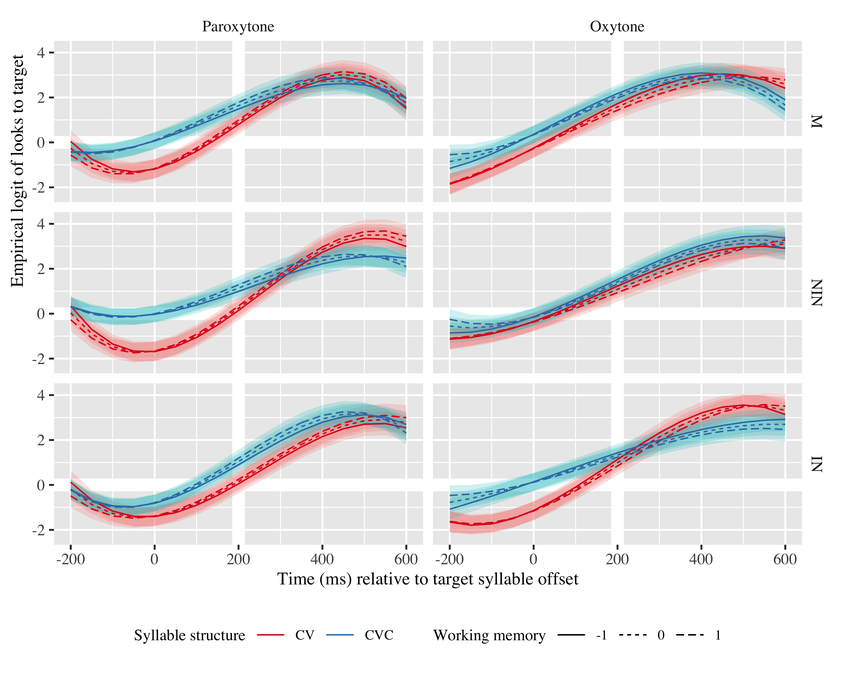

Figure 1: Growth curve estimates of target fixations as a function of lexical stress and syllable structure and working memory for each group during the analysis window. Lines represent model estimates at -1, 0, and 1 standard deviations of working memory. The transparent ribbons represents ±SE. Empirical logit values on the y-axis correspond to proportions of 0.12, 0.50, 0.88, and 0.98. The thick horizontal white line represents the 50% probability of fixating on the target. The thick vertical white line indicates 200 ms after the offset of the target syllable.

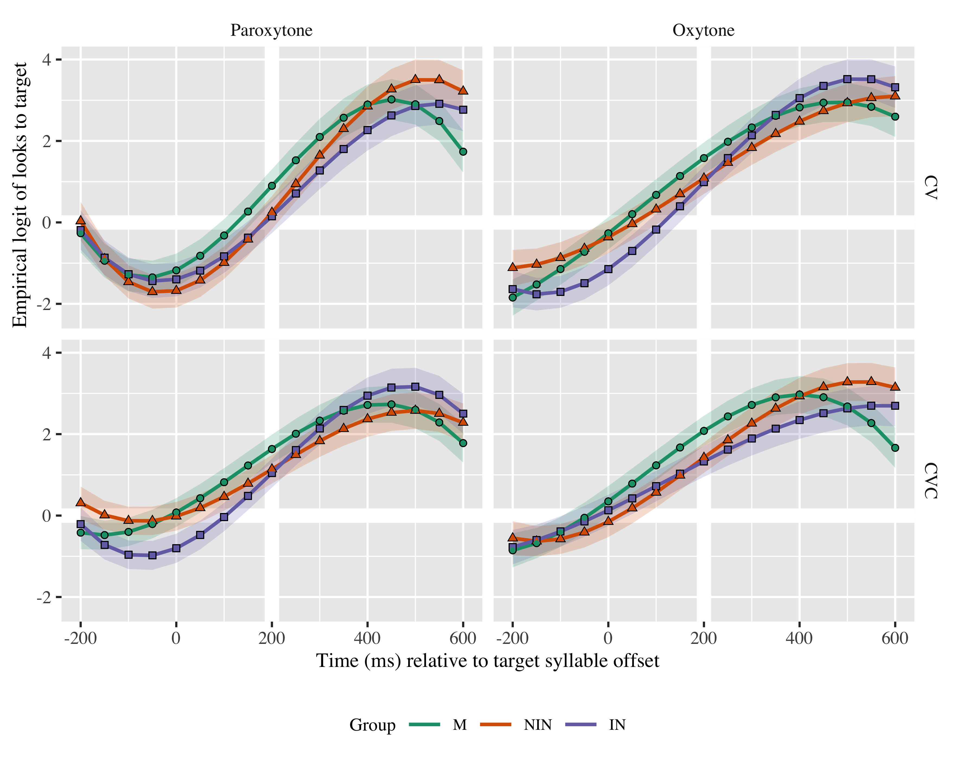

Figure 2: Growth curve estimates of target fixations as a function of lexical stress and syllable structure for each group during the analysis window. Symbols and lines represent model estimates at mean working memory, and the transparent ribbons represents ±SE. Empirical logit values on the y-axis correspond to proportions of 0.12, 0.50, 0.88, and 0.98. The thick horizontal white line represents the 50% probability of fixating on the target. The thick vertical white line indicates 200 ms after the offset of the target syllable.

# Tables

## Model estimates at target syllable offset

| Group | Lexical stress | Syllable structure | Probability | LB | UB |
| --- | --- | --- | --- | --- | --- |
| M | Paroxytone | CV | 0.711 | 0.621 | 0.786 |
|  | Oxytone |  | 0.829 | 0.767 | 0.877 |
|  | Paroxytone | <CVC | 0.837 | 0.783 | 0.879 |
|  | Oxytone |  | 0.889 | 0.847 | 0.921 |
| NIN | Paroxytone | CV | 0.560 | 0.459 | 0.657 |
|  | Oxytone |  | 0.747 | 0.668 | 0.813 |
|  | Paroxytone | CVC | 0.757 | 0.687 | 0.816 |
|  | Oxytone |  | 0.806 | 0.741 | 0.857 |
| IN | Paroxytone | CV | 0.537 | 0.435 | 0.637 |
|  | Oxytone |  | 0.729 | 0.645 | 0.799 |
|  | Paroxytone | CVC | 0.740 | 0.666 | 0.802 |
|  | Oxytone |  | 0.791 | 0.722 | 0.847 |

*Table 1*: Model estimates at mean working memory for probability of target fixations ±SE at 200 ms after the target syllable offset.

## Fixed effects

|  |  |  |  |  |
| --- | --- | --- | --- | --- |
| Parameter | Estimate | SE | *t* | *p* |
| **Intercept (γ00)** | **1.174** | **0.214** | **5.483** | **< .001** |
| **Time1 (γ10)** | **5.413** | **0.746** | **7.253** | **< .001** |
| **Time2 (γ20)** | **−1.374** | **0.396** | **−3.470** | **< .001** |
| **Time3 (γ30)** | **−1.666** | **0.297** | **−5.614** | **< .001** |
| Syllable structure (γ01) | −0.191 | 0.105 | −1.822 | .068 |
| **Time1 × Syllable structure (γ11)** | **0.831** | **0.374** | **2.223** | **.026** |
| Time2 × Syllable structure (γ21) | 0.434 | 0.241 | 1.805 | .071 |
| Time3 × Syllable structure (γ31) | −0.252 | 0.161 | −1.565 | .118 |
| Lexical stress (γ02) | −0.116 | 0.136 | −0.853 | .394 |
| Time1 × Lexical stress (γ12) | −0.215 | 0.374 | −0.575 | .565 |
| **Time2 × Lexical stress (γ22)** | **0.605** | **0.241** | **2.516** | **.012** |
| **Time3 × Lexical stress (γ32)** | **−0.577** | **0.161** | **−3.587** | **< .001** |
| Group NIN (γ03) | −0.078 | 0.276 | −0.284 | .777 |
| Time1 × Group NIN (γ13) | 0.456 | 0.925 | 0.493 | .622 |
| **Time2 × Group NIN (γ23)** | **1.828** | **0.470** | **3.888** | **< .001** |
| Time3 × Group NIN (γ33) | 0.133 | 0.384 | 0.345 | .730 |
| Group IN (γ04) | −0.227 | 0.282 | −0.804 | .421 |
| Time1 × Group IN (γ14) | 0.908 | 0.945 | 0.961 | .337 |
| **Time2 × Group IN (γ24)** | **1.624** | **0.480** | **3.384** | **< .001** |
| Time3 × Group IN (γ34) | 0.017 | 0.392 | 0.044 | .965 |
| Syllable structure × Lexical stress (γ05) | −0.029 | 0.100 | −0.289 | .773 |
| Time1 × Syllable structure × Lexical stress (γ15) | −0.111 | 0.409 | −0.271 | .787 |
| Time2 × Syllable structure × Lexical stress (γ25) | 0.110 | 0.289 | 0.380 | .704 |
| **Time3 × Syllable structure × Lexical stress (γ35)** | **−0.492** | **0.226** | **−2.179** | **.029** |
| Lexical stress × Working memory (γ06) | 0.050 | 0.104 | 0.480 | .632 |
| **Time1 × Lexical stress × Working memory (γ16)** | **0.263** | **0.112** | **2.347** | **.019** |
| **Time2 × Lexical stress × Working memory (γ26)** | **−0.264** | **0.112** | **−2.364** | **.018** |
| Time3 × Lexical stress × Working memory (γ36) | −0.032 | 0.112 | −0.289 | .772 |
| Syllable structure × Working memory (γ07) | −0.003 | 0.057 | −0.052 | .958 |
| **Time1 × Syllable structure × Working memory (γ17)** | **0.231** | **0.113** | **2.041** | **.041** |
| Time2 × Syllable structure × Working memory (γ27) | 0.076 | 0.113 | 0.675 | .499 |
| Time3 × Syllable structure × Working memory (γ37) | 0.188 | 0.112 | 1.676 | .094 |
| Syllable structure × Lexical stress × Group NIN (γ08) | 0.001 | 0.069 | 0.022 | .983 |
| **Time1 × Syllable structure × Lexical stress × Group NIN (γ18)** | **0.893** | **0.277** | **3.222** | **.001** |
| Time2 × Syllable structure × Lexical stress × Group NIN (γ28) | 0.300 | 0.275 | 1.090 | .276 |
| Time3 × Syllable structure × Lexical stress × Group NIN (γ38) | −0.003 | 0.273 | −0.010 | .992 |
| Syllable structure × Lexical stress × Group IN (γ09) | −0.033 | 0.070 | −0.472 | .637 |
| **Time1 × Syllable structure × Lexical stress × Group IN (γ19)** | **−0.681** | **0.281** | **−2.419** | **.016** |
| Time2 × Syllable structure × Lexical stress × Group IN (γ29) | 0.171 | 0.280 | 0.613 | .540 |
| **Time3 × Syllable structure × Lexical stress × Group IN (γ39)** | **0.843** | **0.277** | **3.039** | **.002** |

Appendix 1: Growth curve model fixed effects

## Random effects

|  |  |  |  |  |  |  |  |  |  |
| --- | --- | --- | --- | --- | --- | --- | --- | --- | --- |
| Group | Parameter | Variance | SD | Correlations |  |  |  |  |  |
| Participant | Intercept | 0.869 | 0.932 | 1.00 |  |  |  |  |  |
|  | Syllable structure | 0.179 | 0.423 | −.15 | 1.00 |  |  |  |  |
|  | Lexical stress | 0.719 | 0.848 | −.06 | .16 | 1.00 |  |  |  |
|  | Time1 | 9.492 | 3.081 | .42 | −.14 | .04 | 1.00 |  |  |
|  | Time2 | 1.793 | 1.339 | −.06 | .18 | .05 | .38 | 1.00 |  |
|  | Time3 | 0.920 | 0.959 | −.35 | .01 | −.21 | −.80 | −.17 | 1.00 |
| Item | Intercept | 0.230 | 0.480 | 1.00 |  |  |  |  |  |
|  | Time1 | 3.886 | 1.971 | .21 |  |  | 1.00 |  |  |
|  | Time2 | 1.377 | 1.174 | −.76 |  |  | −.42 | 1.00 |  |
|  | Time3 | 0.397 | 0.630 | .26 |  |  | −.86 | −.08 | 1.00 |
| Residual |  | 13.492 | 3.673 |  |  |  |  |  |  |

Appendix 2: Growth curve model random effects

# Statistical Analysis

Example write up (must be rewritten)

(Reporting rows from final model)

Figure 1 plots the model estimates from the GCA, and the full model summary is available in Appendices 1 and 2. We report the results for the M group and then provide comparisons with and between the learner groups. The model intercept estimates the log odds of M fixating on the target, averaging over the time course, lexical stress, and syllable structure, at the mean working memory (XXX). The log odds were *γ*00 = 1.17 (proportion: .76). The linear, quadratic, and cubic polynomial time terms captured the sigmoid shape of the time course and were retained in the model (γ10 = 5.413; SE = 0.746; *t* = 7.253; *p* = .001; γ20 = −1.374; SE = 0.396; *t* = −3.470; *p* = .001; γ30 = −1.666; SE = 0.297; *t* = −5.614; *p* = .001).

(Reporting nested model comparisons)

There was (was not) a main effect of XXX on the quadratic time term (*χ*2(1) = 0.035, *p* = .852).