Example project

Last update: 2021-07-15 22:52:04

## Chunks

* echo: logical (TRUE/FALSE)
* eval: logical (TRUE/FALSE)
* include: logical (TRUE/FALSE)

dat <- read_csv(here("data", "simulated_data.csv"))

## Plots

Important chunk options

* fig.retina: numeric (1 or 2)
* fig.width: numeric
* fig.height: numeric
* fig.align: character (‘left,’ ‘right,’ ‘center’)

dat %>%   
 ggplot() +   
 aes(x = days, y = score) +   
 geom_point()

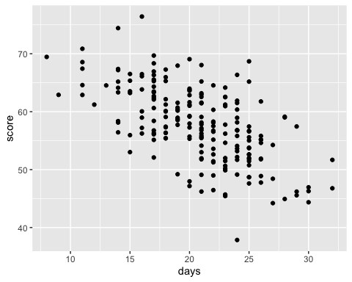

## Tables

Important chunk options

* results: character (‘hide,’ ‘asis’)

### Descriptive stats

dat %>%   
 summarize(n = n(), avg_score = mean(score), sd_score = sd(score)) %>%   
 mutate_if(is.numeric, round, digits = 2) %>%   
 kable(format = "pandoc")

|  |  |  |
| --- | --- | --- |
| n | avg_score | sd_score |
| 200 | 57.79 | 6.52 |

### Fit a model

# Score as a function of days without sleep  
mod <- lm(score ~ days, data = dat)  
  
# Model summary  
summary(mod)

##   
## Call:  
## lm(formula = score ~ days, data = dat)  
##   
## Residuals:  
## Min 1Q Median 3Q Max   
## -16.9936 -3.7448 -0.0837 3.3398 14.7360   
##   
## Coefficients:  
## Estimate Std. Error t value Pr(>|t|)   
## (Intercept) 76.25144 1.74513 43.69 <2e-16 ***  
## days -0.89199 0.08244 -10.82 <2e-16 ***  
## ---  
## Signif. codes: 0 '***' 0.001 '**' 0.01 '*' 0.05 '.' 0.1 ' ' 1  
##   
## Residual standard error: 5.184 on 198 degrees of freedom  
## Multiple R-squared: 0.3715, Adjusted R-squared: 0.3684   
## F-statistic: 117.1 on 1 and 198 DF, p-value: < 2.2e-16

# Assign to tidy object for cleaner printing  
mod_tib <- tidy(mod) %>%   
 mutate_if(is.numeric, round, digits = 2)

mod_tib %>%   
 kable(format = "pandoc")

|  |  |  |  |  |
| --- | --- | --- | --- | --- |
| term | estimate | std.error | statistic | p.value |
| (Intercept) | 76.25 | 1.75 | 43.69 | 0 |
| days | -0.89 | 0.08 | -10.82 | 0 |

sjPlot::tab_model(mod)

## Writing results

We analyzed the simulated data using linear regression. The outcome variable, score was modeled as a function of days without sleep. The model estimate for the intercept was 76.25 ±1.75 standard errors (*t* = 43.69, p < .001). Scores decreased as days without sleep increased. Specifically, for each day without sleep scores decreased by -0.89 ± 0.08 standard errors (*t* = -10.82, p < .001).

## Different outputs

We can change the output: argument of the YAML front matter. Try output: word_document and output: pdf_document (if you have LaTeX installed). We can also change the style of the documents using CSS (see output options).

## Ref sections

You can use .bib files to automate reference sections.

Add this to the YAML front matter:

bib: r-references.bib

And then cite anything in the r-references.bib file using @ and the ref name. For example, we did our analysis in R (R Core Team 2021). References don’t have to be parenthetical.  
Aust and Barth (2020) was used for APA formatting.

For more information about APA formatting with papaja, see the example_apa.Rmd file.

# References

Aust, Frederik, and Marius Barth. 2020. *papaja: Create APA Manuscripts with R Markdown*. <https://github.com/crsh/papaja>.

R Core Team. 2021. *R: A Language and Environment for Statistical Computing*. Vienna, Austria: R Foundation for Statistical Computing. <https://www.R-project.org/>.