**PROJECT PROPOSAL**

JJF Tours is a website whose main objective is to sell tours to visit Dublin, Ireland

The choice was based on the tourist potential that the city offers, coupled with the growing demand for domestic travel resulting from the changes imposed by Covid19. It is a promising business, attractive and capable of attracting diverse consumers.

Our early idea was to create a website whose main objective - selling tours - was clear and direct to the consumer, making it competitive.

The design of the website will reflect the colors of the Emerald Island, which are mostly green, in addition, the photos will illustrate the locations and give a brief idea of what the customer will see after booking the tour.

Our main goal is to create a webpage able to promote the city of Dublin, using a simple, direct, and creative interface that will captivate our public.

**CUSTOMER PERSONA**

To identify our customer persona, a survey was performed trough Google Forms. Where all participants were asked about general and specific information to find out about their tourism needs in Dublin. The answers are as follow:

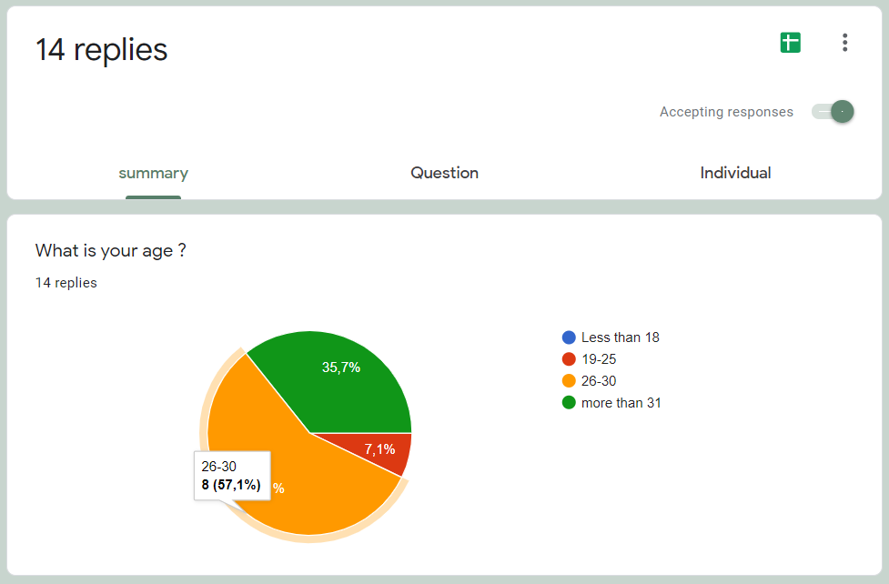

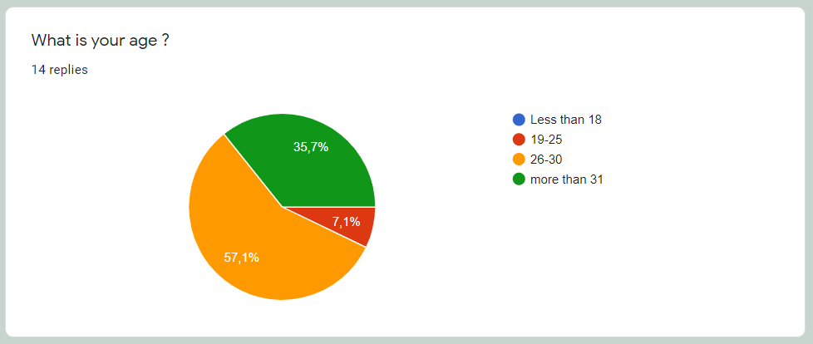

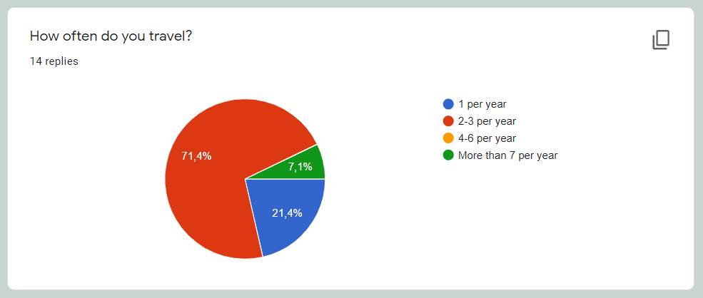

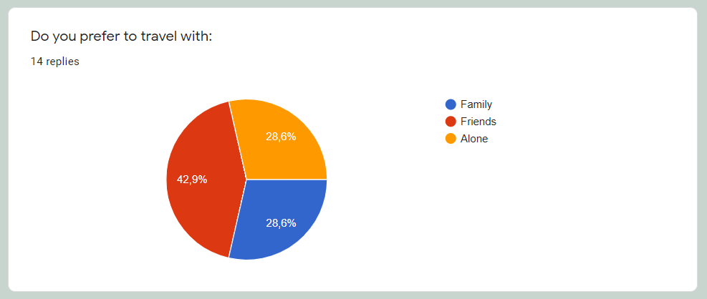 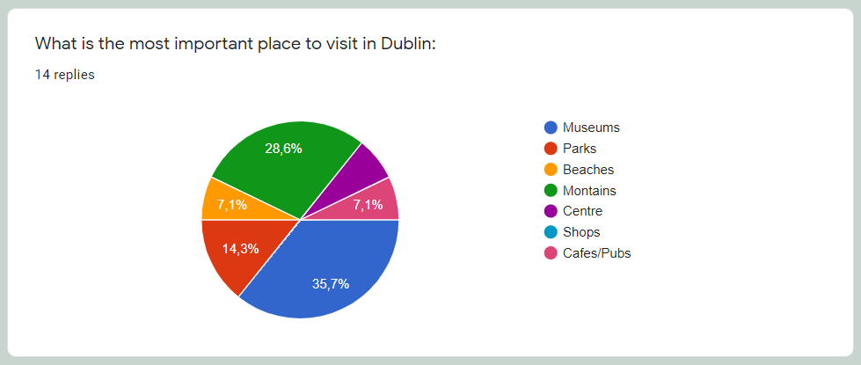 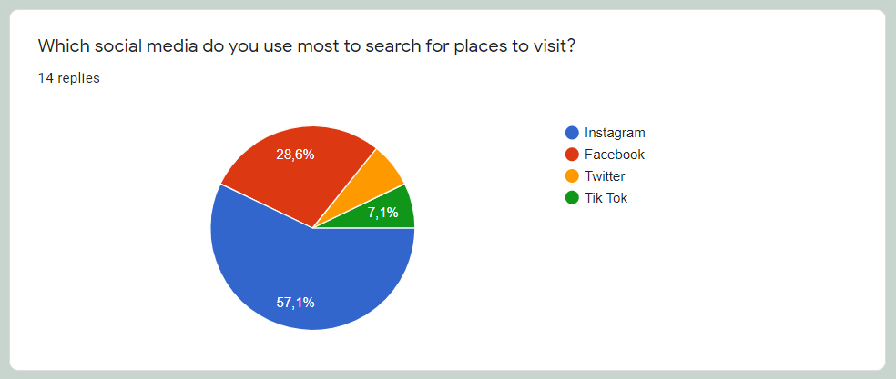

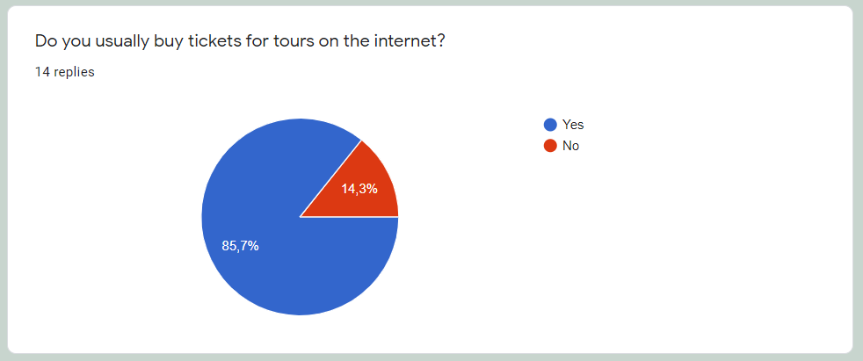 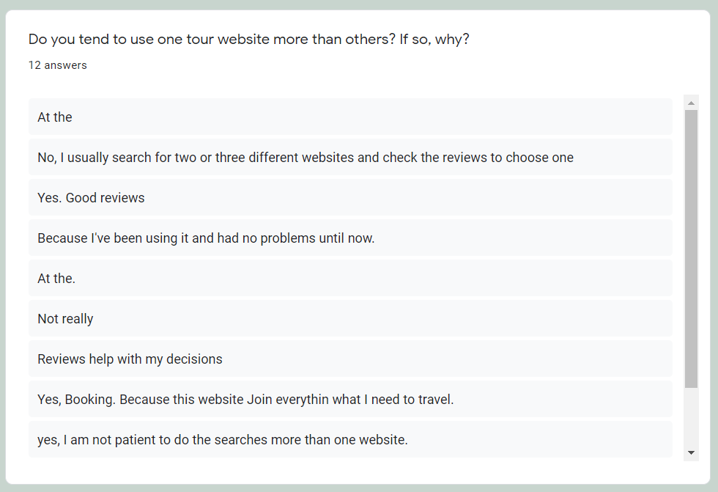

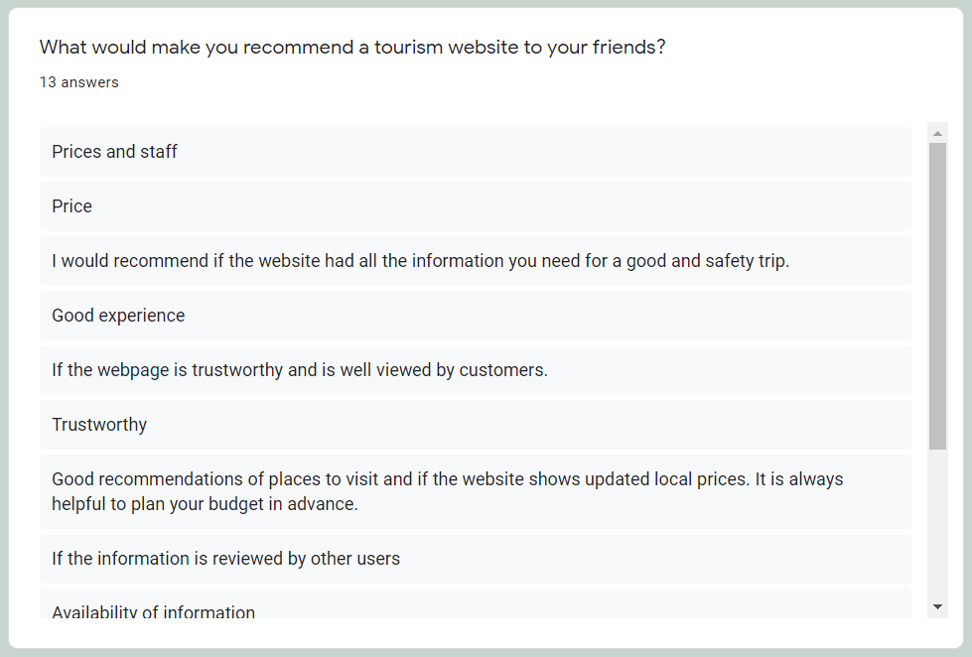 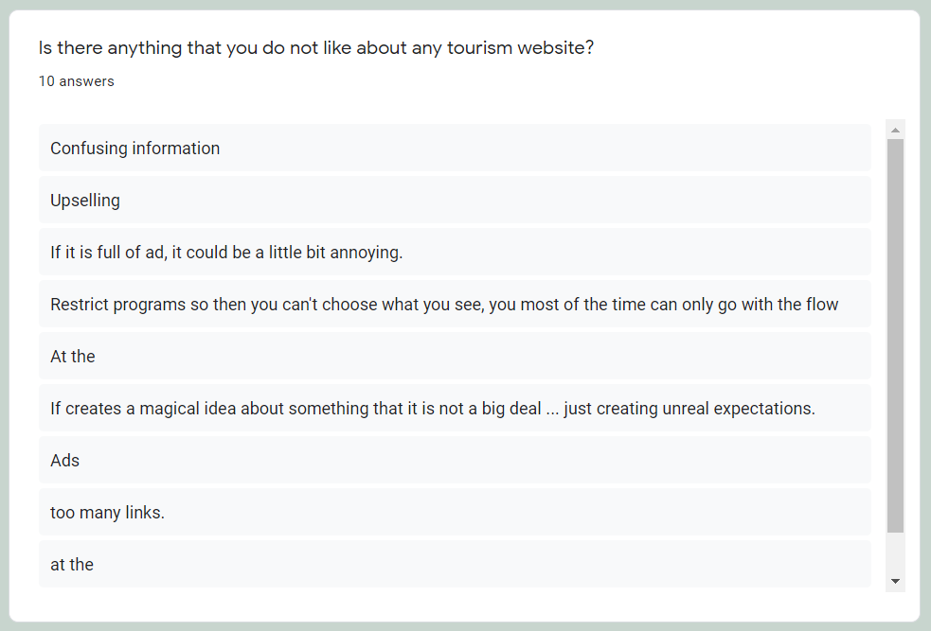

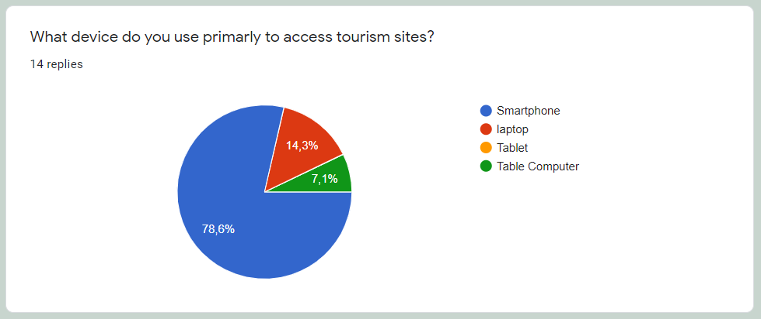

After this survey we could easily identify that our customer persona are mainly people with aged between 26 to 30, who usually travel twice or three times a year, who prefer to travel with friends, most of them rather visit museums in Dublin so they will be essentially included on our tours. Cleary, the majority is on Instagram, so we must implement marketing on Instagram as well. Our customer persona mainly buys tickets online and their criteria for choosing a webpage are based on clear information and good reviews. To achieve the objective of communicating directly with our customer persona, all this information was considered when creating this web site.

**RESEARCH / INVESTIGATION**

Doing an in-depth analysis, with the investigation of competitors, it is possible to measure points of optimizations that can be made in the short, medium, and long-term strategies.

Investigating is important to understand what your competitor's mistakes and successes were. It will be possible to learn from the experiences so as not to stagnate in strategies and to make the same mistakes.

Therefore, we have listed 3 direct competitors that we can take as a basis for our research.

**First competitor:** Irish day tours

They are known as Ireland's leading daily excursion company, with tours of 364 days a year. Currently, they do eight tours in Ireland, where everyone is guided by experienced people who can offer a good cultural experience. They also have a fleet of buses equipped with Wi-Fi and total comfort.

They say they are proud of the customer service they provide and have a 98% rating on review sites. Customers can do the entire booking and purchase process online or they can choose to go to the office located in Dublin.

The company offers a tour in Dublin via a bus that makes a fixed route in the city, so if you want to get off to see the place it can be done.

The ideas and concepts, we have from this competitor were as follows:

* their website offers a clean and very objective layout in relation to the booking and purchase of tour packages. We will also use a very objective layout to facilitate the customer's use in relation to reservations, and contacts with our company.
* their service with a rating of 98% is one of the concepts that will be widely addressed by our company and we will certainly prioritize excellent service for our customers.

**Second competitor:** Shannon Tours

A family business that takes prides in the old values of customer care and comfort. With a long tradition of providing hassle free transportation.

Shannon Tours always offers a variety of modern luxury vehicles of high specification to ensure your comfort and safety. As experienced family tourism providers, they feel it is always important to include something for everyone in the itinerary. That kind of detail led us to a big recurring business.

The ideas and concepts we have from this competitor were as follows:

* We will have as a principle our business with good and old values taking good care of our consumer. Even if we reuse this strong characteristic of our competitor, we will also implement a strong modernism to be always adapting the company to the market and always gaining space with differentials.
* A strong point of their website is the large photo gallery that highlights the fleet of comfortable and luxurious vehicles. We will reuse this concept of gallery with an emphasis on the places of our tour with beautiful pictures of Dublin and its sights.

**Third competitor:** My Ireland tour

A family business founded in 1989, consolidated in the Irish tourist market. In the beginning, they specialized in educational, horticultural, and agricultural tours. They offered highly personalized tours with personalized service to match. Offering a combination of private tours and scheduled tour packages (we sell only our own tours, no reseller or agent fees).

They have a limited number of tours allowing you to supervise each detail separately.

The ideas and concepts we have from this competitor were as follows:

* The concept of exclusive service and customization on the tours will be strongly adopted by our company. We value a unique and quality service.
* We also believe in a strong pricing of our services. The amount we will charge is fair compared to the unique experience we will provide.

**REQUIREMENTS & TECHNICAL APPROACH**

**Business Requirements** - The JFF Tour is a new launch in the business and service market that aims to become a successful website in this area, to achieve this goal it is important that the website communicate it clearly. The index page will present the city of Dublin with a good approach that makes customers want to visit Dublin through our services. The About us page will present who we are, convincing that the webpage is trustworthy and making a strong impression on customers.

**Stakeholder Requirements** – The type of this website is a website that provides services, that is, booking tour tickets for travellers who intend to visit Dublin. The company offers several options for daily tours, through our Tours page they can choose the places they want to visit. Also, the customer can make a reservation, even before they arrive in Dublin, avoiding missing an incredible opportunity to visit marvellous places, which can happen especially if there is a private place, such as museums, that require prior reservation.

**System Requirements** – The website contains functional and non-functional requirements.

Functional Requirements: the system will validate important inputs from the users on the Contact us page and on the Reservation page, these fields must be filled in correctly before being sent. If a field has not been filled out, the system should display an appropriate message informing the user what information is missing. After each registration a message should appear, confirming that all information has been sent and the user will receive an email from the company within few hours. On the Reservation page, the system should notify the total of the reservation according to the number of adults and children informed and the chosen day.

Non-Functional Requirements: the system must perform well, which means that emails must be sent immediately with response not exceeding 24 hours. Each request must be processed in 5 seconds.

**Technical Requirements** – The webpage should have a responsive design, which means that users will be able to use our web page on different devices such as smartphones, tablets, laptops, and desktop computers. In addition, the site should work in different browsers as Internet Explore, Mozilla, Google Chrome, Opera and Microsoft Edge.

**SITEMAP & WIREFRAME**

The webpage will contain six pages in total, where the main section is the Homepage, and the remaining five pages are secondary sections, as shown in the sitemap bellow:

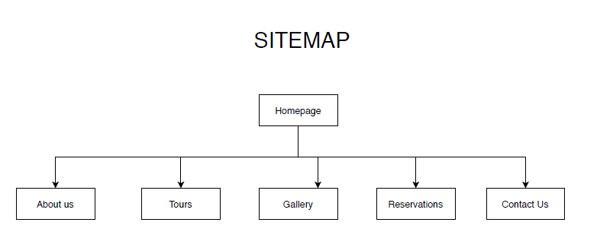

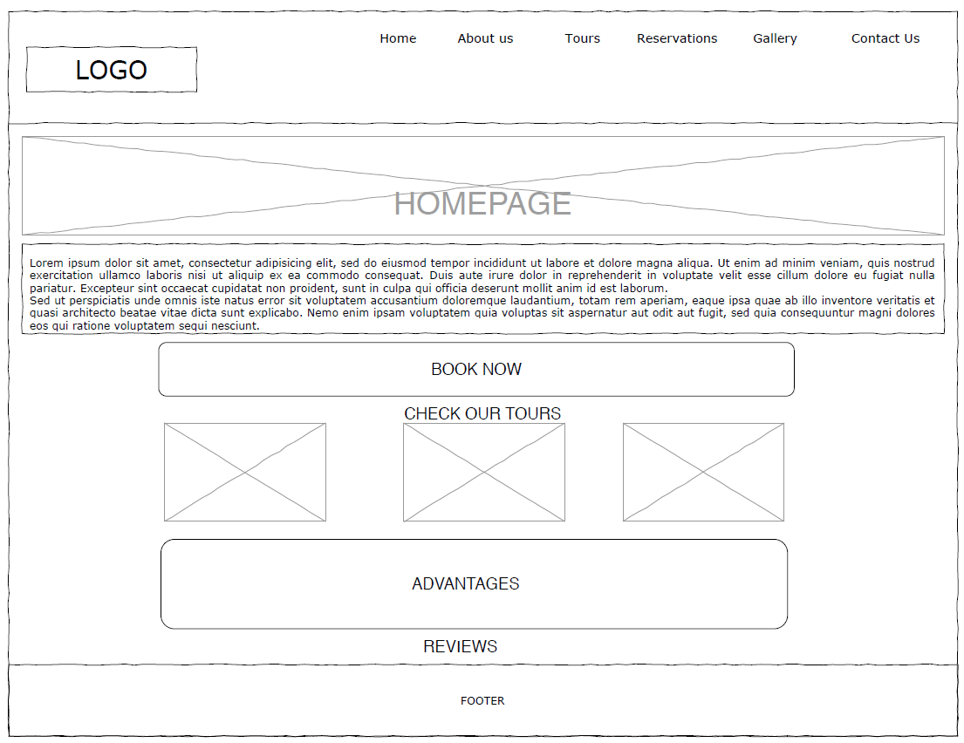**Index** - The main section is the homepage which contains a brief content about the city of Dublin and where people can find out about the tourist services provided by this company. The design pattern chosen was the In The Wild pattern, where information can be displayed in different formats. On this homepage a welcome message was first presented in a single column, then book it now and see our tours it was divided into three columns and finally the review part was divided into two columns. One web page that uses this design pattern is Brad Sawicki.

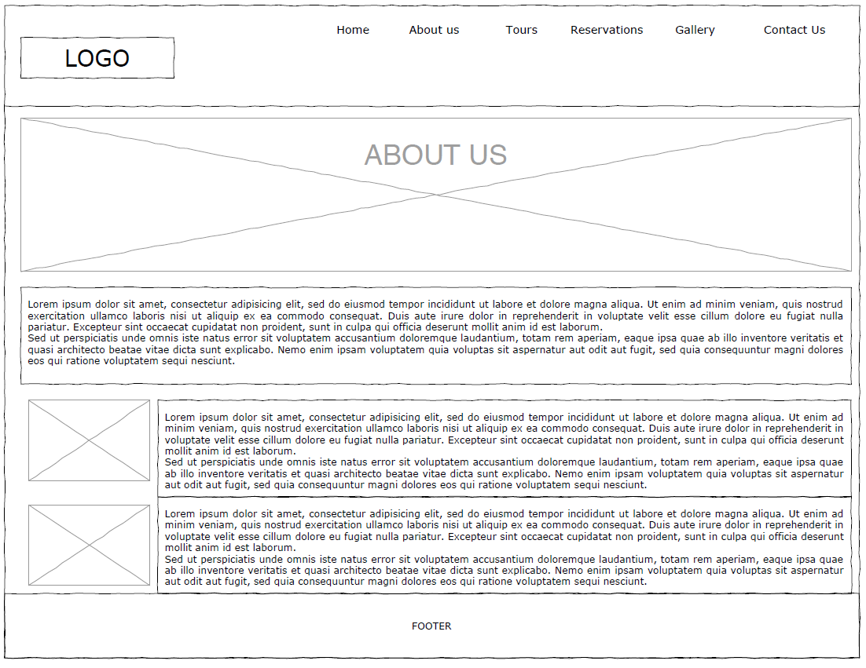

**About us** – it is a secondary section that will contain information about the company, it will tell the story of our business, why we started it, what our mission is, how our tours are managed and features of the founders. Studies show that users tend to scan large text better if the web page has an F pattern design, so the F pattern was chosen for this page. Sites like The New Yorker use this design pattern.

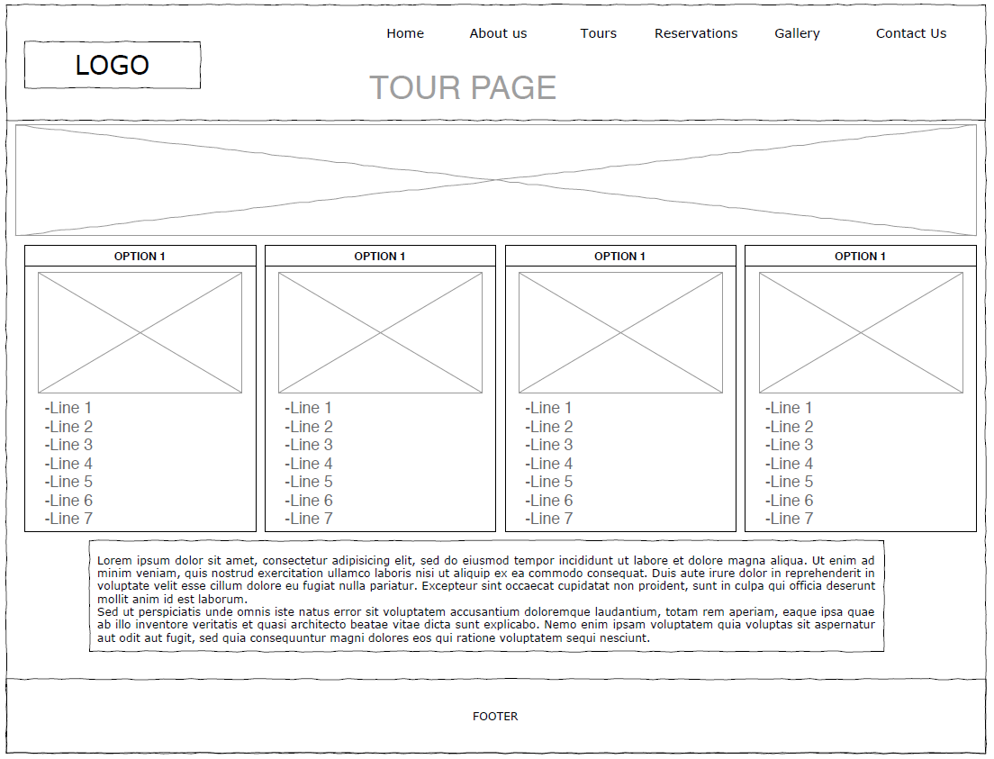

**Tours** – it is a secondary section that contains all the tours options that our company offers with all details of each one of them such as itinerary, duration, date and price, what is included and other details. The design pattern chosen to this page is Featured Items as it highlights the most important details equally. The layout starts with the four featured tours side by side with some content below. Websites like Etsy use this pattern.

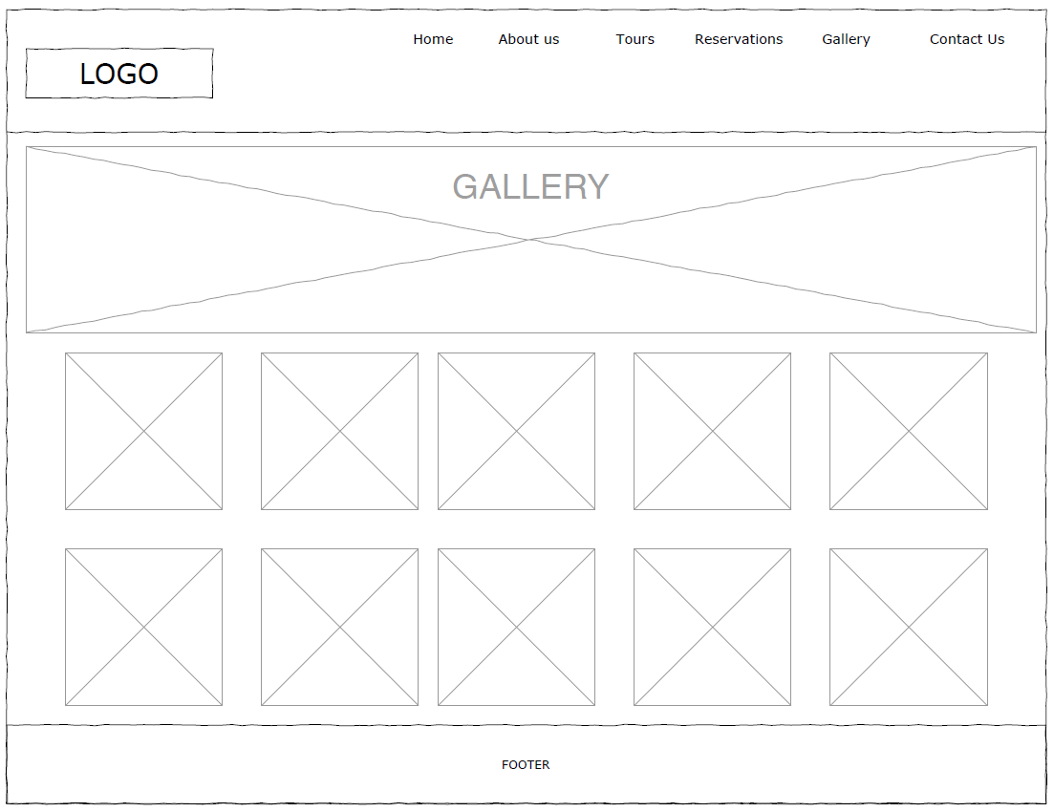

**Gallery** – it is a secondary section that contains all pictures of the most beautiful places in Dublin, where our customers will visit during the tours. The Design Pattern used on this page is a responsive thumbnail gallery where the images are arranged beside of each other, displaying all items with equal hierarchy and strict organization. And if the user clicks on an image it will open a big box with the image. One reference web page that use this design pattern is Sights of Dublin Day Tours.

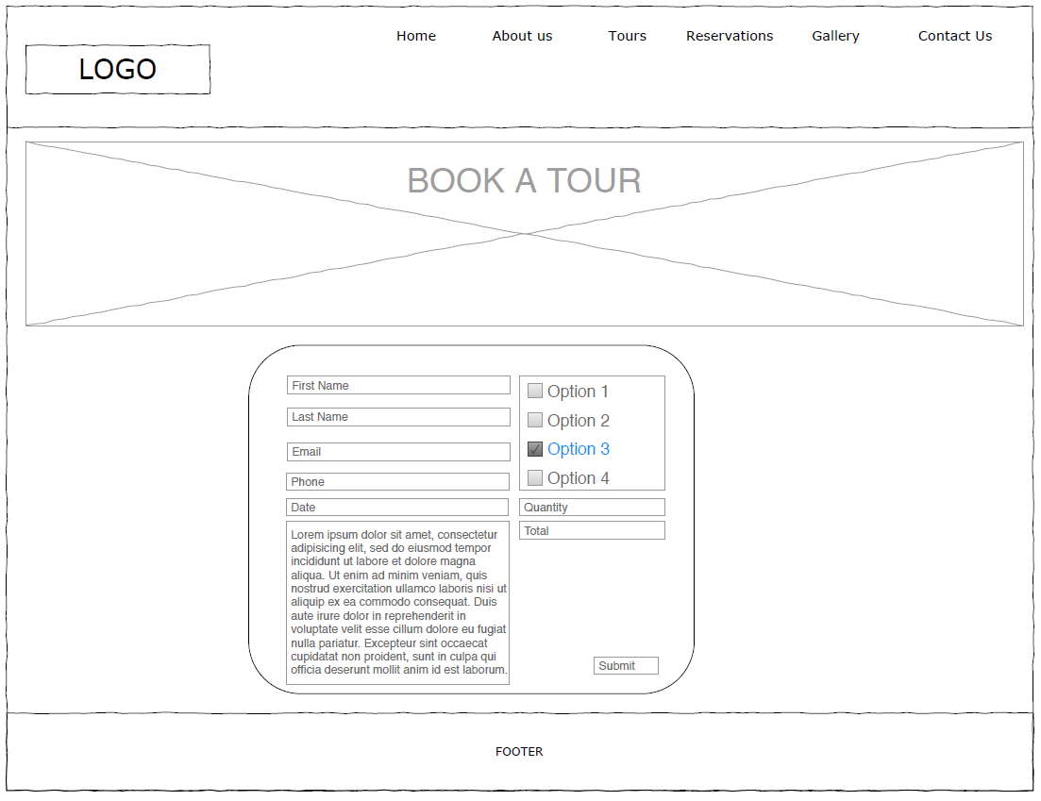

**Reservation** – it is a secondary section where the user can make a tour reservation. There is a form where the customer will fill in some information and choose the tour. After submitted the form, it will be sent to a member of our team to check availability and the booking confirmation will be return. The design pattern chosen was Z pattern as it is more effective in directing the user’s attention to the form.

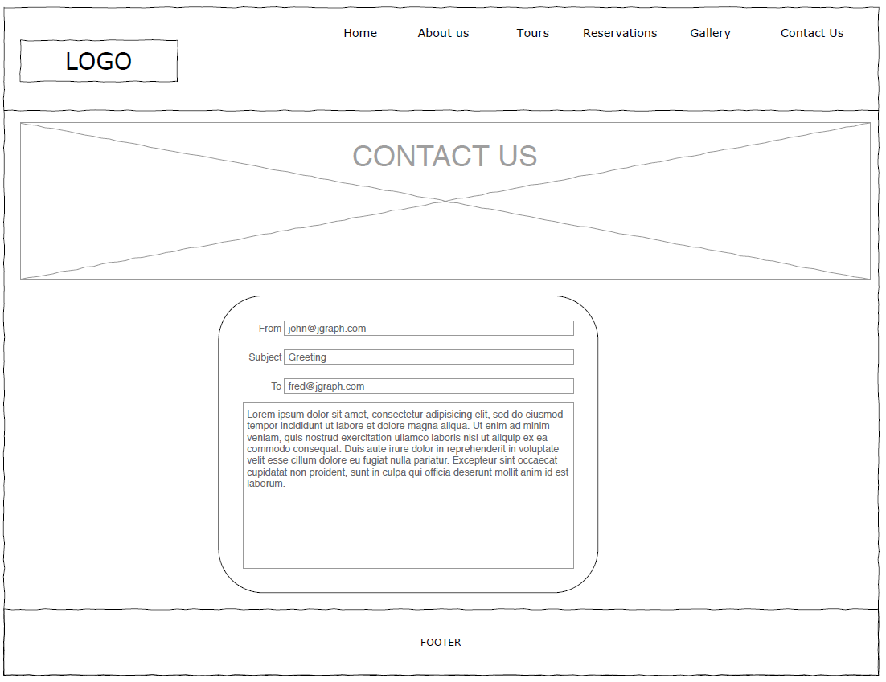

**Contact** **us** – it is a secondary section where the user can contact us directly through this page, there will be a form where they can leave a message about a special request, other information, or even a complaint. Similarly, as on the Reservation page, the Z-pattern was chosen due to fix the customer’s attention to the form.

**Section 2: Development**

Developing a complete tour web page was a big challenge. The web page was expected to be very professional and we wanted to make a good impression on our customers. So, before starting to develop, we planned the appearance of each page and, after defining which design pattern to follow, we developed the layout together. So that we kept a standard to all pages and after that each one developed its pages.

The page layout was basically the header, the navigation bar and the footer where we decided to bring the colours of Ireland and make it more personalized with the colours of the country flag. An error occurred in the navigation bar after applied the responsive design, where it did not fit properly on the page and broke when the page became smaller. This error was corrected when the font size of the navigation bar was set to a small one on the @media screen.

Also, a similar error appeared in the banner that did not fit on the page. It was corrected after the responsive design was applied to the banner ID, where the width was adjusted to 100% and the height to auto.

The index page should attract the customer’s attention, as it is the first impression of our company. One of the requirements was that the index page was clear and objective, as the customer wants to see what the company offers. Instead of a lot of text we chose to add only some important information and draw attention to the tours and to the booking page through a modern design.

The error on the index page was related to turning it into as a responsive page, where the one title mixed with another title. These two titles were found to be in two different divs, but with the same class name instead of two different divs with two different class name.

A form was created on the reservation page to receive user information. The page should send an alert to the user if he tries to submit without filling in any important fields on the form. But it was not working properly with email. After checking some examples on the internet, the email validation was fixed by using .test(reservation.email.value) on the java script page.

**VALIDATION**

On the index page validation, there were three errors. The first one was fixed by deleting the </h3> tag there was forgotten from the previous code. And the second and the third error was the bar on the <br> tag, it was deleted also.

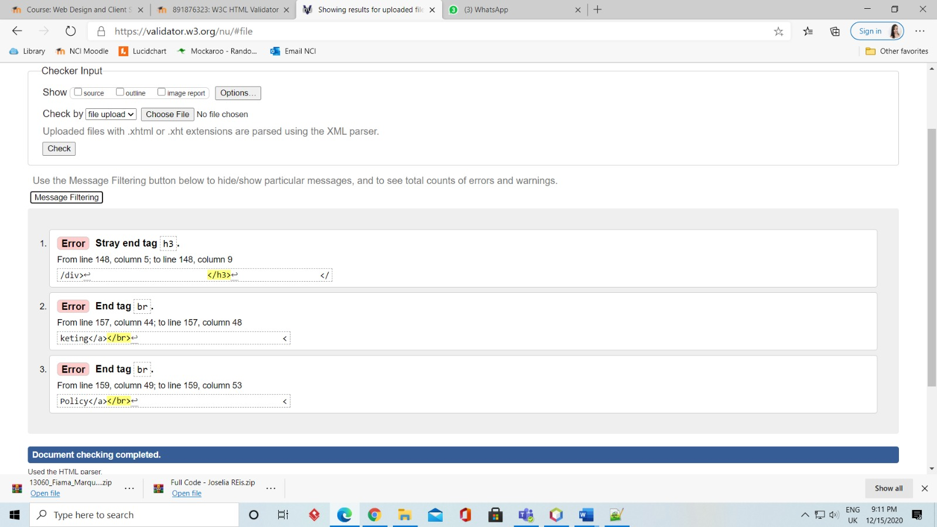

On the booking page, 5 errors were found. The first was corrected by removing the space in the email value. The second and third errors were corrected after deleting the bar in the <br> tag. The fourth and fifth were corrected after correcting the label name where the element ID should be.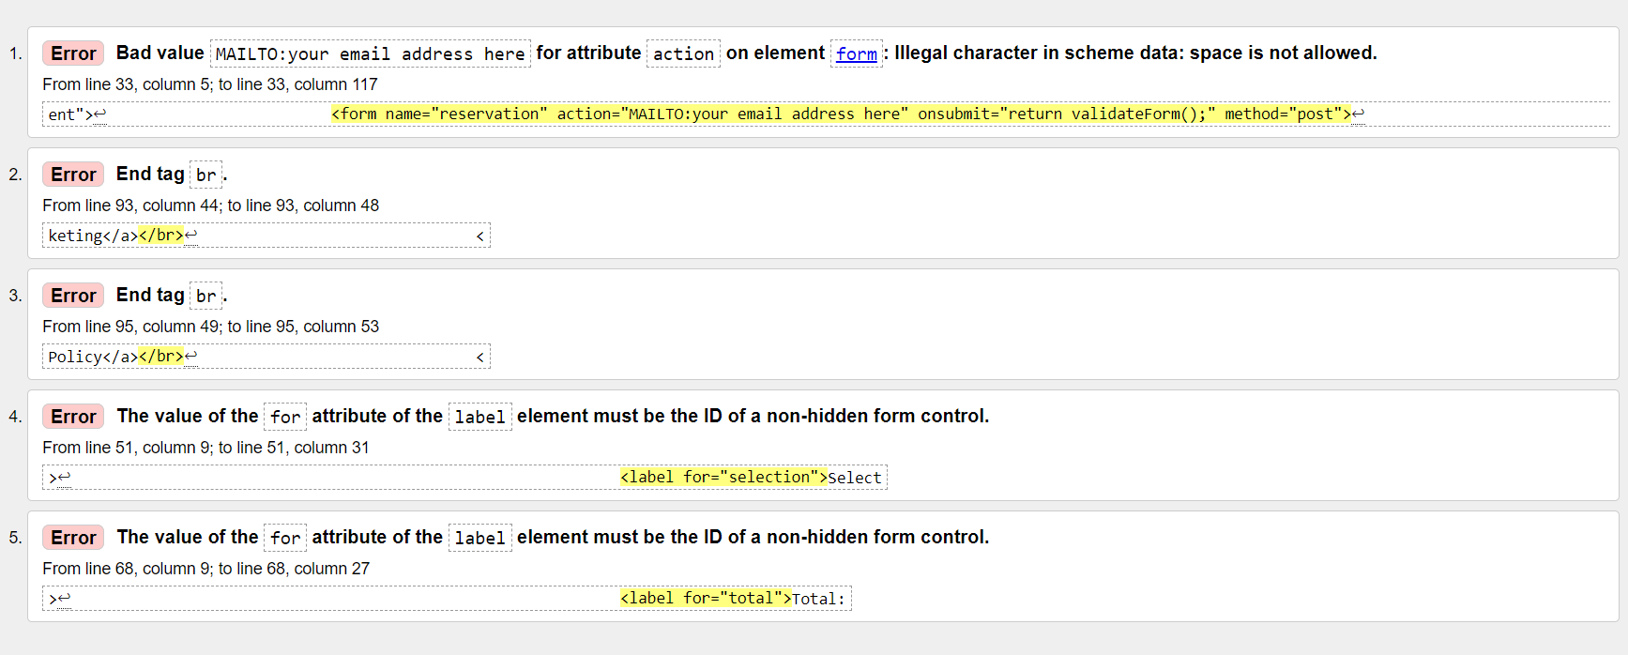

In the CSS file of the style sheet there was only one error, but 6 warnings. The error was corrected by excluding the extra bracket on line 143. All warnings reported the same type of error where family names should have quotes; it was corrected by inserting quotes in the font families.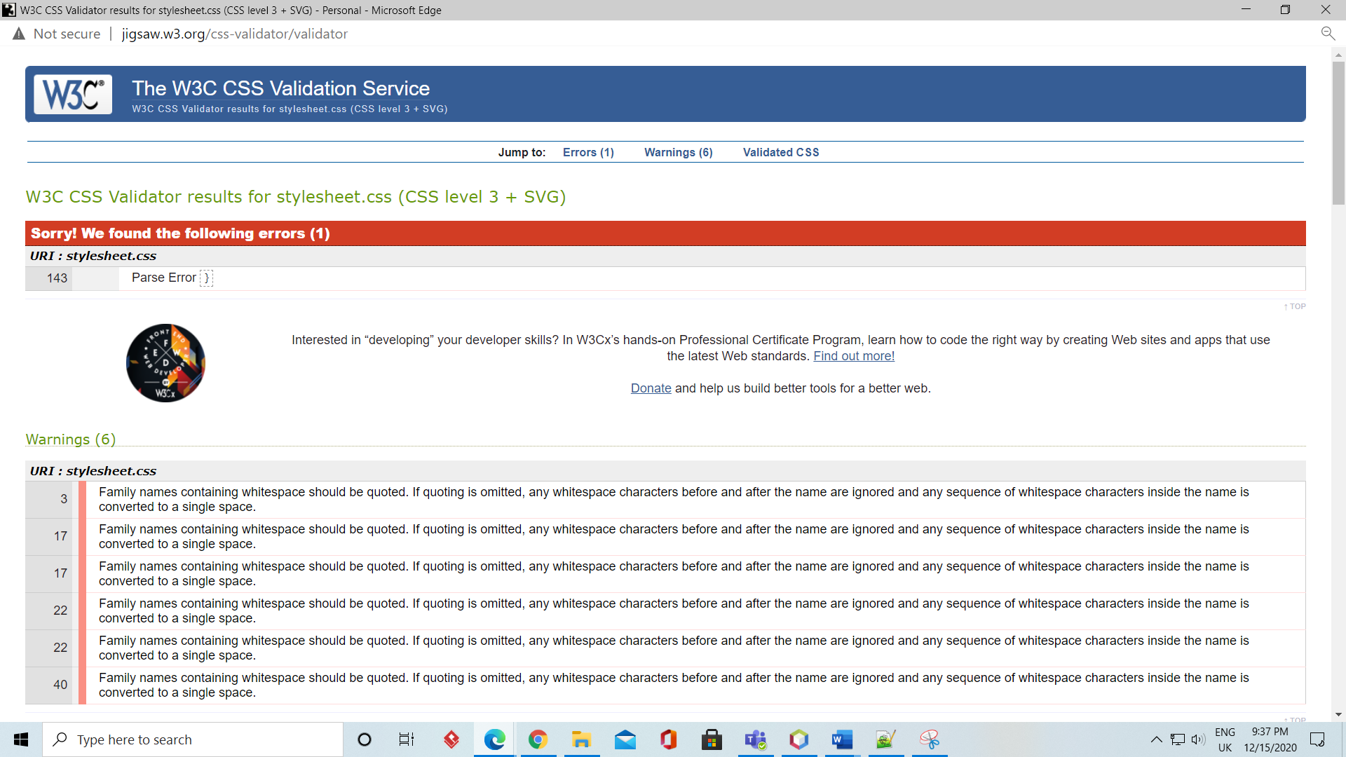

No errors were found in Fiama.css file.

**PROJECT TEAM**

Each member of the group had an important task in the development of the web site. In each section of the project, members were proactive in helping each other when there were questions and there were no problems about the division of tasks, as the group had a good interaction. The tasks were divided as follows:

