**Course: IOC 2310 Fluid Mechanics**

**Period: 201710**

**Experiment Title: Impact Experiment of a Liquid Jet.**

**Date of experiment: 17/05/17**

**Team number: G18**

**Team members: Catalina Solano Vieyra, Ignacio Pizarro Galindo, José Tomás Toledo J.**

**Summary**

In this laboratory experience, the main objective is to address the relationship the flow of water in a jet of water and the force on a flat surface. This was done first, through a theoretical analysis, using the Bernoulli Equation, the water flow rate equation and momentum conservation equation, which provide a mathematical approach to the main problem of this experience. Then proceed to the experimental phase, where measurements are taken for a fluid w ith 4 different flows (Q1 =9 l/ minute, Q2=12 l/minute, Q3 = 15 l/ minute, Q4 = 17 l/ minute), The apparatus used consist of an upward discharging jet contained within a clear cylinder, water is supplied from the lab faucet to the inlet of the apparatus via a hose. Water flowing through the nozzle strikes the flat plate. After the experimental phase, a comparative analysis was performed between the theoretical and the practical phase, where a statistical analysis was implemented to determine the constants of the theoretical equations, also a quantitative error analysis was included.



**Scientific Problem**

The scientific problem presented in this experience is to determine the relationship between the flow of water in a jet of water and the force on a flat surface. Also determine the constants of the theoretical equations (e.g., Venturi coefficient).

**Hypothesis**

Based on the constant flow rate and the Bernoulli Eq. In this case we have:

$\frac{P_{1}}{γ}+\frac{v_{1}^{2}}{2g}+z_{1}=\frac{P_{2}}{γ}+\frac{v_{2}^{2}}{2g}+z_{2}\left(3\right)v_{1}=\frac{Q}{A_{1}},v_{2}=\frac{Q}{A_{2}}\left(4\right)$

With the above we can determine the velocity of the free jet for each flow. Then using the Reynolds transport theorem, we derive the momentum conservation equation:

${\left(\frac{dP}{dt}\right)}_{sys}=\frac{d}{dt}\int_{Cv}^{.}{ρVd∀}+\int_{Cs}^{.}{ρV\left(V_{rel}∗\hat{n}\right)dA}=\sum{F}\left(5\right)$

In this case we are only interested in analyzing the y axis, due to the forces acting on it (spring force and mass weight), it should also be noted that because the control volume does not change over time, we simplified equation (5) to (6):

$\int_{Cs}^{.}{ρV\left(V_{rel}∗\hat{n}\right)dA}=\sum{F}\left(6\right)$

In this particular case the force generated by the jet is:

$F=ρ∗Q∗V_{}\left(7\right)$

Then the velocity at which the jet strikes the vane is given by:

$V_{}^{2}=V_{nozzle}^{2}−2∗g∗s\left(8\right)$

where g is gravity in $\left[\frac{m}{s^{2}}\right]$ and s is the height of the vane above nozzle tip equals to 0.035 $m$.

**Experiment and Measurements**

In the laboratory experiment, data were taken for 4 different flows (Q1 = 9 l / minute, Q2 = 12 l / minute, Q3 = 15 l / minute, Q4 = 17 l / minute), with which analyze the relationship between the flow rate and the impact force generated on the flat surface, and then compare the theoretical and experimental behavior.

**Table 1. Measurements Table**

|  |  |
| --- | --- |
| **Flat surface** | |
| **Flow rate [L/min]** | $X_{2}\left(masslocation\right)\left[cm\right]$ |
| **9** | 11 |
| **12** | 12 |
| **15** | 14 |
| **17** | 15.5 |

* Flow meter (h) did not give, therefore occupied the flow in the first column.
* Spring Axis = $X_{3}$ = 11 [cm].
* From start (A) to where the jet impacts = $X_{1}$ = 15 [cm].
* Without a jet the mass is located 25 [cm] from the origin (A).
* Mass weighs 600 grams = 0.6 [kg] and Gravity = $9.81\left[\frac{m}{s^{2}}\right]$.

**Analysis of Results**

* **Theoretical calculations**:

Taking into account the specific mass of the water ($ρ=1000\left[\frac{Kg}{m^{3}}\right]$) and using the linear momentum conservation equation (7), the following values ​​were obtained:

**Table 2. Table for theoretical results**

|  |  |  |  |
| --- | --- | --- | --- |
| **Flow rate [m^3/s]** | $V_{nozzle}\left[m/s\right]$ | $\begin{aligned}m/s \\ V_{}\end{aligned}$**]** | $\begin{aligned}N \\ F_{Theo}\end{aligned}$**]** |
| **1,50E-04** | 1.91 | 1.72 | 0.258 |
| **2,00E-04** | 2.546 | 2.407 | 0.481575 |
| **2,50E-04** | 3.183 | 3.07 | 0.768335 |
| **2,83E-04** | 3.6 | 3.506 | 1 |

**Table 3. Experimental results, Theoretical results and Quantitative analysis of errors**

|  |  |  |  |
| --- | --- | --- | --- |
| **Flat surface** | | | |
| **Flow rate [L/min]** | $F_{exp}\left[N\right]$ | $\begin{aligned}N \\ F_{Theo}\end{aligned}$] | $Errors\left[N\right]$ |
| **9** | 0.3924 | 0.258 | 0.1344 |
| **12** | 0.7848 | 0.481575 | 0.303 |
| **15** | 1.5696 | 0.768335 | 0.8 |
| **17** | 2.16 | 1 | 1.16 |

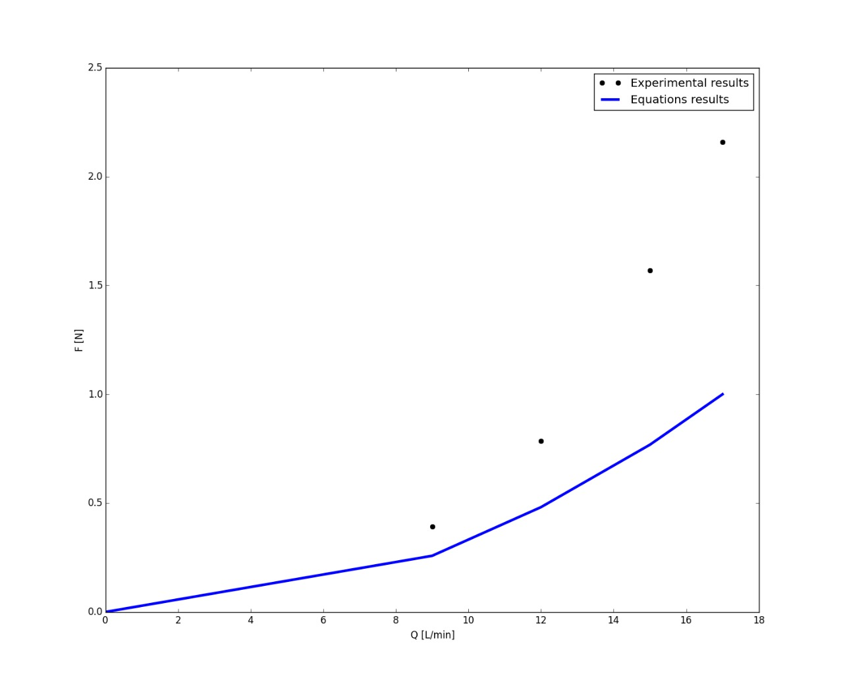

**Figure 1. Comparison of experimental results with theory (hypothesis).**

**Conclusions**