EV model script mass balance
TODO: need to add definition for flow letters (t, c, g, m, w, e) and what they mean for each process/flow

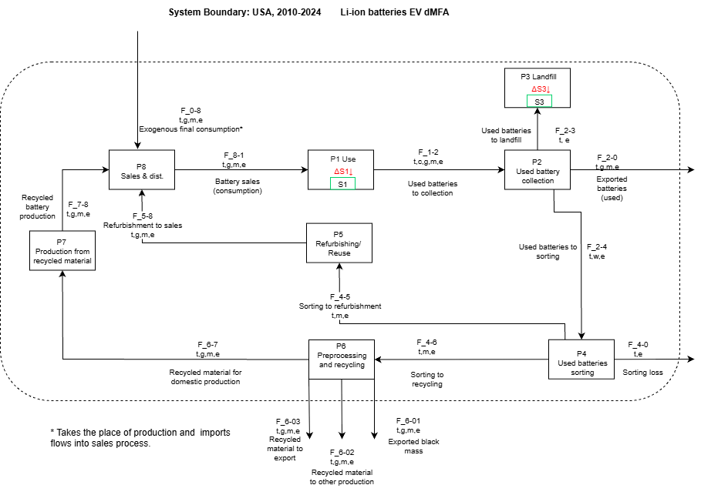

P1: Use process equation
$$F_{1-2}\left(t\right)=\sum_{2010}^{2024}{L_{1}(t-t^{'}, τ,σ)}∙F_{8-1}\left(t^{'}\right)$$
Equation 1
The Use process is the main process of the model and is thus labeled as Process 1. It is the main process because it is here where the inflow of new batteries is combined with the expected lifetime of ‘old’ batteries to determine the flow of used batteries for each time step.
More specifically, Equation 1 determines the outflow of used LIB batteries $X_{1-2}\left(t\right)$, at current year $t$, of LIB produced in previous years (vintage year $t^{'}$) by a convolution (denoted by $∙$) of the lifetime distribution of batteries in use ($L_{1}$; mean = τ, standard deviation = σ) with the inflow values of battery sales, $X_{8-1}\left(t^{'}\right)$. Here

The change in stock is the mass balance of process 1 at current year t (Equation 2; $∆S_{1}$ = output - input), and the stock accumulation at current year t is the sum of changes in stock over the previous years up to the current year (Equation 3):

$$∆S_{1}\left(t\right)=F_{1-2}\left(t\right)- F_{8-1}\left(t\right)$$
Equation 2
$$S_{1}\left(t\right)=\sum_{t^{'}=2010}^{2024}{∆S_{1}\left(t'\right)}$$
Equation 3

P2-P6: End-of-life pathways

P2 Used battery collection
Process 2 represents the collection of batteries after use, and the first separation into either, used battery export, routing for further processing, or landfill. The mass balance of this process is described by the following flows:
$F_{2-0}$, exported batteries (used) flow. $α_{1}$ is a rate defined as used batteries exported/total used batteries in a year, and is estimated based on values from Gaines et al. 2023

$$F_{2-0}\left(t\right)=F_{1-2}\left(t\right)*α_{1}$$
Equation 4

$F_{2-4}$, used batteries to sorting. $α_{2}$ is a rate defined as used batteries sent for further domestic processing (either recycling or refurbishment) divided by the total used batteries in a year.

$$F_{2-4}\left(t\right)=F_{1-2}\left(t\right)*α_{2}$$
Equation 5

$F_{2-3}$, used batteries to landfill. $α_{3}$ is a rate defined as used batteries sent to landfill/total used batteries in a year.
$$F_{2-3}\left(t\right)=F_{1-2}\left(t\right)*α_{3}$$
Equation 6

It is required that the sum of all rates related to P2 is equal to 1, i.e.,

$$α_{1}+α_{2}{+ α}_{3}=1$$
Equation 7
P3 Landfill
Process 3 represents the accumulation of LIB materials in landfills. Note that this does not include accumulation of unmanaged materials in the environment.
We assume no materials leave landfill and thus there are no outflows from this process. This results in the stock change (Equation 8) just being the flow into the landfill every year, and the total stock (Equation 9) the sum of yearly stock changes from this flow.

$$∆S_{3}\left(t\right)=F_{2-3}\left(t\right)$$
Equation 8

$$S_{3}\left(t\right)=\sum_{t^{'}=2010}^{2024}{∆S_{3}\left(t'\right)}$$

Equation 9

P4 Used batteries sorting
Process 4 represents the sorting of used batteries for domestic reuse, either through refurbishment or recycling. The mass balance of this process is represented by the following flows:

$F_{4-5}$, sorted batteries to refurbishment. $λ_{1}$ is defined as the rate at which batteries that have been sorted go to refurbishment.

$$F_{4-5}\left(t\right)=F_{2-4}\left(t\right)*λ_{1}$$
Equation 10

$F_{4-6}$, sorted batteries to recycling. $λ_{2}$ is defined as the rate at which batteries that have been sorted go to recycling.

$$F_{4-6}\left(t\right)=F_{2-4}\left(t\right)*λ_{2}$$
Equation 11

$F_{4-0}$, sorting process loss. This flow is defined as the remaining batteries that have been sorted but are found to be unsuitable to either recycling or refurbishment.
$$F_{4-0}=F_{2-4}\left(t\right)-F_{4-5}(t)- F_{4-6}\left(t\right)$$
Equation 12

This implies a sorting loss rate, $λ_{3}$, that can be defined as
$$λ_{3}=1-λ_{1}-λ_{2}$$

Equation 13

P5 Refurbishment
Process 5 represents the refurbishment of used batteries. Specifically, this represents batteries that are reconditioned for use after being removed from electric vehicles. They can be used either as vehicle batteries again or they can be repurposed. The mass balance for this process is given by the following equation:
$F_{5-8}$, refurbishment to sales. $β_{1}$ is a rate defined as refurbished batteries/total batteries sent for rebushing.

$$F_{5-8}\left(t\right)=F_{4-5}\left(t\right)*β_{1}$$
Equation 14

Currently we assume no loss in refurbishment. To be specific, we assume that batteries that reach this process are suitable for refurbishment, and batteries that are not suitable for refurbishment or recycling are discarded in process 4.

P6 Recycling
Process 6 represents the recycling of used batteries. Specifically, this represents both direct recycling (regeneration and reuse of electrode materials without completely breaking them down) and chemical recycling (hydrometallurgical and pyrometallurgical processes). The mass balance for this process is given by the following flows.

$F_{6-01}$, exported black mass flow. $γ_{1}$ is a rate defined as black mass material exported/ material in used batteries sent to recycling in a year.

$$F_{6-01}\left(t\right)=F_{4-6}\left(t\right)*γ_{1}$$
Equation 15
$F_{6-02}$, recovered material for other production. $γ_{2}$ is a rate defined as recovered material not for battery production/ material in used batteries sent to recycling in a given year.

$$F_{6-02}\left(t\right)=F_{4-6}\left(t\right)*γ_{2}$$
Equation 16
$F_{6-03}$, exported recycled battery material flow. $γ_{3}$ is a rate defined as recycled battery material (e.g. CAM) exported/ material in used batteries sent to recycling in a year.

$$F_{6-03}\left(t\right)=F_{4-6}\left(t\right)*γ_{3}$$

Equation 17

$F_{6-7}$, recycled battery material used for domestic production. $γ_{4}$ is a rate defined as recycled battery material (e.g., CAM) used for domestic production/ material in used batteries sent to recycling in a given year.
$$F_{6-7}\left(t\right)=F_{4-6}\left(t\right)*γ_{4}$$
Equation 18
Note that, from a code implementation standpoint, no flow in out of this process is calculated as the remainder of the sum of the values of the other flows. This is because the materials entering this process undergo a transformation from used material to usable goods, and as a result an explicit input rate is needed for each flow. However, we do check that that sum of the inputs equals the sum of the outputs for this process. That is,

$$F_{4-6}\left(t\right)= F_{6-01}\left(t\right)+F_{6-02}\left(t\right)+F_{6-03}\left(t\right)+F_{6-7}\left(t\right)$$
Equation 19

P7: Production from recycled material
P7 represents domestic battery production from recycled material. $ε_{1}$ is the rate of loss from recycled battery production. We currently assume no loss from this process.
$$F_{7-8}\left(t\right)=F_{6-7}\left(t\right)*ε_{1}$$
Equation 20

P8: Battery sales and distribution
For this script, the exogenous final consumption, $F_{0-8}$, is represented by yearly data points of battery sales (CES data for batteries placed on market, POM; cite). It represents sales of batteries from new production.
The mass balance for P8 is shown below, where $F_{8-1}$ represents sales of batteries from all production.

$$F_{8-1}\left(t\right)=F_{0-3}\left(t\right)+F_{5-8}\left(t\right)+F_{7-8}(t)$$
Equation 21

Note that, as more than one outflow from this process leave the system boundary, the destination number for the flow has two digits. E.g., the exported black mass flow is the first labeled flow that leaves the system boundary from process 6 and as such the flow number is 6-01.

