Theater Ticketing System Project

Software Requirements Specification

Version

17 Sep. 2026

Group 2
Jorge Fonseca, Janelle Ventura, Trea Huff

Prepared for
CS 250- Introduction to Software Systems
Instructor: Dr. Gus Hanna
Fall 2026

Revision History

Date | Description | Author | Comments
09/24/2026 | Final Draft | Team | Sections 1 – 3.5 filled.
10/22/2026 | Test Plan Completion | Team | Section 6 revised and Section 7 complete

Document Approval

The following Software Requirements Specification has been accepted and approved by the following:
Signature | Printed Name | Title | Date
 | <Your Name> | Software Eng.
 | Dr. Gus Hanna | Instructor, CS 250

Table of Contents

Revision History ii
Document Approval ii
1. Introduction 1
1.1 Purpose 1
1.2 Scope 1
1.3 Definitions, Acronyms, and Abbreviations 1
1.4 References 1
1.5 Overview 1
2. General Description 2
2.1 Product Perspective 2
2.2 Product Functions 2
2.3 User Characteristics 2
2.4 General Constraints 2
2.5 Assumptions and Dependencies 2
3. Specific Requirements 2
3.1 External Interface Requirements 3
3.1.1 User Interfaces 3
3.1.2 Hardware Interfaces 3
3.1.3 Software Interfaces 3
3.1.4 Communications Interfaces 3
3.2 Functional Requirements 3
3.2.1 Managing Accounts & Verification/Authentication 3
3.2.2 Payment Processing 3
3.2.3 Ticketing & Booking/Reservations 3
3.2.4 Administration Panel & Customer Service 3
3.2.5 Accessiblity Tools 3
3.2.6 Guest Checkout 3
3.2.7 Concessions & Food Ordering 3
3.2.8 Movie Rating Integration 3
3.3 Use Cases 3
3.3.1 Use Case #1 3
3.3.2 Use Case #2 3
3.3.2 Use Case #2 3
3.4 Classes / Objects 3
3.4.1 Customer 3
3.4.2 Tickets 3
3.5 Non-Functional Requirements 4
3.5.1 Performance 4
3.5.2 Reliability 4
3.5.3 Availability 4
3.5.4 Security 4
3.5.5 Maintainability 4
3.5.6 Portability 4
3.6 Inverse Requirements 4
3.7 Design Constraints 4
3.8 Logical Database Requirements 4
3.9 Other Requirements 4
4. Analysis Models 4
4.1 Sequence Diagrams 5
4.3 Data Flow Diagrams (DFD) 5
4.2 State-Transition Diagrams (STD) 5
5. Change Management Process
6. DESIGN SPECIFICATION 6
6.1 Description of system 6
6.2 Software architecture overview 6
6.2.1 Software Architecture Diagram 6
6.2.2 Description of Software Architecture 6
6.2.3 UML Class Diagram 6
6.2.4 Class Description 6

7. Test plan 7
7.1 OVERVIEW 7
7.2 oRGANIZATION, tasks, and responsibilities 7
7.3 Tools and techniques 7
7.4 coverage and test cases 7
7.5 completion criteria 7
7.6 reporting and documentation 7

A. Appendices 5
A.1 Appendix 1 5
A.2 Appendix 2 5

1. Introduction
The introduction of the Software Requirements Specification (SRS) provides an overview of the entire SRS with purpose, scope, definitions, acronyms, abbreviations, references, and summary. The goal of the SRS is to gather and analyze all system requirements to provide an in-depth look at the JJT Movies ticketing software system. The SRS documents the requirements and high-level features required by stakeholders.

1.1 Purpose
The purpose of the SRS is to provide a detailed overview of our software. This document establishes parameters and goals centered around the consumer. It will describe the user interface, hardware, and software requirements. It will define how our client, development team, and target audience see the product and functionality. The SRS should help any developer on the team at any stage of the software delivery lifecycle.

1.2 Scope
The scope encompasses the ticketing system features required for it to operate. It focuses on the client, the stakeholders, and applications that allow ticket sales and concession sales online or in person.

The SRS is aimed at specifying the functionality of the ticketing system, which includes showing movie showtimes and selection, seat selection, concession sales, payment processing, and transaction management. The JJT Movies ticketing system shall manage operations across 3 cinema locations in San Diego.

1.3 Definitions, Acronyms, and Abbreviations
UI – User Interface
SDLC – Software Delivery Lifecycle
PCI DSS – Payment Card Industry Data Security Standard
API – Application Programming Interface
HTTPS - Hypertext Transfer Protocol Secure
REST – Representational State Transfer
DFD – Data Flow Diagram
STD – State-Transitions Diagram
WCAG – Web Content Accessibility Guidelines

1.4 References
- SRS4.0.doc
- Perforce - How to Write a Software Requirements Specification (SRS) Document

1.5 Overview
The remaining sections of this document provide a general description, including characteristics of this project’s users, hardware, and the functional and data requirements. Section 2 contains the project’s general description and its respective subsections. Section 3 contains the project’s functional requirements, data requirements, constraints, and assumptions made during project development.

2. General Description
The ticketing system software will provide customers and employees with a system to manage ticket and concession sales. It will also be designed to support online and in-person sales by allowing customers to interact with the theater’s services.

2.1 Product Perspective
The ticketing system will consist of three primary interfaces: a customer website, an in-person customer kiosk, and an employee kiosk. The website allows customers access to the theater’s services remotely, while the theater allows them access to said services at the theater. Both allow customers to purchase tickets, pick seats, and purchase concessions. The employee kiosk allows employees to manage transactions and payment processing.

2.2 Product Functions
The ticketing system will provide functions for customers and theater employees. Customer functions will include viewing available movies and showtimes, seat selection, and purchasing tickets and concession and payment processing. Employee functions will include the ability to manage transactions and process refunds.

2.3 User Characteristics
The movie ticketing system will have two primary users: the customer and theater employees. Customers may range from children to senior citizens. Technological fluency may vastly range, so customer interfaces must be simple and easy to navigate. Theater employees will receive training in using employee functions.

2.4 General Constraints
The ticketing system will support multiple payment methods including credit cards, debit cards, gift cards, and cash for in-person transactions. Online transactions will be limited to electronic payment methods, and tickets will be received digitally via email while tickets purchased in-person will print physically via the purchase/payment kiosk. Another constraint is that the website, customer and employee kiosk will require internet connection to communicate with the ticketing system to provide current available seating, movie showings, and transaction information.

2.5 Assumptions and Dependencies
The movie ticketing system assumes the theater will have a reliable internet connection for customers and employee kiosks. The system assumes customers will have a reliable internet connection to access and use the website. The system will depend on external payment processing services to process payments. The system will depend on an email service to deliver digital tickets.

3. Specific Requirements

3.1 External Interface Requirements

3.1.1 User Interfaces
Our main page will show the most popular movies that are available. On this main page, there will be access to a search bar that can be used to find movies not on the home screen, a button that allows you to find a specific theater or format that a theater offers, and a button that allows users to access their profile.

3.1.2 Hardware Interfaces
The kiosk will share a similar interface to the website, with the main difference being that there is no choice in editing location. Kiosk interfaces will have a main page that shows popular releases, a search bar to find specific releases, and a way to sign in to your account to log the data of the movie the customer chooses.

3.1.3 Software Interfaces
Movies will be displayed by referencing a database that holds all movies that are playing. These movies will carry information about what format it’s in, what rating it holds, and what times are available to watch.

3.1.4 Communications Interfaces
Our system will update with each ticket purchase to keep updated numbers of ticket sales as well as provide accurate information when displaying available tickets for a theater. After each purchase, information will be passed to the database about what seat is taken, the room where the seat resides, and the theater that was chosen.

3.2 Functional Requirements

3.2.1 Managing Accounts & Verification/Authentication
3.2.1.1 Introduction
- This feature manages user registration, account authentication, and membership tiers.
3.2.1.2 Inputs
- Email Address & Password
- Name & Phone number
- Selected Membership Tier
3.2.1.3 Processing
- The system shall allow users to create and manage registered accounts.
- The system shall securely store user authentication credentials on the server.
- The system shall support a Regular membership (free) that charges the $1.50 convenience fee and grants 1 point per $1 spent.
- The system supports a Premiere membership ($19.99/mo.) that waives convenience fees, grants 2x reward points per $1 spent, and provides a 10% concession discount.
3.2.1.4 Outputs
- Account creation confirmation status.
- User authentication token upon successful login.
- Display of user membership status, benefits, and reward points balance.

3.2.1.5 Error Handling
- If invalid login or an existing email is used, the system shall display: “Invalid email or password,” or “An account with this email already exists.”

3.2.2 Payment Processing
3.2.2.1 Introduction
- This feature deals with secure financial transactions for tickets, concessions, and subscriptions across multiple payment methods
3.2.2.2 Inputs
- Payment Method Selection (Credit/Debit, Apple Pay, and PayPal)
- Payment Details / Billing Authorization Tokens
- Total Order Amount
3.2.2.3 Processing
- The system shall authorize payment before confirming seat reservations.
- The system shall process payments via Credit Card, Debit Card, Apple Pay, and PayPal using PCI-DSS compliant payment gateways.
- The system shall allow the user to cancel the order and receive a refund.
3.2.2.4 Outputs
- Itemized transaction receipt
- Authorization and approval
3.2.2.5 Error Handling
- If payment is declined, the system shall display the error code.

3.2.3 Ticketing & Booking/Reservations
3.2.3.1 Introduction
- This feature manages showtime scheduling, seat selection mapping, purchasing windows, ticket quantity limits and dynamic price calculations.
3.2.3.2 Inputs
- Selected Movie, Location, and Showtime
- Selected Auditorium Type (Standard, Recliner, IMAX, 3D, IMAX with Recliner)
- Selected Ticket Type (Adult, Senior, Child)
- Promotional Discount (Optional)
3.2.3.3 Processing
- The system shall limit number of tickets purchased to 10 tickets per user.
- The system shall make ticket sales available for purchase exactly 14 days prior to the showtime.
- The system shall keep ticket sales open up to 15 minutes after the scheduled showtime starts.
- The system shall render seating maps that show available, held, and booked seats for an auditorium in real time.
- The system shall dynamically generate seat selection maps based on auditorium layout configurations:
  - Standard Auditoriums: Up to 200 seats.
  - Recliner Auditoriums: Up to 80 seats.
- The system shall make standard pricing for Adult, Senior, and Child tickets: $14.50, $13.50 and $10.50.
- The system shall apply Matinee pricing (Adult $11.50, Senior $10.50, Child $7.50) for showtimes schedules before 4:00PM.
- The system shall apply format surcharges for Recliner (+$2.00), 3D (+$2.00), IMAX (+$4.50).
- The system shall allow a registered user to apply their promotional discount of 20% (Student, Senior, Veteran).
3.2.3.4 Outputs
- Interactive seat map with live seat selections.
- Itemized order summary of base prices, surcharges, discounts, and fees.
3.2.3.5 Error Handling
- If a user attempts to select more than 10 tickets, the system shall display: “Maximum ticket limit reached.”
- If a showtime is outside the purchasing window, the system shall display: “Tickets for this showtime are not yet available.”

3.2.4 Administration Panel & Customer Service
3.2.4.1 Introduction
- This feature provides administrative control and online customer support tools for staff to manage showtimes, inventory, bookings, permissions and customer support inquiries.
3.2.4.2 Inputs
- Administrator Login Credentials
- Customer Support Ticket Category and Inquiry Text
- Booking Reference Number or Account Email
- Showtime Schedule Updates, Ticket Prices, Inventory
3.2.4.3 Processing
- The system shall support Role-Based Access Control separating Administrator and Customer Service permissions.
- The system shall grant Customer Service staff authorization to search for bookings, modify reserved seats, cancel orders, and issue full or partial refunds.
- The system shall allow Administrators to add, modify, or remove movie listings, showtimes, seating layouts, and inventory.
- The system shall place incoming customer inquiries into a prioritized queue for agent assignment and resolutions.
3.2.4.4 Outputs
- Customer support agent queue displays active tickets and resolution status.
- Audit trail logging administrative changes and issued refunds.
- Confirmation email sent to customers upon order modifications.
3.2.4.5 Error Handling
- If an unauthorized user attempts to access administrative pages, the system shall display: “Access denied.”

3.2.5 Accessibility Tools
3.2.5.1 Introduction
- This feature provides a dedicated accessibility menu allowing users to adjust visual formatting, translate page content, and utilize screen readers to ensure compliance with WCAG 2.2 Level AA standards.
3.2.5.2 Inputs
- User selection of accessibility controls
3.2.5.3 Processing
- The system shall display an accessibility menu widget at the bottom of every page.
- The accessibility menu features: scale text size, high contrast display, display zoom, and language selection.
- The system shall maintain compliance with WCAG 2.2 Level AA standards.
3.2.5.4 Outputs
- Real-time re-formatted web interface matching selected user preferences.
- Translated webpage text.
3.2.5.5 Error Handling
- If language translation fails, the system shall display: “Translation service currently unavailable.”

3.2.6 Guest Checkout
3.2.6.1 Introduction
- This feature allows non-registered users to purchase tickets using minimal contact information, with an optional post-purchase account creation process.
3.2.6.2 Inputs
- Customer Email Address (Required)
- Customer Mobile Phone (Optional)
- Payment Information
- Account Password (Optional post-purchase)
3.2.6.3 Processing
- The system shall process guest ticket orders without requiring a password prior to payment.
- The system shall generate a ticket (QR code) via email or SMS upon payment completion.
- The system shall display an account creation prompt on the order confirmation screen.
3.2.6.4 Outputs
- Order confirmation page featuring ticket QR code and account setup option.
- Digital receipt and tickets are also delivered via email or SMS.
3.2.6.5 Error Handling
- If payment processing fails, the system shall display: “Payment declined. Please check payment information.”

3.2.7 Concessions & Food Ordering
3.2.7.1 Introduction
- This feature enables customers to order concessions items online alongside ticket purchases or via mobile device
3.2.7.2 Inputs
- Selected Concession Items and Quantities
- Pickup Showtime / Location Selection
- Membership Log in (Optional)
3.2.7.3 Processing
- The system shall display menu items, sizes, and pricing.
- The system shall allow users to add concession items to their ticket checkout cart.
- The system shall apply a 10% concession discount for verified Premiere members.
- The system shall transmit completed food orders to the theater point-of sale system.
3.2.7.4 Outputs
- Concession item receipt with order pickup number/QR code.
3.2.7.5 Error Handling
- If an item is out of stock the system, shall display: “This item is currently sold out at your selected location.”

3.2.8 Movie Rating Integration
3.2.8.1 Introduction
- This feature displays web-scraped reviews and allows verified purchasers to submit movie ratings and reviews
3.2.8.2 Inputs
- Scraped external review site data
- User Ratings (1-5 Stars) and Written Review Text
- User Order History Data
      - Processing
- The system shall scrape external review sites to collect public feedback for each movie.
- The system shall display exactly 2 positive reviews and 1 negative review from external sources on the movie detail page.
- The system shall verify that a registered user has purchased a ticket for a movie via order history.
- The system shall publish verified user reviews to the movie details section.
3.2.8.4 Outputs
- Display section on movie detail pages featuring 3 external reviews.
- Published user reviews tagged with a verified badge.
      - Error Handling
- If external review scraping fails, the system shall display cached reviews or default to: “External reviews currently unavailable.”

3.3 Use Cases

Use Case #1

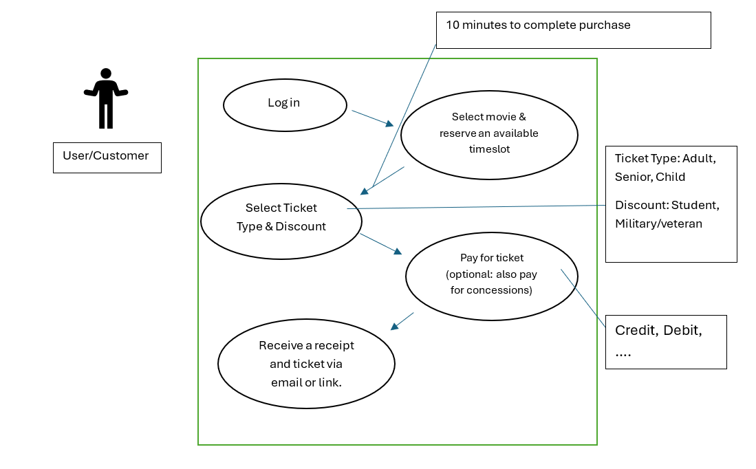
Use Case #1: Consider how a user purchases a ticket online through website or app.
- Actor: User/customer
- Flow of events: Logging in, Search for a movie & reserve a time Select Ticket Type & Discount —> Pay for ticket —> Receive a receipt with ticket info through email.

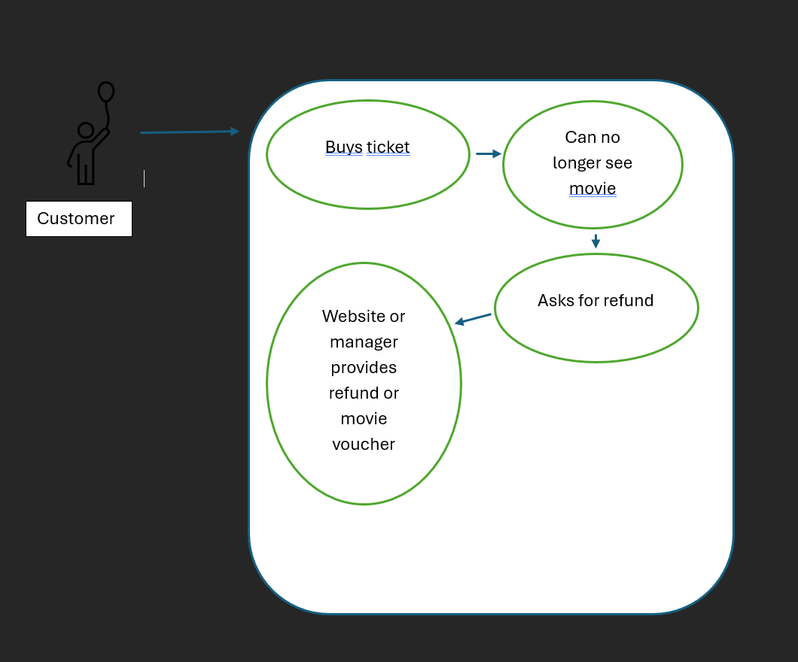
Use Case #2
Use Case #2: Consider user refund
  - Actor: Customer/User
    - Flow of events: User buys ticket --> can no longer see movie --> asks for refund --> Website or manager provides refund or movie voucher.

3.3.3 Use Case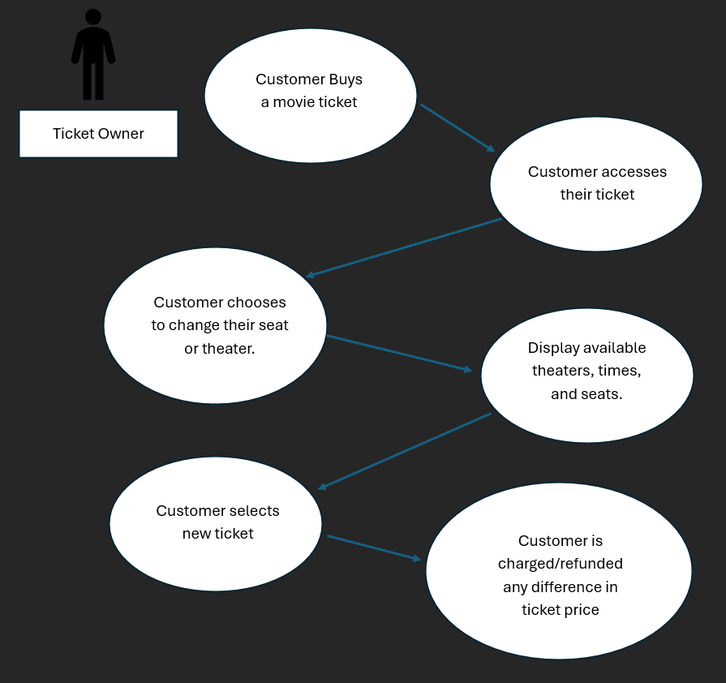
Use Case #3: User wants to change their ticket after purchase.
  - Actor: User/Customer
    - Flow of events: Customer buys a ticket for a movie —> Customer accesses ticket —> Customer chooses to change seat/theater —> show available seats in their selected theater, alternative times, or additional theaters that they can choose from —> Customer chooses a new ticket —> Customer is charged/refunded any difference that could occur with changing theaters.

3.4 Classes / Objects

3.4.1 Customer
3.4.1.1 Attributes
- Private
  - String username
  - String password
  - String name
  - Int age
  - Double credit
3.4.1.2 Functions
- Public
  - getUserName(): returns the username associated with the user.
  - getName(): returns the personal name of the owner of the account.
  - getAge(): Returns the age of the account owner.
  - getCredit(): Returns the amount of money assigned to the account.
  - setUserName(String user): Changes the username assigned to the user.
  - setName(String newName): Allows users to set a personal name to the account.
  - setPassword(String newPassword): Allows users to change their passwords.
  - setAge(int newAge): Allows users to set an age to their account.
  - setCredit(double money): Allows users to add credits to use to purchase tickets.
  - useCredits(double price): Subtracts credits tied to the account from ticket price.
  - checkOrderHistory(): Allows for users to see what tickets they’ve purchased.
  - appendOrderHistory(Tickets ticket): Adds ticket information to the user’s order history

3.4.2 Tickets
3.4.2.1 Attributes
- Private
  - String title
  - String format
  - String rating
  - String theater
3.4.2.2 Functions
- Public
  - getTitle(): Returns the title of the movie linked to the ticket.
  - getFormat(): Returns what format the movie will be shown in.
  - getRating(): Returns the rating of the movie.
  - getTheater(): Returns the theater in which the movie will be shown.
  - setTitle(String title): Allows for the title of the movie to be edited.
  - setFormat(String format): Allows for the format of the movie to be edited on the ticket.
  - setRating(String rating): Allows for the rating of the movie to be edited on the ticket.
  - setTheater(string theater): Allows for the theater to be edited on the ticket.

3.5 Non-Functional Requirements

3.5.1 Performance
- The system shall support up to 3,500 concurrent active users.
- The system shall maintain response times under 2.0 seconds
- The system shall store up to 100,000 registered user profiles
- The system shall use compressed .webp images for posters and banners.
- The data base shall support real-time seat status tracking for a total inventory of 4,290 seats across 36 active screens.

3.5.2 Reliability
- The system shall prevent double-booking of seats.
- The system shall release held seats after 10 minutes if purchase has not been made.
- The system shall maintain a Mean Time Between Failures of greater than 30 days.

3.5.3 Availability
- The system shall maintain 99.9% uptime during operational hours
- The system shall schedule maintenance between 2:00AM and 5:00AM PST.

3.5.4 Security
- The system shall encrypt all web communications using HTTPS.
- The system shall hash user passwords prior to database storage.
- The system shall process payments using PCI-DSS compliant gateways.
- The system shall never store raw credit card numbers.

3.5.5 Maintainability
- The system shall use a modular RESTful API backend.
- The system shall have automated daily database backups.
- The system shall support weekly updates during off-peak hours.

3.5.6 Portability
- The system shall operate on all major desktop and mobile web browsers (Chrome, Safari, Firefox, Edge)
- The system shall automatically adjust layouts for mobile and desktop screens.

3.6 Inverse Requirements
State any *useful* inverse requirements.

3.7 Design Constraints
Specify design constrains imposed by other standards, company policies, hardware limitation, etc. that will impact this software project.

3.8 Logical Database Requirements
Will a database be used? If so, what logical requirements exist for data formats, storage capabilities, data retention, data integrity, etc.

3.9 Other Requirements
Catchall section for any additional requirements.

4. Analysis Models
List all analysis models used in developing specific requirements previously given in this SRS. Each model should include an introduction and a narrative description. Furthermore, each model should be traceable the SRS’s requirements.

4.1 Sequence Diagrams

4.3 Data Flow Diagrams (DFD)

4.2 State-Transition Diagrams (STD)

5. Change Management Process
Identify and describe the process that will be used to update the SRS, as needed, when project scope or requirements change. Who can submit changes and by what means, and how will these changes be approved.

6. Design Specification

6.1 Description of System

The movie theatre system is a centralized client-server with three sections. The client interfaces, a backend that includes separate managers, a central database, and connects to external services. Information is pulled from the central server and gets a response back. Ordering tickets via desktop, mobile, and kiosk pulls info from central server and gets a response back. Ticket delivery is a one-way message (email/QR code delivery) that the user wont reply to.

6.2 Software Architecture Overview

6.2.1 Software Architecture Diagram
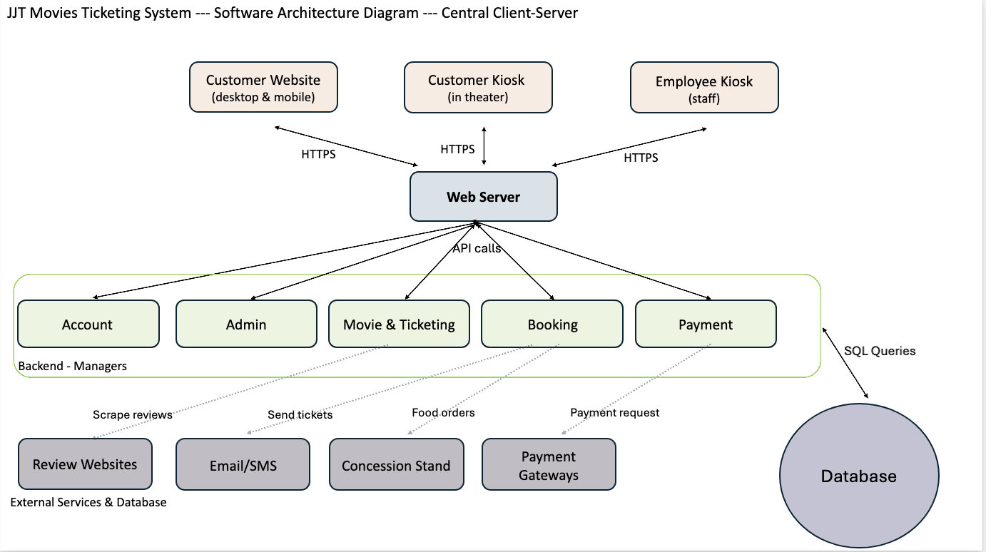

Description of Software Architecture
Components
- Customer Website: Lets customers search movies, pick seats on live maps, add concessions, pay, and manage their account profile from desktop or mobile browser. Includes accessibility.
- Customer Kiosk: Same features as website but has a card reader.
- Employee Kiosk: Staff uses to sell tickets in person, look up bookings, issue refunds, and manage movies and showings.
- Web Server: Receives requests from clients, checking and reviewing information client’s input. Then, sends requests to correct manager.
- Account Manager: Handles accounts creation, login, memberships, and reward points.
- Movie & Review Manager: Handles movie listings, showtimes, and reviews.
- Booking Manager: Handles seat selection, ticket limits, pricing, discounts, cancellations, and ticket changes. Sends tickets by email and food orders to concessions.
- Payment Manager: Sends payments and refund to the payment gateway and creates receipts.
- Admin Manager: Handles employee, administration, and customer service actions.
- Database: Stores all accounts, movies, showtimes, seats, orders, and payments.
- External Services: Review websites, Tickets (Email/SMS), Concessions, Payment
Connectors
- HTTPS: Clients are connected to the web server. Communication between the website, kiosks, and the server is encrypted with HTTPS.
  - Payment manager is connected to the payment gateway. Sends a secure payment token and the amount. Card numbers aren’t stored.
- API calls: Web server is connected to the Managers. The web server calls the backend managers through a RESTful API and returns to the client.
- SQL query: Managers are connected to the database. The managers read and write data into the database. Seats and bookings are saved efficiently so customers don’t overlap bookings.
- Emailing tickets: Booking manager is connected to email/SMS service. Send tickets with QR code and receipts after purchase.
- Scraping Reviews: Collects external reviews from a select number of sites to show on each movie page.
- Food Ordering: (online and kiosk through booking manager and concession stand)

UML Class Diagram
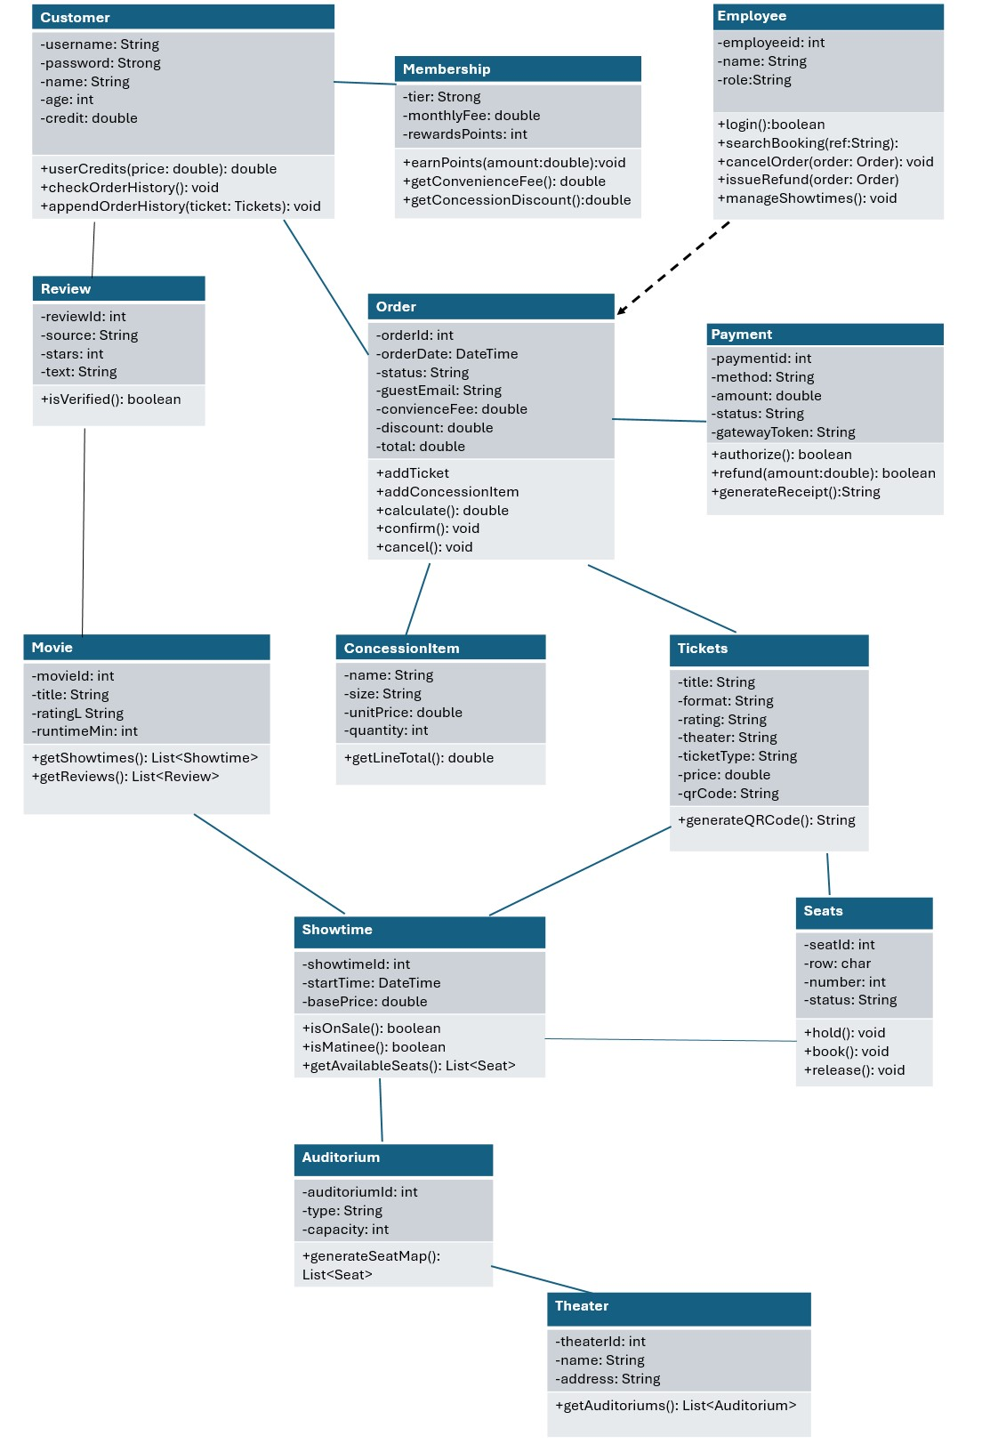

Description of Classes
Booking
- Tickets: One ticket for one seat. Records the movie, format, rating, theater, ticket type, price, and QR code.
  - generateQRCode() creates the code that is emailed or printed.
- Seat: A single seat for showtime.
  - hold(): boolean holds seat for 10 minutes and returns false if it’s not available.
  - book() and release() marks the seat as booked after payment and makes the seat available again.
- ConcessionItem: A food or drink item that can be added in an order.
  - getLineTotal(): double calculates the total of an items’ price and quantity.
- Order: A customer’s cart and booking, containing tickets and concessions. If customer is null, the order is a guest checkout.
  - addTicket() enforces the ticket time limit and calculateTotal() adds surcharges and fees and subtracts discounts.
  - confirm() and cancel() finish or undo the order.

Payment
- Payment: A payment or refund for an order, processed through the external payment gateway. The payment by credit card, debit card, Apply Pay, or Paypal. The card numbers are never stored, just the token.
  - Authorize() runs before seats are confirmed, refund() returns money, and generate Receipt() builds the itemized receipt.

Movie and Ticketing.
- Theater: One of the three movie locations in San Diego. It groups its auditoriums.
- Movie: A movie that will be playing currently at the theater and shown on the movie detail page.
  - getShowtimes() and getReviews() returns its showings and reviews.
- Review: A movie review, from external sites or from a verified customer who bought a ticket to the movie they review. A 1-5 star rating with written text.
  - isVerfied() tells which customer is verified to post.
- Showtime: One screening of a movie in an auditorium. Live seats are tracked and are available, held, or booked.
  - isOnSale() is true from 14 days before the start until 15 minutes after it.
  - isMatinee() is true before 4:00PM.
  - getAvailableSeats() lists open seats.
- Auditorium: A room that holds seats of different types (Standard, Recliner, IMAX, and 3D) and capacity inside a theater.
  - generateSeatMap() builds live seat maps for a showing.

Account
- Membership: A customer’s tier: Regular or Premiere.
  - earnPoints(amount) adds reward points.
- Customer: A registered user. Stores login and profile information and account credit.
  - useCredits(price) subtracts credit from ticket prices.
  - checkOrderHistory() and apprendOrderHistory(ticket) show and update past purchases.

Admin
- Employee: Theater staff member or who uses the employee kiosk. The attribute decides which functions the employee can use (administrator or customer service).
  - searchBooking(), cancelOrder(), and issueRefund() are customer service operations.
  - manageShowtimes() are administration operations (add, change, or remove movies, showtimes, and seating layouts)

Relationships
- Customer – Membership
- Customer – Order
- Order – Tickets
- Order – ConcessionItem
- Order – Payment
- Tickets – Showtime
- Tickets – Seats
- Showtime – Seats
- Showtime – Auditorium
- Auditorium – Theater
- Movie – Showtime
- Review – Movie
- Employee – Order

6.3 Development Plan
Task | Responsible | Timeline
Section 1 | Jorge Fonseca | 09/24/2026
Section 2 | Trea Huff | 09/24/2026
Section 3 | All members | 09/24/2026
SWA/Database set up | Janelle Ventura | 10/08/2026
UML Diagram and Descriptions (ver. 1) | Jorge Fonseca and Trea Huff | 10/08/2026
UML Diagram and Description (ver. 2) | Janelle Ventura | 10/19/2026
Test Plan | All members | 10/22/2026
Test Cases | All members | 10/22/2026

7. Test Plan
Test Plan: This section lays out test plans for verification and validation. In addition to the test itself, you will need to clearly explain your test. Be as detailed as possible, identifying what features of your design you are testing, what the test sets/vectors are, and how your selected test(s) cover the targeted feature(s). (Hint: use or modify your design diagram to indicate the target and scope of the tests, what kind of failures you are covering, etc.). Feel free to use any methods discussed in class.

7.1 Overview

This plan covers verification and validation for the JJT Movies ticketing system. It follows the IEEE 1012-1998 Validation Test Plan outline. Ten test cases are provided and cover the three levels that are covered in the test cases: Unit (one class or method), Functional (one feature across several classes), and System (a complete user scenario).

Scope
- Seat selection and booking, pricing, payment, refunds, concessions, and ticket changes. These are features where a mistake can cost the theater money or double-booked seats.
- Not tested: movie reviews, theater location data, accessibility tools, and performance under heavy load. There are SRS requirements that are required and are left for further testing.

7.2 Organization, tasks, and responsibilities

- Tasks: write the test cases, review them against the SRS, then eventually run them and record the results.
- Schedule: write by 10/22/2026, run by TBD, report by TBD.
- Responsibilities: All members contribute to test plan and test cases.

7.3 Tools and techniques
- Tools: the Excel test case sheet and the GitHub repository.
- Technique: manual testing, with boundary values and ALAC (Act like a customer) tests.
- Test estimation: ten test cases that cover the main features first: seating, pricing, payments, and refunds.
- Tests are run though websites and kiosk screens with payment and emails.
- Tests will pass or fail depending on the expected results otherwise they will be recorded in comments or actual results.

7.4 Coverage & Test Cases

Test | Level | Class or Feature | What is verified | Failure it catches | SRS
Unit_1 | Unit | Seat.hold() & seat.book() | Booked seat cannot be held or booked again. | Double-booking | 3.5.2
Unit_2 | Unit | Auditorium.generateSeatMap() | The seat map matches the auditorium layout and shows which seats were available or taken. | A wrong layout or a seat being shown as available | 3.2.3.3
Unit_3 | Unit | Payment.authorize() | A credit card or debit card is accepted when valid and wrong card prompts re-entry. | Payment accepted or blocked incorrectly | 3.2.4.3
Functional_1 | Functional | Order total for Premiere member | Matinee base price + 3D surcharge, no fee for Premiere, and rewards points. | Wrong prices, fees, or points | 3.2.3.3, 3.2.1.3
Functional_2 | Functional | Order refund | A refund before the deadline returns $11.50 and frees the seat. | Wrong refund, seat left unavailable | 3.2.3.3
Functional_3 | Functional | Concessions purchase | The item quantity appears in the order summary and the total. | Missing items or wrong totals | 3.2.7.3
Functional_4 | Functional | Declined payment | A message says payment was invalid or declined and transaction is not completed. | Order completed without valid payment | 3.2.4.5, 3.2.6.5
System_1 | System | Online ticket purchase | Login to emailed QR ticket. | Broken purchase flows | Use Case #1
System_2 | System | Ticket refund | Refund issued as account credit or original payment; seat becomes available again. | Refund not issued or seat left unavailable | Use Case #2
System_3 | System | Change ticket after purchase | New seat booked, old seat released, price difference charged or refunded. | Wrong seat or price after a change | Use Case #3

Test vectors are documented in the Excel test case sheet (pre-requisites, test steps, and expected result columns).

7.5 Completion Criteria

Testing is complete when all ten cases have been run, and every P0 case passes, and every failure is recorded in the results and comments.

7.6 Reporting and Documentation

Results are recorded in the Excel sheet and will be stored in the GitHub repository: https://github.com/jventura0076/JJT-Ticketing-System-SRS

A. Appendices
Appendices may be used to provide additional (and hopefully helpful) information. If present, the SRS should explicitly state whether the information contained within an appendix is to be considered as a part of the SRS’s overall set of requirements.

Example Appendices could include (initial) conceptual documents for the software project, marketing materials, minutes of meetings with the customer(s), etc.

A.1 Appendix 1

A.2 Appendix 2

