Architecture Diagram (I have the html version in the shared drive)
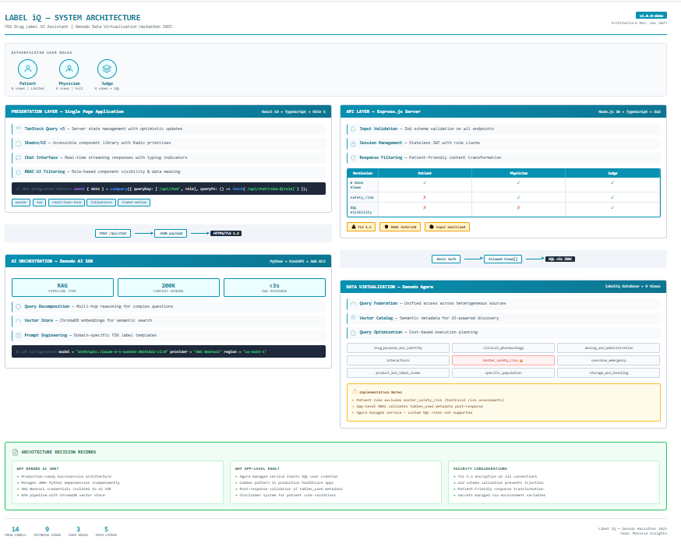

Label iQ Architecture - Speaker Notes that explain the diagram
Opening (Header)
"This is Label iQ - an AI-powered FDA drug label assistant built for the Denodo Hackathon 2025. Let me walk you through our five-layer architecture."

1. User Roles Section
"We support three distinct user roles with different access levels:
- Patients get simplified, safe information - they can access 8 of our 9 database views
- Physicians get full clinical access to all 9 views
- Judges - that's you - get everything plus visibility into the actual SQL queries being generated
- This demonstrates real-world healthcare RBAC - Role-Based Access Control."

2. Presentation Layer (Frontend)
"Our frontend is a React single-page application built with TypeScript.
Key highlights:
- TanStack Query manages all our server state and caching
- Shadcn/UI gives us accessible, production-ready components
- The chat interface streams responses in real-time
- RBAC filtering hides sensitive UI elements based on your role
- The code snippet shows our actual API integration pattern."

3. Data Flow - Frontend to Backend
"All communication happens over HTTPS with TLS 1.3 encryption. We POST JSON payloads to our chat endpoint."

4. API Layer (Express.js)
"Our Node.js backend handles three critical functions:
- Zod validation sanitizes all input to prevent injection attacks
- Session management tracks user roles
- Response filtering transforms technical content into patient-friendly language
- The RBAC matrix shows exactly what each role can access. Notice patients cannot see the master_safety_risk view - that contains technical risk assessments meant for healthcare providers."

5. Data Flow - Backend to Denodo
"We use Basic Authentication to connect to Denodo, passing an allowed views list that enforces our RBAC policy. The AI SDK translates natural language into SQL."

6. AI Orchestration Layer (Denodo AI SDK)
"This is where the magic happens. The Denodo AI SDK runs as a microservice on AWS EC2.

Three key metrics:
- RAG - Retrieval Augmented Generation pipeline
- 200K token context window - can handle complex medical documents
- The SDK uses query decomposition to break complex questions into sub-queries, ChromaDB for semantic vector search, and custom prompt engineering for FDA-specific responses.

Under the hood, it's calling Claude 3.5 Sonnet on AWS Bedrock."
7. Data Virtualization Layer (Denodo Agora)
"Finally, our data layer - Denodo Agora with our labeliq database.

We have 9 specialized views covering different aspects of drug labels:
- Drug identity and purpose
- Clinical pharmacology
- Dosing instructions
- Drug interactions
- Safety risks (restricted for patients)
- Overdose emergencies
- Product indexing
- Special populations
- Storage handling
The yellow note highlights an important architectural decision: since Agora is a managed service, we couldn't create custom database users. So we implemented app-level RBAC that validates the tables_used metadata after each response. This is actually a common pattern in production healthcare applications."

8. Architecture Decision Records (Green Panel)
"We documented our key decisions:

- Why Denodo AI SDK? - Production microservice pattern, manages 200+ Python dependencies, isolates AWS credentials
- Why App-Level RBAC? - Agora's managed service limitations, plus post-response validation
- Security - TLS everywhere, input validation, environment variable secrets"

Closing (Footer Stats)
"In summary: 14 drug labels, 9 database views, 3 user roles, 5 architectural layers - all working together to make FDA drug information accessible through natural language."

May want to mention – It is SLOW!
The 45-60 second response time reflects the quality and thoroughness of the AI - it's decomposing your question, searching the vector database, generating SQL, retrieving data from Denodo Agora, and synthesizing an accurate medical response. We prioritize accuracy over speed when it comes to healthcare information.
Step | Time | What It Does
1. Query Decomposition | ~5s | AI breaks your question into sub-queries
2. Vector Search | ~5s | ChromaDB searches for relevant metadata
3. SQL Generation | ~10s | LLM generates SQL from natural language
4. Denodo Query | ~15s | SQL executes against Agora, data retrieved
5. LLM Response | ~15s | Claude synthesizes answer from retrieved data
6. Network Overhead | ~5s | Replit → EC2 → Bedrock → Agora round trips

