Push Notification Message Flow (Overview)

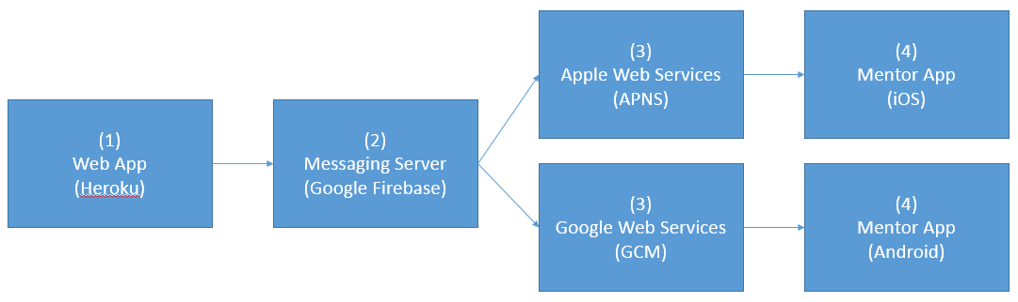

**Firebase Overview:**

<https://firebase.google.com/docs/cloud-messaging/>

------------------------------------------------------------------------------

1. Web App (hosted via Heroku, using Ruby/Sinatra)

**Goal:** Format and send push notifications to Firebase server.

**Overview:** For basic implementation, the web app should send data (a hash?) to the method/class that will craft the push notification message and send it on to the Firebase server. This will happen in two instances: (1) when a new user (mentor/mentee) registers with the Mined Minds Mentor website and (2) when a mentor/mentee sends a message to another mentor/mentee.

**Research:** (1) How to send a message to Firebase and (2) how to determine which device(s) should receive the message. I believe this may involve retrieving a list of device IDs that have the mentor app installed from Firebase, but could be mistaken. See notes on (2) Messaging Server.

**Resources:**

<https://firebase.google.com/docs/cloud-messaging/>

<https://github.com/spacialdb/fcm>

<https://github.com/spacialdb/fcm/blob/master/README.md>

**Loosely Related (May be useful):**

<http://stackoverflow.com/questions/40955600/send-firebase-cloud-message-programmatically>

<http://stackoverflow.com/questions/40236093/how-can-i-schedule-a-cloud-message-in-firebase-from-a-rails-post-request>

<http://stackoverflow.com/questions/39523829/send-push-notification-to-specific-user/39524734#39524734>

<http://stackoverflow.com/questions/37371990/how-can-i-send-a-firebase-cloud-messaging-notification-without-use-the-firebase>

------------------------------------------------------------------------------

1. – 4) Messaging Server (Google Firebase) > Apple Web Services (APNS) > Mentor App (iOS)

**Goal:** Configure Firebase to send push notifications to APNS and have them appear on target device(s).

**Overview:** For basic implementation, this will require an Apple Developer account (common), a Google Firebase account (common), and on the iOS side, tying in Firebase to the iOS app in Xcode. Testing will require a physical iOS device attached to a Mac, as push notifications will not work with the iPhone/iPad simulators in Xcode.

**Research:** Need to obtain/create common accounts for Apple Developer and Google Firebase. Once that has been done, work on prototyping an iOS app with Firebase hooks and get push notifications via the Firebase web console working. This may be a blocker for getting the necessary code in the (1) Web App created.

**Resources:**

<https://firebase.google.com/docs/notifications/ios/console-device>

<https://www.youtube.com/watch?v=JsWHzU1DxjM>