Revelate.co
The Enterprise Control Plane
From governed data to governed decisions
A product and technology thesis for Revelate — beginning with AI governance
Vision, competitive position, economics, and an executable build & GTM plan
July 2026
Companion to the Strategic Concept Proposal (V2)
DRAFT — For Discussion Purposes Only

A note on intent
This is a short strategic thesis that captures how I think about Revelate’s long-term product positioning.
It is not a recommendation that the company immediately pursue every element. It is meant to illustrate how I
approach product strategy — by connecting market evolution, architecture, execution sequencing, and business
economics into a single coherent plan.

IF YOU READ ONE PAGE

The Thesis, in Five Lines
- The opportunity we see. Enterprises are about to spend on governing AI the way they spent a decade governing data — and Revelate already owns the engine that does it. Almost no one is positioned to turn that spend into a platform.
- The reframe. This is not an AI feature bolted onto a data product. It is Revelate positioning itself as the neutral control plane for how AI touches enterprise data — governance today, autonomous business decisions tomorrow.
- The moat. Governance enforced in the request path, across clouds and tenants — a position few vendors can credibly match, and one the cloud platforms and point tools are structurally ill-suited to copy. This document sets out to prove it, not assert it.
- The plan. Build the platform in three value-first stages with today’s five engineers. Prove the wedge before scaling. Let validated revenue — not hope — fund the pace of everything after.
- The prize. A second budget (risk and compliance), a second revenue stream (the governance plane), and a materially stickier, higher-NRR, higher-valuation company.
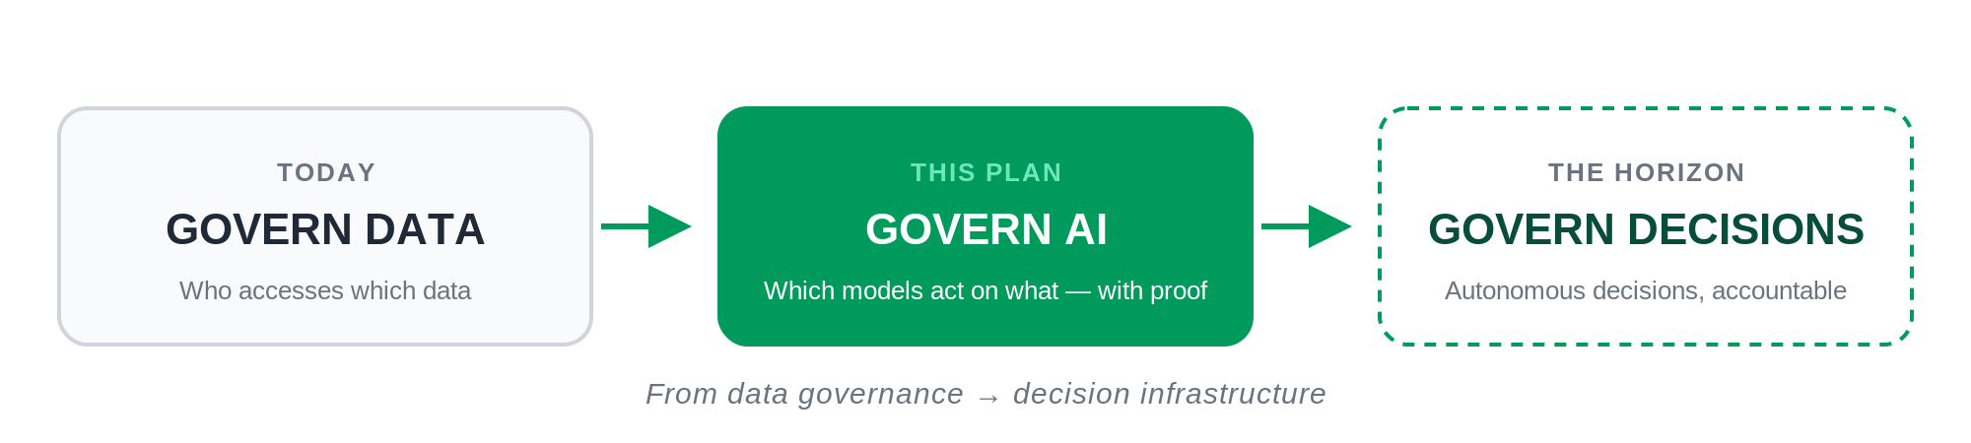

EXECUTIVE SUMMARY

A Strategic Thesis
Revelate is usually described as a governed data-delivery platform. That description undersells it. What Revelate actually owns is an enforcement engine — identity, entitlements, policy, lineage — that works across clouds and tenants. In a world where every enterprise is about to put AI in front of its data, that engine is the scarce asset. The question worth asking is not “how do we add AI to Revelate?” It is “what does Revelate become if governance is the product?”
The answer this document argues for: Revelate is uniquely positioned to evolve toward the neutral control plane for enterprise AI — the place where an organisation proves and enforces how models and agents use its data, with the audit evidence a regulator or a general counsel will accept. AI governance is the first, urgent application of that platform. Decision governance — accountability for what autonomous systems actually do — is where it can go next.
The plan to get there is deliberately disciplined. The product cannot do these things yet; we build the platform first, we design governance into it from the first commit rather than bolting it on, and we sequence the build so a five-person team proves real value early. Market validation and the revenue it produces are what unlock a few additional engineers to go faster — resources follow proof, never precede it.
The bet, in one line
Point the enforcement engine we already own at a new object — AI, and eventually decisions — and become
a neutral control plane few cloud platforms or point tools can credibly replicate. Prove it in stages; let
validated revenue fund the pace.

SECTION 1

From Data Governance to Decision Infrastructure
There is a straight line from what Revelate does today to a category-defining company, and it runs through three questions enterprises are asking in sequence — each with a larger buyer, all powered by the same enforcement engine.
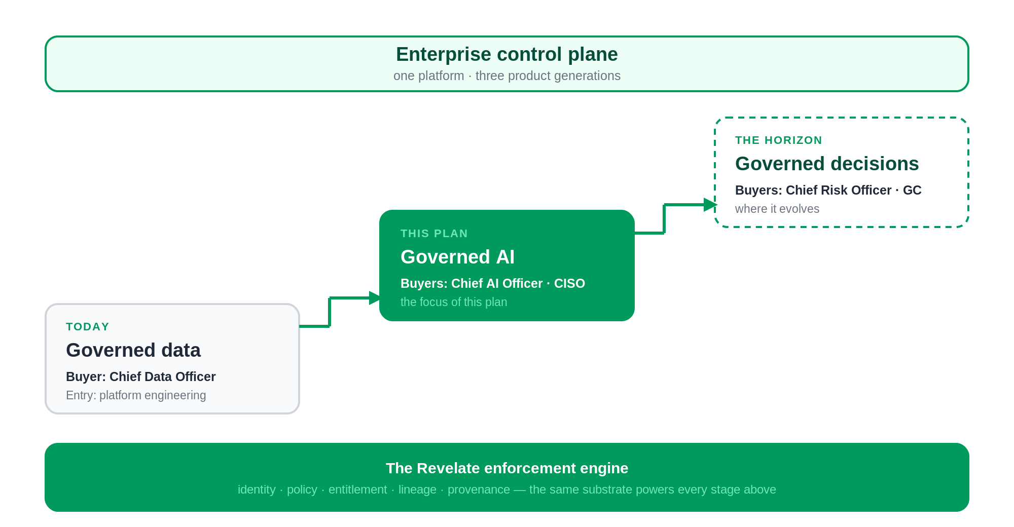
Today they ask: who can access which data. Revelate answers this now.
Now they are asking: which model or agent may act on which data, and can you prove what it did. This is AI governance — the same primitives, aimed at a new principal. It is the focus of this plan.
Soon they will ask: can you govern the autonomous decisions our AI makes on our behalf. That is decision infrastructure — lineage not of a query but of a decision, with accountability attached. It is the same engine, one layer higher.
Framed this way, governance is not a feature of the data platform — governance is the platform, and data delivery is its first application. Positioning AI governance as the first application of a control plane (rather than as a standalone compliance tool) is the difference between a useful product and a company that redefines its market. It is also honest: we earn the larger vision one proven layer at a time.
SECTION 2

Why Now — the Business Case, Not the Regulatory One
Regulation is a tailwind, but it is not the reason to build this now. Four business curves are bending at the same time, and governance spend follows all four:
- AI adoption is exploding — every enterprise is putting models and agents in front of proprietary data.
- AI spend is exploding — budgets are being created faster than the controls to govern them.
- AI failures are exploding — wrong answers, leaked data, and unexplainable decisions are now board-level incidents.
- Audit expectations are exploding — customers, insurers, and regulators increasingly demand proof of how AI reached an answer.
The pattern is reliable: capability outruns control, incidents follow, and governance spend arrives to close the gap. Frameworks like ISO 42001, the EU AI Act, and NIST AI RMF put a deadline on it — but the demand is business-driven, and it would exist without them. (Confirm current regulatory timelines before any external use.)

2.1 Why now for Revelate, specifically
The market timing is one thing; the timing for Revelate is sharper. The hard part is already built. Revelate spent years assembling the enforcement substrate — multi-tenant entitlements, policy, lineage — that most AI-governance entrants are only now trying to stand up. The market has finally caught up to capabilities the platform already has. That is the rare and valuable kind of timing: not chasing a trend, but demand arriving to meet a substrate that already exists.
SECTION 3

Five Beliefs That Drive This Roadmap
Roadmaps are the output of a point of view. These are the convictions the sequencing is built on — each one is a bet, and each is defensible.
1. Governance must be enforcement, not documentation. Catalogs and policies that describe governance do not stop an AI from leaking data. Value accrues to the layer that enforces, in the request path, before data is touched.
2. Policy should be data-centric, not model-centric. Models churn every few months; the data and the rules that govern it persist. Bind policy to the data and every model — today’s and next year’s — inherits it. Model-centric governance is the wrong abstraction.
3. AI identity will matter as much as human identity. An agent that queries data is a principal that must be authenticated, authorised, and audited. The enterprises that win treat non-human identity as first-class; so should the platform that governs it.
4. Data lineage becomes decision lineage. The audit object of the future is not the query — it is the decision an autonomous system made. Whoever owns the lineage of decisions owns the most valuable record in the enterprise.
5. Neutral, cross-cloud enforcement compounds as AI fragments. Enterprises are going multi-model and multi-cloud. A neutral broker that enforces consistently across all of them becomes more valuable precisely as the landscape splinters — the opposite of a single-cloud vendor’s trajectory.
A sixth, underneath the rest: trust is becoming the primary enterprise-AI differentiator. The best AI platform is not the smartest one — it is the one legal signs off on.

3.1 What we will deliberately not do
Strategy is as much what you exclude. To keep the thesis credible and a five-person team focused, five things are explicitly out of scope:
- Build our own foundation model. We govern models; we do not compete with them.
- Compete with the cloud data platforms. We sit above Snowflake and Databricks, not against them.
- Replace GRC platforms. We feed them evidence; they keep the workflow.
- Replace data catalogs. We enforce where they describe, and integrate rather than displace.
- Be single-cloud. Neutrality across clouds is the entire point.

SECTION 4

Why Existing Vendors Cannot Own This
The moat is only real if it survives contact with the incumbents. Plot the field on the two axes that matter — how governance is delivered (observed and documented vs. enforced in the request path) and how broadly it reaches (single-cloud vs. neutral and cross-cloud) — and the open quadrant is visible.
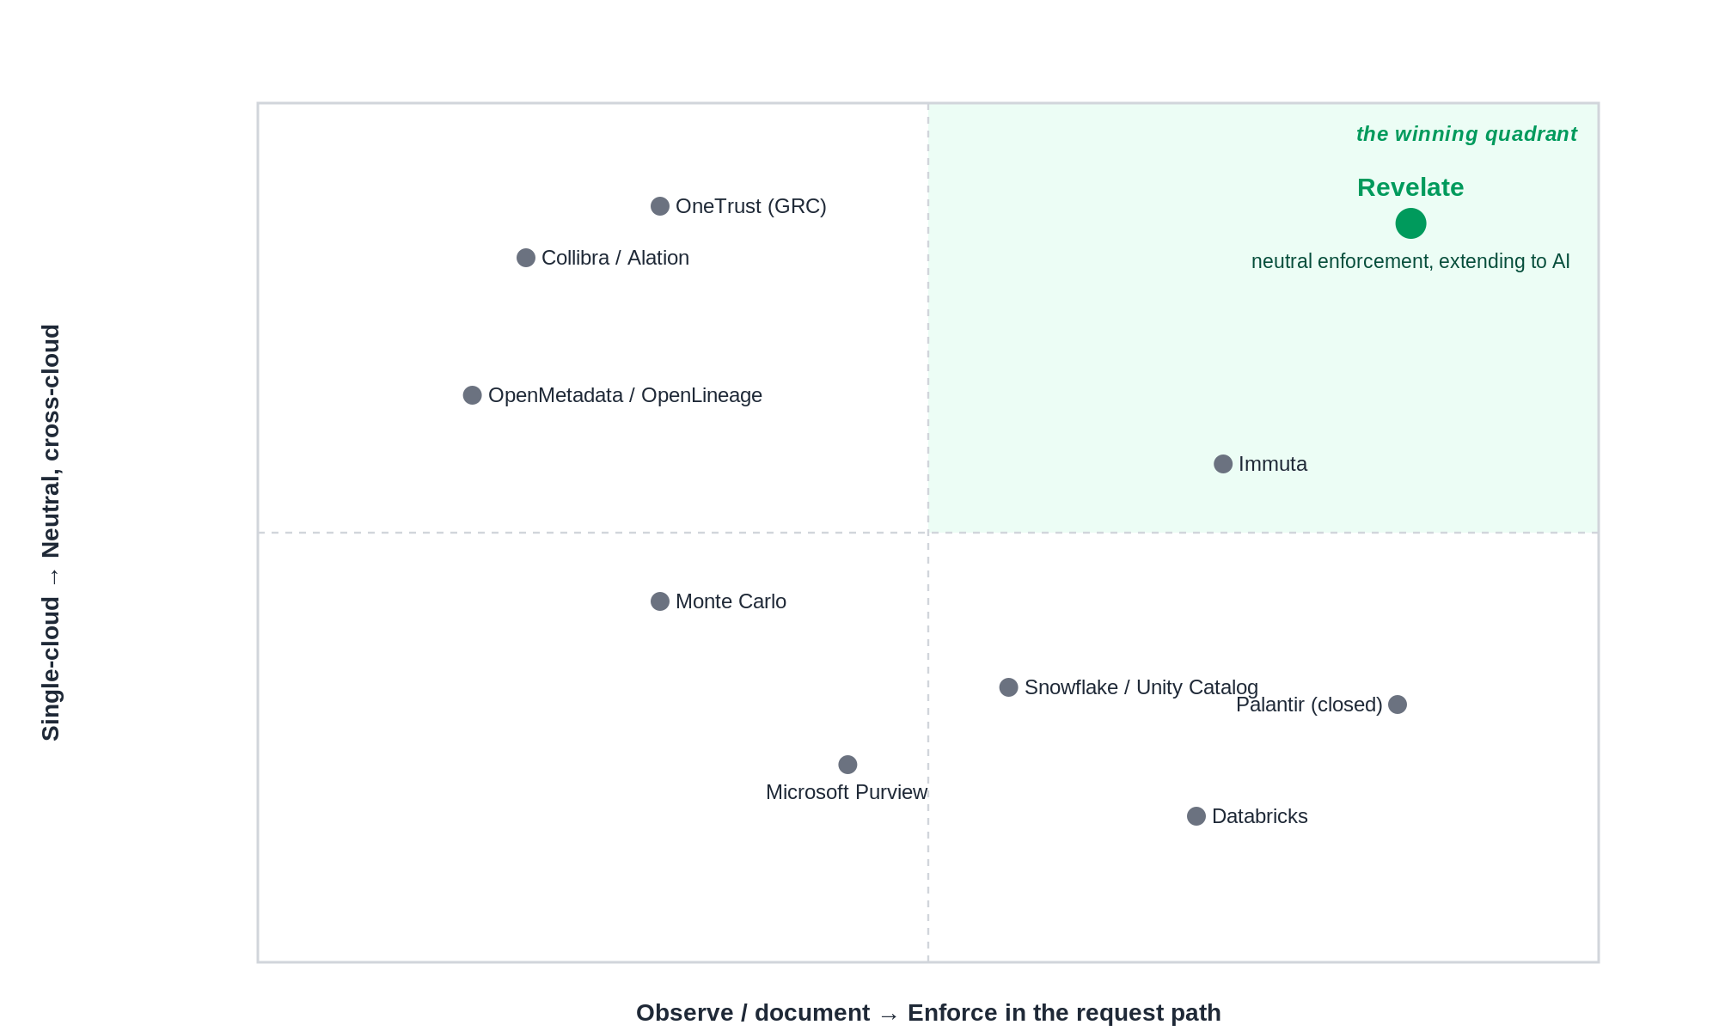
Each category is structurally optimised for something other than neutral, in-request-path AI governance. That is not a criticism — it is why the position is defensible.
Category | Representative players | Structurally built for — and the ceiling
Cloud data platforms | Snowflake, Databricks, Unity Catalog, Microsoft Purview | Governing data inside their own cloud. Neutrality across clouds erodes the lock-in their AI layer exists to deepen.
Data catalogs | Collibra, Alation, OpenMetadata | Describing and cataloguing data. They document governance; they do not enforce it in the request path.
Access & policy | Immuta | Enforcing data-access policy. Focused on data access, not AI identity, provenance, or decision-level accountability.
Observability & lineage | Monte Carlo, OpenLineage | Detecting data and pipeline issues after the fact. No policy enforcement, no AI principal model.
GRC | OneTrust | Risk and compliance workflow. Evidence and documentation, sitting on no live data-enforcement substrate.
Proprietary decisioning | Palantir | Closed, bespoke decision systems. Powerful but proprietary and single-tenant — the opposite of neutral, open enforcement.
The synthesis: Revelate holds a differentiated position — one few vendors can credibly match — combining a live, cross-cloud, multi-tenant enforcement engine with an AI-governance overlay built on top of it. To match it, most competitors would have to give up their lock-in or rebuild the substrate. That is the core of the moat — and it compounds with every governed data product and every audit cycle.

SECTION 5

The Architectural Bet — Governance in the Request Path
Most governance tooling sits beside the system: it catalogs, scans, and reports after the fact. That is why it fails for AI. By the time an after-the-fact control notices a problem, the answer has already left the building. Governance for AI has to live in the request path — enforced before data is touched — or it is theatre.
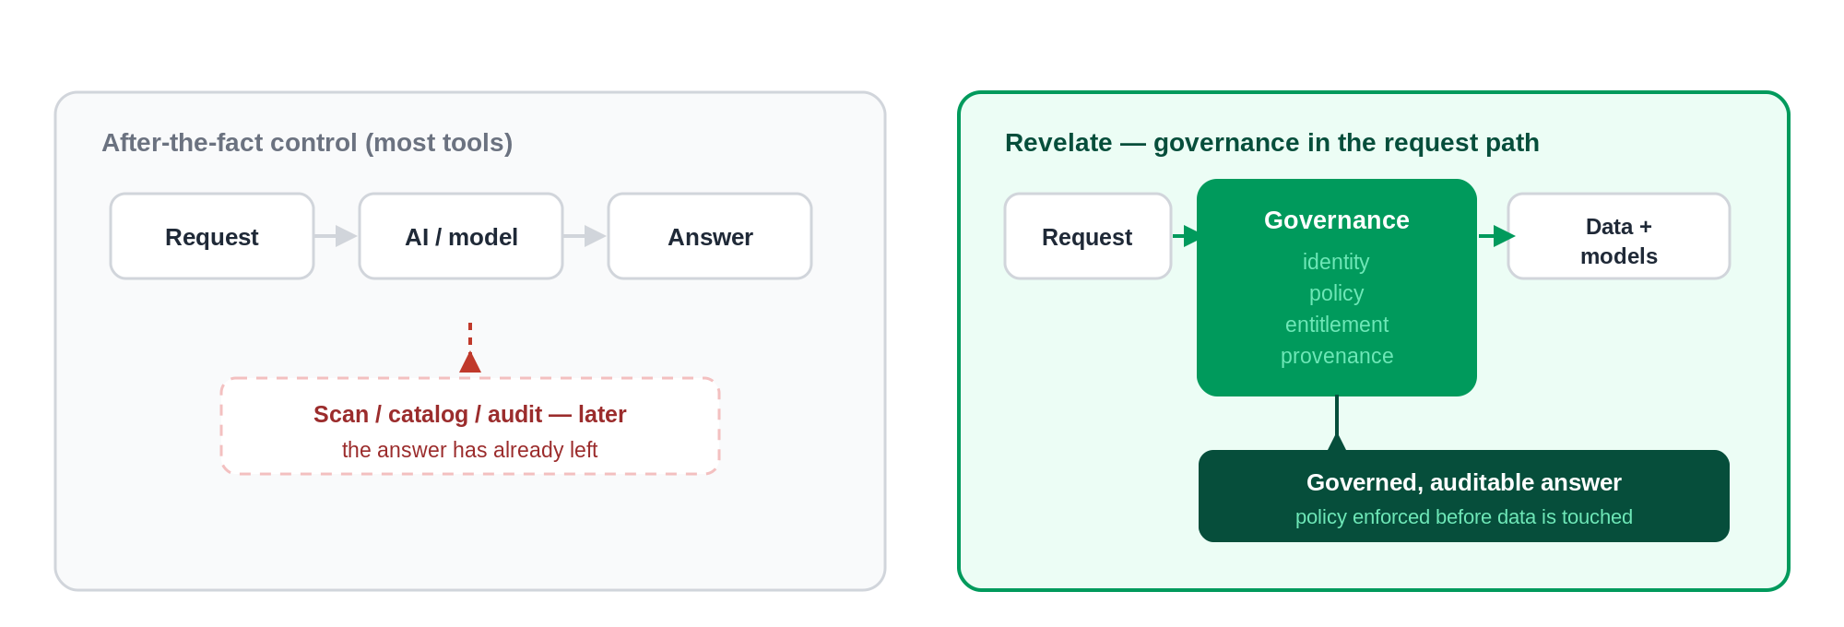
This is also why model-centric governance is the wrong abstraction. Wrapping controls around each model means re-solving the problem every time a model changes and hoping no path bypasses the wrapper. Put policy on the data, enforce it at the gateway every request must pass through, and correctness stops depending on which model is calling. It is a smaller surface to secure and a far stronger claim to make to an auditor: not “we reviewed the model,” but “no request reaches data without policy.”

SECTION 6

What We Build — and the Executive Problem Each Piece Removes
The build splits into two tracks that emerge together: Track A is the AI platform the product needs to exist at all; Track B is the governance overlay that extends it. Read every capability as the executive problem it makes disappear — not as a feature.

Capability | The executive problem it removes | Track | Size
A1 · Semantic layer | “Our AI keeps misreading what the data means.” | A | S
A2 · Governed AI gateway (MCP) | “We can’t safely let AI touch production data.” | A | L
A3 · Telemetry foundation | “We have no idea what the AI actually did.” | A | M
A4 · Interrogation layer | “Business users can’t get answers without an analyst.” | A | L
A5 · Agentic data-product creation | “Productising data takes weeks of engineering.” | A | M
A6 · Reliability layer | “We don’t trust the data behind the answer.” | A | L
B1 · AI access governance | “We don’t control which model touches what.” | B | M
B2 · Provenance & audit records | “We can’t prove how an AI answer was produced.” | B | M
B3 · Policy & guardrail enforcement | “PII and residency rules leak through AI.” | B | M
B4 · AI inventory & risk registry | “We don’t know what AI we run, or its risk.” | B | L
B5 · Evaluation & attestation | “Audits are manual, slow, and frightening.” | B | L
The design rule that ties them together: the governance hooks (B1, B2) are built into the platform layers (A2, A3, A4) as they are created. Governance retrofitted onto a shipped product is both costly and unconvincing to an auditor.

SECTION 7

The Staged Plan
Three dependency-ordered stages. Both tracks appear in each. Every stage carries a value proof point and a go-to-market overlay, so the build and the market validate one another. Effort is t-shirt sized against engineer-weeks (S ≈ 2–4, M ≈ 6–10, L ≈ 12–20) for today’s five engineers; risk is read across Market, Cost, and Sales (Low / Medium / High).

Stage 1 — Governed, auditable AI access
Value proof
A design-partner demo: an AI agent answers a question on their governed data — entitlements enforced,
full audit trail attached. The smallest credible build that proves a claim few rivals can credibly make.

Capability | Track | Size | Eng-weeks | Mkt | Cost | Sales
A1 · Semantic layer (partner-first Cube/dbt) | A | S | 2–4 | L | L | L
A2 · Governed AI gateway (MCP) | A | L | 12–20 | M | M | L
A3 · Telemetry foundation (OpenTelemetry) | A | M | 6–10 | L | M | L
B1 · AI access governance (seed) | B | M | 6–10 | M | M | M
B2 · Provenance & audit records (seed) | B | M | 6–10 | L | M | L
Stage build subtotal |  |  | ≈ 32–54

Validate | Sell | Partner
2–3 FS and healthcare design partners. Test willingness to pay for governance, not chat. | Founder-led POC on “governed & auditable AI access.” Engage the risk/compliance buyer early. | Snowflake/Databricks technical alignment; semantic-layer partner (Cube/dbt).

Stage 2 — Auditable AI answers, made repeatable
Value proof
Self-serve governed interrogation with native audit; first paid conversions; Revelate’s own ISO 42001
readiness underway as a trust and sales asset.

Capability | Track | Size | Eng-weeks | Mkt | Cost | Sales
A4 · Agentic interrogation (B1/B2 built in) | A | L | 12–20 | M | L | M
B3 · Policy & guardrail enforcement (PII, residency, purpose) | B | M | 6–10 | M | M | M
A5 · Agentic data-product creation (alpha — deferrable) | A | M | 6–10 | M | M | L
ISO 42001 program (Revelate itself) | E | S | 2–4 | L | M | L
Stage build subtotal |  |  | ≈ 26–44

Validate | Sell | Partner
Convert design partners to paid. Prove governance commands a separate budget and a premium. | Add the CRO/CISO buyer. Land-and-expand: platform + consumption + a governance seed. | GRC integration design (OneTrust/ServiceNow); Big 4 ISO 42001 readiness conversations.

Stage 3 — The enterprise AI control tower
Value proof
AI governance sold as a distinct plane; an attestation pack used in a real customer audit; a second
vertical (insurance) live; pipeline sourced through partners, not only founder-led.

Capability | Track | Size | Eng-weeks | Mkt | Cost | Sales
A6 · Data reliability layer | A | L | 12–20 | L | M | L
B4 · AI inventory & risk registry (ISO 42001 / EU AI Act / NIST) | B | L | 12–20 | M | M | M
B5 · Evaluation, monitoring & attestation packs | B | L | 12–20 | M | L | M
Admin console + GRC/SIEM connectors | B | M | 6–10 | L | M | M
Stage build subtotal |  |  | ≈ 42–70

Validate | Sell | Partner
Prove the second revenue stream and partner-led scale. | Sell AI governance as a separate plane to the risk/compliance budget; open insurance; discover media and energy. | Big 4 implementation + attestation; GRC integrations live; cloud marketplace co-sell.

SECTION 8

The Economic Model — Why This Improves the Company, Not Just the Product
The engineering case is only half the argument. The reason to do this is what governance does to the shape of the business: it opens a second budget, converts usage into expansion, and turns manual services into software margin. Governance is not a cost centre bolted onto delivery — it is a compounding revenue flywheel.
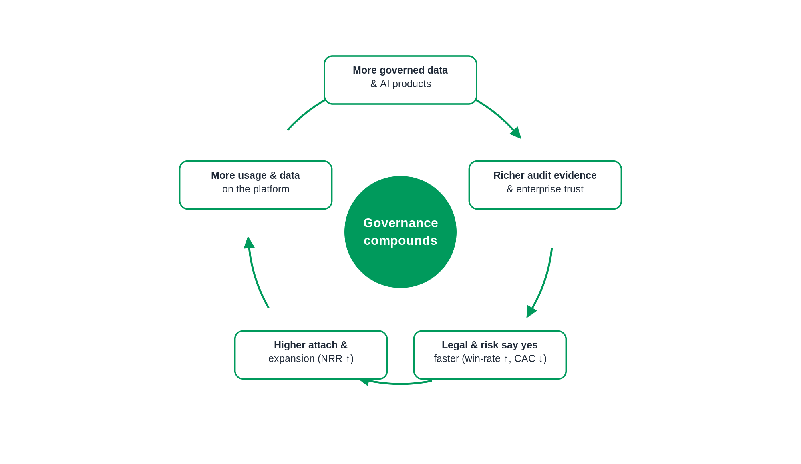
The levers, and the metric each one moves:
Lever | Mechanism | Metric moved
New revenue line | Governance plane sold into the risk/compliance budget | ACV ↑ (a second budget pool)
Consumption expansion | AI queries, attestations, and agent workflows metered | NRR ↑ (usage-led, no new sales cycle)
Stickiness | Embedded in audit cycles as a system of record | Gross retention ↑
Faster sign-off | Legal and risk approve sooner; regulatory urgency | Win-rate ↑, sales cycle ↓, CAC ↓
Services to software | Automated attestation replaces manual audit prep | Gross margin ↑
Attach | Governance attaches to existing platform deals | ACV ↑ and NRR ↑ together

Illustrative, to be validated in Stage 1–2: a governance attach on 40–60% of platform customers, lifting ACV on the order of 1.5–2x where it attaches, and pushing net revenue retention from a typical ~110% toward 130%+ as consumption compounds. These are hypotheses the design-partner and paid-conversion data exist to prove or correct — the point is the direction and the mechanism, not the decimal.
The valuation consequence follows directly: higher ACV, higher NRR, higher gross margin, and lower CAC are exactly the inputs that move a SaaS multiple. Governance is how Revelate becomes not just a bigger company but a more valuable kind of company.

SECTION 9

The Self-Funding Growth Model
The plan is scoped to five engineers on purpose. Speed is bought with validated revenue, not with headcount added ahead of proof. Each gate opens only when its evidence exists.

Gate | Evidence required to open it | What it unlocks
Baseline | Today’s team of five | Funds Stage 1 and the start of Stage 2. No hiring until Gate 1.
Gate 1 — Demand | 2–3 signed design partners actively using governed AI access, with documented willingness to pay | +1–2 engineers to firm up the platform and start Stage 2 in earnest
Gate 2 — Revenue | First paid conversions, governance attach at a premium, a defined incremental-ARR threshold | +2–3 engineers to parallelise Stage 3 and hold the ~24-month line
Gate 3 — Scale | Partner-sourced pipeline and a validated second revenue stream | Scale the team to compress the roadmap and open further verticals

The principle, stated plainly: engineering headcount is a lagging function of validated demand and revenue — never a leading bet on it. Every added engineer is paid for by demand that already exists, which keeps burn disciplined and the output-per-head story intact.

SECTION 10

Markets & Industry Wedges
Five industries, each with its own AI-governance forcing function and its own entry stage.
The market expands along two axes at once — industries and buyers. As the mandate grows, so does who signs: platform engineering and the Chief Data Officer today; the Chief AI Officer and CISO for AI governance; the Chief Risk Officer and, ultimately, the General Counsel for decision governance. Each step is a larger and more urgent budget than the last.

Industry | AI-governance wedge | Enters
Financial services | Model risk management lineage (SR 11-7); AI in credit, AML, trading; explainability and audit. Highest regulatory intensity — the lead vertical. | Stage 1
Healthcare & life sciences | PHI governance (HIPAA); provenance for clinical and FDA validation; consent and purpose limitation on AI use of patient data. | Stage 1
Insurance | AI in underwriting, claims, pricing; fairness and adverse-action explainability (NAIC model bulletin). High urgency, less crowded. | Stage 2
Media & advertising | Content provenance; training-data rights and consent; IP lineage for generative output. A “rights governance” framing of the same engine. | Stage 3
Energy & utilities | Critical-infrastructure data governance; safety-critical auditability for AI in grid and operations. Long cycle, high defensibility. | Stage 3
SECTION 11

Partnerships
Partnerships escalate in lockstep with the build — technical alignment first, then design and readiness, then live co-sell and attestation.

Partner type | Role | Activates
Cloud platforms | Snowflake, Databricks, AWS, GCP, Azure — neutral co-sell and marketplace reach | Stage 1 → 3
GRC platforms | OneTrust, ServiceNow, Archer — Revelate as the data/AI evidence layer feeding risk workflows | Stage 2 → 3
Advisory / SI | Big 4 and responsible-AI boutiques — ISO 42001 readiness, model validation, implementation | Stage 2 → 3
Certification & audit | Certification bodies and auditors — audit-ready attestation packs; Revelate’s own ISO 42001 | Stage 2
Model & semantic | Anthropic and others; Cube/dbt — governed access with Revelate as the governance broker | Stage 1 → 3

SECTION 12

Risks, Metrics & Next Steps

12.1 Principal risks and mitigations
- Foundation dependency — the overlay needs the platform to exist. Mitigation: interleave the tracks; seed governance into the build.
- Crowded category — many entrants. Mitigation: compete on “enforce, not document” and neutral cross-cloud reach no point tool can match.
- Capacity at five engineers — the arc exceeds the team. Mitigation: value-first staging, partner-first, named deferral valves (A5, deep B3), self-funding gates.
- Buyer education — B1 is a new concept to sell. Mitigation: anchor to existing governance language and the forcing function; let advisory partners carry credibility.
- The MCP bet — concentrated interface risk. Mitigation: a thin adapter over a protocol-agnostic governed core.

12.2 What each stage is measured on
Stage 1 — validation: design partners signed (2–3); POC-to-active-usage; risk/compliance buyers engaged; documented willingness to pay.
Stage 2 — revenue: paid conversions; governance attach rate; incremental ARR from governed AI; premium vs. base ACV; ISO 42001 readiness reached.
Stage 3 — scale: governance-plane bookings; attestation packs used in real audits; partner-sourced pipeline share; second-vertical logos; NRR trend.

12.3 Next steps
- Confirm current regulatory timelines (EU AI Act phase-in, NAIC state adoption) before any external use.
- Pressure-test the economic hypotheses (attach rate, ACV lift, NRR) with the CEO and CFO and set the Gate thresholds.
- Agree the Stage 1 design-partner target list across financial services and healthcare.
- Confirm the partner-first semantic-layer choice and secure telemetry rights in the agreement.
A closing note
This is an executive thesis backed by an executable plan, not a promise of scale on a fixed date. Five
engineers are enough to prove the wedge; validated revenue buys the pace of everything after. Confident in
the vision, specific about the moat, disciplined about the resourcing.

