You are given three tables: Students, Friends and Packages. Students contains two columns: ID and Name. Friends contains two columns: ID and Friend_ID (ID of the ONLY best friend). Packages contains two columns: ID and Salary (offered salary in $ thousands per month).

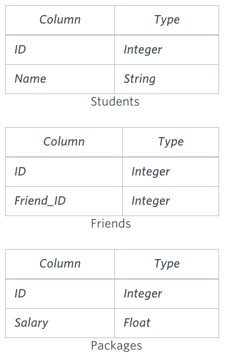

Write a query to output the names of those students whose best friends got offered a higher salary than them. Names must be ordered by the salary amount offered to the best friends. It is guaranteed that no two students got same salary offer.

**Sample Input**

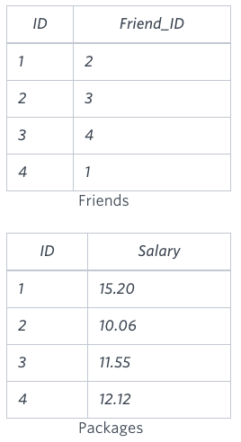

**Sample Output**

Samantha

Julia

Scarlet

**Explanation**

See the following table:

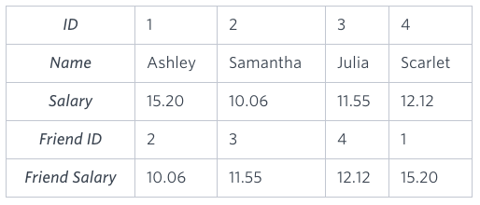

Now,

* *Samantha's* best friend got offered a higher salary than her at 11.55
* *Julia's* best friend got offered a higher salary than her at 12.12
* *Scarlet's* best friend got offered a higher salary than her at 15.2
* *Ashley's* best friend did NOT get offered a higher salary than her

The name output, when ordered by the salary offered to their friends, will be:

* *Samantha*
* *Julia*
* *Scarlet*