**DSSD Project Set-up**

This document will explain the set-up procedure for analyzing data collected in the DSSD experiment using pre-written scripts interfacing with EEGLAB and ADAM.

Users will need:

1. Matlab 2017b or newer.
2. EEGLAB 14.1.2b or newer
3. ADAM 1.0.4 or newer
4. Not required but Git is recommended

**Step 1**

Create folder named “DSSD” or any other of your choosing. The tutorial will assume the name is “DSSD”.

**Step 2**

Create the following folders within “DSSD”: “Data”,”Results”,”Scripts”, and “Toolboxes”

Note: Images are from windows. This also works on Mac but scripts will have to be (easily) modified

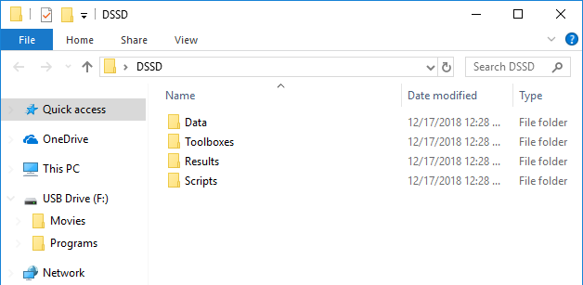

**Step 3**

Here we will get three Matlab toolboxes and place them in the corresponding folder. These are ADAM, EEGLAB, and Fieldtrip.

Find the latest version of ADAM ( <https://github.com/fahrenfort/> )

If the current version is 1.0.4 use <https://osf.io/8vby7/download> . This link will also contain EEGLAB and Fieldtrip.

Otherwise, download each separately. Though we don’t use Fieldtrip directly, it is called by some ADAM scripts.

Place them in “Toolboxes”.

*Should ADAM or EEGLAB be different versions, scripts may have to be updated to address the change in folder name

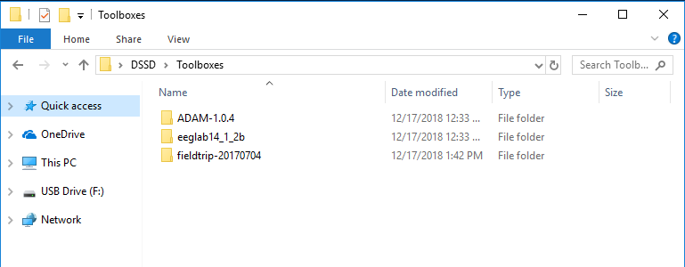

**Step 4**

Within “data” place the “dssd_divided” data. This should be ~1.91 GB.

Create three additional folders within “data” and name them: “decodable_files” and “flipped files” and “decodable_flipped_files”

dssd_divided contains the experimental data split into epochs and separated by subject and condition.

decodable_files, and decodable_flipped_files contains files separated by subject and ready for MVPA analysis. The later contains a flipped version, as explained below.

flipped_files contains the experimental data with the same set-up as dssd_divided. However, electrodes locations were flipped across the longitudinal fissure for cases where saccades were to the left.

*decodable_files and flipped_files will remain empty until scripts are run to create this data

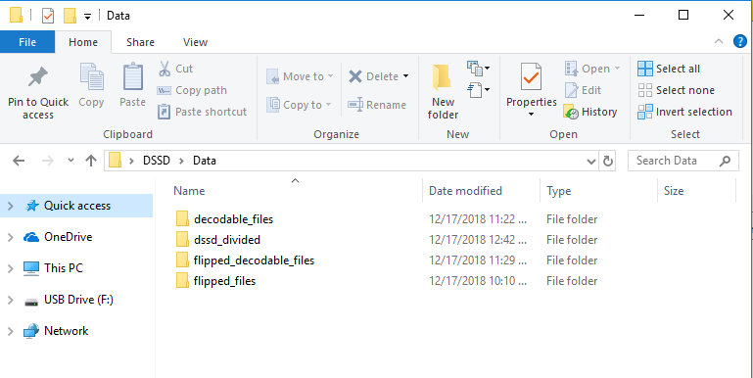

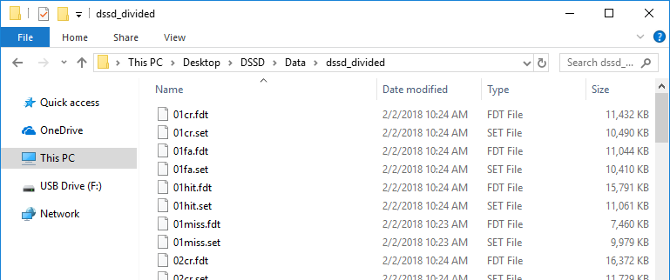

**Step 5**

Now we will download the corresponding scripts. Go to: <https://github.com/jvgiordano/DSSD>

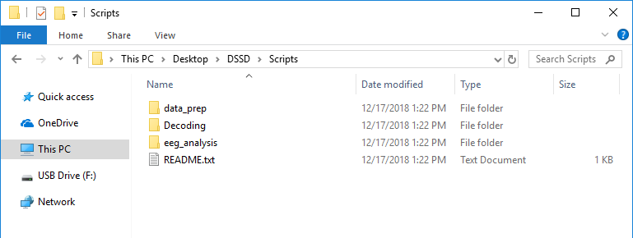

**Step 6**

Open Matlab. Open to “DSSD” in the Current Folder selection. Press ‘+’ to also show contents of the “Toolboxes” folders.

Highlight all folders then, Right Click >> Add to Path >> Selected Folders

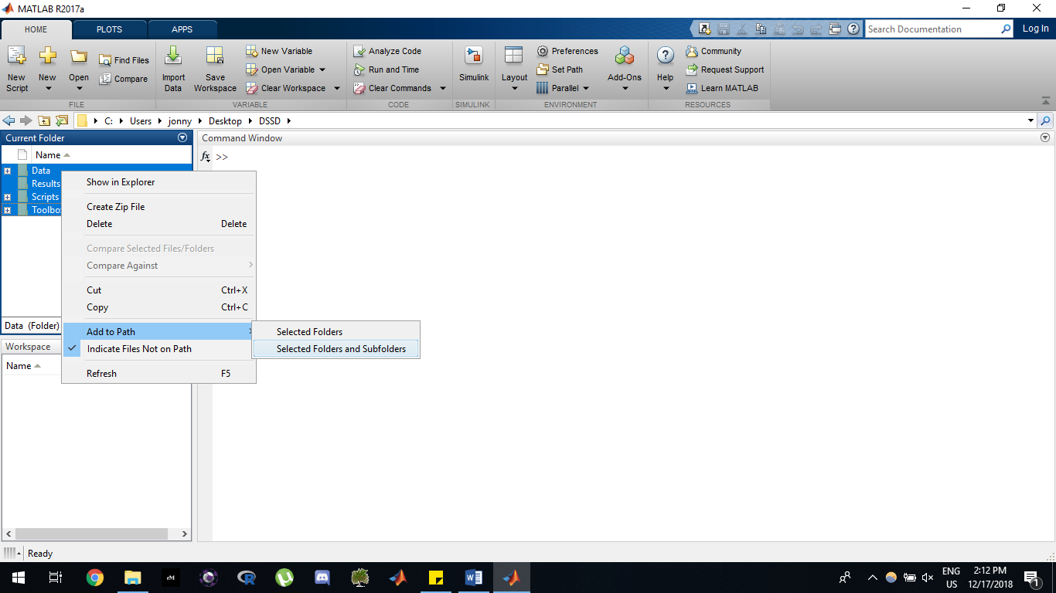

**Step 7**

Open Scripts >> startup.m

*If you have a Mac, go to the sections labeled MAC and remove the block comment markers. Then, create block comments around the WNDOWS section. This is the only type of change to be made for any future types of scripts. ( Highlight >> Right Click >> (Un)comment) is a quick way to do this.

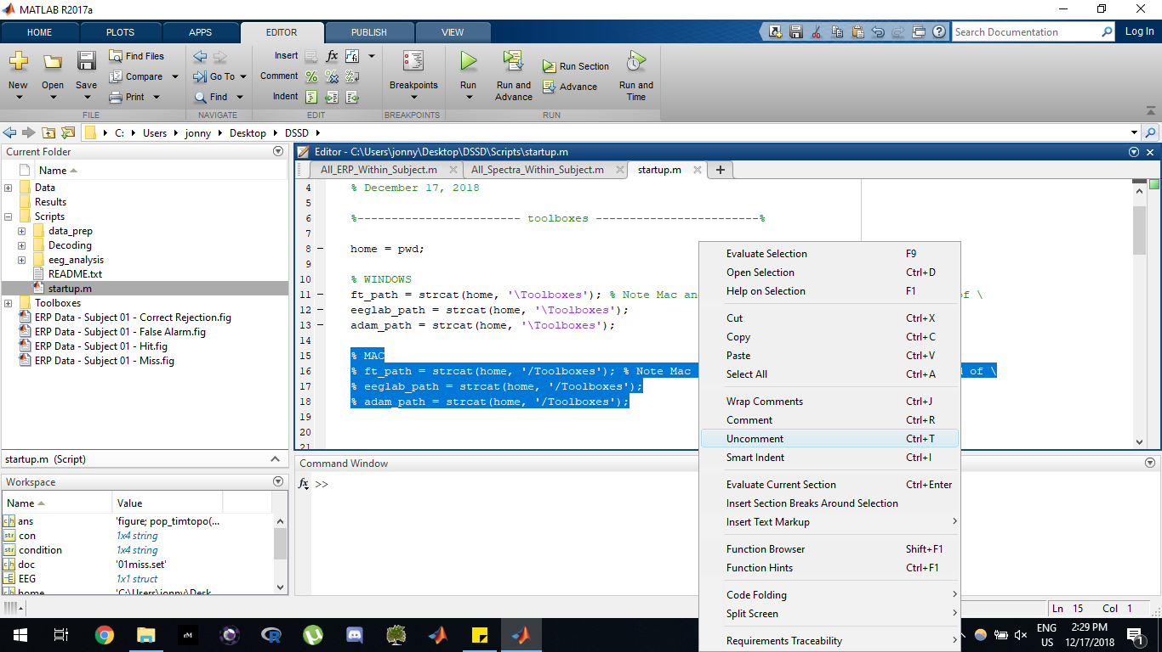

Run the script. You should then see:

FIELD TRIP IS ALIVE

EEGLAB IS ALIVE

ADAM IS ALIVE

**End**

Set-up is now complete. Scripts can be run from the “Scripts”.

“data_prep” contains scripts for preparing data, such as flipping electrodes and putting it into a format the ADAM toolbox can analyze. Processed files will go into corresponding “data” folders.

“decoding” contains scripts which use the ADAM toolbox for decoding

“eeg_analysis” contains scripts which use EEGLAB for analyzing ERPS and the like