# Intro to Java Week 2 Coding Assignment

**Points possible:** 70

|  |  |  |
| --- | --- | --- |
| Category | Criteria | % of Grade |
| Functionality | Does the code work? | 25 |
| Organization | Is the code clean and organized? Proper use of white space, syntax, and consistency are utilized. Names and comments are concise and clear. | 25 |
| Creativity | Student solved the problems presented in the assignment using creativity and out of the box thinking. | 25 |
| Completeness | All requirements of the assignment are complete. | 25 |

**Instructions:** In Eclipse, or an IDE of your choice, write the code that accomplishes the objectives listed below. Ensure that the code compiles and runs as directed. Take screenshots of the code and of the running program (make sure to get screenshots of all required functionality) and paste them in this document where instructed below. Create a new repository on GitHub for this week’s assignments and push this document, with your Java project code, to the repository. Add the URL for this week’s repository to this document where instructed and submit this document to your instructor when complete.

**Coding Steps:**

1. What do each of the following Boolean expressions evaluate to?

|  |  |
| --- | --- |
| **Boolean Expression** | **Answer** |
| true && false | False |
| true || false | True |
| false && false | False |
| true && (false || true) | True |
| false || (true && false) | False |
| false || 1 < 5 | True |
| 5 >= 4 && 1 > 3 | False |
| 10 < 4 || 1 > 4 | False |
| 12 >= 2 && 1 < 24 | True |
| “Hello”.charAt(0) == ‘h’ | False |

1. In Eclipse, create the following Boolean variables and choose what values they hold:
   1. isHotOutside
   2. isWeekday
   3. hasMoneyInPocket
2. Create the following variables (not boolean type, choose the best data type for the variable):
   1. costOfMilk
   2. moneyInWallet
   3. thirstLevel (how thirsty you are on a scale of 1-10)
3. Using the variables you created above and Boolean operators, create variables for the following scenarios:
   1. shouldByIcecream – this should be true if it is hot outside and there is money in your pocket
   2. willGoSwimming – this should be true if it is hot outside and it is not a weekday
   3. isAGoodDay – this should be true if it is hot outside, there is money in your pocket, and it is not a weekday
   4. willBuyMilk – this should be true if it is hot outside, and thirstLevel is greater than or equal to 3, and moneyInWallet is greater than or equal to 2 times the cost of milk.

Example: If I had the variables isWeekday and isSummer and I was going to create a variable isSchoolDay, I would do something like the following:

boolean isSchoolDay = isWeekday && !isSummer;

1. Create a new class called Loops. In the main method of this class, create the following loops with any variables you feel are needed:
   1. A while loop that prints all even numbers from 0 to 100
   2. A while loop that prints every 3rd number going backwards from 100 until we reach 0
   3. A for loop that prints every other number from 1 to 100
   4. A for loop that prints every number from 0 to 100, but if the number is divisible by 3, it prints “Hello” instead of the number, and if the number is divisible by 5, it prints “World” instead of the number, and if it is divisible by both 3 and 5, it prints “HelloWorld” instead of the number.

**Screenshots of Code:**

**Main.java:**

*package* assign02;  
  
*import* java.util.Scanner;  
  
*public class* Main {  
  
 *public static void* main(String[] args) {  
 */*  
 Part 1  
 Display boolean expressions  
 */* System.out.println(*true* && *false*);  
 System.out.println(*true* || *false*);  
 System.out.println(*false* && *false*);  
 System.out.println(*true* && (*false* || *true*));  
 System.out.println(*false* || (*true* && *false*));  
 System.out.println(*false* || 1 < 5);  
 System.out.println(5 >= 4 && 1 > 3);  
 System.out.println(10 < 4 || 1 > 4);  
 System.out.println(12 >= 2 && 1 < 24);  
 System.out.println("Hello".charAt(0) == 'h');  
  
 */*  
 Part 2  
 Create Boolean variables and values  
 */  
  
 // Is it hot outside  
 int* temp = 37;  
 *boolean* isHotOutside = *false*;  
  
 *if* (temp > 80)  
 isHotOutside = *true*;  
  
 System.out.println("isHotOutside: " + isHotOutside);  
  
 *// Is it a weekend* String day = "Monday";  
 *boolean* isWeekDay = *false*;  
  
 *if* (day != "Saturday" || day != "Sunday")  
 isWeekDay = *true*;  
  
 System.out.println("Is it a week day: " + isWeekDay);  
  
 *// Is there money in my wallet  
 double* amountOfMoney = 999999999;  
 *boolean* moneyInWallet = *false*;  
  
 *if* (amountOfMoney > 0)  
 moneyInWallet = *true*;  
  
 System.out.println("There money in my pocket: " + moneyInWallet);  
  
 */*  
 Part 3  
 Variables Cont.  
 */  
  
 double* costOfMilk = 2.69;  
 *// Im going to use money in wallet from part 2  
 int* thirstLevel = 6;  
  
 */*  
 Part 4  
 Using variables  
 */  
  
 // Should I Buy Ice Cream  
 boolean* shouldBuyIceCream = *false*;  
  
 *if* (isHotOutside && moneyInWallet)  
 shouldBuyIceCream = *true*;  
  
 System.out.println("I should buy ice cream: " + shouldBuyIceCream);  
  
 *// Should I Swim  
 boolean* willGoSwimming = *false*;  
  
 *if* (isHotOutside && !isWeekDay)  
 willGoSwimming = *true*;  
  
 System.out.println("I am going to swim: " + willGoSwimming);  
  
 *// It is a good day  
 boolean* isAGoodDay = *false*;  
  
 *if* (isHotOutside && moneyInWallet && !isWeekDay)  
 isAGoodDay = *true*;  
  
 System.out.println("It is a good day: " + isAGoodDay);  
  
 *// I should buy milk  
 boolean* willBuyMilk = *false*;  
  
 *if* (isHotOutside && thirstLevel >= 3 && amountOfMoney >= (costOfMilk * 2))  
 willBuyMilk = *true*;  
  
 System.out.println("I am going to buy milk: " + willBuyMilk);  
  
 */*  
 Create a new instance of loops object  
 and call its constructor  
 */* Loops myLoop = *new* Loops();  
 System.out.println("Print every even number between 0 - 100:");  
 *//myLoop.evenTo100();* System.out.println("Print every 3rd number counting back from 100 - 0:");  
 *//myLoop.every3rd();* System.out.println("Print every number between 1-100");  
 *//myLoop.oneTo100();* System.out.println("Print every number between 1 - 100 but every number " +  
 "divisible by 3 and 5 have a surprise:");  
 myLoop.oneTo100HelloWorld();  
 }  
}

**Loops.java**

*package* assign02;  
  
*public class* Loops {  
 *int* count;  
  
 *// Constructor will set all count variables and display  
 public* Loops() {  
 count = 0;  
 }  
  
 *// Display even numbers from 0 - 100  
 public void* evenTo100() {  
 *while* (count < 101) {  
 System.out.println(count);  
 count += 2;  
 }  
 }  
  
 *// Display every 3rd number goint backwards from 100 - 0  
 public void* every3rd() {  
 count = 100;  
 *while* (count > -1) {  
 System.out.println(count);  
 count -= 3;  
 }  
 }  
  
 *// Prints out 1-100  
 public void* oneTo100() {  
 *for*(*int* i = 1; i < 101; i++) {  
 System.out.println(i);  
 }  
 }  
  
 *// Prints out 1 - 100 but every third number it says Hello  
 // If the number is divisible by 5 it prints world  
 // and if its divisible by 3 and 5 print hello world  
 public void* oneTo100HelloWorld() {  
 *for* (*int* i = 1; i < 101; i++) {  
 *if* (i % 3 == 0 && i % 5 == 0)  
 System.out.println("HelloWorld");  
 *else if* (i % 3 == 0)  
 System.out.println("Hello");  
 *else if* (i % 5 == 0)  
 System.out.println(("World"));  
 *else* System.out.println(i);  
 }  
 }  
}

**Screenshots of Running Application:**

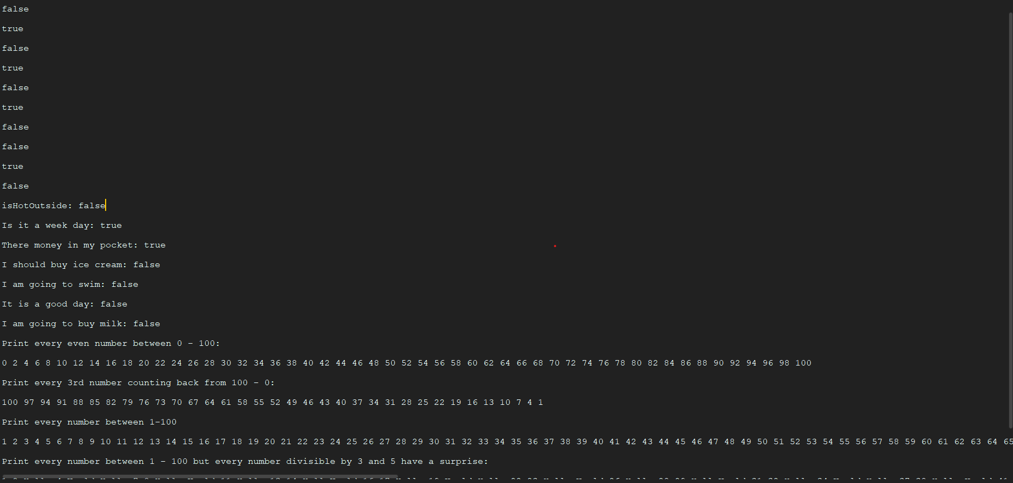

Full listing of the last two loops output (They where cut off in the screen shot)

Print every number between 1-100

1 2 3 4 5 6 7 8 9 10 11 12 13 14 15 16 17 18 19 20 21 22 23 24 25 26 27 28 29 30 31 32 33 34 35 36 37 38 39 40 41 42 43 44 45 46 47 48 49 50 51 52 53 54 55 56 57 58 59 60 61 62 63 64 65 66 67 68 69 70 71 72 73 74 75 76 77 78 79 80 81 82 83 84 85 86 87 88 89 90 91 92 93 94 95 96 97 98 99 100

Print every number between 1 - 100 but every number divisible by 3 and 5 have a surprise:

1 2 Hello 4 World Hello 7 8 Hello World 11 Hello 13 14 HelloWorld 16 17 Hello 19 World Hello 22 23 Hello World 26 Hello 28 29 HelloWorld 31 32 Hello 34 World Hello 37 38 Hello World 41 Hello 43 44 HelloWorld 46 47 Hello 49 World Hello 52 53 Hello World 56 Hello 58 59 HelloWorld 61 62 Hello 64 World Hello 67 68 Hello World 71 Hello 73 74 HelloWorld 76 77 Hello 79 World Hello 82 83 Hello World 86 Hello 88 89 HelloWorld 91 92 Hello 94 World Hello 97 98 Hello World

**URL to GitHub Repository:**

https://github.com/jvgreen/Promineo-Boot-Camp/tree/master/Week2/codingAssignment02/assignment02/src/assign02